Enterprise Project Report
Building a Unified Customer 360 & Sales Analytics Platform
(ECRMDP)

Team Members:
Sriviknesh T
Sharan S M
Siddharth P
School of Computer Science and Engineering
VIT Chennai

Table of Contents
1. Executive Summary
2. Introduction
3. Objectives and Scope
4. Solution Architecture and Technology Stack
5. Sprint 0: Project Initiation and Architecture
6. Sprint 1: Data Discovery and Ingestion
7. Sprint 2: Data Profiling and Data Warehouse
8. Sprint 3: Data Governance, Lineage and Analytics
9. Results
10. Known Limitations and Data Quality Notes
11. Conclusion and Future Scope
Appendix: Deliverables Traceability

1. Executive Summary
The team built a working Customer 360 and sales analytics platform for ABC Global Solutions. It takes 10 CRM and digital-channel sources through bronze, silver and gold layers into a PostgreSQL star schema and a 5-page Power BI dashboard. Every layer is reconciled: the validation report records 110 PASS, 0 FAIL and 11 INFO checks, and all 24 dashboard KPIs match their SQL-tested reference values in the Business Glossary.
Item | Delivered
Sources ingested | 10 sources in 4 file formats (CSV, Excel, JSON, XML), 2,000 rows each
Warehouse | 5 dimensions, 8 facts, 22 foreign-key relationships
ETL | 23 Pentaho transformations run by one master job (ECRMDP_Master_ETL.kjb)
Governance | Data lineage document, source-to-target mapping, business glossary with 24 KPIs
Validation | python/reconciliation.py: 110 PASS, 0 FAIL, 11 INFO
Reporting | Power BI: Executive Overview, Sales Pipeline, Marketing, Customer Service, Customer 360
Delivery | GitHub Actions pipeline that deploys and validates the schema on every push to main

Headline figures: 2,000 customers, won revenue of 58,523,409.29, a 50.0% deal win rate and an open pipeline of 209,008,202.45. The currency is not stated in the source data (DQ6), so amounts are shown without a symbol.

2. Introduction
ABC Global Solutions Ltd. runs sales, marketing, customer support, service operations and digital channels on separate CRM applications, so no single system shows a complete view of a customer. Records for one customer are spread across customer master, leads, opportunities, the sales pipeline, campaigns, support tickets, the contact center, the website, the mobile app and social media.
This fragmentation makes it hard to track customer journeys, measure sales performance, judge campaign effectiveness and monitor service quality. UC16 asks for an enterprise CRM data platform (ECRMDP) that consolidates these sources into one trusted warehouse and reporting layer.

3. Objectives and Scope
- Collect customer and sales data from multiple CRM systems and digital channels.
- Clean, validate and standardise customer, lead and sales data.
- Store curated data in a PostgreSQL data warehouse.
- Maintain metadata and end-to-end data lineage.
- Support customer, sales, marketing and service analytics through Power BI.
- Use Git and GitHub for version control, with documentation for every sprint.
In scope: the 10 sample sources provided with UC16 (2,000 rows each), batch ETL with Pentaho Data Integration, profiling and cleansing in Python (Pandas), a star schema in PostgreSQL, and a Power BI dashboard.
Out of scope: real-time ingestion, connection to live CRM systems, and a permanently hosted production database. The deployment pipeline deploys to a temporary database on each run (section 8.6).

4. Solution Architecture and Technology Stack
The platform follows a medallion architecture: raw files land in bronze staging tables, a Python cleansing step produces silver files, and Pentaho loads those into a gold star schema that Power BI reads.
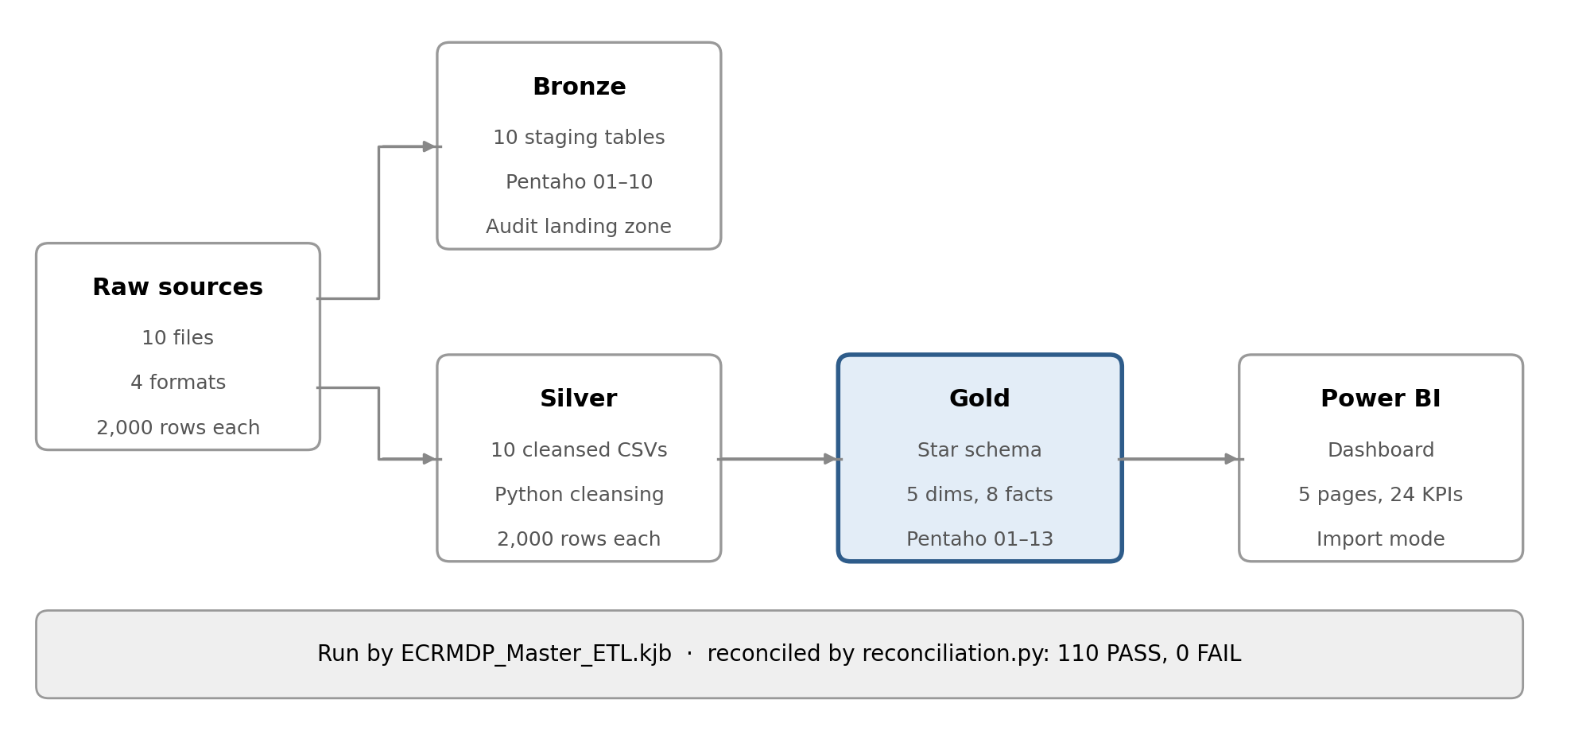
Figure 1. ECRMDP architecture
Bronze and silver are parallel branches: the cleansing script reads the raw files, not the staging tables. Bronze therefore serves as the auditable landing zone, and the star schema is built from the silver files.
Layer | Storage | Built by | Output
Raw | datasets/01_… to 10_… | Source systems | 10 files
Bronze | PostgreSQL ecrmdp_dw | pentaho/transformations/01–10 | 10 staging tables
Silver | datasets/*_silver.csv | silver/cleansing/data_cleaning.py | 10 cleansed files
Gold | PostgreSQL ecrmdp_dw | silver/transformations/01–13 | 5 dimensions, 8 facts
Reporting | dashboards/ | Power BI Desktop | 5-page dashboard

Category | Technology | Used for
ETL | Pentaho Data Integration (Spoon) | Ingestion, warehouse loading, orchestration
Database | PostgreSQL | Staging tables and star schema
Programming | Python (Pandas) | Profiling, cleansing, reconciliation
Reporting | Power BI Desktop | Executive dashboard
Version control | Git and GitHub | Code, documents, releases
Delivery | GitHub Actions | Automated schema deployment and validation
Project management | Agile Scrum | Four sprints (0–3)

5. Sprint 0: Project Initiation and Architecture
Sprint 0 set the requirements, scope, architecture and repository before development began.
Deliverable | File
Business Requirement Document | docs/BRD Document.docx
Project Charter | docs/ECRMDP_Project_Charter.docx
Solution Architecture | docs/System Architecture.docx
Product / Sprint Backlog | docs/Product backlog (Sprint 0,1).docx
Git repository | GitHub repository with the enterprise folder structure

6. Sprint 1: Data Discovery and Ingestion
Sprint 1 built the landing zone: 10 Pentaho transformations load 10 sources in four file formats into 10 PostgreSQL staging tables, 2,000 rows each.
# | Source system | Raw file | Format | Bronze table
1 | Customer Master | 01_customer_master.csv | CSV | customer_master_01
2 | Lead Management | 02_lead_management.xlsx | Excel | lead_management_02
3 | Opportunity Management | 03_opportunity_management.json | JSON | opportunity_management_03
4 | Sales Pipeline | 04_sales_pipeline.xml | XML | sales_pipeline_04
5 | Marketing Campaigns | 05_marketing_campaign.csv | CSV | marketing_campaign_05
6 | Customer Support | 06_customer_support_tickets.csv | CSV | customer_support_tickets_06
7 | Contact Center | 07_contact_center_logs.csv | CSV | contact_center_logs_07
8 | Website | 08_website_registration.csv | CSV | website_registration_08
9 | Mobile App | 09_mobile_application.csv | CSV | mobile_application_09
10 | Social Media | 10_social_media_engagement.csv | CSV | social_media_engagement_10

Each transformation uses the input step for its format (CSV file input, Microsoft Excel input, JSON input, Get data from XML), a Select values step for type conversion, and a Table output step on the shared connection DA-1_Project, with Write to log steps for logging. No columns are renamed or dropped, so bronze is a faithful copy of the source.
Deliverables: source inventory (docs/ECRMDP_Source_Inventory.xlsx), data dictionary (docs/CRM_Data_Dictionary (1).xlsx), the ingestion transformations and job (pentaho/jobs/ECRMDP_Sprint1_ETL.kjb), the staging DDL (sql/TableCreation_DA_1_DE.sql) and the Git commit history.

7. Sprint 2: Data Profiling and Data Warehouse
Sprint 2 profiled and cleansed the sources in Python, then loaded a star schema of 5 dimensions and 8 facts into PostgreSQL with Pentaho.

7.1 Profiling and cleansing
data_profiling.py reports shape, data types, missing values, duplicates, unique values and statistics for each source. data_quality.py checks nulls, duplicate keys, foreign keys between sources, value ranges and close-before-engage dates. data_cleaning.py then applies four rules to all 10 sources:
- Remove fully duplicate rows, then rows with a duplicate business ID.
- Standardise text: trim and lowercase emails; trim and Title Case gender, country, city, lead source and status, opportunity stage and deal stage.
- Parse dates (registration, lead, created, engage and close); invalid values become null.
- Fill missing customer income and age, lead score and opportunity probability with the column median.
The cleansed output is 10 silver files of 2,000 rows each, matching the raw counts, so no source row was lost.

7.2 Star schema
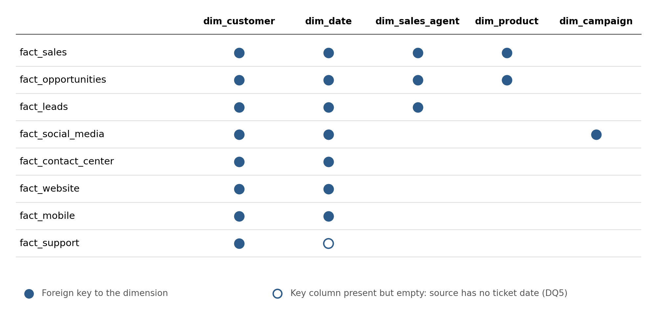
Figure 2. Bus matrix: 8 facts × 5 dimensions, 22 foreign keys
The 8 facts share two conformed dimensions, customer and date, which is what lets the Customer 360 view combine all channels for one customer. Each fact row receives its dimension keys from a Pentaho Database lookup on a business key (for example customer_id → customer_key). dim_date is generated: 731 days from 2025-01-01, with the smart key date_key = year × 10000 + month × 100 + day.
Table | Grain | Source
dim_customer | One customer | Customer Master
dim_product | One product | Opportunity Management
dim_sales_agent | One sales agent | Lead Management
dim_campaign | One campaign | Marketing Campaigns
dim_date | One calendar day | Generated
fact_leads | One lead | Lead Management
fact_opportunities | One opportunity | Opportunity Management
fact_sales | One deal | Sales Pipeline
fact_support | One ticket | Customer Support
fact_contact_center | One interaction | Contact Center
fact_website | One registration | Website
fact_mobile | One app event | Mobile App
fact_social_media | One engagement | Social Media

The DDL is in sql/Silver.sql, and validation queries for nulls, duplicate keys and relationships are in sql/.

8. Sprint 3: Data Governance, Lineage and Analytics
Sprint 3 made the platform traceable, repeatable and reportable: every column is mapped and traced, the full load runs from one job, every layer is reconciled, and the results reach executives through Power BI.

8.1 Source-to-target mapping
metadata/ECRMDP_Source_to_Target_Mapping.xlsx documents, column by column, how each raw field moves into bronze, silver and the warehouse, including type conversions, renames, surrogate-key lookups and fields deliberately dropped. An Open_Issues sheet tracks every known gap with its status.

8.2 Data lineage
lineage/Data_Lineage.md traces the data at four levels: the end-to-end layer flow, each source to its gold tables, each transformation step, and job orchestration. It lists 9 lineage gaps found during Sprint 3: 7 fixed, 1 verified correct and 1 accepted limitation. A SQL check confirmed that all 2,000 date keys in each of the three date-time facts fall on the correct calendar day.

8.3 Business glossary
metadata/ECRMDP_Business_Glossary.xlsx defines the business terms and 24 KPIs (K01–K24). Each KPI has a definition, a SQL formula tested against the warehouse and a reference value. A Data_Quality_Notes sheet records 6 findings (DQ1–DQ6, section 10).

8.4 ETL orchestration
pentaho/jobs/ECRMDP_Master_ETL.kjb runs the full load as one chain: reset the star schema, load the 10 bronze tables (B01–B10), build dim_date (G05), load the other 4 dimensions (G01–G04), load the 8 facts (G06–G13), then run sql/post_load_check.sql. Every hop follows only on success, so any failing step stops the run, and the final check fails the job if any warehouse table is empty or a required key is null. Before Sprint 3, dim_date had to be run by hand; the master job removes that step.

8.5 Reconciliation and validation
python/reconciliation.py compares row counts, key integrity and money totals (tolerance ±0.01) across the layers and writes docs/ECRMDP_Validation_Report.xlsx.
Layer checked | PASS | FAIL | INFO
Raw → Bronze | 22 | 0 | 0
Raw → Silver | 0 | 0 | 10
Silver → Warehouse | 46 | 0 | 0
Key integrity | 42 | 0 | 1
Total | 110 | 0 | 11

The 11 INFO rows are expected results: 10 report that cleansing removed 0 duplicate rows from each source, and 1 reports that all 2,000 fact_support.date_key values are empty because the source has no date (DQ5).

8.6 Continuous deployment
.github/workflows/deploy.yml runs on GitHub Actions on every push to main. It starts a fresh PostgreSQL 16 database, deploys the staging and star-schema DDL, runs sql/gold_validation.sql and packages the project as a downloadable bundle. Any SQL error fails the run. On a version tag such as v1.0.0, it also publishes the bundle as a GitHub Release.

8.7 Power BI executive dashboard
dashboards/ECRMDP_Executive_Dashboard.pbix (with a PDF export) imports the 13 warehouse tables, using the 22 foreign-key relationships as one-to-many, single-direction filters. All 24 glossary KPIs are DAX measures, and each was checked against its SQL reference value before the pages were built, with 0 mismatches.
Page | KPIs | Main visuals
Executive Overview | K01, K02, K03, K08, K09 | Won revenue by country; monthly won revenue trend; year slicer
Sales Pipeline | K04, K06, K07, K10, K11 | Opportunities by current stage (process order); won revenue by agent and by product; leads by source
Marketing | K12–K16 | ROI and engagement by campaign type; acquisition cost by channel; impressions by platform
Customer Service | K17–K21 | Tickets by priority; contact center volume by channel
Customer 360 | Activity counts | Customer search; profile table; leads, deals, tickets, calls, web, app and social activity for the selected customer

The Customer 360 page shows the platform’s main goal in one click: selecting a customer filters all 7 activity fact tables through customer_key. For example, customer CUST00414 has 1 lead, 2 deals, 1 ticket, 1 call, 1 web registration, 1 app event and 1 social engagement.

8.8 Final release
The final project state is tagged v1.0.0 in Git, which triggers the deployment pipeline to publish the release bundle.

9. Results
Every figure below appears identically in the glossary SQL and the Power BI dashboard.
KPI | Area | Value
K01 Total customers | Customer | 2,000
K02 Active customer rate | Customer | 49.7%
K03 Customer 360 coverage | Customer | 99.90%
K04 Lead conversion rate | Sales | 18.4%
K05 Average lead score | Sales | 50.07
K06 Open pipeline value | Sales | 209,008,202.45
K07 Weighted pipeline value | Sales | 111,474,444.01
K08 Deal win rate | Sales | 50.0%
K09 Won revenue | Sales | 58,523,409.29
K10 Average won deal size | Sales | 182,315.92
K11 Average sales cycle | Sales | 117.3 days
K12 Average campaign ROI | Marketing | 5.19
K13 Average campaign conversion | Marketing | 18.39%
K14 Total acquisition cost | Marketing | 25,790,125.02
K15 Social click-through rate | Marketing | 7.32%
K16 Average engagement rate | Marketing | 23.22%
K17 Average first response | Service | 301.4 minutes
K18 Average resolution time | Service | 59.9 hours
K19 Support satisfaction (CSAT) | Service | 3.02
K20 Ticket closure rate | Service | 51.65%
K21 Contact resolution rate | Service | 25.35%
K22 Average handling time | Service | 30.9 minutes
K23 Mobile purchases | Digital | 328
K24 Average app session | Digital | 60.4 minutes

Key findings
- Revenue is spread across all 7 countries, led by the UK at roughly 10.3M; no single country dominates.
- Monthly won revenue varies between about 2.2M and 4.3M with no sustained trend. The lower 2026 total reflects partial-year data (January to August), not a decline.
- Campaign types perform alike: ROI is about 5 and engagement about 22–24% for every type. Acquisition cost by channel shows the largest spread, from about 4.0M (Email) to 4.6M (Facebook).
- Service is the weakest area: only 51.65% of tickets are closed, 25.35% of contact-center interactions are resolved, and CSAT averages 3.02.
- The deal win rate (50.0%) and the opportunity Won share (371 of 707 closed, about 52.5%) differ because K08 is defined on deals in fact_sales, while opportunity stages are a separate table.

10. Known Limitations and Data Quality Notes
# | Finding | Impact | Status
DQ1 | Cleansing turned UK and USA into “Uk” and “Usa” | Countries appeared twice in filters | Fixed: 559 rows corrected
DQ2 | Data dictionary lists fields not in the delivered data | Readers look for columns that do not exist | Open
DQ3 | Probability is 0–100; conversion and engagement rates are 0–1 | Mixing them gives results 100× off | Note: formatted consistently in Power BI
DQ4 | Source caps engagement rate at 0.5 (333 of 2,000 rows) | Averages understate top posts | Note
DQ5 | Support tickets have no date | Support KPIs cannot be trended over time | Accepted
DQ6 | No currency stated for monetary columns | Amounts shown without a currency symbol | Open

Three structural limits also apply. Campaign KPIs come from dim_campaign, which has no date, so date filters do not affect them. fact_sales carries no campaign reference, so revenue cannot be attributed to campaigns. The deployment pipeline deploys to a temporary database on each run rather than a permanently hosted one.

11. Conclusion and Future Scope
ECRMDP meets the UC16 objectives: 10 heterogeneous CRM sources are ingested, cleansed, modelled and reported, with lineage, metadata and reconciliation showing that the dashboard figures trace back to the source data without loss. The full load runs from one Pentaho job, and the schema is redeployed and validated automatically on every push.
- Request a created date for support tickets so service KPIs can be trended (DQ5).
- Confirm the currency with the data owner and label monetary figures (DQ6).
- Align the data dictionary with the delivered columns (DQ2).
- Add a campaign reference to sales deals to enable revenue attribution.
- Deploy to a hosted PostgreSQL instance, with credentials in GitHub Secrets, and schedule the master job for incremental loads.
- Add an acquisition and retention page to the dashboard.

Appendix: Deliverables Traceability
Sprint | UC16 deliverable | Repository evidence
0 | BRD | docs/BRD Document.docx
0 | Solution Architecture | docs/System Architecture.docx
0 | Git Repository | GitHub repository
0 | Sprint Backlog | docs/Product backlog (Sprint 0,1).docx
0 | Project Charter | docs/ECRMDP_Project_Charter.docx
1 | Source Inventory | docs/ECRMDP_Source_Inventory.xlsx
1 | Data Dictionary | docs/CRM_Data_Dictionary (1).xlsx
1 | Pentaho ETL Pipelines | pentaho/transformations/01–10, ECRMDP_Sprint1_ETL.kjb
1 | Staging Database | sql/TableCreation_DA_1_DE.sql
1 | Git Commit History | GitHub commit log
2 | Data Profiling Report | silver/cleansing/data_profiling.py
2 | Data Quality Report | silver/cleansing/data_quality.py
2 | Star Schema | sql/Silver.sql
2 | PostgreSQL Data Warehouse | silver/transformations/01–13
2 | SQL Scripts | sql/ validation scripts
2 | Git Repository Updates | GitHub commit log
3 | Data Lineage Document | lineage/Data_Lineage.md
3 | Metadata Repository | Source-to-target mapping and business glossary (metadata/)
3 | Pentaho Jobs | pentaho/jobs/ECRMDP_Master_ETL.kjb
3 | Validation Report | docs/ECRMDP_Validation_Report.xlsx
3 | Power BI Dashboard | dashboards/ECRMDP_Executive_Dashboard.pbix and .pdf
3 | Final Git Release | Tag v1.0.0 and its GitHub Release
3 | Project Report | This document
3 | Sprint Presentation | Sprint review deck

