Data Lineage Document
Enterprise Customer Relationship Management Data Platform (ECRMDP)

Team Members:
Sriviknesh T
Sharan S M
Siddharth P
School of Computer Science and Engineering
VIT Chennai

1. Overview
This document traces how data moves through ECRMDP, from the 10 raw source files to the PostgreSQL star schema and the Power BI dashboard. Everything below was traced from the Pentaho .ktr/.kjb files, the SQL scripts and silver/cleansing/data_cleaning.py in the project repository. Column-level detail is in metadata/ECRMDP_Source_to_Target_Mapping.xlsx.

2. End-to-End Flow (Medallion Architecture)
Raw files land in bronze staging tables, a Python cleansing step produces silver files, and Pentaho loads those into the gold star schema that Power BI reads.
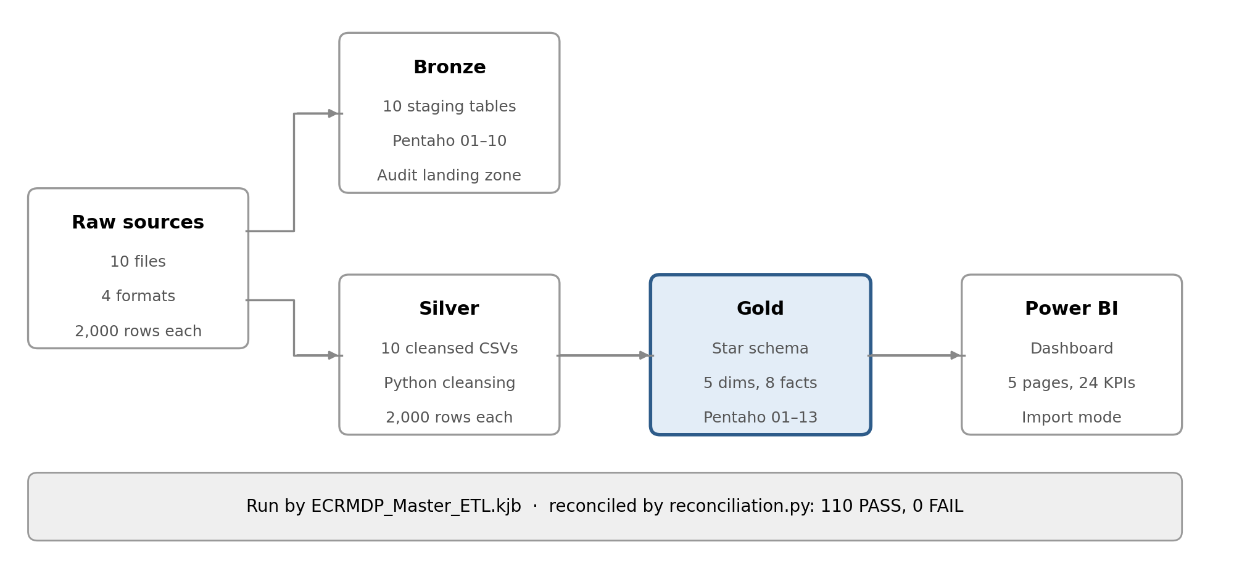
Figure 1. ECRMDP data flow from raw sources to Power BI
Layer | Storage | Built by | Output
Raw | datasets/01_… to 10_… | Source systems | 10 files
Bronze | PostgreSQL ecrmdp_dw | pentaho/transformations/01–10 | 10 staging tables
Silver | datasets/*_silver.csv | silver/cleansing/data_cleaning.py | 10 cleansed files
Gold | PostgreSQL ecrmdp_dw | silver/transformations/01–13 | 5 dimensions, 8 facts
Reporting | dashboards/ | Power BI Desktop | 5-page dashboard

Bronze and silver are parallel branches. The cleansing script reads the raw files, not the staging tables. Bronze is the auditable landing zone (an unchanged copy of each source), and the star schema is built from the silver files.

3. Source Systems (Raw → Bronze)
Each source has one Pentaho transformation that loads it, unchanged, into its own staging table. All 10 sources have 2,000 rows.
# | Source system | Raw file (format) | Bronze table | Main columns
1 | Customer Master | 01_customer_master.csv (CSV) | customer_master_01 | customer_id, name, email, gender, age, country, city, income, education, marital status, registration date, status
2 | Lead Management | 02_lead_management.xlsx (Excel) | lead_management_02 | lead_id, customer_id, lead source, lead date, lead status, lead score, sales agent
3 | Opportunity Management | 03_opportunity_management.json (JSON) | opportunity_management_03 | opportunity_id, lead_id, customer_id, product, stage, value, probability, created date, sales agent
4 | Sales Pipeline | 04_sales_pipeline.xml (XML) | sales_pipeline_04 | deal_id, opportunity_id, customer_id, product, deal stage, engage date, close date, close value, sales agent
5 | Marketing Campaigns | 05_marketing_campaign.csv (CSV) | marketing_campaign_05 | campaign_id, company, campaign type, target audience, duration, channel, conversion rate, acquisition cost, ROI, location
6 | Customer Support | 06_customer_support_tickets.csv (CSV) | customer_support_tickets_06 | ticket_id, customer_id, product, ticket type, status, priority, first response minutes, resolution hours, satisfaction rating
7 | Contact Center | 07_contact_center_logs.csv (CSV) | contact_center_logs_07 | interaction_id, customer_id, agent_id, date-time, channel, call reason, duration minutes, outcome, satisfaction score
8 | Website | 08_website_registration.csv (CSV) | website_registration_08 | registration_id, customer_id, date-time, registration source, device type, browser, country
9 | Mobile App | 09_mobile_application.csv (CSV) | mobile_application_09 | app_event_id, customer_id, date-time, device type, app version, event type, session minutes, app source
10 | Social Media | 10_social_media_engagement.csv (CSV) | social_media_engagement_10 | engagement_id, campaign_id, customer_id, platform, post date, post type, impressions, clicks, likes, comments, shares, engagement rate

Each transformation uses the input step for its format (CSV file input, Microsoft Excel input, JSON input with path $..[*].<field>, Get data from XML with loop /sales_pipeline/record), a Select values step for type conversion only, and a Table output step on the connection DA-1_Project. No columns are renamed or dropped at this layer.

4. Cleansing (Raw → Silver)
silver/cleansing/data_cleaning.py applies four rules to all 10 sources and writes one *_silver.csv file per source:
- Remove fully duplicate rows, then rows with a duplicate business ID (for example customer_id, lead_id, deal_id).
- Standardise text: trim and lowercase emails; trim and Title Case gender, country, city, lead source and status, opportunity stage and deal stage; trim product names. UK and USA are restored after Title Case (data quality fix DQ1).
- Parse dates (registration, lead, created, engage and close); invalid values become null.
- Fill missing numeric values with the column median: customer income and age, lead score, opportunity probability.
No source row was lost: each silver file has the same 2,000 rows as its raw file.

5. Data Warehouse (Silver → Gold)

5.1 Dimensions
Dimension | Source (silver file) | Business key | Notes
dim_customer | customer_master_silver.csv | customer_id | Direct copy of the customer profile
dim_product | opportunity_management_silver.csv | product → product_name | De-duplicated (Unique rows, HashSet)
dim_sales_agent | lead_management_silver.csv | sales_agent | De-duplicated (Unique rows, HashSet)
dim_campaign | marketing_campaign_silver.csv | campaign_id | Keeps conversion rate, acquisition cost and ROI
dim_date | Generated | full_date | 731 days from 2025-01-01

5.2 Facts
Fact | Source (silver file) | Grain | Dimension keys
fact_leads | lead_management_silver.csv | One lead | customer, sales agent, date
fact_opportunities | opportunity_management_silver.csv | One opportunity | customer, sales agent, product, date
fact_sales | sales_pipeline_silver.csv | One deal | customer, product, sales agent, date
fact_support | customer_support_tickets_silver.csv | One ticket | customer (date key empty: DQ5)
fact_contact_center | contact_center_logs_silver.csv | One interaction | customer, date
fact_website | website_registration_silver.csv | One registration | customer, date
fact_mobile | mobile_application_silver.csv | One app event | customer, date
fact_social_media | social_media_engagement_silver.csv | One engagement | customer, campaign, date

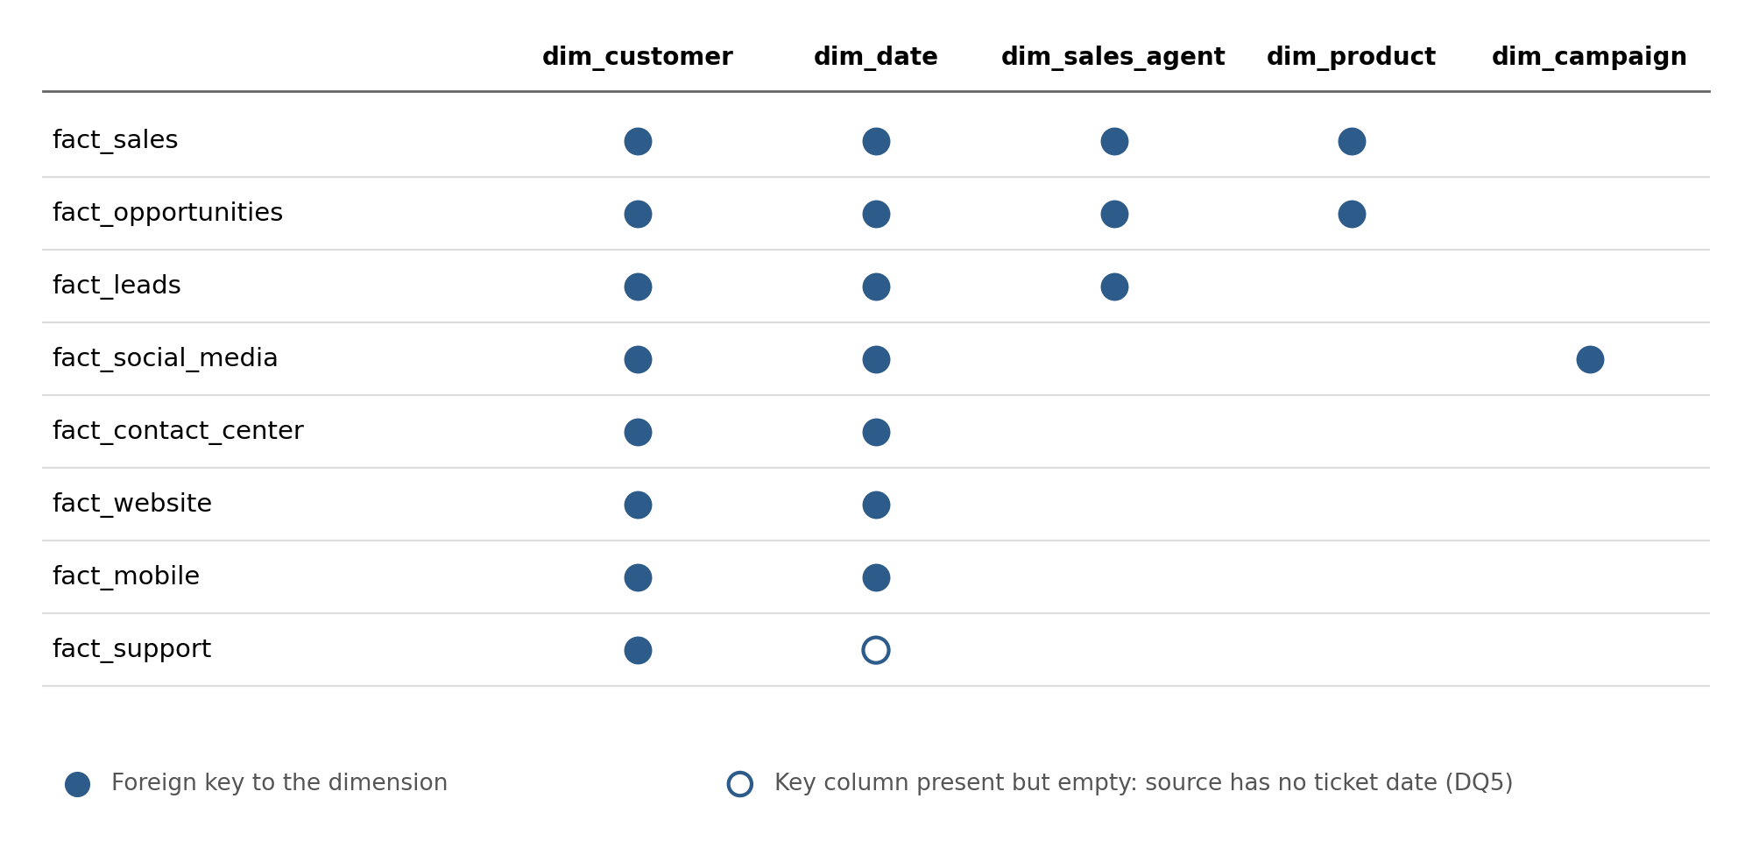
Figure 2. Which dimensions each fact table joins (22 foreign keys)

5.3 Surrogate-key lookups
Each fact row gets its dimension keys from a Pentaho Database lookup step on a business key. A Select values step then removes the business keys that were replaced.
Key | Looked up from | Business key used | Used by
customer_key | dim_customer | customer_id | All 8 facts
sales_agent_key | dim_sales_agent | sales_agent | fact_leads, fact_opportunities, fact_sales
product_key | dim_product | product → product_name | fact_opportunities, fact_sales
campaign_key | dim_campaign | campaign_id | fact_social_media
date_key | dim_date | full_date matched to the source date | 7 facts (not fact_support: no date in source)

date_key is a smart key: year × 10000 + month × 100 + day. For example, 2025-01-01 becomes 20250101. dim_date is built by Generate rows (731) → Add sequence → Calculator (date parts) → JavaScript (date_key).

5.4 Fields deliberately not carried into the warehouse
Source | Fields dropped | Where
Support tickets | customer_name, customer_email, ticket_subject, resolution, ticket_channel | 09_support_silver.ktr

6. Orchestration Lineage
pentaho/jobs/ECRMDP_Master_ETL.kjb runs the whole load as one chain. Every hop follows only on success, so a failing step stops the run.
- 00 Reset star schema (sql/reset_star_schema.sql).
- B01–B10: load the 10 bronze staging tables.
- G05: build dim_date.
- G01–G04: load dim_customer, dim_product, dim_sales_agent, dim_campaign.
- G06–G13: load the 8 fact tables (after all dimensions, so every key lookup can succeed).
- 99 Post-load checks (sql/post_load_check.sql): fail the job if any warehouse table is empty or a required key is null.
The silver files are produced beforehand by running data_cleaning.py. The older jobs ECRMDP_Sprint1_ETL.kjb (bronze only) and silver/job_1.kjb (warehouse only) remain in the repository.

7. Known Lineage Gaps
Nine gaps were found while tracing the lineage in Sprint 3. They are also tracked in the Open_Issues sheet of the source-to-target mapping workbook.
# | Gap | Status
1 | fact_support.date_key: the support source has no date column | Accepted limitation
2 | fact_contact_center, fact_website, fact_mobile date keys: a date-time is looked up against a date | Verified: 2,000 of 2,000 rows on the correct day in each
3 | fact_social_media.campaign_key was dropped by Select values 2 | Fixed in Sprint 3
4 | fact_sales.opportunity_id was removed, breaking deal → opportunity tracing | Fixed in Sprint 3
5 | Campaign cost and ROI fields were not stored in the warehouse | Fixed in Sprint 3
6 | dim_product / dim_sales_agent duplicates | Fixed (commit ed6dd39)
7 | fact_support missing date_key column | Fixed (commit 025af5e)
8 | Bronze steps had no database connection | Fixed (commit 025af5e)
9 | data_cleaning.py read raw files from a path outside the repository | Fixed: paths are now relative to the repository

7.1 Verification of gap 2
This query compares each fact’s date_key with the calendar day of the original timestamp in the staging layer. On 9 October 2026, correct_day equalled rows_checked (2,000) for all three facts.
SELECT 'fact_contact_center' AS fact, COUNT(*) AS rows_checked,
SUM(CASE WHEN f.date_key = TO_CHAR(s.interaction_datetime::date, 'YYYYMMDD')::int
THEN 1 ELSE 0 END) AS correct_day
FROM fact_contact_center f JOIN contact_center_logs_07 s USING (interaction_id);
-- repeated for fact_website (registration_datetime) and fact_mobile (event_datetime)

8. Related Documents
- metadata/ECRMDP_Source_to_Target_Mapping.xlsx: column-level mapping and open issues
- metadata/ECRMDP_Business_Glossary.xlsx: business terms, 24 KPIs, data quality notes
- lineage/Data_Lineage.md: this lineage in the repository, with Mermaid diagrams
- docs/ECRMDP_Validation_Report.xlsx: reconciliation results

