1. Go to pusher.com and register, get the app keys and cluster

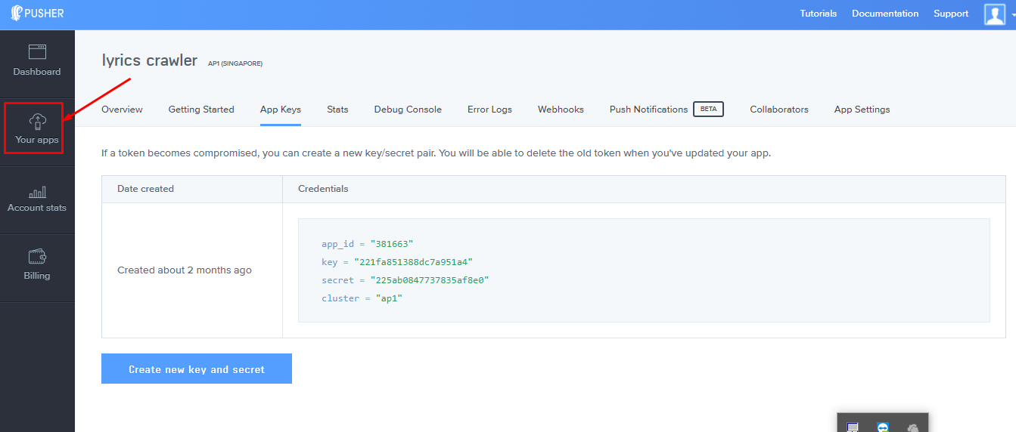

2. Install composer. Follow this tutorial

<http://webdevzoom.com/how-to-install-composer-on-windows/>

3. Copy and paste 2 folder (crawlerRefactor and cleansing) in htdocs.

4. Install pusher using composer. Go to the crawlerRefactor root directory in htdocs using cmd. Type

composer require pusher/pusher-php-server

5. Change line 109 and 105 in crawlerRefactor main.php

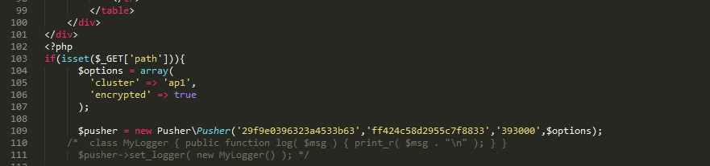

6.Copy the Lyrics Extension files.

7. Change line 5 and 6 in js/popup.js in the extension file.

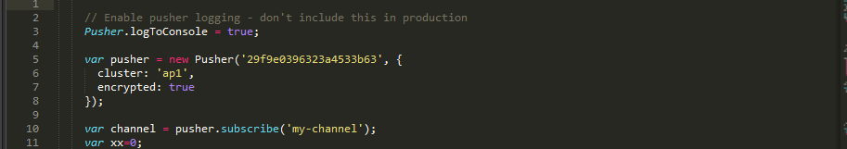

8.Open the chrome browser,type chrome://extensions

9.Check the developer mode then point to the root directory of the extension.

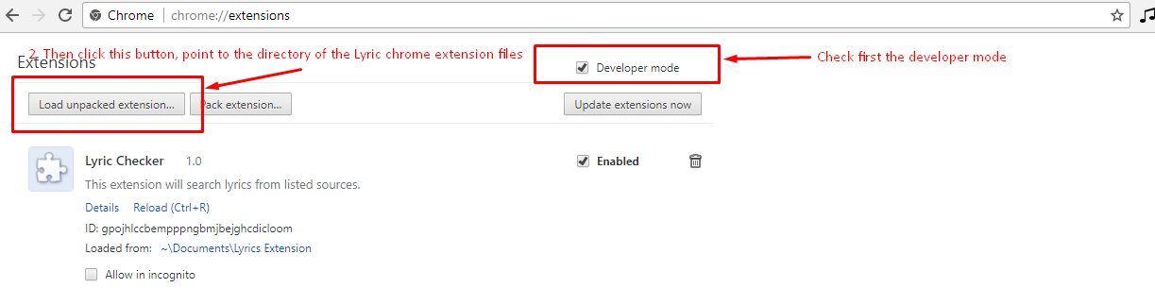

10. Set max_execution_time =0 in php.ini

11. Add the google api keys in apis.php in crawlerRefactor folder, dont put spaces between the api keys.