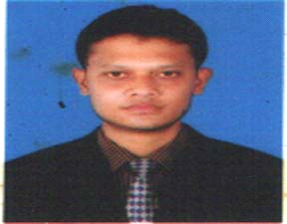

**Curriculum Vitae**

***Of***

**Yasir Arafath**

Cell: 01832890816

**Personal Information:**

Name : **Yasir Arafath**

Father’s Name : SM Shamim

Mother’s Name : Nargis Akter

Date Of Birth : 15/07/1987

**Present Address** : Vill/Road- Chikondondi

P.O- Fatabad, P.S- Hathazari,

Dist- Chittagong.

**Permanent Address :** Vill/Road- Chikondondi

P.O- Fatabad, P.S- Hathazari,

Dist- Chittagong.

Nationality : Bangladeshi (By Birth)

Gender : Male

Religion : Islam

Marital Status : Unmarried

**Educational Qualification:**

|  |  |  |  |  |
| --- | --- | --- | --- | --- |
| **Exam Name** | **Group** | **Passing Year** | **GPA/Division** | **Board** |
| S.S.C | Humanities | 2003 | 2.13 | Chittagong |
| H. S.C | Humanities | 2009 | 1.60 | Chittagong |
| B.S.S | Humanities | 2014 | Running | Govt. City College |

**Skill : Strong Communication Skill**

**Others : Good English verbal and written skill and**

**Also have management skill**

**: power point ,ms word and have**

**Good knowledge about internet.**

Experience : I **Hello World Communication 01 Year**

**: cogent Bangladesh limited 01year**

**: post: customer service officer**

Interest : music,travelling,sports

**I like to offer myself to serve the nation through hard and sincere work, if you kindly appoint me in your *organization*.**

**Yasir Arafath**

**Date: 21/14/2017**