AI, Economic Perceptions, and Consumer Sentiment Ahead of the 2026 Midterm Elections
Final Course Project — AI Applications in Finance · Data cut-off 16 October 2026 (October Michigan reading preliminary)
Deliverables: this report · reproducible package (README.md) · monitoring dashboard (dashboard/index.html) · summary deck

Executive summary
Bottom line: media bias does not explain the sentiment gap. We find real, measurable partisan slant in economic coverage, but it cannot account for record-low sentiment: (1) coverage measures add no out-of-sample predictive power once household cost pressures are modelled; (2) across the 2025 presidential transition, aggregate coverage tone barely moved — even under our least favourable filter, the change implies about 0.9 point of sentiment, against an actual fall of 14.5 points; (3) the decline is shared by every age and income group, lines up within each month with reported price and income hardship, and the extra decline of the young is largely explained by the inflation they lived through. The gap is best explained by a price-level grievance that headline data and history-trained models miss, experience effects, a survey-mode change and partisan identity — with media as an amplifier of price salience, not the source.
Michigan consumer sentiment averaged 51.2 in 2026 (October preliminary 46.3; May's 44.8 is the lowest on record), while a real-time model using only U-3 unemployment, headline PCE inflation and real GDP growth predicts about 85. The resulting sentiment gap (-33.5 points; every 2026 month below the 95% prediction interval) is real under that model — but it is mostly not a mystery once the measurement and the household economy are taken seriously. We decompose the 41-point fall since 2019:
Component of the 2019→2025–26 change in ICS | Points | Share | Status
Headline indicators (U-3, PCE, GDP) | -5.2 | 13% | FINDING
Household pressures not in headline data (cumulative price level, food, U-6, gasoline, real income) and policy uncertainty | -14.7 | 36% | FINDING (associational; 2000–2019 coefficients)
Survey-mode change (phone→web, 2024; Michigan's own estimate) | -6.6 | 16% | FINDING (external estimate)
Partisan composition of respondents (illustrative, 5-pp Republican share drop) | -2.4 | 6% | HYPOTHESIS (back-of-envelope)
Unexplained residual — the space any media/perception story must fill | -12.4 | 30% | Residual
Actual change, 2019 → 2025–26 | -41.3 | 100%

- RQ1 — measuring bias. Bias is defined as deviation from a stated benchmark, never as negativity. We built a 2017–2026 corpus of 247,108 items (news headlines from 9,515+ outlets; Hacker News since 2010; Mastodon for the monitoring window), coded six codebook dimensions with pinned open-source AI models (validated on 300 human labels: 70% tone accuracy, κ = 0.45, beating a dictionary, FinBERT and an LLM), and ran four benchmark tests plus factual calibration. The clearest bias is partisan slant: holding each month's facts fixed, right-leaning outlets' economic headlines are 0.43 net-tone points more negative under a Democratic than a Republican president relative to other outlets (p < 0.001, all four coders agree). We find no negativity asymmetry, coverage of falling inflation rises when inflation falls, and numeric claims are not systematically skewed toward bad news.
- RQ2/RQ5 — impact and prediction. Corpus-based coverage measures do not reliably improve out-of-sample prediction once economic indicators are included: the nested Clark–West test is marginal (p = 0.03) but realised RMSE gets worse (8.7 → 10.9), whereas household-pressure controls cut it to 6.6; Michigan's own bad-news recall predicts strongly (RMSE 13.2→9.6) but Granger-causality runs both ways (p<0.001 each), so recall is a symptom as much as a cause. No design here identifies a causal effect of media bias on the national index.
- RQ3. U-3, inflation and GDP explain ~13% of the 2019→2025–26 fall; household pressures (price level, food, U-6, policy uncertainty) raise this to roughly half; the web-mode change adds ~16%.
- RQ4. Measurable: supply-side negativity and framing, price-level anchoring (proxy) and experience effects — groups that lived through more inflation expect more and feel worse within the same month, explaining ~78% of why the young fell further. Not measurable: confirmation or availability bias in readers (no exposure data).
- Fresh test — the 2025 transition as a natural experiment. Outlet slant flips with the party in power (right-leaning outlets turned markedly more positive after January 2025, as they had under Trump-1), but aggregate coverage tone barely changed: even under our least favourable filter it implies under 1 point of sentiment, against a 14.5-point fall. Whether individual partisan audiences track their outlets is filter-sensitive and we say so (Section 6.1).
- RQ6. Pre-specified falsification tests (Section 8) mostly point away from a media-supply explanation: coverage negativity is not excessive relative to fundamentals; sentiment and recall feed back on each other; and the decline is visible in every group alongside large, measurable cost-of-living pressures.
- Implication. For spending forecasts in 2022–26, the fundamentals-consistent part of sentiment helped and the gap component hurt: forecasters and risk managers should decompose sentiment rather than read headline gloom as a recession signal (Section 10).

1. Question, competing explanations, and approach
The brief asks us to distinguish three explanations for low sentiment relative to measured conditions: (E1) consumers respond to pressures that headline indicators miss; (E2) perceptions reflect selective information, framing or cognitive bias; (E3) the discrepancy is an artefact of measurement, timing or an incomplete model. We treat each as a hypothesis with an explicit way to fail (Section 8). Two design rules run throughout: (i) every regressor is the value public at the survey date (real-time vintages, publication lags, shutdown overrides), and (ii) text measures describe the supply of content; they are never treated as proof of readers' cognitive bias.
On the original hypothesis (age-group hardships drive the decline). It is a good instinct and we test it formally (Section 4), but it needs two corrections. First, 'which group has the most impact' must be measured as weight × change, not as which group is gloomiest. Second, group hardship is evidence for E1 only if it explains differences within a month, after national news and macro data are held fixed; otherwise 'other factors correlated with sentiment' cannot be separated from common shocks. The age analysis is therefore one component of the answer — it does not by itself address media bias (RQ1, 2, 5, 6), which the brief weights most heavily.

2. Economic and survey baseline
Data. Monthly 1978–2026 (analysis window 2010–2026; monitoring window 2025–October 2026). Michigan ICS with Current (ICC) and Expectations (ICE) indices, age/income/region sub-indices and the qualitative 'reasons' and 'news heard' tables; BLS U-3 (SA); BEA headline PCE price index (YoY = 100×(P_t/P_t−12 − 1)); real GDP from the Philadelphia Fed real-time data set (monthly vintages), reported both as q/q SAAR and y/y. Controls: U-6, food-at-home and shelter CPI, real gasoline, real disposable income per capita, saving rate, interest burden, 30-year mortgage rate, an affordability index, cumulative 3-year inflation, and news-based policy uncertainty. Sources, vintages and URLs are in docs/DATA_PROVENANCE.md.
Timing. Michigan interviews run from late month t−1 to about the 20th of month t, so the information set is what was public by mid-month t: U-3 for t−1, PCE for t−2, and the latest GDP quarter in the vintage dated t (first or then-current estimate, never today's revised figure; quarterly GDP is never interpolated). The October-2025 household survey was not conducted and the Sept–Nov 2025 BLS/BEA releases were delayed by the shutdown; explicit overrides assign the data actually available.
Data-integrity findings (all documented and handled). (1) The supplied 'PCE YoY' column is core PCE — it matches BEA's DPCCRG to 0.00001 over 584 months but differs from headline by up to 2.25 pp; we use headline as required and core as a robustness check. (2) The supplied GDP column includes 2026Q3 = 3.7%, which BEA had not published by the cut-off (advance estimate due late October); using it would be look-ahead, so it is excluded. (3) Supplied GDP is a current vintage (up to 9 pp from first releases in 2020). (4) Michigan's demographic tables are 3-month moving averages (verified), so monthly sub-indices come from the archive file. (5) Michigan moved from phone to web interviewing in April–July 2024; Michigan estimates a −6.6-point level effect (an outside estimate is −8.9).
Economic-only model (M1). ICS_t = α + β₁U3 + β₂PCE + β₃GDP + ε, chosen by BIC on pre-2000 data among q/q-SAAR and y/y GDP variants (y/y wins; adding Δ12 U-3 does not help). Estimated 1978–2019: U-3 -2.67 (HAC t -3.0), PCE -1.95 (t -4.1), GDP 2.54 (t 4.6), R² 0.56. The sentiment gap is the actual value minus the out-of-sample prediction from an expanding window: each month is predicted from a model fit only on earlier months, with an OLS prediction interval (80% and 95%).
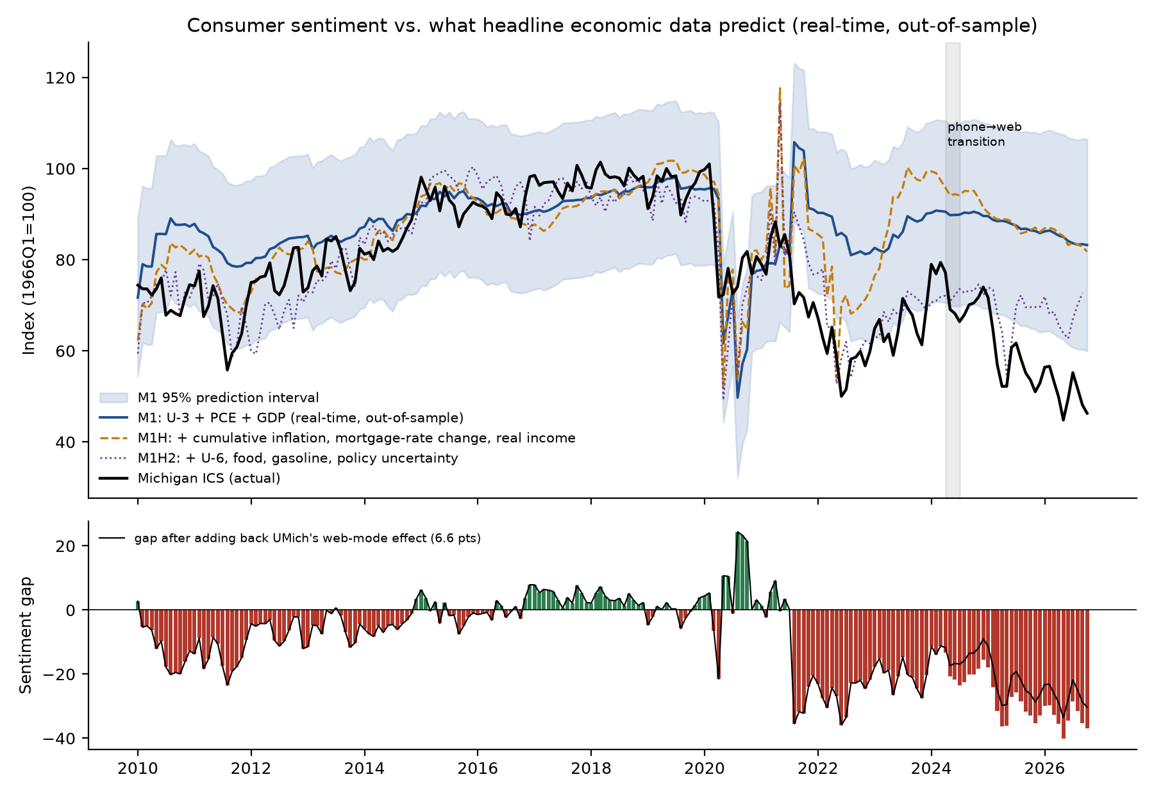
Figure 1. Michigan ICS vs. real-time, out-of-sample predictions with 95% prediction interval (top) and the monthly sentiment gap (bottom). The dashed line adds household-pressure and policy-uncertainty controls (M1H2). Black line in the lower panel adds back Michigan's 6.6-point web-mode effect.
Table 1. Real-time out-of-sample sentiment gap by period (M1: U-3 + headline PCE + GDP y/y).
Period | N | Actual | Predicted | Gap | Gap (mode-adj.) | Share < 95% PI | ICC gap | ICE gap
1990–2007 | 216 | 91.2 | 93.3 | -2.1 | -2.1 | 8% | -3.2 | -1.4
2008–2009 GFC | 24 | 65.0 | 83.8 | -18.8 | -18.8 | 58% | -21.0 | -17.5
2010–2019 | 120 | 85.5 | 89.0 | -3.5 | -3.5 | 6% | -1.3 | -5.0
2020 COVID | 12 | 81.5 | 75.4 | 6.2 | 6.2 | 8% | 6.6 | 5.9
2021–2022 inflation surge | 24 | 68.3 | 86.7 | -18.4 | -18.4 | 71% | -27.1 | -12.8
2023–2024 disinflation | 24 | 68.9 | 88.1 | -19.1 | -17.0 | 50% | -30.4 | -11.9
2025 | 12 | 57.6 | 87.6 | -30.0 | -23.4 | 92% | -37.7 | -25.1
2026 (to Oct, pre-midterm) | 10 | 51.2 | 84.6 | -33.5 | -26.9 | 100% | -43.7 | -25.8
A negative gap is unexplained pessimism under this model, not proof of perceptual bias. The 2008–09 gap (−18.8) is a useful benchmark: large gaps also occur when the model misses real shocks (housing wealth, credit).
Robustness. The 2025–26 gap is essentially unchanged with core instead of headline PCE (-31.1), q/q instead of y/y GDP (-33.1) or revised data (-31.5); the forbidden look-ahead GDP variant gives -32.8 (outputs/tables/robustness_gap.csv). It shrinks sharply only when the model may re-estimate on recent data (rolling 60-month window: -13.4) — the relationship itself shifted. A post-2021 intercept dummy is -20.1 (p < 0.001) with the web share -13.6 (p = 0.007): evidence for E3 (model instability and measurement) alongside E1. Seasonality: Michigan's index is not seasonally adjusted, but calendar-month dummies are jointly insignificant (HAC F = 1.45, p = 0.15) and leave the 2025–26 gap at -32.0.

3. How much do unemployment, inflation and growth explain? (RQ3) — and what else does
FINDING. Between 2019 and 2025–26, ICS fell 41.3 points. With 1978–2019 coefficients, the three headline indicators account for only -5.2 points (13%): unemployment is up ~0.5 pp, inflation is above 2019 but well below 2022, and growth is close to trend. Adding Michigan's web-mode offset raises the explained share to about 29%. The brief's three indicators therefore leave most of the decline unexplained.
Alternative explanation E1: household pressures. We test a small set of controls, each one at a time (Holm-adjusted) and in a combined model fit on 2000–2019 (M1H2) and evaluated out-of-sample from 2008. Long-history levels (mortgage rate, price-level gap) enter with counter-intuitive signs on 1978–2019 because they trend with regimes, so we specify the household model a priori in growth/changes and use the 2000+ controls.
Table 2. Decomposition of the 2019 → 2025–26 change with the household-pressure model (M1H2).
Variable | Coef (2000–19) | p | Change 2019→25/26 | Contribution (pts)
U-3 | 3.85 | 0.201 | 0.54 | 2.1
PCE inflation y/y | -0.34 | 0.718 | 1.35 | -0.5
Real GDP y/y | 1.86 | 0.011 | -0.46 | -0.9
Cumulative 3-yr inflation (price level) | -1.95 | 0.000 | 4.03 | -7.8
Δ12m mortgage rate | 0.82 | 0.537 | 0.46 | 0.4
Real disposable income pc y/y | 0.44 | 0.268 | -1.84 | -0.8
U-6 underutilisation | -4.45 | 0.012 | 0.73 | -3.3
Food-at-home inflation | -1.55 | 0.001 | 1.40 | -2.2
Real gasoline price y/y | -0.09 | 0.045 | 9.35 | -0.9
Policy uncertainty (news-based EPU) | -0.04 | 0.000 | 151.10 | -6.1
TOTAL predicted | – | – | – | -20.0
Web-mode offset (UMich) | – | – | – | -6.6
ACTUAL change | – | – | – | -41.3
Unexplained residual | – | – | – | -14.7
M1H2 explains -20.0 of -41.3 points; with the mode offset, -26.6. The out-of-sample 2025–26 gap shrinks from −31.6 (M1) to about −12 (M1H2). Coefficients are associational; EPU is itself built from newspaper text, so its contribution sits between E1 (real policy shocks — tariffs, shutdown) and E2 (coverage).
Why falling inflation need not reverse concern about prices. Inflation measures the rate; households experience the level. The PCE price level rose 24% between January 2021 and August 2026, against 12% on a 2%-a-year path — prices are roughly 11% higher than the pre-2021 norm would imply and do not come back down when inflation falls. Michigan respondents say so: the share reporting they are worse off because of higher prices rose from 7% in 2019 to 45% in 2025–26 — above its 2022 inflation-peak level (40%). Buying conditions for durables (−81 points), vehicles (−81) and homes (−97) collapsed, with 'interest rates high' as a reason for homes up 36 pp: the cost of money is part of the perceived cost of living (Bolhuis, Cramer, Schulz & Summers, 2024). Wage growth that has caught up with prices does not erase the memory of the reference price (anchoring) — a mechanism we can proxy but not isolate.
A first-principles check: how long do consumers remember inflation? We replaced current inflation with an exponentially weighted memory of past monthly inflation and estimated its half-life from 1978–2019 alone. History says memory is short (half-life ≈ 3 months), and the memory model leaves the 2025–26 gap unchanged (-31.3 vs -31.6). So today's level-anchored behaviour is not how consumers reacted in the past four decades: the 2021–22 shock pushed households outside the range the models were trained on (explanation E3 — a regime break), and 'worse off because of higher prices' now exceeds its 2022 peak. The gap is a measurement and modelling failure as much as a perception problem.
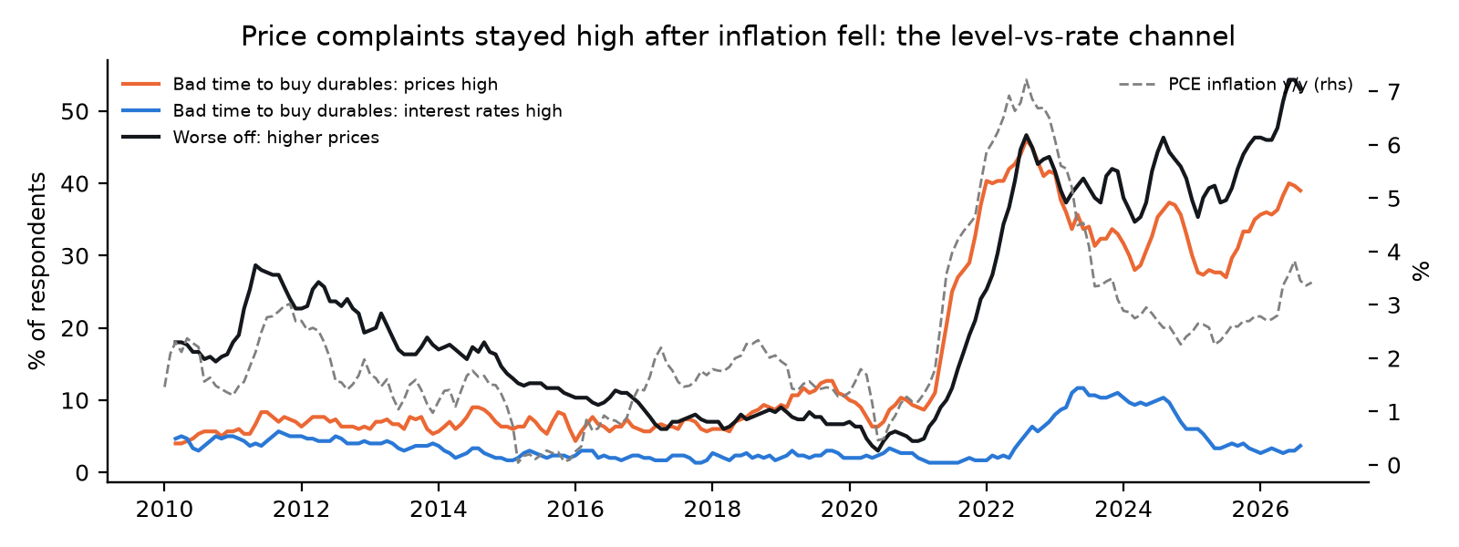
Figure 2. Price complaints stayed high after inflation fell. Michigan: % worse off citing higher prices; % saying it is a bad time to buy durables because of prices or interest rates; PCE inflation (dashed, right axis).
Is the CPI wrong? No — it answers a narrower question. The BLS prices a fixed basket (~80,000 prices a month), weights items by dollars spent (so higher-spending households weigh more), measures owner housing as an imputed rent that lags market rents by about a year, adjusts for quality, and — since 1983 — excludes interest costs. Its known biases (Boskin Commission, 1996) ran upward and were largely corrected. So official inflation does not hide price growth; it measures the rate for an average basket, while households feel the level, their own basket and borrowing costs. From January 2021 to September 2026 headline CPI rose 28%, shelter 31%, groceries 27% and gasoline 68% (from a pandemic low), while average hourly earnings rose 26% — real wages are still slightly below their January-2021 level (a level that was flattered by low-wage job losses).
Why aggregate growth can differ from household experience. GDP and payroll growth are averages; household finances depend on the distribution of real income, on borrowing costs and on prices of necessities. Expected real income (income vs prices) fell 45 points; the Current Conditions index carries a larger gap than Expectations (Table 1: ICC gap −43.7 vs ICE −25.8 in 2026), consistent with present-day affordability rather than a general forecast of collapse.

4. Who is pessimistic, and which hardships do they report? (age and income)
Table 3. Concentration of the decline by age and income tercile (monthly sub-indices).
Group | ICS 2019 | ICS 2025–26 | Change | % change | Weight | Contribution | Share of decline
18–34 | 101.2 | 53.8 | -47.4 | -47% | 0.22 | -10.4 | 25%
35–54 | 96.7 | 52.9 | -43.8 | -45% | 0.34 | -15.0 | 36%
55+ | 93.2 | 56.3 | -37.0 | -40% | 0.44 | -16.2 | 39%
Bottom third | 88.7 | 49.2 | -39.5 | -45% | 0.34 | -13.4 | 33%
Middle third | 98.7 | 55.2 | -43.5 | -44% | 0.34 | -14.8 | 36%
Top third | 100.8 | 61.2 | -39.6 | -39% | 0.32 | -12.7 | 31%
Weights are implied by constrained least squares of the headline on the three sub-indices (2015–2026). Unweighted respondent counts are not used: the web sample is ~66% aged 55+, which Michigan's weights correct.
FINDING — the decline is broad-based. Every age group lost 37–47 points and every income tercile 40–43. Young adults (18–34) fell furthest (-47 points, -47%), but because older groups carry more weight, those aged 55+ contribute the most points to the headline (39%) and 18–34 the least (25%). So the answer to 'which age group drives the rating' depends on the question: severity is highest among the young; contribution is largest among older consumers. Geography tells the same story: every Census region fell 36–42 points (39–45%).
Hardships differ in mix, not in direction. The share citing higher prices as a reason for being worse off rose ~35–40 pp in all three age groups. What is specific to the young is income and housing: 'worse off — lower income' +8 pp (vs +1 for 55+), 'can't afford a home' +7.5 pp (vs +3.1), and higher year-ahead inflation expectations (+2.4 pp). The young also report hearing far more unfavourable economic news (+49 pp vs +35) and rate government economic policy 'poor' more often (+41 pp).
Is this generation scarred? A test, not an assertion. Economists Malmendier & Nagel show that people form inflation beliefs from the inflation they have lived through, weighting recent years more — and the young, with shorter lives, weight recent years most. For each Michigan age group we computed lifetime-experienced CPI inflation (Philadelphia Fed history from 1947; weights ∝ (age − years ago)^1.5) and asked, within the same month (so current inflation and national news are identical for everyone), whether groups with more experienced inflation think and feel differently. They do: one extra point of experienced inflation raises a group's year-ahead inflation expectation by 0.67 pp (p < 0.001) and lowers its sentiment by 10.6 points (p = 0.002), robust to the weighting (θ = 1, 3). The 2021–23 shock raised the young's experienced inflation most, and this alone predicts 8.2 of the 10.4 extra points the 18–34s lost relative to the 55+ (~78%). FINDING: the generational 'scarring' story is supported for inflation — a measurable, rational-learning channel, not a media effect. Caveats: three age groups, 3-month-averaged tables, and group-specific trends are not absorbed by the fixed effects; the test needs full lifetime histories (an earlier version using PCE from 1959 truncated older groups and was discarded).
Table 4. Group-level ICS on reported hardships with group and MONTH fixed effects (age groups, 2008–2026).
Within-month regressor (age groups) | Coef | Driscoll–Kraay SE | p
Worse off: higher prices (pp) | -0.62 | 0.07 | 0.000
Worse off: lower income (pp) | -0.26 | 0.11 | 0.019
Home: can't afford (pp) | -0.53 | 0.10 | 0.000
Expected job-loss probability (pp) | -0.35 | 0.13 | 0.008
Heard bad news: prices (pp) | -0.37 | 0.10 | 0.000
Heard bad news: jobs (pp) | -0.24 | 0.07 | 0.000
Month fixed effects absorb everything common to all groups in a month — national coverage and the macro releases — so coefficients use only cross-group differences. Within-R² 0.64. Caveat: hardship and sentiment come from the same respondents (reverse causality possible).
Interpretation. Within a month, groups that report more price and income hardship are less confident (≈ −0.6 ICS points per pp citing prices), and this survives controls for the bad news each group says it heard. Group-specific hardship is therefore a credible channel (E1). But the hardship increase is common to all groups, so it cannot explain why the young fell further on its own; the young's extra income/housing stress and extra bad-news recall both line up with their larger decline. Your original intuition is supported in direction, with the correction that the story is 'everyone feels the price level; younger households additionally feel income and housing strain' rather than 'one group drives it'.

5. Measuring bias in news coverage and social media (RQ1)
Corpus design. News: Google News US-edition RSS, nine fixed topic queries and fourteen outlet-specific queries per month, 2017-01 to 2026-10 (headline, outlet, date); GDELT full-population daily volume and full-text tone for the same period. Social: Hacker News (Algolia) since 2010 — the only platform with free historical access — and Mastodon hashtag timelines for the 2024–26 monitoring window. Reddit, Bluesky and X refused unauthenticated access, so we make no claims about them, and HN's tech-heavy audience means social results describe that community, not Michigan respondents. Items are headlines/titles/posts (not full articles). We flag exact duplicates (wire syndication, reposts), ads, foreign-only items and suspected automated accounts, and keep three levels separate: supply (what was published), engagement (HN points, Mastodon favourites) and exposure/recall (Michigan's 'news heard' questions).
Table 5. Corpus composition and quality flags.
Source group | Items | Relevant | Duplicates | Bot-flagged | Foreign | Sources
Hacker News | 18,839 | 14,734 | 631 | 0 | 1,509 | 2
Mastodon | 15,995 | 9,643 | 512 | 8,765 | 2,974 | 1
News: local regional | 53,672 | 36,546 | 1,435 | 0 | 4,587 | 7,153
News: national, wire & business | 138,721 | 38,586 | 970 | 0 | 17,363 | 54
News: other institutional | 19,881 | 15,630 | 193 | 0 | 1,258 | 2,308
Google News results are ranked by Google's relevance algorithm, not randomly sampled; this is a selection layer we cannot remove and is one reason supply measures are compared across outlets within the same month rather than read as absolute levels.
Coding scheme and AI measurement. The codebook (docs/CODEBOOK.md, frozen before any model was run) defines six dimensions: tone (with emotional wording separated from factual valence), selection/salience (eleven topics), framing (price level vs rate; household vs aggregate; current vs forecast), factual calibration, and political attribution (credit/blame by actor, without equating criticism with bias). The AI coder is a zero-shot natural-language-inference model (DeBERTa-v3, pinned revision) whose hypotheses transcribe the codebook definitions, with FinBERT as a domain model and an emotion classifier plus loaded-word lexicon for emotional wording. Baselines are a direction-aware economic dictionary, GDELT's full-text dictionary tone, and a TF-IDF/logistic-regression classifier trained on the human labels. An optional LLM coder (Claude, same codebook, prompts/llm_coding_prompt_v1.md) is scripted for comparison. Coding uses a fixed-seed stratified sample (≤12 headlines per topic query and ≤10 per outlet per month) so every month and outlet is represented.

5.1 Validation
Design and deviation from the brief. The brief asks for two independent annotators; only one was available, and we did not simulate a second. One human annotator labelled the full stratified sample of 300 items (news by outlet-lean group, Hacker News and Mastodon × four periods; AI-predicted positives oversampled so per-class F1 is estimable) for relevance and household tone, using a one-tap web tool blind to all machine labels. Inter-annotator agreement therefore cannot be reported; reliability is assessed by test–retest on a 30-item re-check (Table 6a). Topic, framing and attribution remain machine-coded only. An LLM (Claude Opus 5.5) also labelled the same items as an additional coder; it is evaluated against the human labels like any other model, never used as ground truth.
Table 6a. Test–retest reliability (same annotator, re-labelled later, new order, blind to first answers).
Dimension | N | % agree | Cohen's κ | Krippendorff's α
relevant | 30 | 80% | 0.30 | 0.29
tone | 30 | 60% | 0.26 | 0.26
The 30 re-check items were drawn from the items on which the machine coders disagreed — the hardest, most ambiguous cases — so these figures are a lower bound on human reliability. Even one person is only moderately consistent on ambiguous economic headlines: that is the ceiling against which the AI coder's 70% agreement should be read.
Table 6. Coders vs the human labels (relevant items).
Coder (household tone) | N | Accuracy | Macro-F1 | κ vs human
AI coder v2 (NLI + price rule) | 269 | 70% | 0.59 | 0.45
LLM (Claude Opus 5.5) | 269 | 50% | 0.35 | 0.26
FinBERT | 269 | 51% | 0.42 | 0.19
Dictionary | 269 | 43% | 0.38 | 0.16
TF-IDF + logistic regression (5-fold CV) | 269 | 55% | 0.32 | 0.01
TF-IDF is trained and tested on the human labels with 5-fold cross-validation (out-of-fold predictions); all other coders are zero-shot.
FINDING (validation). Against the human labels, our AI coder is the most accurate tone measure (70%, κ = 0.45, moderate agreement), well ahead of the dictionary (43%), FinBERT (51%) and an LLM (50%). Accuracy is similar across sources (64%–80%; right-leaning news 74%, left-leaning 64%), so the partisan-slant result in Section 5.2 is not an artefact of the coder working better for one side. Relevance is the weak dimension: the AI relevance filter agrees with the human only 58% of the time (κ = 0.16), but κ understates what matters for an index: of the items our indices actually keep (keyword filter + AI gate), 98% are relevant by the human's judgement (precision), at the cost of keeping only about half of all relevant items (recall 54%). Section 6.1 re-runs the key media results with the keyword filter alone (90% precision, 100% recall). The annotator labelled 67% of relevant items negative versus 53% for the AI coder, so the AI coder, if anything, understates negativity.
AI coder development (documented, not hidden). The first tone hypotheses ('good/bad news for American households') were almost never entailed by the NLI model (98.9% of items neutral). On an 18-headline development set we then compared wordings: the generic sentiment template reached 83% but read 'inflation cools' and 'gas prices fall' as negative — exactly the household-polarity cases this study depends on. The final coder (v2) therefore combines the NLI sentiment template with a codebook polarity rule for price-direction headlines (applied to 7% of items), 94% on the development set. The development set was written by us, so this is a design check, not validation.
Table 7. Name- and source-swap tests on otherwise identical text.
Counterfactual test | N | Tone flips | |Δ score| | Signed Δ | Attribution flips | FinBERT flips
party/name swap | 367 | 7.1% | 0.082 | – | 7.4% | 5.7%
source label 'Fox News:' vs none | 400 | 9.5% | 0.105 | -0.043 | 3.0% | 5.8%
source label 'CNN:' vs none | 400 | 6.0% | 0.076 | +0.010 | 3.2% | 5.8%
Fox vs CNN label (direct) | 400 | 6.2% | – | -0.053 | – | –
Party/name swap: Biden↔Trump, Democrats↔Republicans, etc. Source test: prefixing 'Fox News:' or 'CNN:' to the same headline. Non-zero flip rates measure the coder's sensitivity to political cues that should be irrelevant to economic tone.

5.2 Bias benchmarks
B1 — Negativity asymmetry in supply. Benchmark: equal-sized good and bad macro news (real-time changes in U-3, inflation and growth, sign-aligned). Monthly AI net tone responds +0.062 per s.d. of good news and -0.036 per s.d. of bad news (test of equality p = 0.01; N = 117). FINDING: the asymmetry runs the other way — headline tone responds more to good news than to bad news — so there is no evidence of negativity bias in coverage supply relative to this benchmark (FinBERT and dictionary tone show no significant asymmetry either).
B2 — Selective salience. Benchmark: the direction of the latest inflation release. Among inflation headlines, the share about inflation falling is 25% in months when the latest release showed inflation rising and 31% when it showed inflation falling (difference p = 0.007). Coverage tracks the direction of the data.
B3 — Partisan slant. Benchmark: the same month across outlets (month fixed effects hold the facts constant) and the same outlet across presidencies (outlet fixed effects). The difference-in-differences coefficient (right-leaning × Democratic president) on net tone is -0.426 (SE 0.050, p = 0.000, N = 6,408). FINDING: right-leaning outlets' economic tone is measurably more negative under a Democratic president relative to other outlets — partisan slant in framing, not just in volume.
B4 — Excess negativity. Regressing monthly tone on fundamentals (U-3, inflation, growth, cumulative inflation, mortgage rates) gives R² = 0.09; the residual ('excess negativity') is the candidate bias series carried into Section 6.
Table 8. Factual calibration: numeric claims vs official data public on the publication date.
Indicator | Claims | Calibrated | Definition error | Uncalibrated | Median error, bad-news direction
cpi | 479 | 53% | 9% | 38% | -0.01
gdp | 158 | 56% | 3% | 42% | -0.01
mortgage | 120 | 76% | 0% | 24% | +0.00
payrolls | 173 | 60% | 0% | 40% | +6.00
pce | 2 | 0% | 50% | 50% | +0.18
unemployment | 108 | 84% | 0% | 16% | +0.00
ALL | 1040 | 60% | 5% | 35% | –
Calibrated = within rounding tolerance of the latest or previous official release (GDP: real-time vintage). Definition error = matches a different official measure (core vs headline, monthly vs annual). Positive bad-news error = the claim makes the economy look worse than the data. Rule-based extraction; forecasts, ranges, polls and non-US claims excluded.
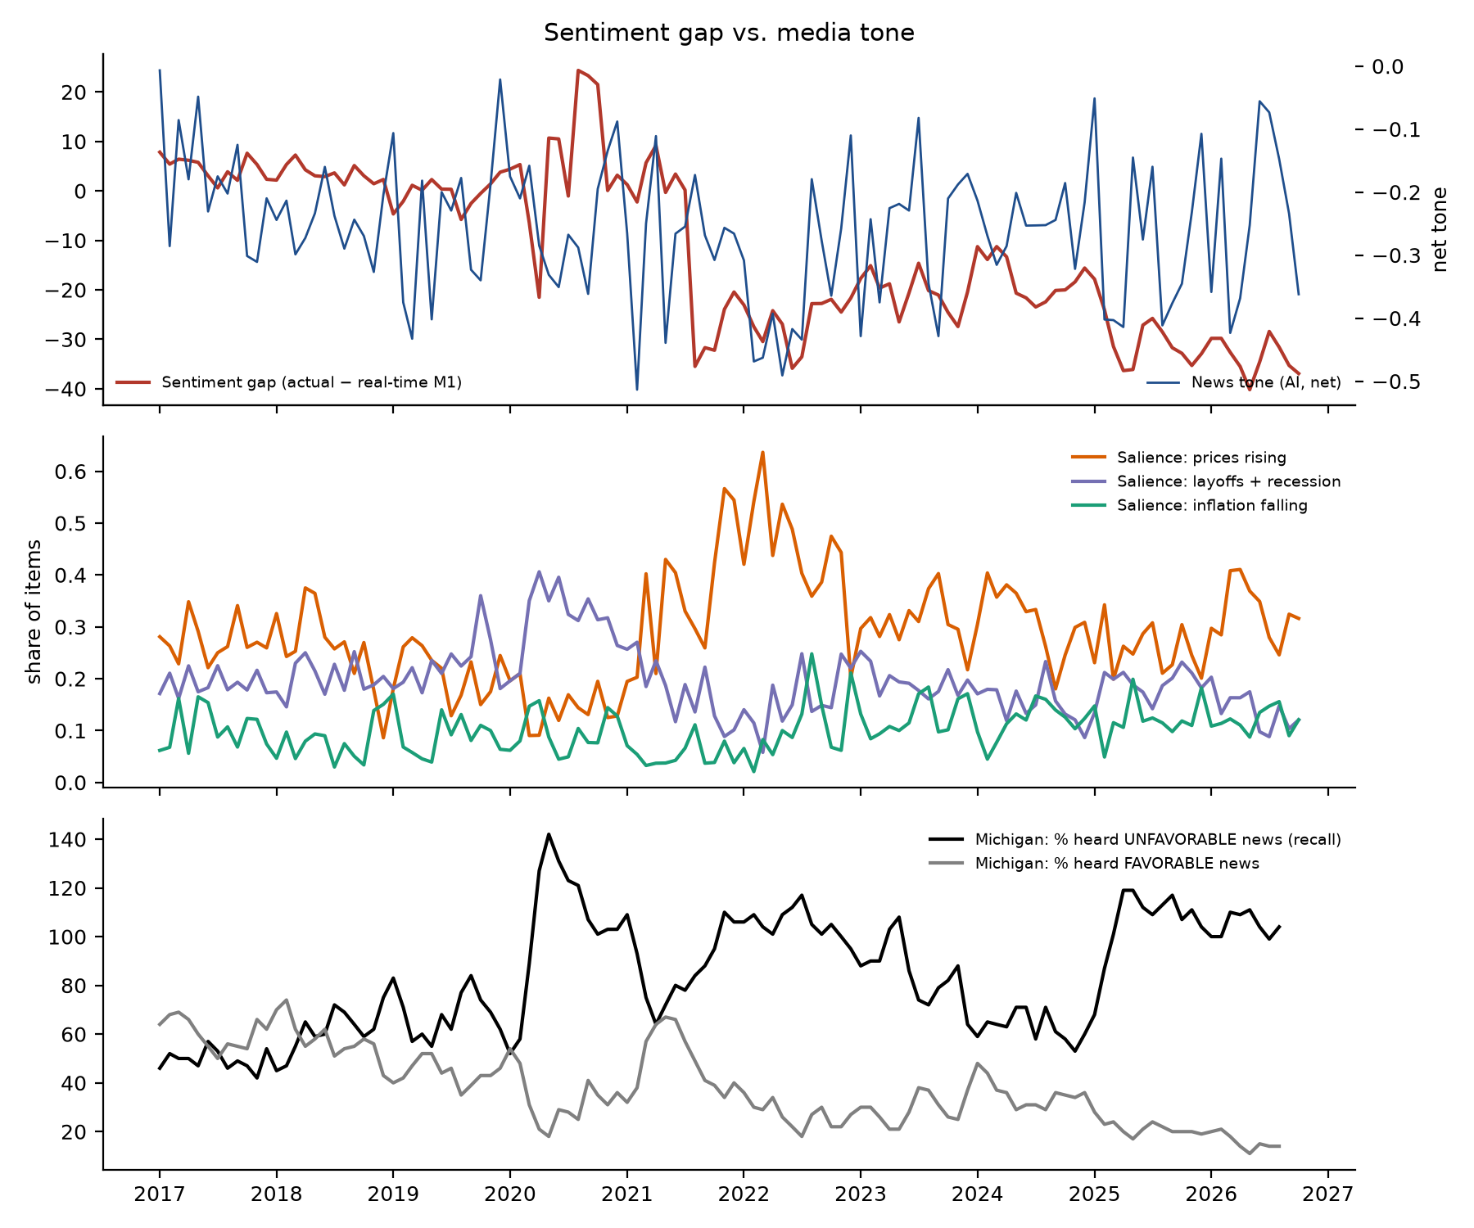
Figure 3. Sentiment gap vs AI-coded headline tone (top), topic salience (middle), and Michigan respondents' recall of favourable/unfavourable news (bottom).

6. Does media analysis improve predictions, and what is its impact? (RQ2, RQ5)
Table 9. Three-model comparison, expanding-window out-of-sample 2020–2026 (estimation from 2017).
Target | Model | N (OOS) | RMSE | Mean error | Nested vs | Clark–West p | DM p
ICS level | M1 econ only | 82 | 8.67 | -5.15 | – | – | –
ICS level | M2 + media | 82 | 10.87 | -3.62 | M1 econ only | 0.031 | 0.295
ICS level | M3 + media + controls | 82 | 7.29 | -3.32 | M3b econ + controls (no media) | 0.101 | 0.136
ICS level | M3b econ + controls (no media) | 82 | 6.62 | -3.13 | M1 econ only | 0.001 | 0.027
M1 gap | M1 econ only | 82 | 8.03 | -4.81 | – | – | –
M1 gap | M2 + media | 82 | 10.05 | -3.28 | M1 econ only | 0.048 | 0.290
M1 gap | M3 + media + controls | 82 | 6.88 | -2.93 | M3b econ + controls (no media) | 0.097 | 0.179
M1 gap | M3b econ + controls (no media) | 82 | 6.37 | -2.73 | M1 econ only | 0.001 | 0.041
M1: U-3, PCE, GDP, web share. M2: + net tone, prices-rising salience, layoffs/recession salience (all t−1). M3: + cumulative inflation, Δ mortgage rate, EPU, post-2025 transition. M3b: M3 without media, to isolate media's contribution given controls. Clark–West is the appropriate test for nested models.
FINDING: adding corpus-based media measures does not reliably improve out-of-sample prediction: the Clark–West statistic is marginal (p = 0.03) but realised RMSE rises from 8.7 to 10.9; household-pressure and policy-uncertainty controls without media lower it to 6.6 (Clark–West p = 0.001). Given those controls, adding media gives p = 0.10 (M3 vs M3b) and a higher RMSE. Rolling 36-month coefficients are unstable (outputs/figures/fig_rolling_coefs.png).
What does line up with the gap: price salience. The coverage measures most associated with the gap are about prices: the share of headlines on rising prices (standardised coefficient -0.44, Holm p < 0.001), GDELT's share of US articles mentioning inflation (-0.56) and respondents' own recall of bad price news (-0.67). Tone itself (AI, FinBERT, GDELT) is weakly or not associated after correction. Because price coverage tracks actual price pressure (B2) and fails to add out-of-sample information beyond the household-pressure variables, the most defensible reading is that coverage transmits the price-level grievance rather than creating it.
Sensitivity and multiple testing. Across 24 measure × timing combinations (AI, FinBERT, dictionary and GDELT tone; excess negativity; emotional wording; level framing; salience; recall), 7 survive a Holm correction when regressing the gap on the measure with mode and transition controls (full table: outputs/tables/media_sensitivity.csv). Results are similar excluding 2020 or the web-transition months.
Reverse causality. In monthly changes, tone→sentiment Granger p = 0.085 and sentiment→tone p = 0.125 (lag 3 by BIC). For Michigan's recall measure over 1978–2026 both directions are significant (p = 2.98e-10 and 4.26e-05): pessimistic respondents recall bad news and bad-news recall precedes pessimism — a feedback loop, not a one-way effect.
Placebo. If media move sentiment, future media should not predict current sentiment. tone_net: lead coefficient p = 0.05 (lag p = 0.03); excess_negativity: lead coefficient p = 0.83 (lag p = 0.81); news_u_all: lead coefficient p = 0.37 (lag p = 0.76). A significant lead indicates common shocks or audience-driven coverage rather than media leading opinion.
Long-history recall test (1978–2026). Respondents' net bad-news recall exceeded what fundamentals predict by 25 points in 2021–22 and 34 in 2025. Adding lagged recall to M1 cuts out-of-sample RMSE from 13.2 to 9.6 (Clark–West p < 0.001) and the 2025–26 gap from -31.6 to -18.9. This is the strongest media-related association in the project — but it is recall from the same interview, it feeds back both ways, and it cannot separate what outlets published from what pessimistic consumers noticed (availability vs mood).
Causal design. Given these limits we adopt the brief's third option — observational analysis plus a causal-design proposal (docs/CAUSAL_DESIGN.md): (i) a market-level shift-share design using media-diet exposure shares and cable channel-position instruments with geo-identified sentiment, testing pre-trends; (ii) a pre-registered, IRB-approved four-arm framing experiment (balanced vs rate vs price-level vs household framing of the same CPI release, N = 2,400, 2×2 cross-randomised partisan attribution). An experimental effect would apply to the sample; mapping it to the national index requires exposure shares by demographic cell, reweighting to Michigan's margins, an effect-decay estimate, and transportability assumptions (no unmeasured effect modifiers, comparable web measurement, no interference).

6.1 A natural experiment: does sentiment follow the coverage each side reads?
Most analyses ask whether negative coverage correlates with low sentiment. From first principles, a media-supply explanation makes a sharper prediction: when the presidency changed in January 2025, the outlets whose coverage turned more positive or negative should move the sentiment of their audiences, and aggregate coverage should move with aggregate sentiment. Using identical economy queries for every outlet, with outlet and month fixed effects (so the facts are held constant), right-leaning outlets' net tone rose by +0.41 under Trump-2 relative to Biden (p < 0.001) — and, symmetrically, had been 0.33 higher under Trump-1, so outlet slant flips with the party in power in both transitions. Michigan's party series moved far more: Republicans +52 points, Democrats -34, independents -8 (June 2022 vs May 2026 troughs).
Robustness to the relevance filter. Under the main (high-precision) filter, left-leaning outlets did not change (-0.06, p = 0.32); under the broader keyword-only filter they turned modestly more negative (-0.11, p = 0.007). So we do not claim that Democrats' coverage was unchanged; their decline may partly track their outlets. What is robust under both filters is (i) partisan slant (-0.43 and -0.23, both p < 0.001), (ii) the right-leaning swing (+0.40, +0.16) and (iii) the magnitude argument: aggregate coverage tone changed by +0.014 (main) or -0.033 (broad) between the Biden years and 2025–26. With the estimated tone–gap slope (≈27 points per unit), even the less favourable figure implies about 0.9 point of sentiment — against an actual fall of about 14.5 points. FINDING: whatever partisan slant does to individual audiences, the aggregate supply of economic coverage did not deteriorate nearly enough to produce the 2025–26 collapse; a media-bias explanation of the national gap fails this test.
Table 10. Coverage supply vs sentiment across administrations (same queries, monthly averages).
administration | AI net tone | FinBERT tone | GDELT full-text tone | Share of headlines on rising prices | Michigan ICS (mean)
Trump-1 (2017–20) | -0.23 | -0.23 | -1.17 | 22% | 93.1
Biden (2021–24) | -0.29 | -0.22 | -0.79 | 36% | 68.4
Trump-2 (2025–26) | -0.27 | -0.24 | -0.74 | 29% | 53.9
Caveats: lean groups follow AllSides outlet ratings; audiences are inferred from outlet lean, not measured; party readings are Michigan's published 3-month averages for two troughs. This is a design-based argument, not a causal estimate.
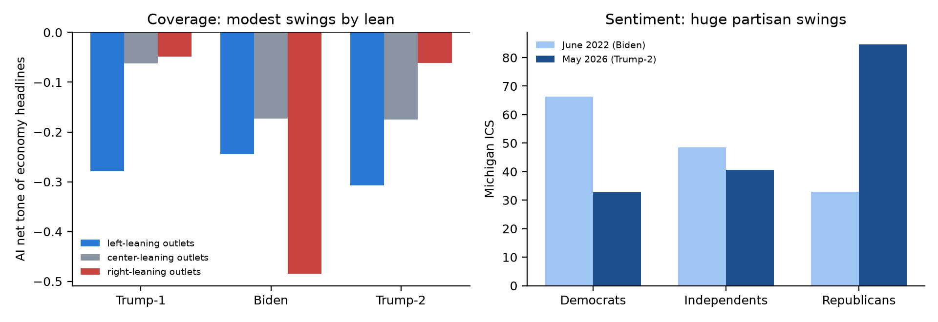
Figure 4. Left: AI net tone of identical economy queries by outlet lean and administration. Right: Michigan sentiment by party at the 2022 and 2026 troughs.

7. Which perceptual mechanisms can the data actually measure? (RQ4)
Measured directly (supply side): negativity asymmetry in coverage (B1 — not found), level-vs-rate framing and price salience (Section 5). Measured by proxy: anchoring to past prices ('worse off: higher prices' after disinflation) and experience effects — lifetime-experienced inflation shapes each age group's expectations and sentiment (Section 4, a significant within-month result). Indirect only: partisan motivated reasoning (Michigan party data, outlet slant, Section 6.1). Not measurable here: availability and confirmation bias in readers — they require individual exposure and belief data; Michigan's 'news heard' is recall, not exposure. Text establishes framing and selective coverage; it cannot by itself establish a reader's cognitive bias.

8. What evidence would contradict a media-bias explanation? (RQ6) — scorecard
Table 11. Falsification scorecard.
Contradicting evidence (pre-specified) | Test | Result
Coverage negativity fully explained by fundamentals; symmetric to good/bad news | B1, B4 | Contradicts
Media measures add no out-of-sample predictive content | Table 9 | Contradicts
Sentiment leads media, or future media 'predict' current sentiment | Granger, placebo | Mixed (feedback both ways)
Decline equally large in less-exposed groups / explained by group hardship within month | Section 4 | Partly contradicts (broad-based; hardship significant within month)
Partisan flips at transitions dominate | Michigan party data | Partly contradicts (party-in-power pattern; composition shift)
Aggregate coverage should deteriorate with aggregate sentiment (2025 transition) | Section 6.1 | Contradicts: tone change implies <1 pt vs a 14.5-pt fall (robust to filter)
Truthful reframing has negligible experimental effect | Experiment (proposed) | Not yet tested
Taken together: the evidence is more consistent with E1 (real price-level and income pressures) and E3 (measurement/model change), with media acting as an amplifying feedback channel at most — a hypothesis, not a finding.

9. Pre-election monitoring, partisanship and survey method
Dashboard. dashboard/index.html (rebuilt by run_all.sh) shows sentiment vs the real-time prediction with 80/95% intervals, the gap, media tone/salience/framing/calibration, recall, group indices, releases and events, corpus composition, missingness and model-performance indicators. Cut-off: 16 October 2026. Update plan: re-run after Michigan's October final (~30 Oct), the Q3 GDP advance estimate (late October — it enters the information set only once published), Election Day (3 Nov) and the November preliminary (mid-November); media refresh weekly.
Partisanship. Michigan documents that the party in the White House is more optimistic, that independents track the national index, and that party sentiment co-moves (r ≈ 0.85) between transitions. In May 2026 Democrats read 32.8, independents 40.6, Republicans 84.6. The self-identified Republican share fell below its historical 23–29% range after the 2025 transition (not because of web interviewing); a 5-point fall mechanically lowers the headline by ≈2.4 points. Affiliation is therefore both a moderator and a confounder: it shapes which outlets people consume and how they rate the economy. Election proximity: we do not attribute 2026 movements to the campaign; the May trough coincided with tariff-driven price increases and inflation re-acceleration, and the gap was already −30 in 2025.
Survey method. Michigan's 2024 move to web interviewing lowered measured levels (−6.6 by Michigan; −8.9 by an outside estimate) because interviewers elicit more favourable answers. We apply it as an external offset rather than estimating it from the gap period. Michigan's parallel web series shows May 2026 (44.8) is still below the June-2022 trough (web 46.3), so the 2026 low is not a mode artefact.

10. Practical implication for financial forecasting and risk management
Sentiment is widely used as a leading indicator of consumer spending and credit risk. We forecast next-six-month real PCE growth out of sample. In 2015–19, sentiment and its gap component both added information (Clark–West p = 0.03 and 0.01). In 2022–26 the relationship broke: adding raw sentiment raised RMSE from 1.45 to 1.74 and the gap component to 1.92, while the fundamentals-consistent component lowered it to 1.21 (p < 0.001). Real spending grew ~2.5% a year while sentiment sat near record lows. Implication: decompose sentiment into a fundamentals-consistent part and a gap; use the first in spending, retail-credit and earnings models, and treat a large, persistent gap as a regime flag (measurement change, price-level grievance, partisanship) rather than a recession signal. Stress tests should not mechanically map a 40-point sentiment drop into a consumption shock.

11. Limitations and research ethics
- One annotator: 300 human labels but no inter-annotator agreement (test–retest instead); relevance coding is weak (Section 5.1). The AI coder also shows measurable sensitivity to party names and outlet labels (Table 7).
- Corpus selection: Google News ranking, HN's unrepresentative audience, Mastodon's short window and bot share; no Reddit/X/Bluesky; headlines not full text.
- No exposure data: supply and engagement are not exposure; Michigan recall is endogenous to mood.
- Revisions: GDP is real-time; U-3/PCE use latest vintages with publication lags (revisions to these are small — see the robustness paragraph in Section 2); spending target is current-vintage.
- Short media sample (2017–2026, ~115 months) limits power, and many specifications invite false positives — hence Holm/BH corrections and pre-specified models.
- Associational controls: household-pressure coefficients are not causal; EPU is itself newspaper-derived.
- Ethics: public data only; social authors pseudonymised by hash; no full text stored; the proposed experiment requires IRB approval, informed consent, truthful arms and debriefing.
References. Bolhuis, Cramer, Schulz & Summers (2024), 'The cost of money is part of the cost of living', NBER WP 32163 · Soroka (2006), 'Good news and bad news: asymmetric responses to economic information', J. Politics · Martin & Yurukoglu (2017), 'Bias in cable news', AER · Gentzkow & Shapiro (2010), 'What drives media slant?', Econometrica · Baker, Bloom & Davis (2016), 'Measuring economic policy uncertainty', QJE · Clark & West (2007), J. Econometrics · Driscoll & Kraay (1998), REStat · Loughran & McDonald (2011), J. Finance · Laurer et al. (2024) zero-shot NLI classifiers · Araci (2019) FinBERT · University of Michigan Surveys of Consumers: methodology transition (Apr 2024), partisan reports (Apr 2025, Jul 2026).

