

Moule: Software
Engineering Management and Development

Tutor: Ahmed Eissa

Course work 1: library system

Student name: Viren Sureshbhai
Galani

Student number: M00875417

 | INDEX
1. | Introduction
2. | Design
3. | Implementation
4. | Software demonstration
5. | Testing Approach
6. | Conclusion

1.Introduction

- Brief description

Our library management system revolutionizes library operations by seamlessly integrating key features for efficient management, and this system only allows for librarians. For that, before accessing the system, librarians have to add their login details, which they get from authorities, and once approved, they are allowed to use the system. Librarians effortlessly add and manage member details, stored in a user-friendly text file. Book issues are streamlined with CSV file integration, capturing vital information such as issue and return dates. The system automates fine calculations, imposing a fair £1 per day for overdue books. Returning books is simplified, and librarians gain valuable insights through a detailed display of borrowed books, facilitating effective library oversight. This comprehensive solution optimizes workflows, providing a user-friendly experience that benefits both librarians and members. The result is a well-organized and efficient library environment, enhancing the overall experience for all stakeholders involved in the library ecosystem.

2.Design

- Description of diagrams:

I.CLASS DAIGRAMS
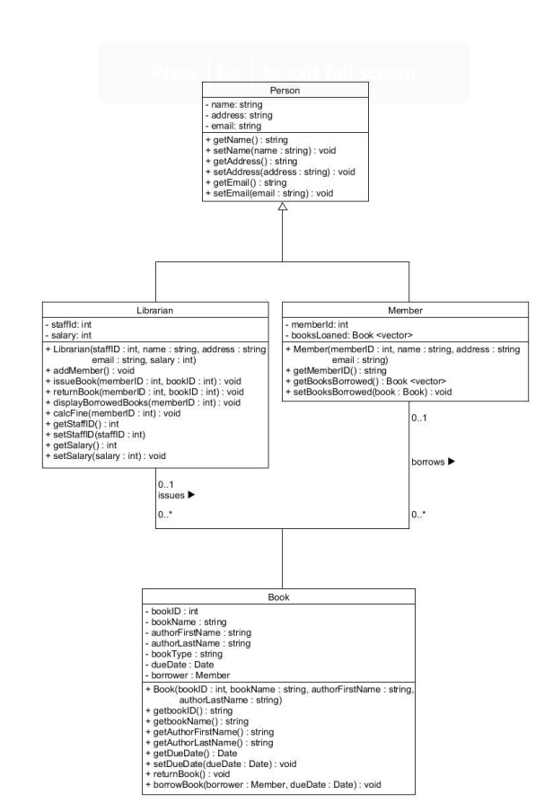
The Class Diagram illustrates the structure of the system by detailing classes and relationships. This diagram includes four classes:

1. Person: This is the base class with common attributes like name, address, and email, and operations for getting and setting these attributes.
2. Librarian: Inherits from Person and includes specific attributes like staff ID and salary. Its operations include managing members and books, such as adding members, issuing books, and calculating fines, reflecting the librarian's administrative responsibilities within the library.
3. Member: Also, an extension of Person, with an additional attribute for the member ID. It has operations related to the member's interaction with books, including borrowing and getting the list of borrowed books.
4. Book: Represents a book with attributes like book ID, book name, and author details. It includes operations for book management, such as getting book details and managing the borrowing process.

The classes are interconnected, indicating relationships such as a librarian issuing books to members and members borrowing books. The diagram displays inheritance through the generalization relationships from Librarian and Member to Person, meaning they share common attributes and operations.

II. USER CASE DAIGRAMS
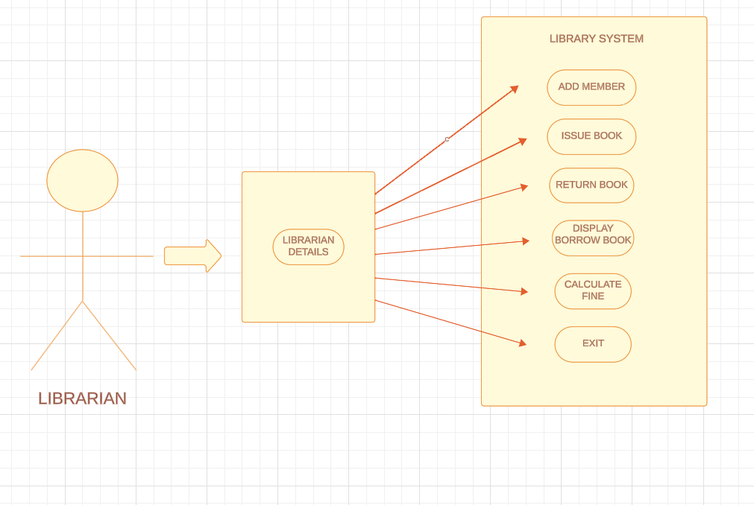

The Use Case Diagram you have provided depicts the functional requirements of a library management system from the perspective of a librarian. The primary actor in this diagram is the "Librarian," who interacts with the system to perform various tasks. The diagram outlines the following use cases:

1. Add Member: This use case allows the librarian to add new members to the library system.
2. Issue Book: The librarian can issue books to members through this function.
3. Return Book: This enables the librarian to manage the return of books borrowed by members.
4. Display Borrowed Books: This use case is for showing a list of books that are currently borrowed from the library.
5. Calculate Fine: If a member has overdue books, this function helps the librarian calculate the fine owed.
6. Exit: This represents the librarian's ability to exit the system after completing their tasks.

Each use case is connected to the librarian with a simple association, indicating that the librarian initiates these use cases. The diagram does not detail the internal workings of the system but rather focuses on the interaction between the user and the system's functionalities.

II. ACTIVITY DAIGRAMS

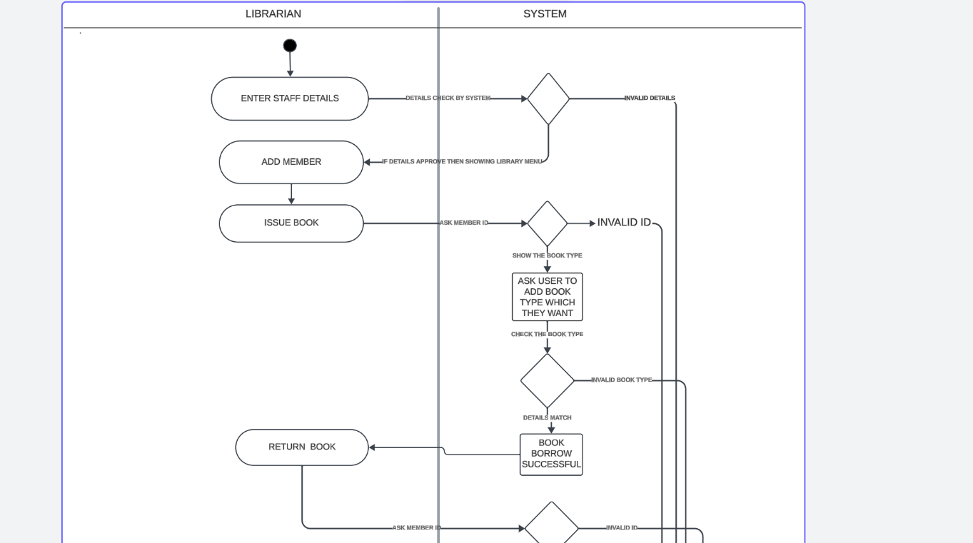
The Activity Diagram provides a dynamic view of the workflow within the library system. It starts with the "Enter Staff Details" activity, which involves authentication or selection of the librarian using the system. Following this, the librarian can choose to perform several tasks, represented as different branches of activity:
1. Add Member: The librarian enters details to add a new member to the system.
2. Issue Book: In this branch, the librarian goes through the process of issuing a book, which includes checking for an invalid ID and asking the user which book they want.
3. Return Book: This path outlines the steps for a member to return a book, including showing all borrowed books and confirming the return.
4. Display All Borrow Books: This activity allows the librarian to view all books currently borrowed.
5. Calculate Fine: This activity involves the librarian calculating any fines for overdue books.
6. Exit: This is the end of the workflow, where the librarian can exit the system.
The diagram includes decision nodes representing points where the system or the librarian must choose a path based on certain conditions. It visually describes the sequence of activities and the flow of control from one activity to the next, including parallel processes and choices.

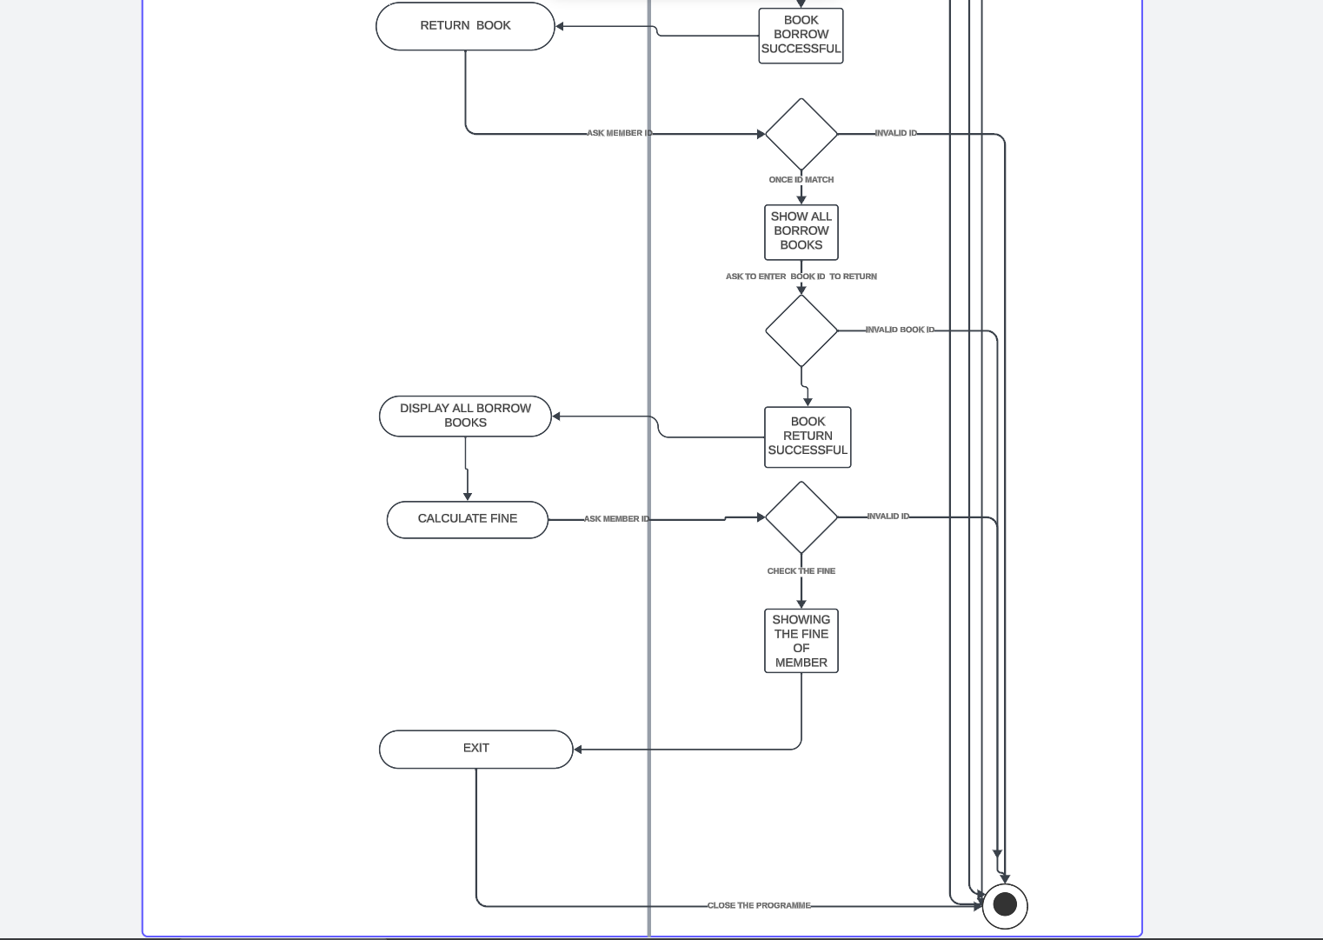

3. IMPLEMENTATION

- EXPLAIN HOW TRANSLATED THE DESIGN INTO WORKING SOFTWARE

1. From Use Case Diagram to Software:
Each use case would be implemented as a series of functions or methods within the code. For example, the "Add Member" use case would translate into a function that captures member details and stores them in the system.
The interactions between the Librarian and the system are coded as part of the user interface, where the librarian can input commands or data that the system responds to.

2. From Class Diagram to Software:
Relationships such as inheritance are directly translated into the code using language-specific keywords, like class Librarian public Person in C++.
Associations between classes, like a member having borrowed Book objects, are implemented using pointers or references within the classes.
Operations in the class diagram become methods within the class definitions in the code. These methods have the logic to perform the tasks depicted in the diagram.

3. From Activity Diagram to Software:
The flow of activities is implemented using control structures in the code, such as if-else statements, loops, and function calls.
Decision points in the activity diagram are translated into conditional statements that control the flow of execution.

- EXPLANTION OF WHAT THE MAKEFILE WAS USED FOR:

In my project, the Makefile acts as a powerful orchestration tool. It defines rules and dependencies to automate the compilation process efficiently. The compiler flags ensure code quality and debugging capabilities. Our Makefile simplifies the build process for the 'librarian program' executable by compiling source files (main.cpp, librarian.cpp, member.cpp, and book.cpp) into object files. The 'clean' rule helps keep a tidy workspace by removing compiled files. This organized and automated approach streamlines development, ensuring consistent and reliable builds for our library management system.

- HOW VERSION CONTROL WAS USED:

To enhance collaboration and streamline our development workflow, I have integrated Git into our project. Git, a distributed version control system, empowers us to efficiently manage our codebase. It enables seamless collaboration, code tracking, and version management. With Git, we can easily coordinate contributions, track changes, and support a robust history of our library management system's development, fostering transparency and accountability in our collaborative efforts.
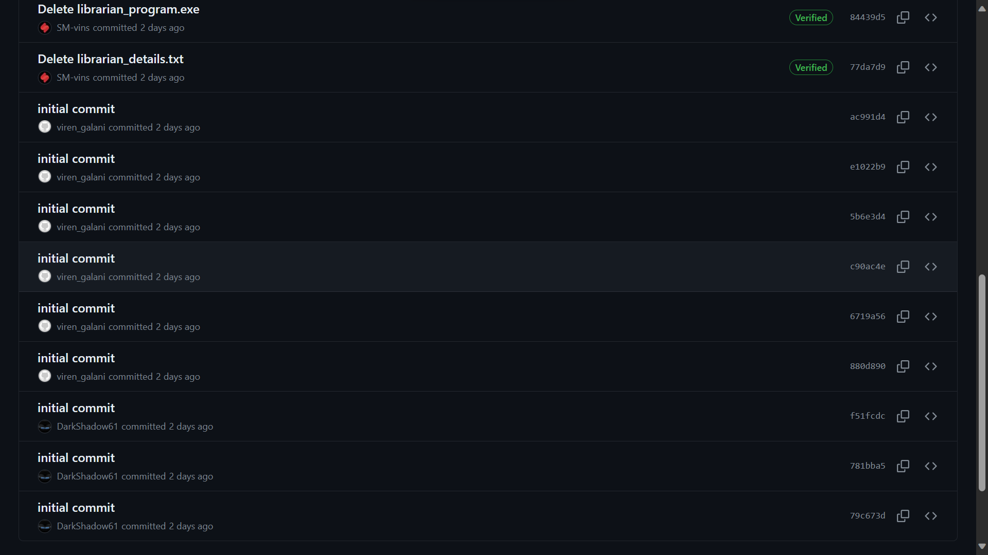
- Here is evidence of using version control during my project:

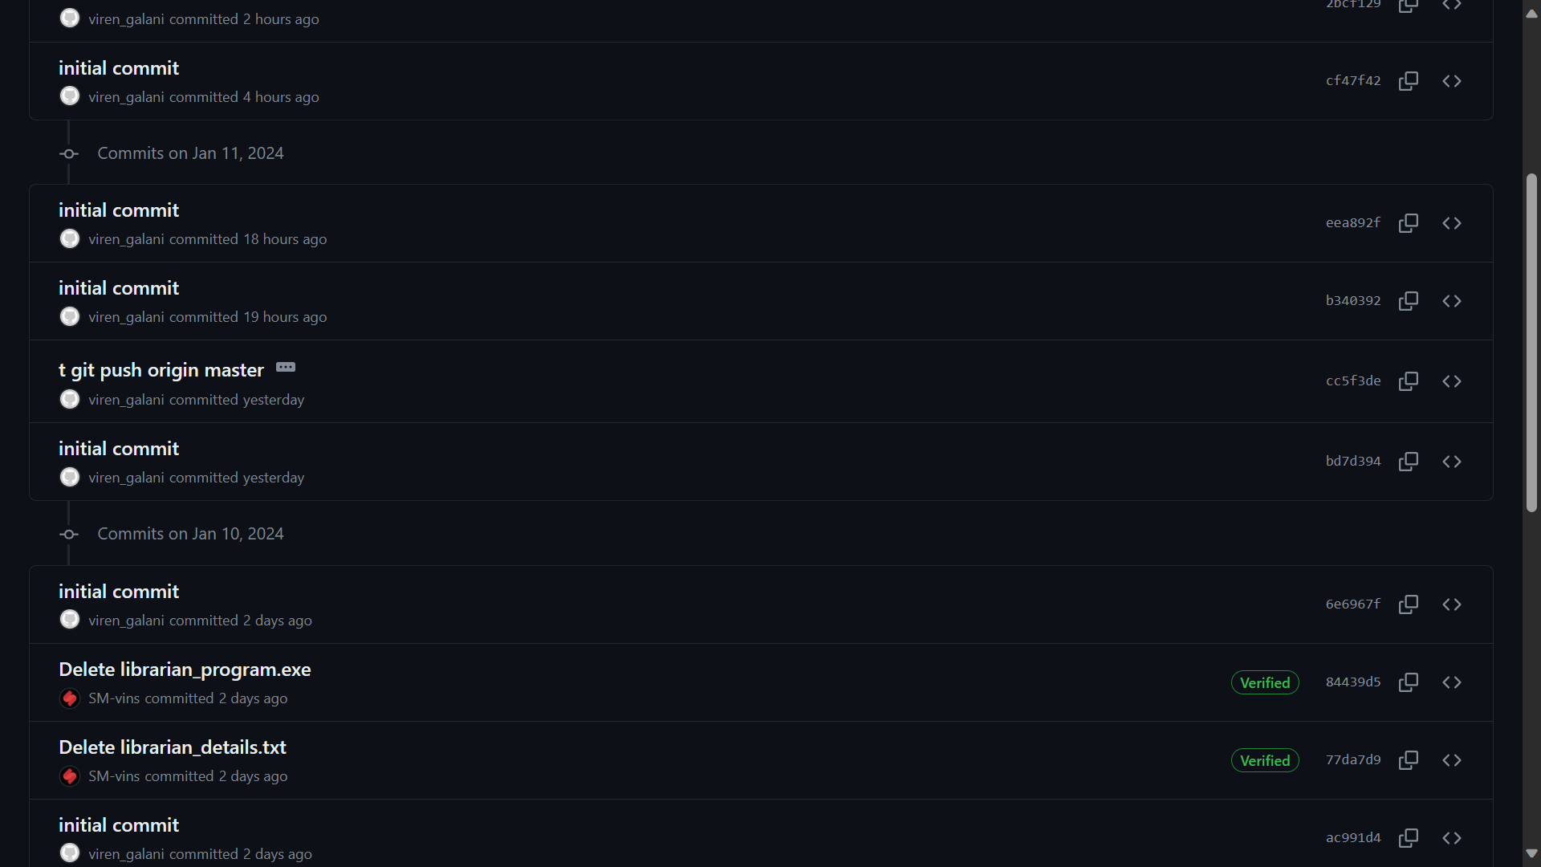

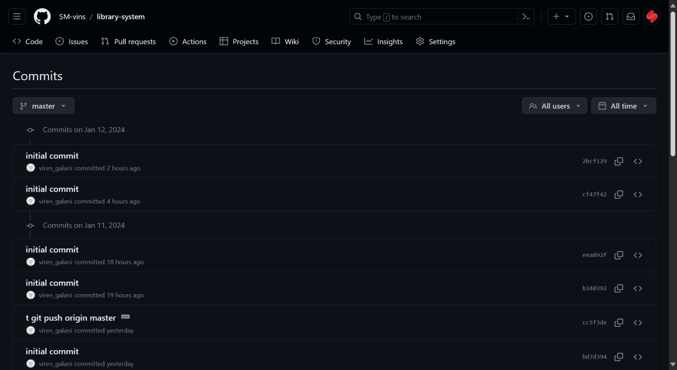

4.SOFTWARE DEMONSTRATION

Overview:

The Library Management System is designed to facilitate the daily operations of a library. It is likely to allow librarians to manage book inventories, track book lending, register new members, and process returns. Additionally, the system would handle administrative tasks such as calculating fines for late returns and maintaining records of all transactions.

- IN DETAILS DESCRIPTION ABOUT SOFTWARE:

Software Structure:

The software is built using C++, a statically typed, compiled language known for its performance and control over system resources. The project structure indicates a modular design, with separate classes for handling different aspects of the library's functionality. Here is a breakdown of the primary components:
I. User Management:
Classes: Librarian and Member, as outlined in librarian and members header and c++ files.
Functionality: The Librarian class would provide the librarian with tools to add or remove members, issue, and collect books, and calculate fines. The Member class would represent library members, managing information such as borrowed books and personal details.
II. Main Application Flow:

File: main.cpp
Functionality: This is likely where the application initializes and starts the interaction with the user. It could present a menu system for librarians to perform various tasks and might implement the main loop of the application.

III. Data Storage and Data Handling:
Files: books.csv, members.txt, borrow-book_details.txt
Functionality: These text-based files act as a simple database to persistently store data about books, members, and borrowing details. The software would read from and write to these files to maintain up-to-date records. Given the presence of .txt and .csv files, the system does not use a sophisticated database system. Instead, it manages data using flat files, which are read into the program at runtime and updated accordingly. Operations on data would involve parsing these files, updating records in memory, and then writing the changes back to the files.
IV. User Interface:

The system provides a command-line interface through which the librarian interacts with the software, performing tasks like registering members, checking out books, and so on. The user experience would be text-based, with prompts and messages guiding the user through various operations.

5. TESTING APPROACH

Testing Approach:
In testing approach follows a comprehensive strategy, encompassing unit testing with the Catch2 framework. This approach aims to verify individual components, specifically the `Book` class methods `borrowBookById` and `returnBookById`, ensuring their functionality meets the specified requirements.

Application of the Approach:

1. Borrowing Functionality:
We tested the method with valid and invalid book IDs, assessing if the borrowing process behaves correctly. Applied scenario-based testing to cover instances where a valid book can and cannot be borrowed.

2. Return Functionality:
Checked the `returnBookById` method for its correctness in handling valid returns and scenarios where the book was not borrowed, or the book ID was invalid. Ensured the method behaves as expected in various return scenarios.

6.CONCLUSION

- Summary of the work:

In summary, the Library Management System is a specialized tool designed for the efficient management of library operations, with a focus on simplicity and the fundamental tasks of library administration. It illustrates a clear separation of concerns, with distinct components for handling several aspects of the system, and it is structured for ease of use and maintenance.

- Limitations of work:

Being written in C++, the software is expected to be performant for typical library sizes. However, the use of flat files for data storage could become a bottleneck as the data grows. The system might not support concurrent access by multiple librarians, which would be a limitation in larger library environments.

- How you would approach a similar project in the future to avoid the limitations:

In our future library management projects or similar project, we aim to overcome current limitations by adopting best practices. This includes transitioning to a relational database for efficient data handling, implementing measures for concurrent access, exploring modern languages and frameworks, leveraging scalable cloud-based solutions, and committing to regular system upgrades and maintenance. These strategies ensure optimal performance and adaptability to the evolving demands of larger library environments.

