Experiment 1 – Clock and Periodic Signal Generation

Seyed Mohammad Amin Atyabi

810198559

Abstract— This document is Seyed Mohammad Amin Atyabi report on experiment 1 for digital logic design laboratory. In this experiment we will discuss about different method of clock generation (Ring Oscillator, LM555 Timer and Schmitt Trigger), Frequency divider and Baud Rate Generator for UART Serial Communication.

Keywords— Ring Oscillator, LM555, Schmitt Trigger, Frequency Divider, **Baud Rate Generator for UART Serial Communication**

Introduction

Most of digital circuits use a system called clock to work property and there are many methods to generate clock but we discuss about three of them in this experiment. Then we will design a Baud Rate Calculator for UART Serial Communication.

1. Clock Generation Using ICs and Analog Components
2. *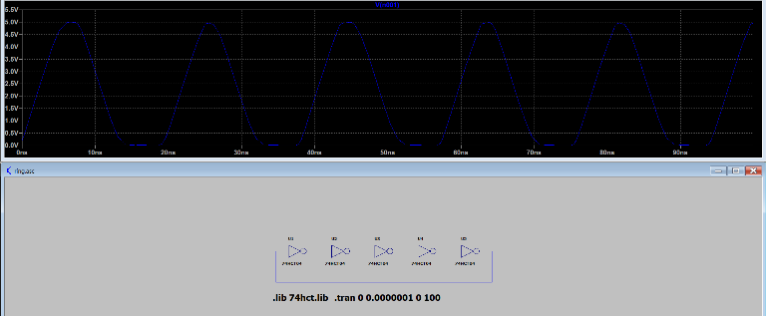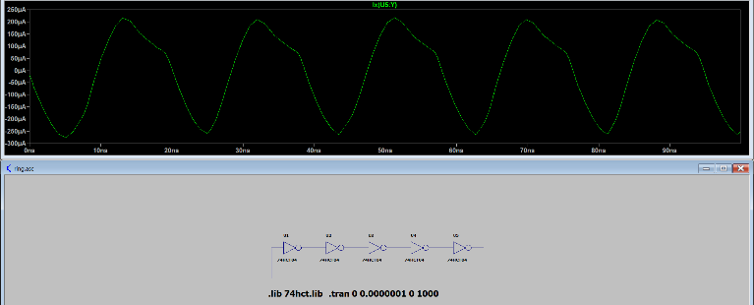Ring Oscillator*

By measuring two points time in wave form of ring oscillator we collect these data:

Time1: 32 ns

Time2: 51.3 ns

1. So, the time period of propagation delay of this chain will be 19.3 ns.
2. Using the delay formula:
$$2N× {Delay}_{inv}=19.3ns$$

$${Delay}_{inv}= \frac{19.3ns}{2×5}$$

$${Delay}_{inv}=1.93ns$$

3. *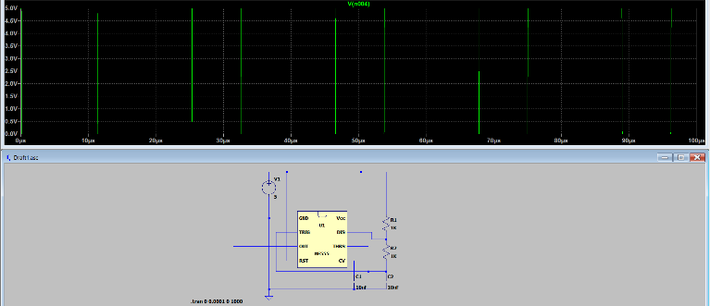LM555* Timer

In LTspice software LM555 IC named NE555.

R2 = 1KΩ)

R2 = 10KΩ)

R2 = 100KΩ)

1. *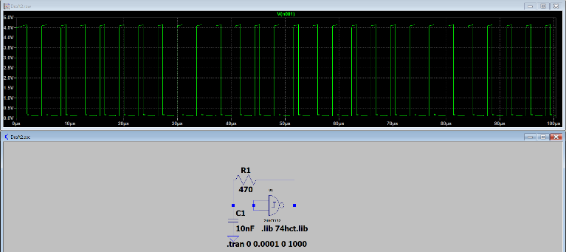Schmitt Trigger Oscillator*

For every resistor value we calculate time from wave form, then calculate frequency to find α value.

R = 470Ω)

Time1: 22.7µs

Time2: 26.3µs

T = 3.6µs F=278KHz

α = 1.3

R = 1KΩ)

Time1: 23.7µs

Time2: 30.9µs

T = 7.2µs F=139KHz

α = 1.39

R = 2.2KΩ)

Time1: 19.9µs

Time2: 35.2µs

T = 15.2µs F=65.8KHz

α = 1.45

2. FPGA Design

*A. Ring Oscillator*

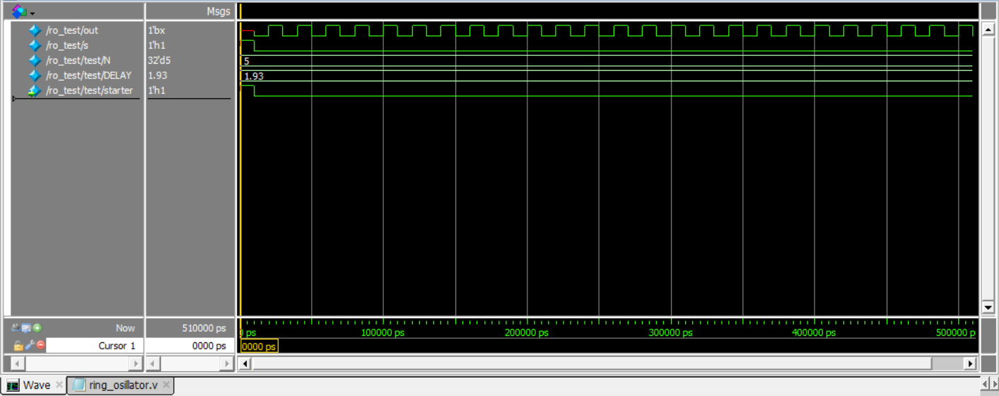

We chose 5 as number of inverter gates and 1.93 as delay of each gate. Also, we generate a starter signal to initiate the chain, the time value of starter signal is N×Delayinv witch in our case is 9.65ns.

*B. Synchronous Counter as a Frequency Divider*

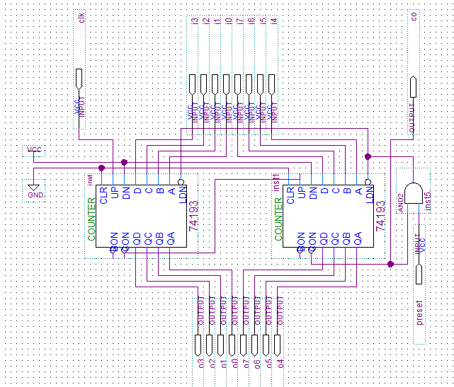

We designed the frequency divider using 74193 IC in Quartus program. Then synthetize the schematic to create Verilog description and timing files to simulate the circuit.

The preset mechanism helps us to indicate when do circuit starts to load our manual values to divide frequency.

By input value (10001110)2 as input to circuit (25510 - 11310 = 14210 = 100011102) we have a modulo 113 frequency divider.

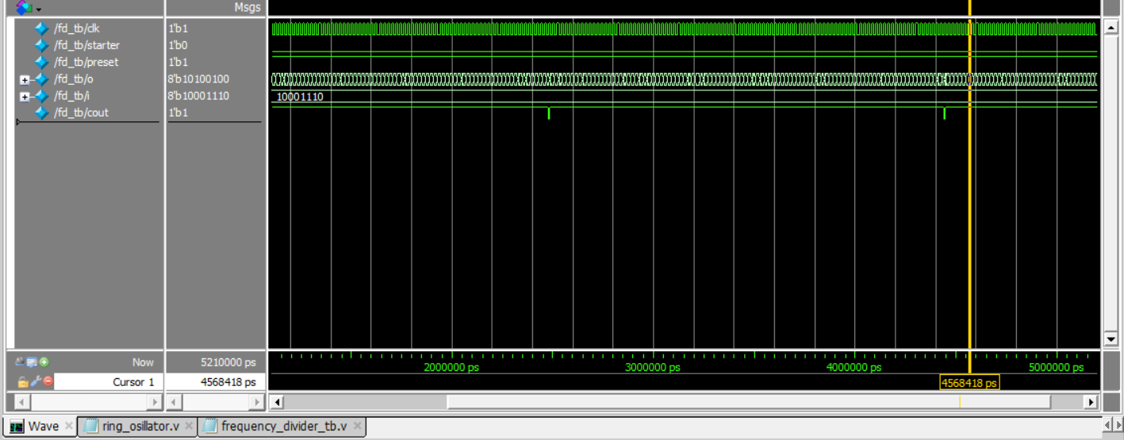

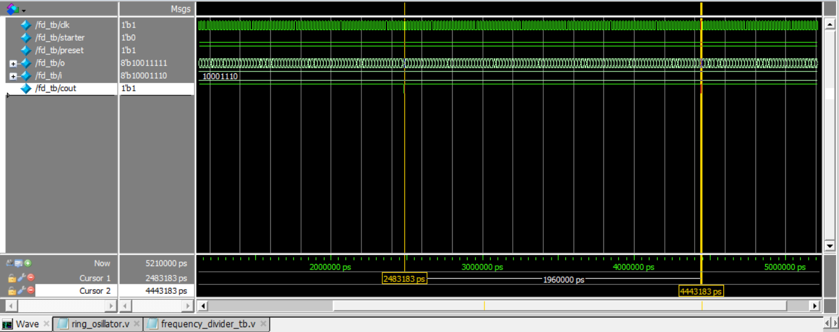

In simulation I find out the clock speed is too high for this circuit so I had to lower the frequency of clock by adding more not gate and increase time delay of each not gate. In this simulation I have 7 inverter gates with delay of 3ns, So the frequency of clock will be 23.8MHz.

By measuring two points of frequency divider where we have carry out, below data collected:

Time1: 4985355ps

Time2: 39731355ps

T = 4746000ps

F = 210.7KHz

So, by dividing above frequencies ($\frac{23.8MHz}{210.7KHz}$) we have $≅113$ ratio witch we expect.

*C. T Flip-Flop*

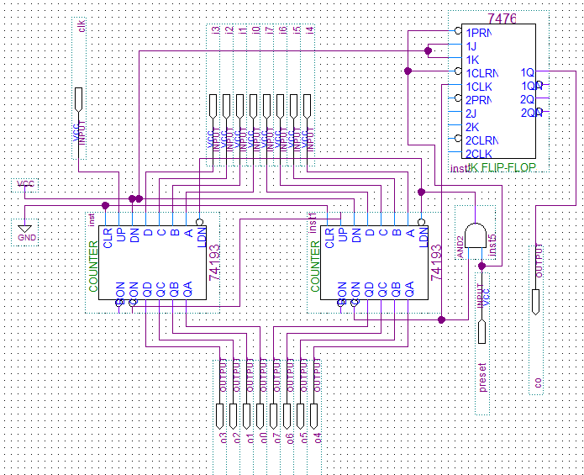

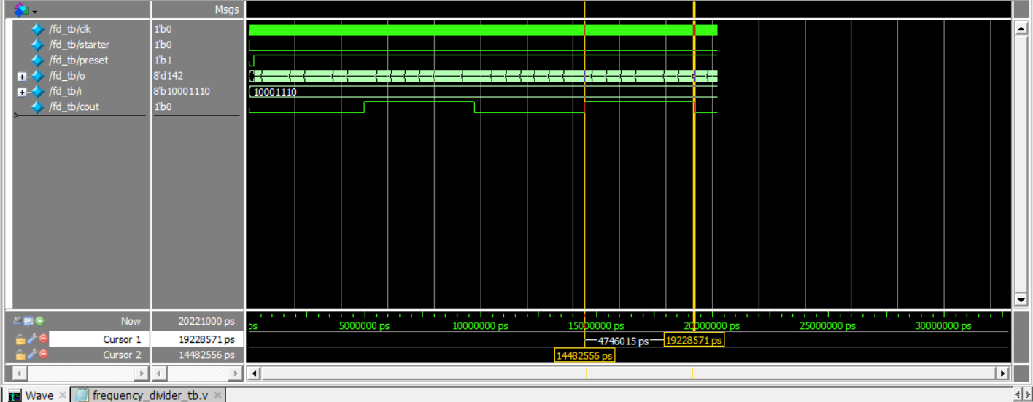

Then we create a T-Flip-Flop using a JK-Flip-Flop to make frequency divider duty cycle 50%.

1. Baud Rate Generator for UART Serial Communication

*A. Automatic* Baud Rate Generator

