Experiment: 1

NAME: Sankalp Misal

ROLL NO : 41
CLASS: B .TECH

THEORY:
- Android Studio
Android Studio is the official Integrated Development Environment (IDE) for Android App development. It is a powerful tool that allows developers to build high-quality applications for the Android platform. It has complete tools for the process of Android App development. From writing code to testing and deployment, Android studio has all the functionalities for developers to develop an Android App.

- What is use of Java in Android Studio
Android app development can play a major role in writing the app functionalities using Java programming. Java code defines how your app behaves—what happens when users click buttons, enter data, or navigate screens. Every activity can be designed with Java programming

- What is the use of XML in Android Studio
XML is used to design the app interface. You define Views (e.g., TextView, Button, ImageView) and layout containers (e.g., LinearLayout,ConstraintLayout) in XML.

- What is the use of Gradle in Android Studio
Automates the build process : Compiles code, processes resources, and packages APK/AAB. Supports modular development: Build and manage multi-module apps (e.g., app, libraries, features) Customizable build logic: Add custom Gradle tasks (e.g., auto-deploy, clean builds).

- What is the use of SDK in Android Studio
Provides Android APIs: Includes classes and methods to build apps (e.g., UI, networking, storage, sensors).Contains SDK Manager : Lets you download and manage different Android API levels, system Images, and tools. Used in Real Device & Emulator Deployment: Required to install, run, debug, and profile apps on physical and virtual devices.

<?xmlversion="1.0"encoding="utf-8"?>
<RelativeLayoutxmlns:android="http://schemas.andro id.com/apk/res/android"
xmlns:app="http://schemas.android.com/apk/res- auto"
xmlns:tools="http://schemas.android.com/tools" android:id="@+id/main" android:layout_width="match_parent" android:layout_height="match_parent" tools:context=".MainActivity">

<TextView android:id="@+id/textView" android:layout_width="wrap_content"
android:layout_height="wrap_content" android:layout_alignParentStart="true" android:layout_alignParentTop="true" android:layout_marginStart="33dp" android:layout_marginTop="122dp" android:text="Name" android:textSize="16sp" android:textStyle="bold"/>

<EditText android:id="@+id/editTextText" android:layout_width="wrap_content" android:layout_height="wrap_content" android:layout_alignParentTop="true" android:layout_alignParentEnd="true" android:layout_marginTop="96dp" android:layout_marginEnd="6dp" android:ems="10" android:inputType="text" android:text="Name"/>

<TextView android:id="@+id/textView2" android:layout_width="wrap_content" android:layout_height="wrap_content" android:layout_alignParentStart="true" android:layout_alignParentTop="true" android:layout_marginStart="34dp" android:layout_marginTop="196dp" android:text="Age" android:textSize="16sp" android:textStyle="bold"/>
<EditText android:id="@+id/editTextText2" android:layout_width="wrap_content" android:layout_height="wrap_content" android:layout_alignParentTop="true" android:layout_alignParentEnd="true" android:layout_marginTop="185dp" android:layout_marginEnd="9dp" android:ems="10" android:inputType="text" android:text="Name"/>

<TextView android:id="@+id/textView3" android:layout_width="wrap_content" android:layout_height="wrap_content" android:layout_alignParentStart="true" android:layout_alignParentTop="true" android:layout_marginStart="12dp" android:layout_marginTop="268dp" android:text="EnterPassword" android:textSize="16sp" android:textStyle="bold"/>

<EditText android:id="@+id/editTextTextPassword" android:layout_width="wrap_content" android:layout_height="wrap_content" android:layout_alignParentTop="true" android:layout_alignParentEnd="true" android:layout_marginTop="252dp" android:layout_marginEnd="16dp" android:ems="10" android:inputType="textPassword"/>

<Button
android:id="@+id/button" android:layout_width="wrap_content" android:layout_height="wrap_content" android:layout_alignParentStart="true" android:layout_alignParentBottom="true" android:layout_marginStart="152dp" android:layout_marginBottom="284dp" android:text="Submit" android:textStyle="bold"/>
</RelativeLayout>

Step 1:
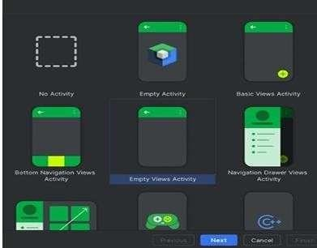

Step2 :
Step 3:
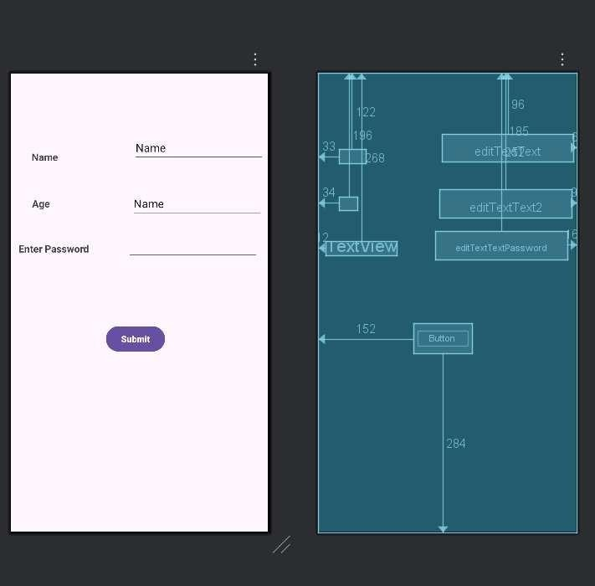

Step 4:

