Name: Sankalp Misal
Roll No.: 41
Subject: MAD

XML FILE:
<?xml version="1.0" encoding="utf-8"?>
<RelativeLayout

xmlns:android="http://schemas.android.com/apk/res/ android"
xmlns:app="http://schemas.android.com/apk/res- auto"
xmlns:tools="http://schemas.android.com/tools" android:id="@+id/main"
android:layout_width="match_parent" android:layout_height="match_parent" android:background="@drawable/img" tools:context=".MainActivity">

<TextView
android:id="@+id/textView4" android:layout_width="145dp" android:layout_height="53dp" android:layout_alignParentStart="true" android:layout_alignParentTop="true" android:layout_marginStart="17dp" android:layout_marginTop="279dp" android:text="Name"
android:textColor="#0D0C0C" android:textSize="34sp" android:textStyle="bold" />

<TextView
android:id="@+id/textView6" android:layout_width="144dp" android:layout_height="59dp" android:layout_alignParentStart="true" android:layout_alignParentBottom="true" android:layout_marginStart="16dp" android:layout_marginBottom="309dp" android:text="Age"
android:textColor="#0D0C0C" android:textSize="34sp" android:textStyle="bold" />

Class: B.Tech ‘A’

<EditText
android:id="@+id/editTextText" android:layout_width="wrap_content" android:layout_height="wrap_content" android:layout_alignParentTop="true" android:layout_alignParentEnd="true" android:layout_marginTop="285dp" android:layout_marginEnd="26dp" android:ems="10" />

<EditText
android:id="@+id/editTextNumber" android:layout_width="wrap_content" android:layout_height="wrap_content" android:layout_alignParentEnd="true" android:layout_alignParentBottom="true" android:layout_marginEnd="29dp" android:layout_marginBottom="315dp" android:ems="10"
android:inputType="number" />

<ImageView
android:id="@+id/imageView" android:layout_width="wrap_content" android:layout_height="wrap_content" android:layout_alignParentStart="true" android:layout_alignParentTop="true" android:layout_marginStart="114dp" android:layout_marginTop="18dp" app:srcCompat="@drawable/img1" />

<Button
android:id="@+id/button" android:layout_width="wrap_content" android:layout_height="wrap_content" android:layout_alignParentStart="true"

android:layout_alignParentBottom="true" android:layout_marginStart="154dp" android:layout_marginBottom="183dp" android:text="Submit" />

</RelativeLayout>
s2 = e2.getText().toString();
Toast.makeText(MainActivity.this, "\"Name:
\" + s1 + \"\\nAge: \" + s2", Toast.LENGTH_SHORT).show();}
});

}
}
JAVA FILE
package com.example.demo3;

import android.os.Bundle; import android.view.View;
import android.widget.Button;
import android.widget.EditText; import android.widget.Toast;

import androidx.activity.EdgeToEdge;
import androidx.appcompat.app.AppCompatActivity; import androidx.core.graphics.Insets;
import androidx.core.view.ViewCompat;
import androidx.core.view.WindowInsetsCompat;

public class MainActivity extends AppCompatActivity { EditText e1, e2;
String s1, s2; Button b;

@Override
protected void onCreate(Bundle savedInstanceState) {
super.onCreate(savedInstanceState); EdgeToEdge.enable(this);
setContentView(R.layout.activity_main);

ViewCompat.setOnApplyWindowInsetsListener(findVie wById(R.id.main), (v, insets) -> {
Insets systemBars =
insets.getInsets(WindowInsetsCompat.Type.systemBar s());
v.setPadding(systemBars.left, systemBars.top, systemBars.right, systemBars.bottom);
return insets;
});

e1 = findViewById(R.id.editTextText);
e2 = findViewById(R.id.editTextNumber); b = findViewById(R.id.button);
b.setOnClickListener(new View.OnClickListener() { @Override
public void onClick(View v) { s1 = e1.getText().toString();

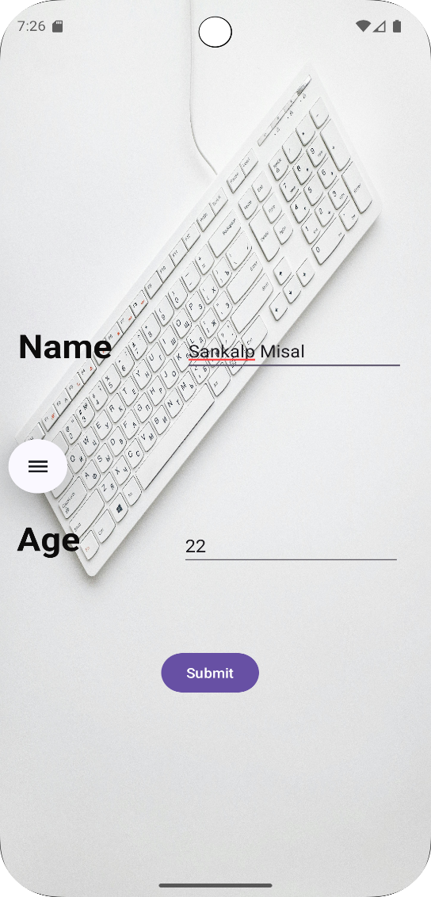

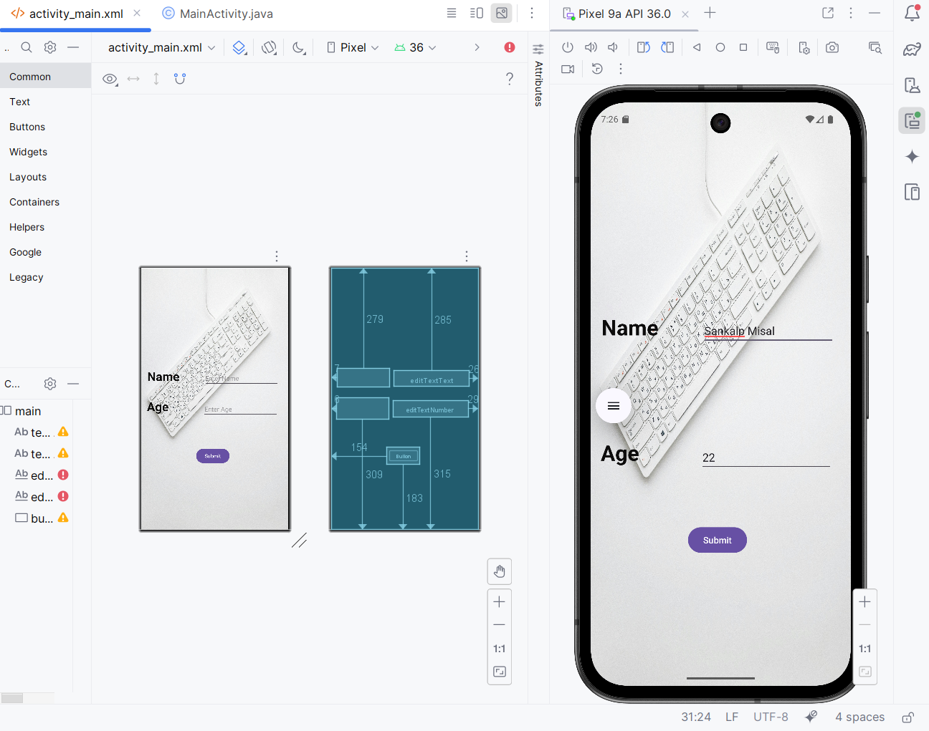

Experiment: 4B

Add a Video File to res/raw Folder
- Right-click res > New > Android Resource Directory
- Select raw as the resource type.
- Put your video file there (e.g., car.mp4)

JAVA Code:
package com.example.exp4b;
import android.net.Uri;
import android.os.Bundle;
import android.widget.Button;
import android.widget.MediaController;
import android.widget.VideoView;
import androidx.activity.EdgeToEdge;
import androidx.appcompat.app.AppCompatActivity;
import androidx.core.graphics.Insets;
import androidx.core.view.ViewCompat;
import androidx.core.view.WindowInsetsCompat;
public class MainActivity extends AppCompatActivity {

VideoView vi;
Button b;
MediaController m;

@Override
protected void onCreate(Bundle savedInstanceState) {
super.onCreate(savedInstanceState);
EdgeToEdge.enable(this);
setContentView(R.layout.activity_main);
ViewCompat.setOnApplyWindowInsetsListener(findViewById(R.id.main), (v, insets) -> {
Insets systemBars = insets.getInsets(WindowInsetsCompat.Type.systemBars());
v.setPadding(systemBars.left, systemBars.top, systemBars.right, systemBars.bottom);
return insets;
});
// Mapping
vi = findViewById(R.id.videoView);
b = findViewById(R.id.button);
m = new MediaController(MainActivity.this);

// OnClickListener
b.setOnClickListener(v -> {
String path = "android.resource://" + getPackageName() + "/" + R.raw.car;
Uri u = Uri.parse(path);

vi.setVideoURI(u);
vi.setMediaController(m);
m.setAnchorView(vi);
vi.start();
});
}
}

XML Code:

<RelativeLayout
xmlns:android="http://schemas.android.com/apk/res/android"
xmlns:app="http://schemas.android.com/apk/res-auto"
xmlns:tools="http://schemas.android.com/tools"
android:id="@+id/main"
android:layout_width="match_parent"
android:layout_height="match_parent"
android:background="@drawable/car_bg"
tools:context=".MainActivity">

<VideoView
android:id="@+id/videoView"
android:layout_width="362dp"
android:layout_height="233dp"
android:layout_alignParentStart="true"
android:layout_alignParentTop="true"
android:layout_marginStart="24dp"
android:layout_marginTop="61dp" />
<Button
android:id="@+id/button"
android:layout_width="150dp"
android:layout_height="92dp"
android:layout_alignParentStart="true"
android:layout_alignParentBottom="true"
android:layout_marginStart="134dp"
android:layout_marginBottom="195dp"
android:text="Play"
android:textColorLink="#DE0E0E" />
</RelativeLayout>

