Loading the Extension in Google Chrome
Follow the steps below to install the Salesforce Case Exporter extension from a local folder (unpacked). You will need access to the extension source files on your machine.
Note: Chrome closes the extension popup when it loses focus. After exporting, the popup will stay open briefly showing a success message — this is expected behavior. You can close it by clicking elsewhere.

Step 1: Open the Extensions Management Page
In the Chrome address bar, type the following and press Enter:
chrome://extensions
Alternatively, click the puzzle piece in the top-right corner of Chrome, select Manage extensions.

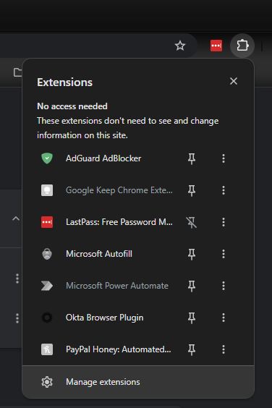

Step 2: Enable Developer Mode
On the Extensions page, find the Developer mode toggle in the top-right corner of the page and turn it on.

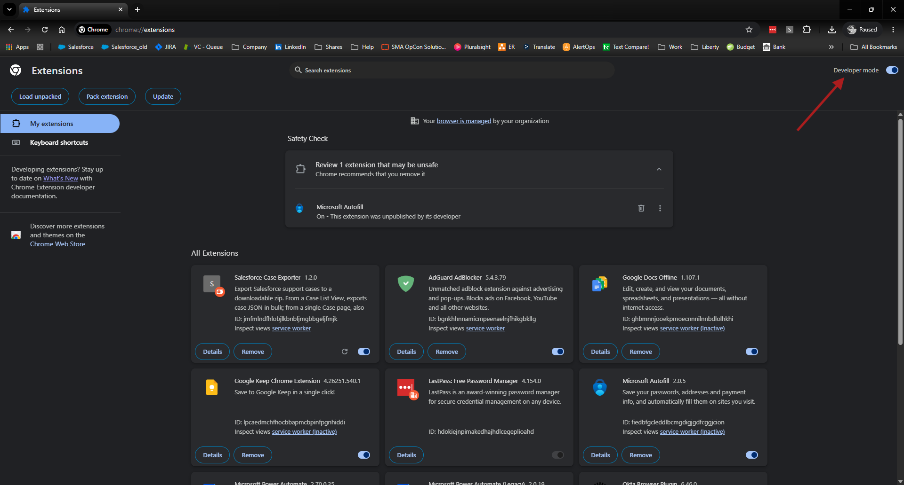

Once enabled, three new buttons will appear at the top-left of the page:
- Load unpacked
- Pack extension
- Update

Step 3: Load the Extension Folder
Click the Load unpacked button. A file browser dialog will open.

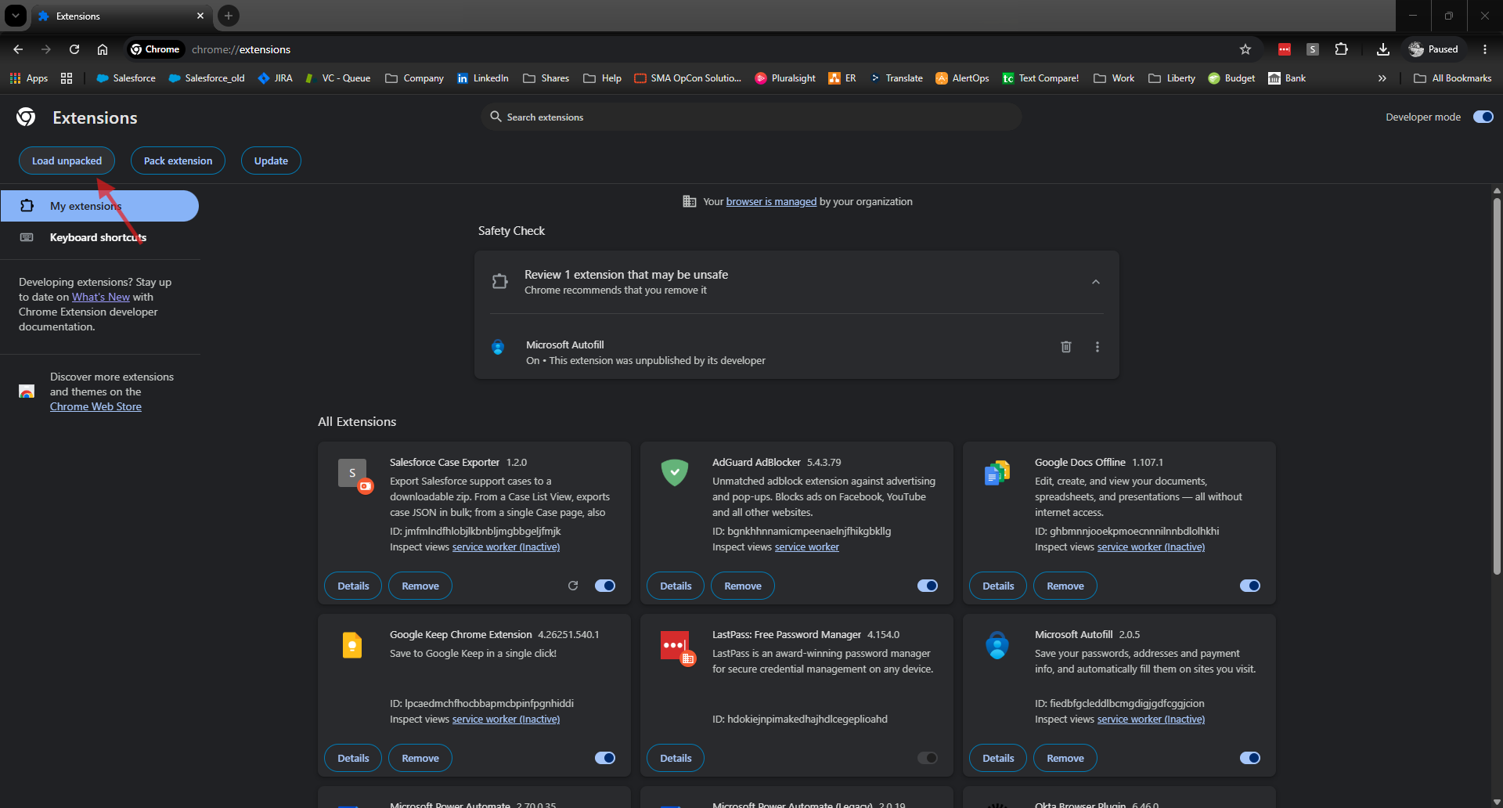

Navigate to the folder that contains the extension files. Select the root folder of the extension (the folder that contains manifest.json) and click Select Folder.

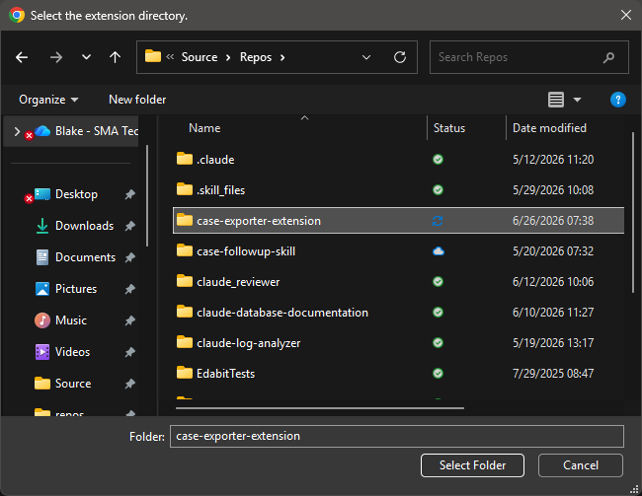

Step 4: Confirm the Extension Loaded
The Salesforce Case Exporter extension will now appear on the Extensions page. You should see:
- The extension name and version number
- A toggle to enable or disable it (should be enabled by default)
- An ID and path showing where the files were loaded from

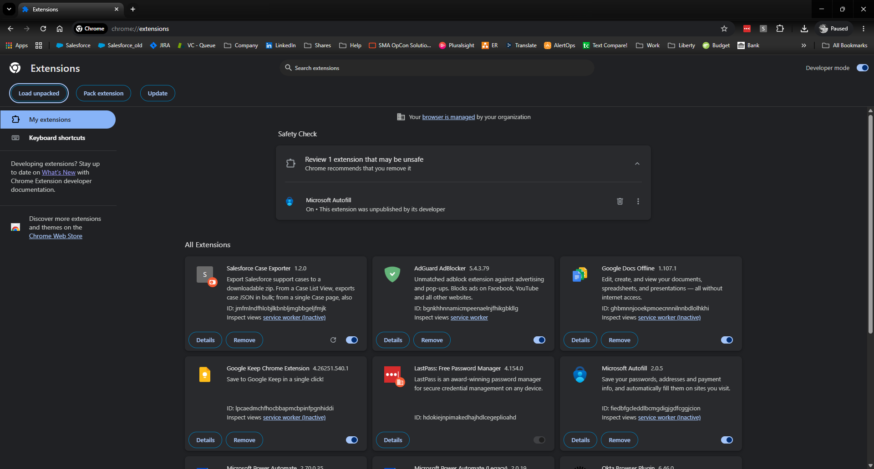

Step 5: Pin the Extension to the Toolbar
Click the puzzle piece icon (🧩) in the Chrome toolbar. Find Salesforce Case Exporter in the list and click the pin icon next to it to pin it to the toolbar for easy access.

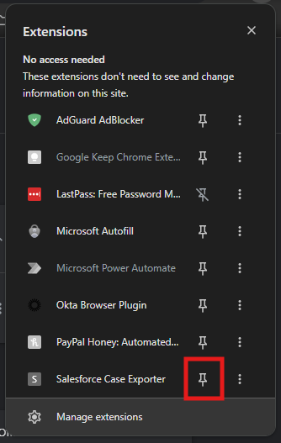

Step 6: Configure Your Download Location (Recommended)
Chrome's "Ask where to save each file" setting affects how the download dialog behaves. Both settings work with this extension:
- If Ask where to save is off: the ZIP file downloads automatically to your default folder.
- If Ask where to save is on: Chrome will show a Save As dialog. The extension popup will stay open while you choose a save location — this is normal.
To check this setting, go to chrome://settings/downloads.

Step 7: Use the Extension
Navigate to a Salesforce Case List View or a single Case page in your browser. Click the Salesforce Case Exporter icon in the toolbar to open the popup and export cases.
After a successful export, the popup will remain open showing a confirmation message. Click anywhere outside the popup to close it.

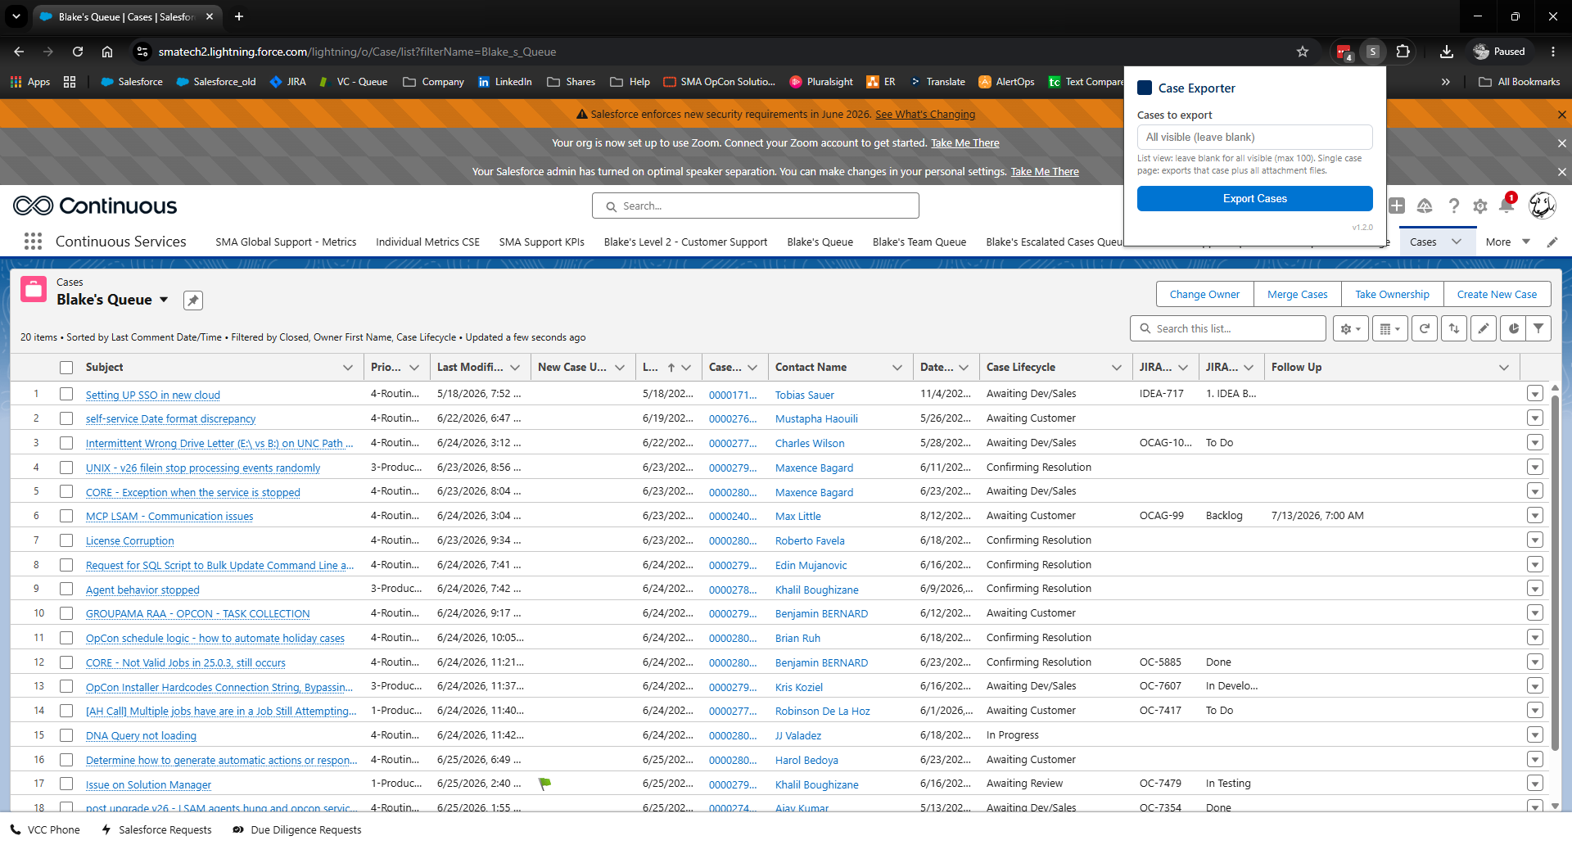

Troubleshooting
Issue | Fix
Extension does not appear after loading | Make sure you selected the folder containing manifest.json, not a parent or child folder.
Icon does not appear in toolbar | Click the puzzle piece icon and pin the extension manually.
Popup says "Navigate to a Salesforce page" | Make sure you are on a Salesforce Case List View or Case detail page.
Download fails or nothing happens | Check chrome://settings/downloads and confirm your download location is set. If "Ask where to save" is on, look for a Save As dialog that may be hidden behind other windows.
Popup closes before showing success | This should not happen in v1.2.0 or later. Check the extension version on the Extensions page and reload if needed.

