Loading the Extension in Microsoft Edge
Follow the steps below to install the Salesforce Case Exporter extension from a local folder (unpacked). You will need access to the extension source files on your machine.
Note: These instructions are for Microsoft Edge version 79 or later. The interface may look slightly different depending on your version.

Step 1: Open the Extensions Management Page
In the Edge address bar, type the following and press Enter:
edge://extensions
Alternatively, click the puzzle piece in the top-right corner of Edge, then select Manage extensions.

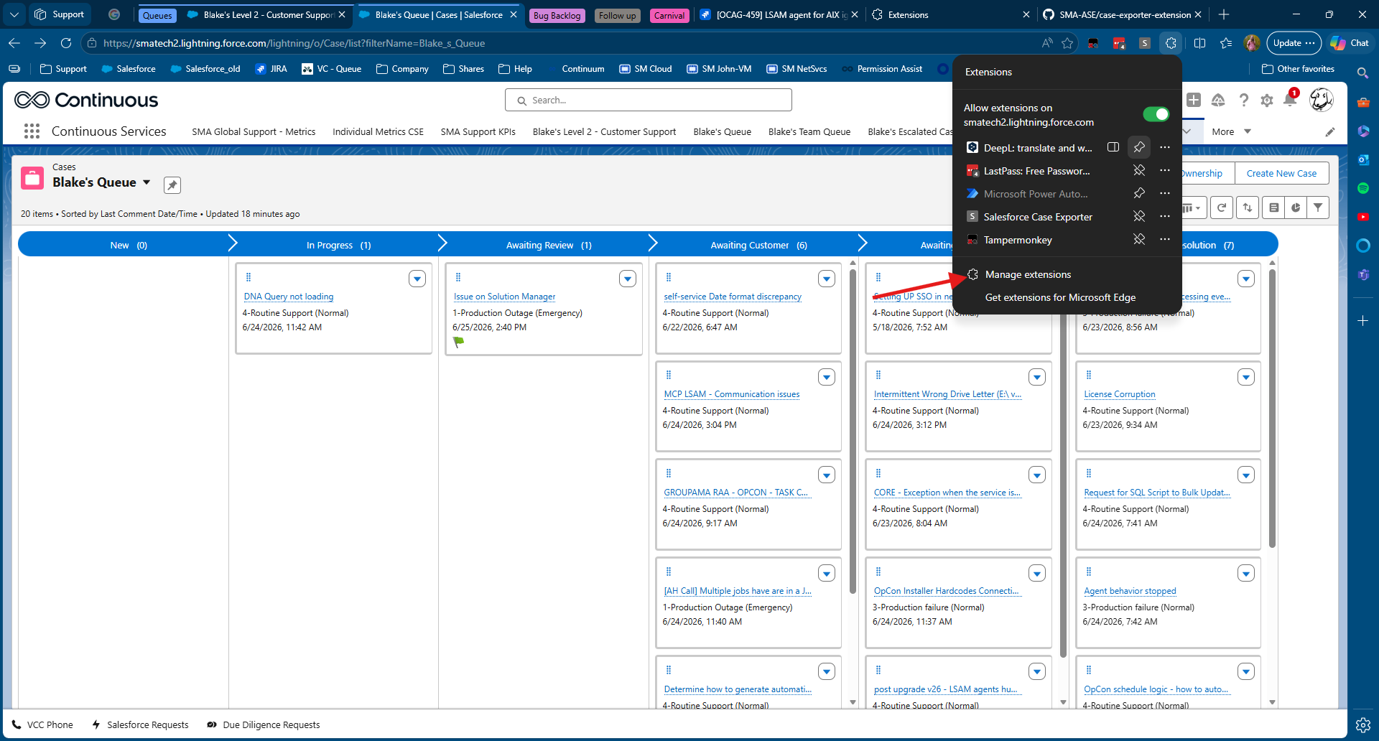

Step 2: Enable Developer Mode
On the Extensions page, find the Developer mode toggle in the lower-left corner of the sidebar and turn it on.

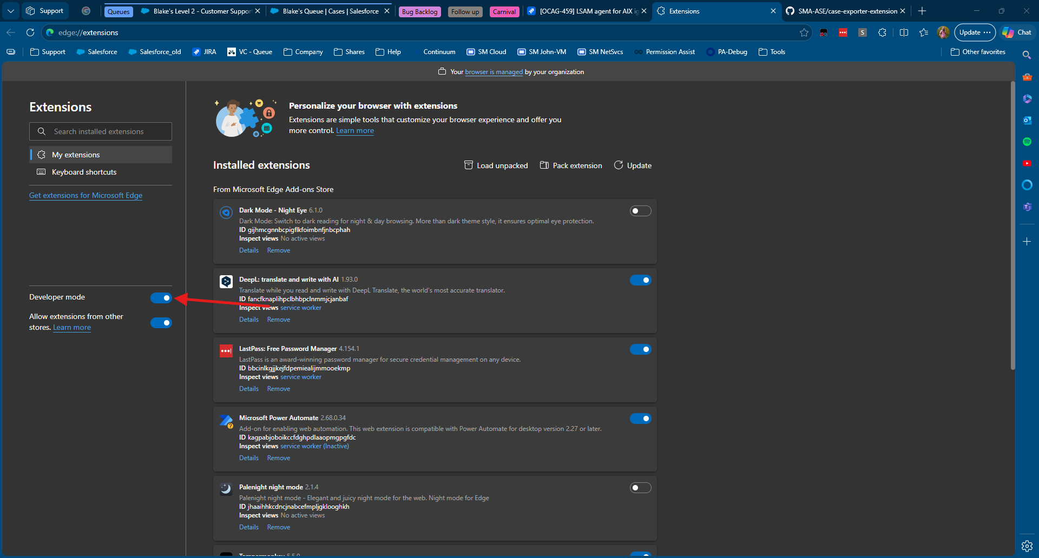

Once enabled, three new buttons will appear at the top of the page:
- Load unpacked
- Pack extension
- Update

Step 3: Load the Extension Folder
Click the Load unpacked button. A file browser dialog will open.

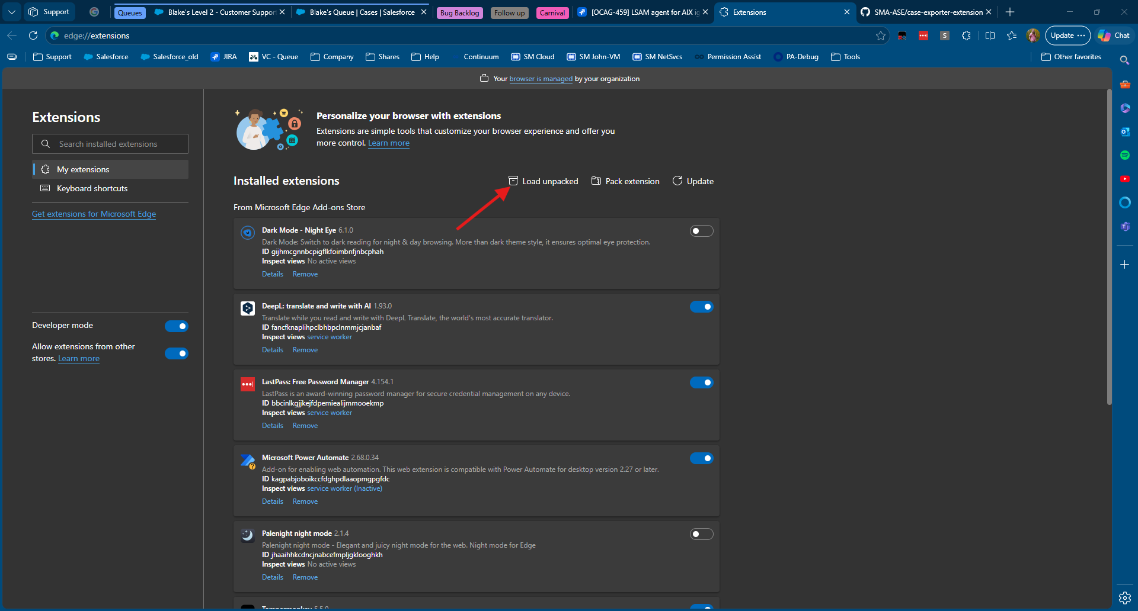

Navigate to the folder that contains the extension files. Select the root folder of the extension (the folder that contains manifest.json) and click Select Folder.

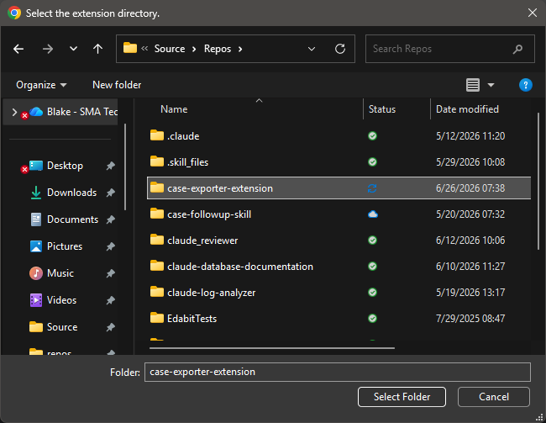

Step 4: Confirm the Extension Loaded
The Salesforce Case Exporter extension will now appear on the Extensions page. You should see:
- The extension name and version number
- A toggle to enable or disable it (should be enabled by default)
- An ID and path showing where the files were loaded from

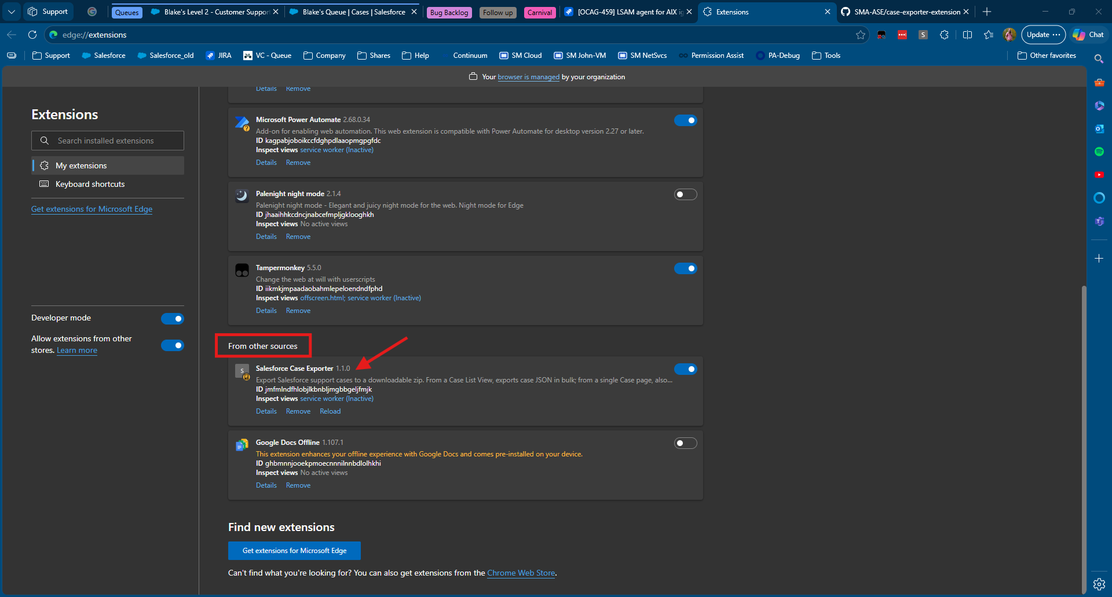

Step 5: Pin the Extension to the Toolbar
Click the puzzle piece icon (🧩) in the Edge toolbar. Find Salesforce Case Exporter in the list and click the eye/pin icon next to it to pin it to the toolbar for easy access.

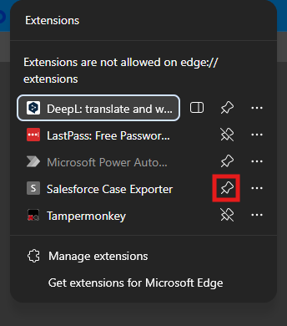

Step 6: Use the Extension
Navigate to a Salesforce Case List View or a single Case page in your browser. Click the Salesforce Case Exporter icon in the toolbar to open the popup and export cases.

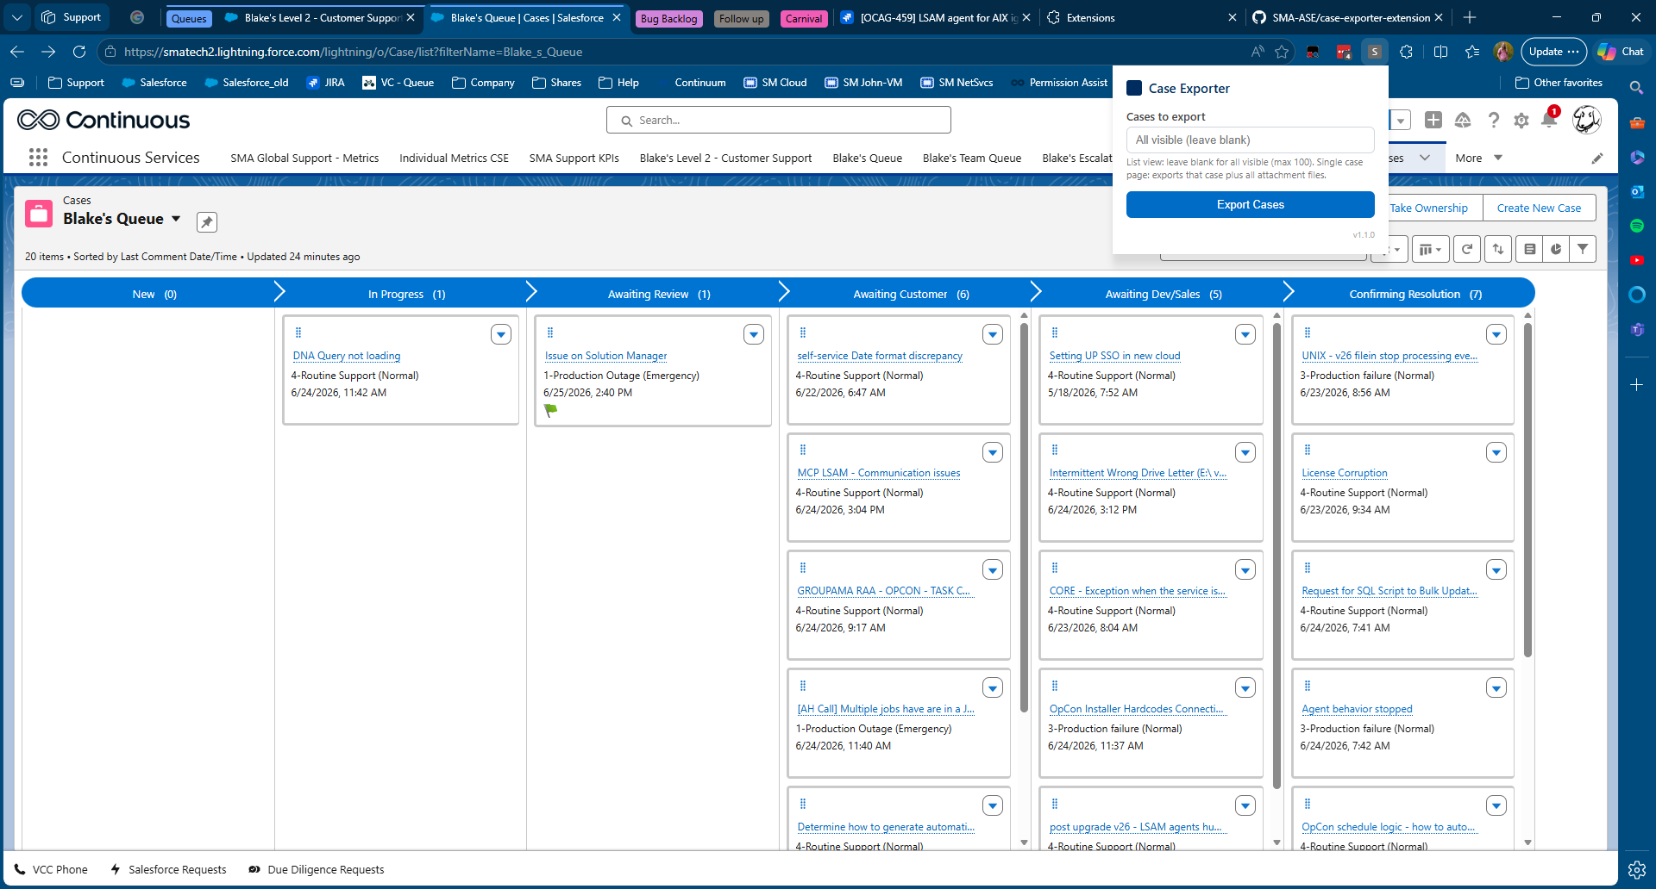

Troubleshooting
Issue | Fix
Extension does not appear after loading | Make sure you selected the folder containing manifest.json, not a parent or child folder.
Icon does not appear in toolbar | Click the puzzle piece icon and pin the extension manually.
Popup says “Navigate to a Salesforce page” | Make sure you are on a Salesforce Case List View or Case detail page.
Download fails or nothing happens | Check that Edge has permission to download files. Go to edge://settings/downloads and confirm the download location is set.

