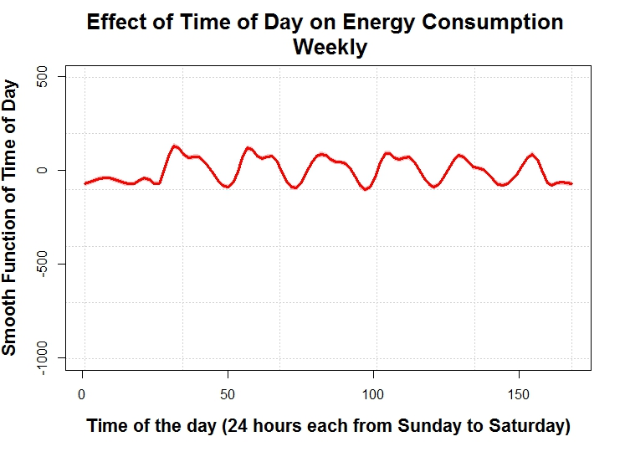

1) The period in which the occupancy is constant

* 12AM to 3PM everyday
* 11PM to 12 AM everyday
* 3PM to 12AM on Satuday
* All day on Sunday

2) The distribution of the max occupancy

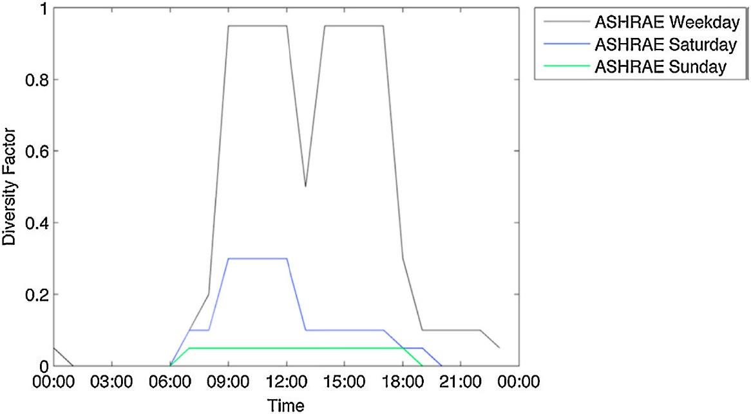

3) When do you think the max occupancy happens

* Tuesday to Thursday 10 AM or 11AM