Chemical Properties
As a Precursor to Aspirin
Salicylic acid is one of the organic compounds from which aspirin can be synthesised. As shown below, it can be reacted with acetic anhydride, using a sulfuric acid or phosphoric acid catalyst, to produce aspirin and acetic acid as a side product.
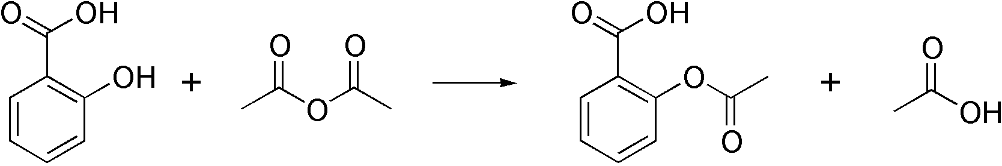
Aspirin is used as an analgesic to relieve minor aches and pains, and as an anti-inflammatory agent. It is also used long-term at low doses to help prevent heart attacks, strokes, and blood clots in some patients. Around 40,000 tonnes of aspirin are consumed worldwide every year.

