**The Third Republican Debate: During and After**

Social media activity in the form of tweets potentially offers a window into how interested viewers, and different segments of those viewers, are reacting to political debates in real time. During a fluid primary season – a description that certainly fits the campaign for the Republican Party presidential nomination in 2016 – other sources of information, such as polling data, may fail to pick up on subtle shifts in attention that could end up having outside influence on the process. While viewers tweeting about a debate are not fully representative of the population, they do give us a window into the thoughts and feelings of those who most actively follow American politics. The public tweets reveal a mix of which topics, and candidates, are getting attention.

What can we learn from this kind of data? When combined with contextual information that we can infer about the people posting the tweets, we can investigate how different groups (Republicans vs. Democrats, for example) respond to events and whether they are doing so in a supportive or critical way. For the analyses here, we start with a collection of every tweet posted during the debate that contained one of the associated hashtags[1] – giving us a set of of 404,750 tweets. We then combined the tweets with unique measures of the ideology of the sender of each tweet, derived from the follower networks of each sender, a method developed by Pablo Barberá.[2] (Details at the end of this report.)

Our analyses of tweets during the debate focuses mainly on the subset of users in our sample for whom we have ideological scores -- that is, those who followed at least 3 political or media accounts on Twitter at a time when we scanned political accounts for followers. We are then left with a set of 221,718 tweets, which we can label as being posted by a “Republican” (someone with an estimated ideological score to the right of center) or a “Democrat,” although both designations potentially include those who lean to one party or another. In some of the analyses, we further subdivide the Republican group into “moderate” and “conservative” Republicans.

1. “Winners” and “Losers”

If we just examine overall mentions of candidates, Ted Cruz was the clear winner among both Democrats and Republicans. Among the latter especially, he was mentioned in 26% of tweets about the debate – far ahead of the runner-up, Marco Rubio, with 15%. And Ben Carson, who entered the debate the front-runner in some national polls, was even further behind, being mentioned in only 8% of tweets by Republicans. Donald Trump, the other leader in opinion polls, was mentioned far more frequently by Republicans than was Carson, being mentioned in 14% of Republican tweets. The table below gives the proportion of mentions of each candidate by Democrats and Republicans.

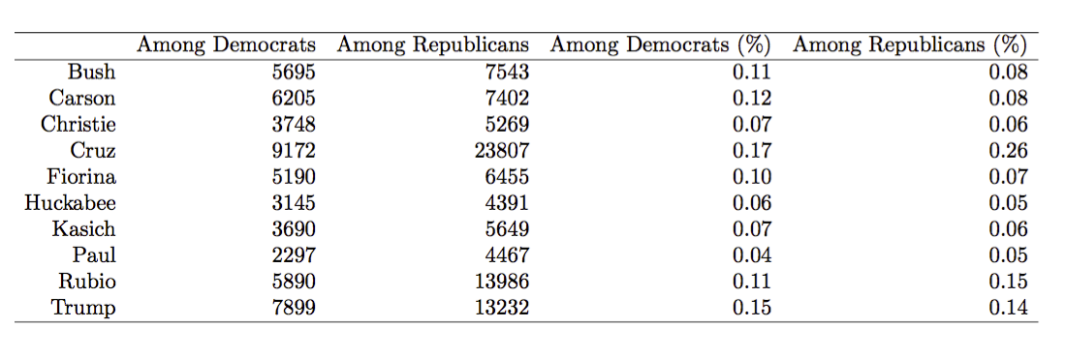

By paying attention to the differences across Republicans and Democrats in how the debate is interpreted, we can gain some insight into the politics of the event. We do not, of course, pretend to have gotten a concrete measure here of who “won” the debate. However, we can see that Ted Cruz maintains a fascination for Republican voters that, not surprisingly, is not reciprocated by voters on the Democratic side. And we can see that Carson simply did not generate as much attention on social media as his main rivals did. These patterns are also clear in the graph below, which plots mentions over the course of the debate.

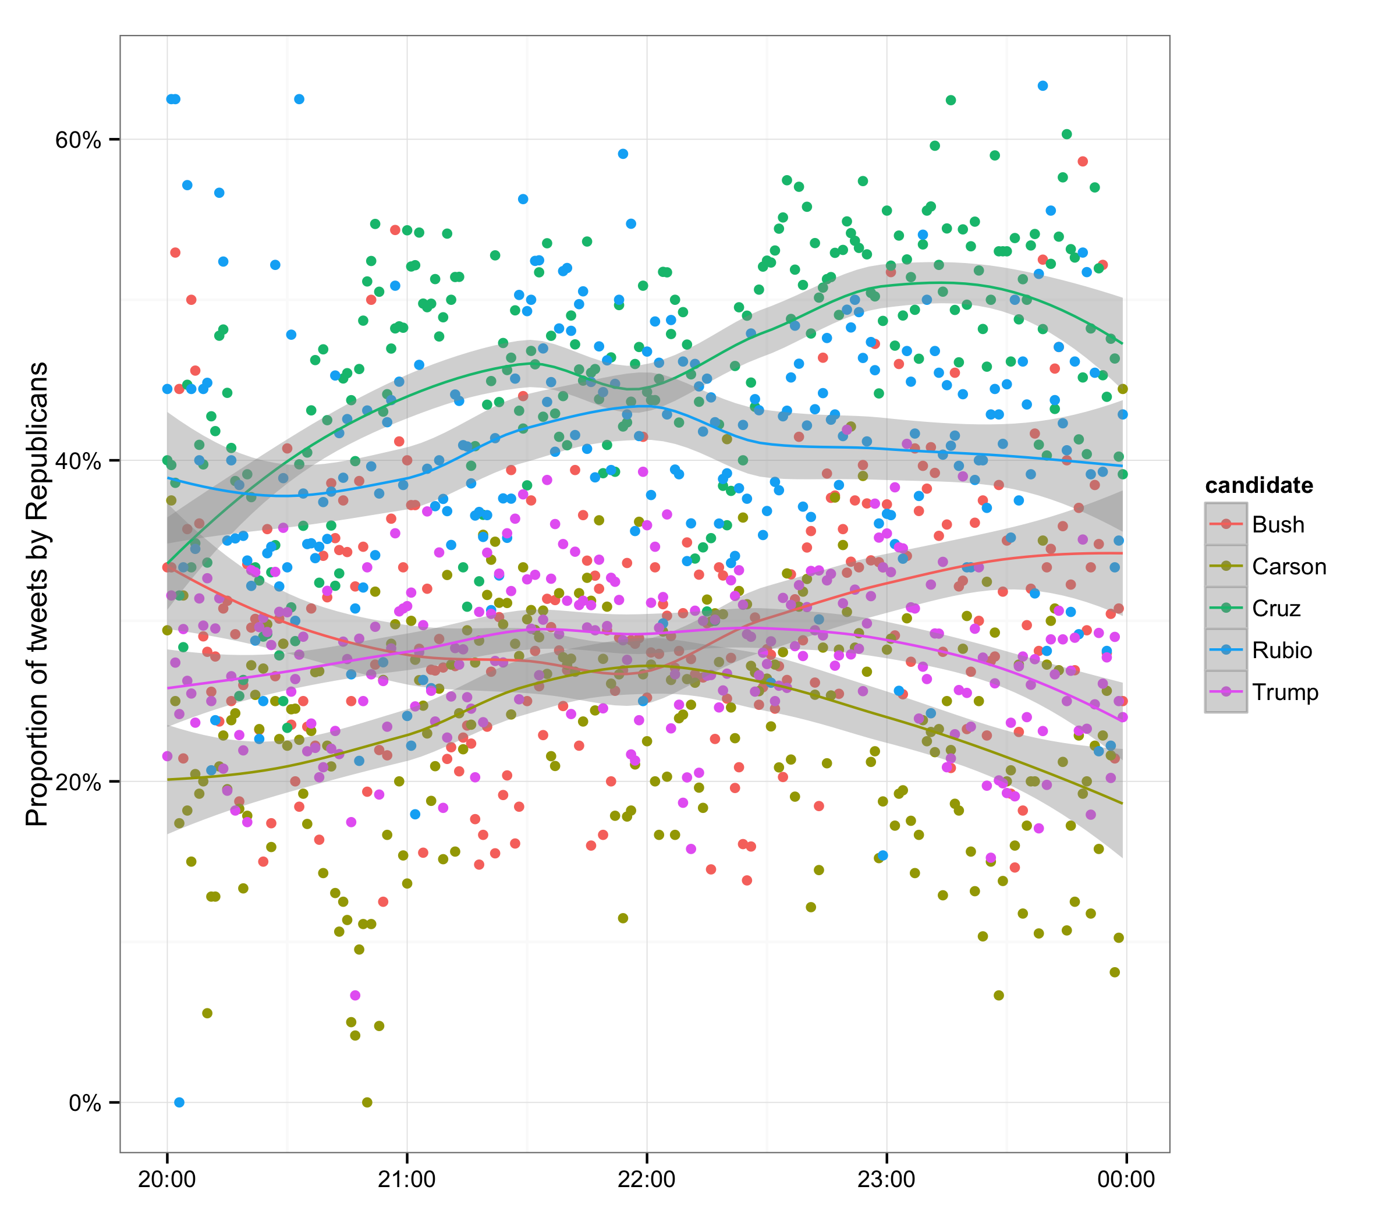

1. Terms and Topics

Of course, mentions of the candidates tell us neither what these tweeters thought about the candidates, nor what issues they cared about. To illustrate what people were tweeting about, we combined all words used by Democrats and all words used by Republicans, then removed the names of candidates and the main hashtags (as well as common English words such as “and” or “that”), and displayed the words most commonly used by each group. We see very few issues mentioned among the most popular words. But we can also see that the questions asked by the moderators were a major topic of concern among Republicans (much more so than Democrats). And we can see that Democrats frequently retweeted posts by Hillary Clinton, as well as tweets by Patton Oswalt (a comedian who was live-tweeting the debate).

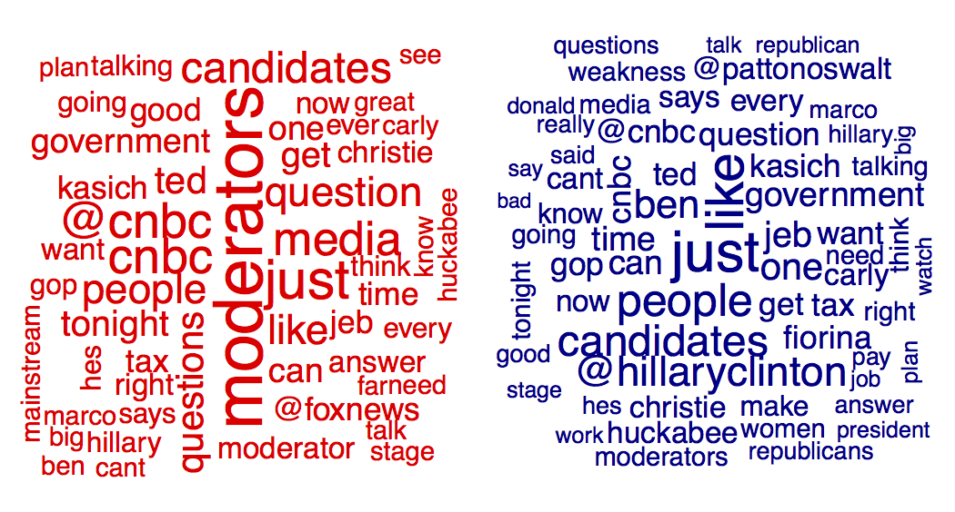

However, by looking at the terms used in real time, we can see that at different points during the debate those following it did tweet about specific topics being discussed. For instance, mentions of “sports,” “fantasy,” or “betting” within this set of tweets suddenly spiked when the moderators asked Jeb Bush about allegations of insider trading in fantasy sports leagues at around 9:55 p.m. Eastern, as the figure below shows:

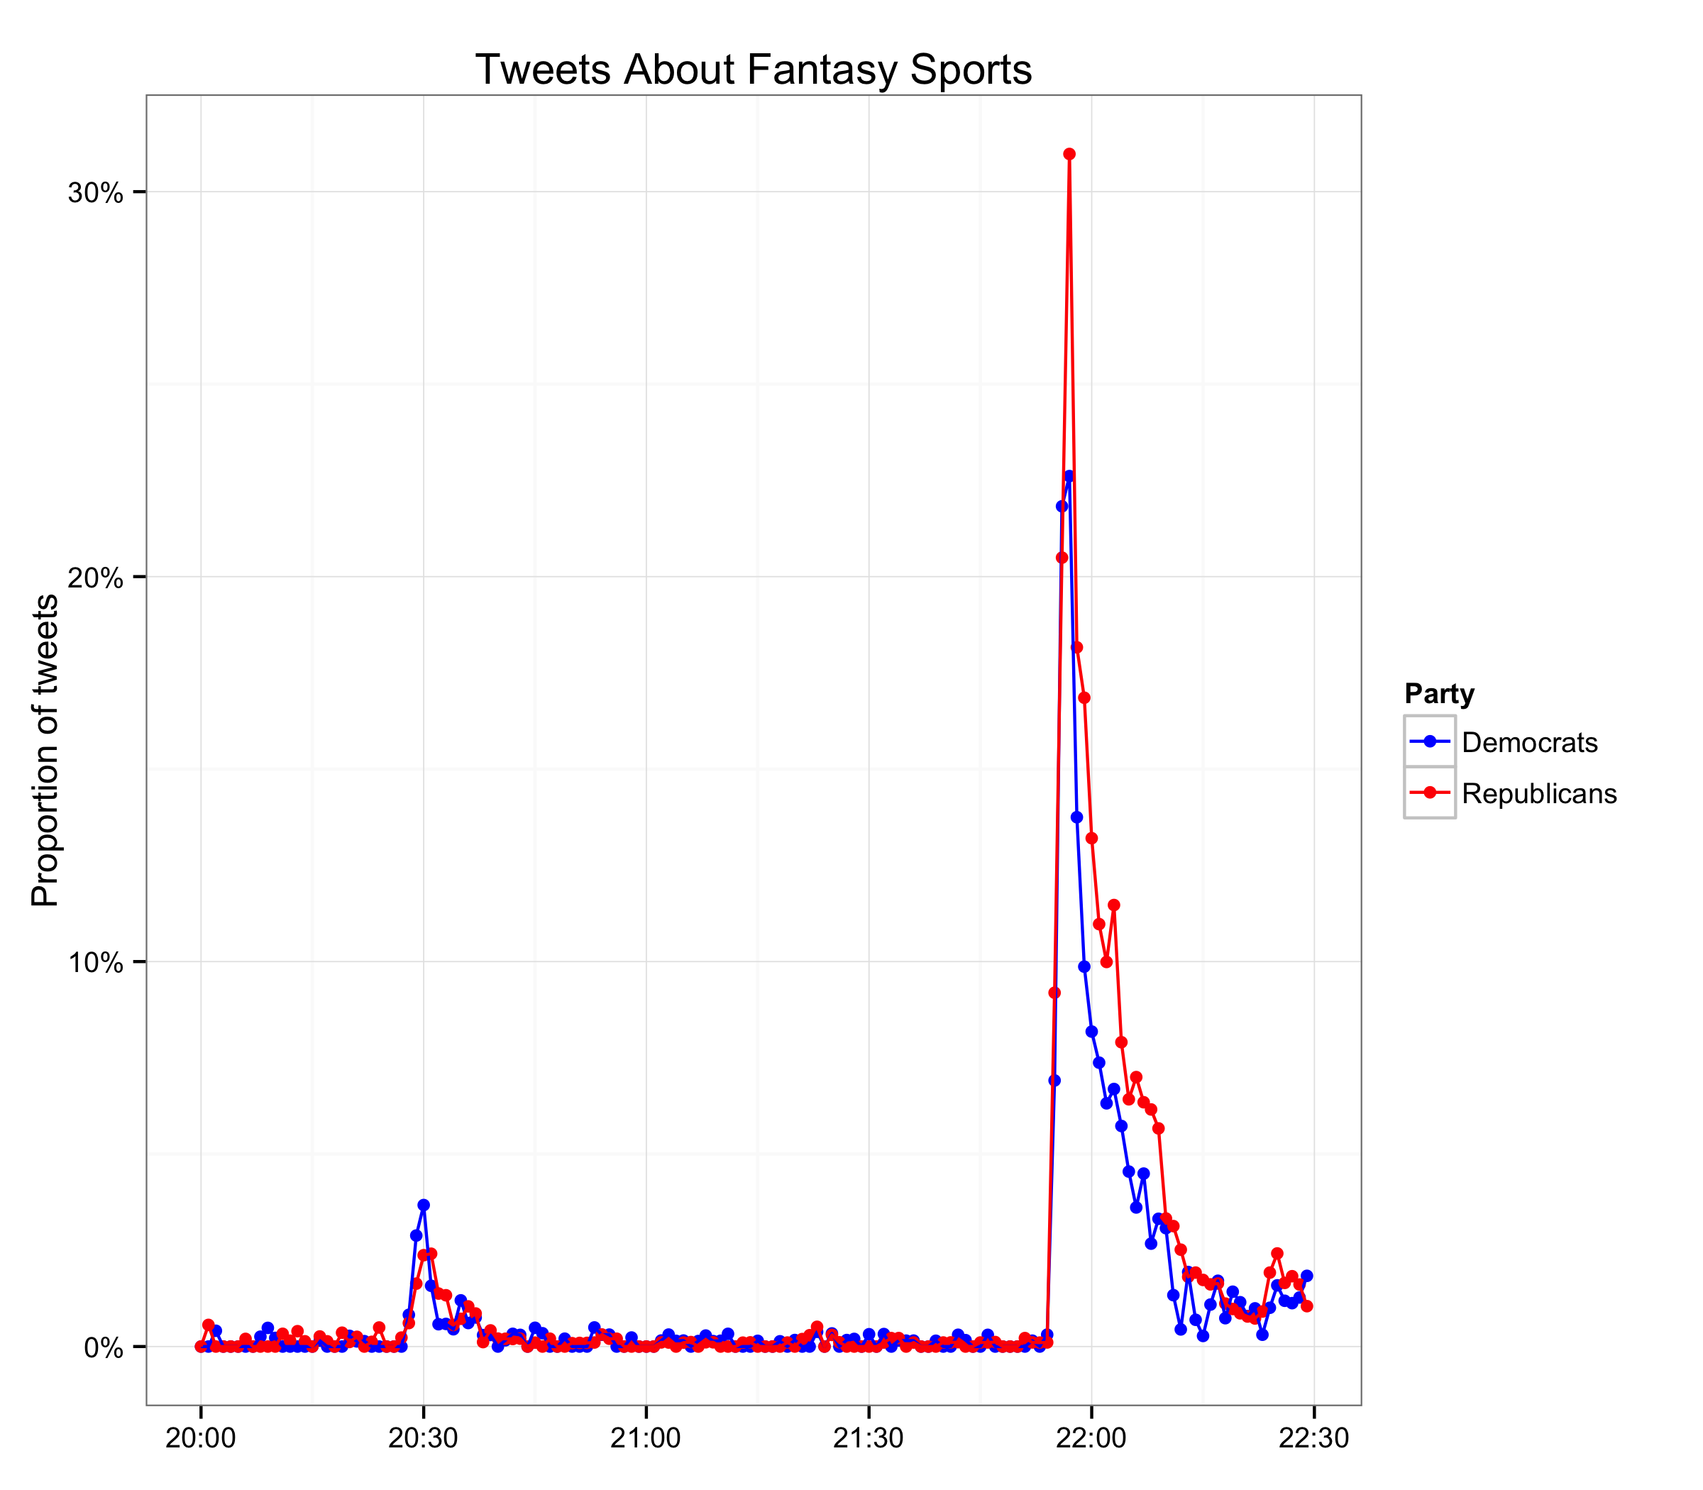

Another way to see what topics are of particular interest to those following the debate is to see which tweets are most frequently retweeted. Four out of the top 10 retweets during the debate were from Hillary Clinton’s official account. (For comparison, Fox News had two and Jeb Bush and *The Onion* each had one.)

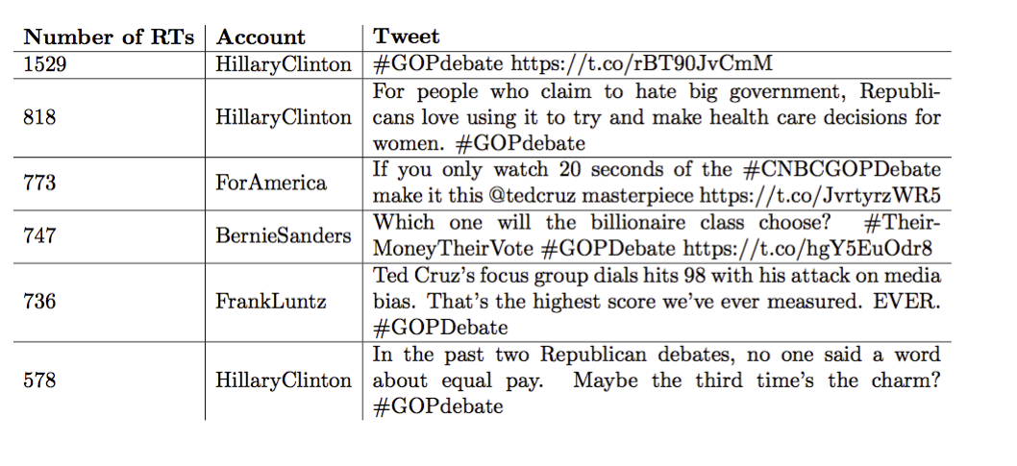

1. Rubio vs. Bush

As we saw in the first table, Rubio received more mentions than Bush did. But in the following graph we can see when some of those mentions happened. The graph below plots the absolute number of mentions of both candidates by Republicans only over the course of the debate with two key moments – the Rubio/Bush exchange and Rubio’s assertion that the mainstream media is Hillary Clinton’s “super PAC.” Although Rubio’s mentions tapered off after each moment, social media activity generally focused more on him than on Bush throughout the debate.

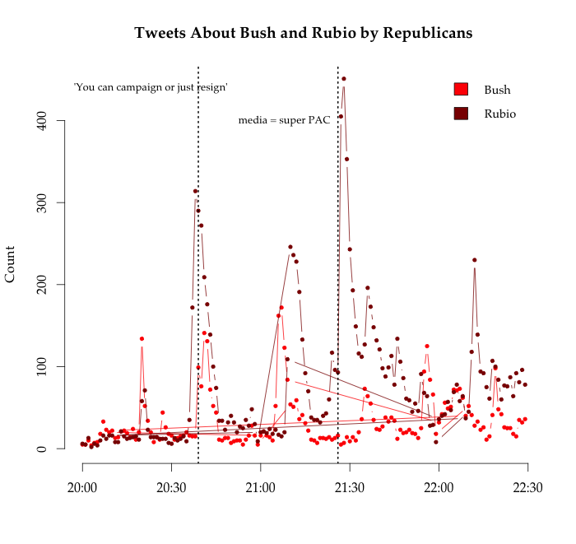

Bush may not have generated as much excitement on social media as measured by pure engagement. But among those that did tweet about his performance, how did they feel? We can attempt to answer that question using sentiment analysis, in which we compare the words used in tweets to those found in a labeled dictionary of positive and negative terms.[3] We summarize our results in the graph below, which shows how Democrats and Republicans each viewed Bush and Rubio. Trends are not nearly as stark as the post-debate spin suggested, although it is possible to discern a gradual shift toward more positive sentiment about Rubio as the debate progressed. Overall, however, average sentiment was fairly neutral for both types of partisan. It is also possible that the sentiment dictionaries are simply not picking up the language (let alone the irony or sarcasm) used by savvy Twitter users to describe political candidates in 2015.

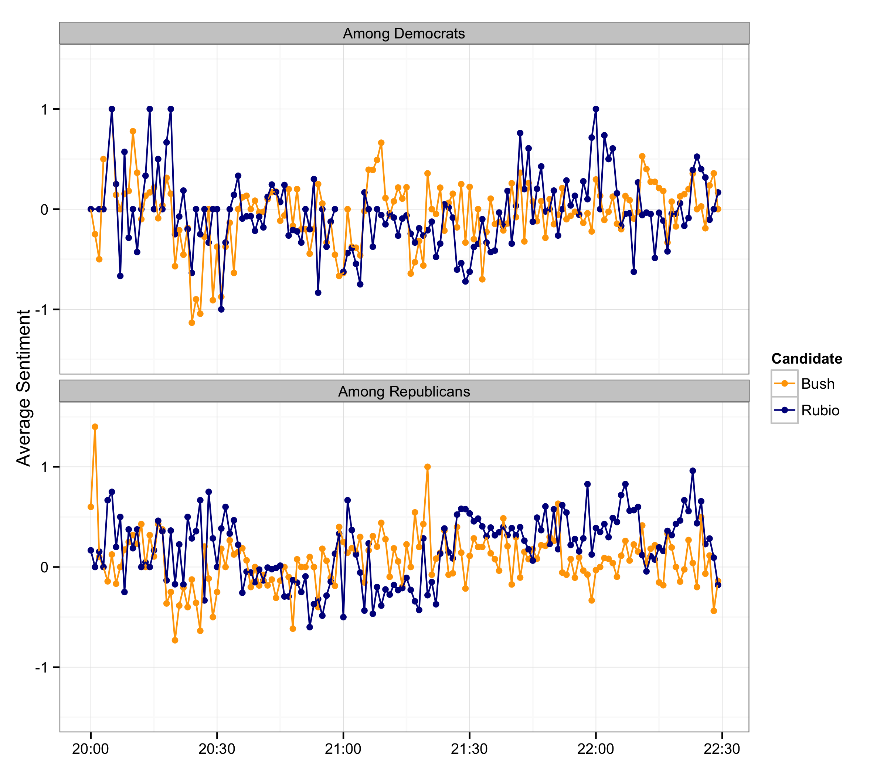

1. The Moderators

Sentiment analysis did pick up on another phenomenon, however: Republicans were not happy with the moderators of the debate. Democrats, too, tweeted critically about the moderators’ job, but they were comparatively less negative than Republicans. Figure 5 graphs the sentiment throughout the course of the debate in tweets mentioning the moderators.

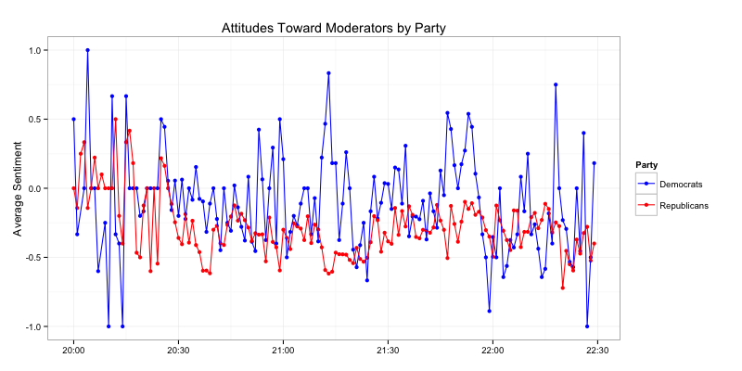

1. Moderates vs. Conservatives

How much did the reactions of those closer to the center of the ideological spectrum differ from those farther to the right? We took a closer look among those we labeled as Republicans.

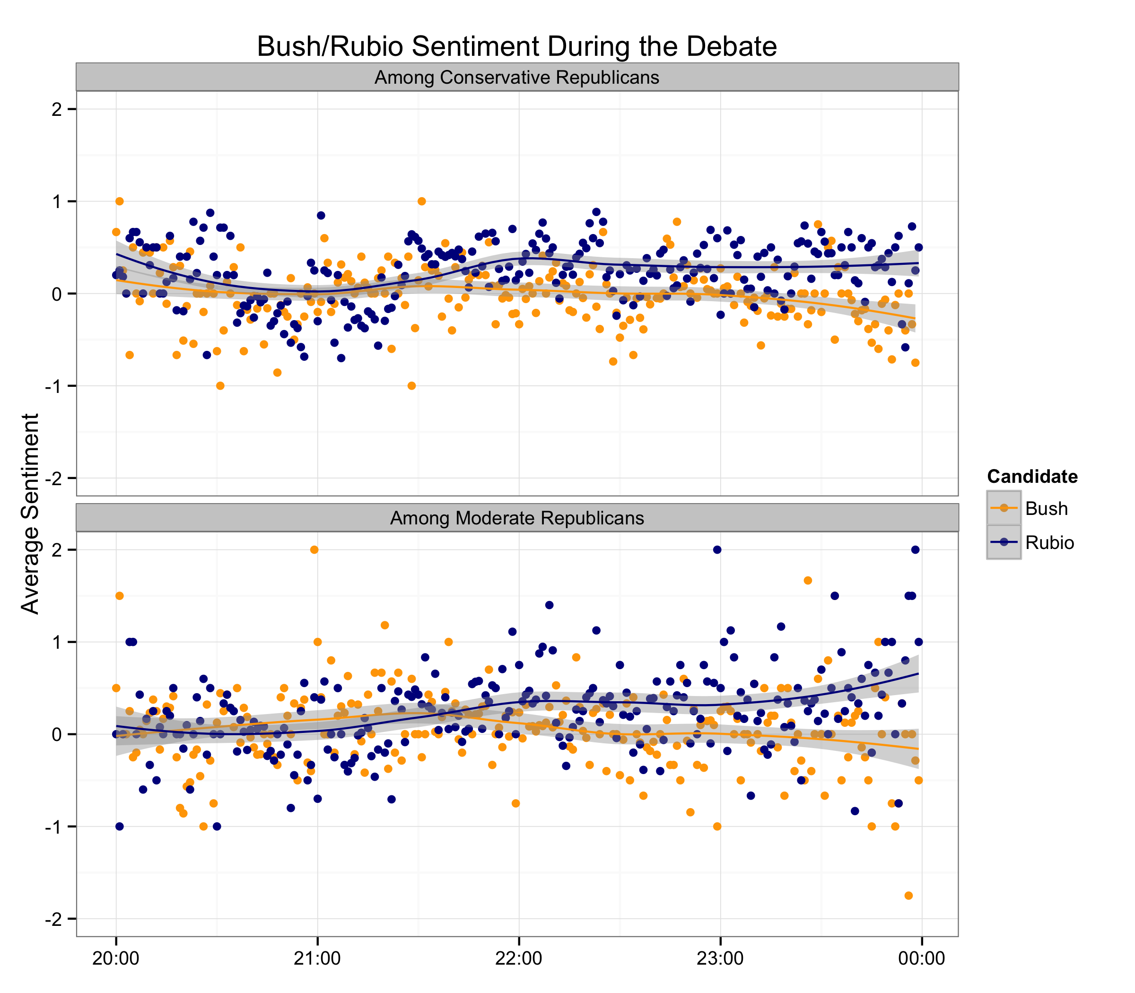

In the graph above, we see how average sentiment toward Bush and Rubio (where greater than zero is positive) shifted over time among more moderate and more conservative Republican Twitter users. As estimated by the language they used in their tweets, we see that both groups came to view Rubio somewhat more favorably as the debate went on. The divergence – which was subtle but measurable – occurred roughly after the clash over Rubio’s Senate record and Bush’s suggestion that Rubio should resign. For this comparison, at least, there seemed to be no meaningful difference between the two ideological subgroups.

1. Post-Debate Reactions

Did the real-time reactions carry over into the morning after? The graph below plots a rolling average of sentiment beginning at midnight and into the next morning. This is a slightly more difficult exercise because the volume of tweets dropped off substantially after the debate ended (to fewer than 5,000 from midnight to 11:15 the next morning). Still, we can see that [the conventional wisdom about Rubio’s performance as compared to Bush](http://www.nytimes.com/2015/10/30/us/politics/critics-early-take-on-gop-debate-rubio-won-and-cnbc-lost.html) did not immediately register: Sentiment about the two on Twitter on the morning after the debate was roughly equal. As afternoon approached, however, Rubio began to take off again, especially among the more conservative users on Twitter.

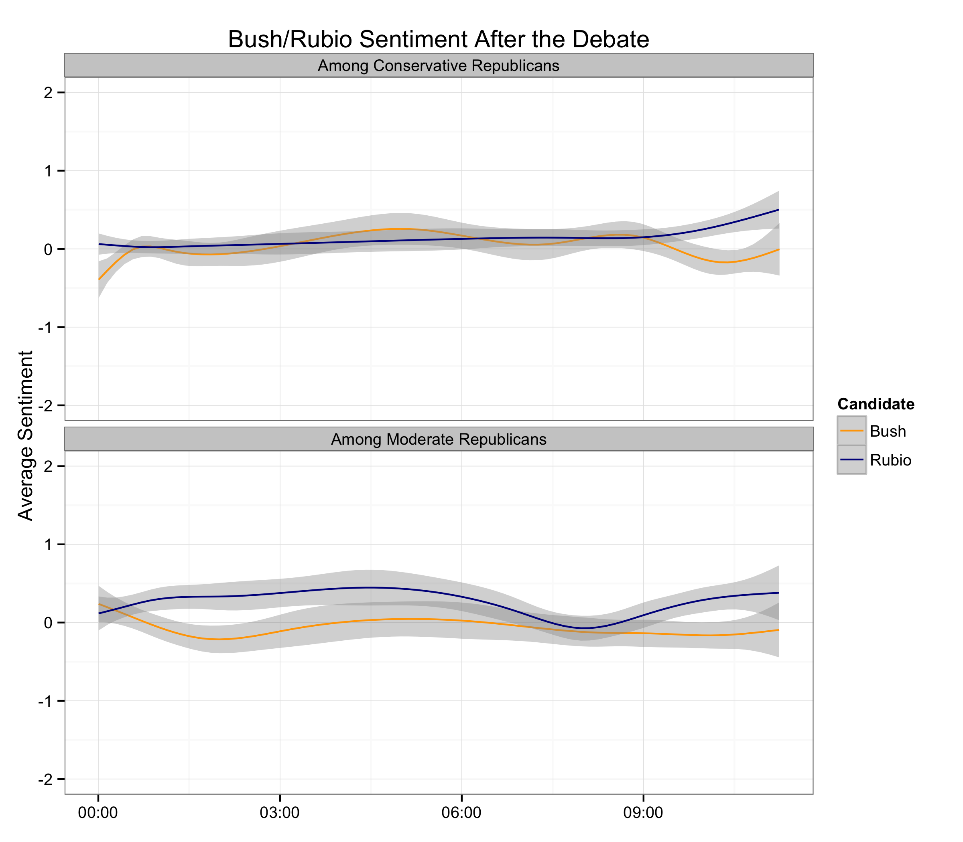

Rubio thus appeared to have solidified his claim, on social media, as the winner by the next afternoon. Whether this reflects what viewers thought from his debate performance, or what they thought from coverage of the performance, is not immediately clear.

Beyond simply counting the number of tweets about each candidate, this kind of analysis allows us to use publicly available data to explore what different subgroups on Twitter are saying about various political topics – and how they felt about them. Combining simple sentiment analysis with minute-by-minute social media data lets us see how narratives are shaped both by the people who experience an event as it happens and those who package it afterwards.

Details of the Analysis

Twitter users don’t tell us which political party they support or directly reveal their ideological leanings. But thanks to Twitter’s network structure, we can infer these attributes using a [scaling method developed by Pablo Barberá](http://pan.oxfordjournals.org/content/23/1/76.full). At the most basic level, people on Twitter who are interested in politics follow relevant accounts: news sources, journalists, parties, and politicians themselves (in Congress and elsewhere). Thanks to the clear partisan affiliation of many of these sources, it is more likely that someone who follows mainly Republican-leaning media outlets and elected officials will be conservative than someone who follows mainly Democratic-leaning outlets and officials.

Our analyses of 404,750 tweets during the debate focuses mainly on the subset of users in our sample for whom we have ideological scores -- that is, those who followed at least 3 political or media accounts on Twitter at a time when we scanned political accounts for followers. We are then left with a set of 221,718 tweets, which we label as being posted by a “moderate Republican” (someone with an estimated ideological score to the right of 0 but left of 1), a “conservative Republican” (a score to the right of 1) or a “Democrat” (left of 0). These designations potentially include those who lean to one party or another.

Data analysis provided by the SMaPP Toolkit package (<http://smapp.nyu.edu/toolsNcode.html>).

1. #GOPDebate, #CNBCGOPDebate, #RepDebate, and #RepublicanDebate
2. See <https://github.com/pablobarbera/twitter_ideology>
3. Dictionaries developed by Hu and Liu (<http://www.cs.uic.edu/~liub/FBS/sentiment-analysis.html)>