**IMPORTANT INSTRUCTIONS FOR STARTING UP THE LARGE HADRON COLLIDER**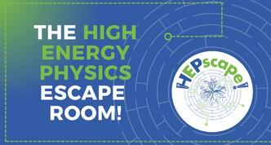

There are many magnets in the LHC tunnel, which are used to bend the particles and keep them on the circular orbit of the LHC.

The LHC magnets have been specially designed and have a very high magnetic field. They are superconductors and must be kept at a very low temperature.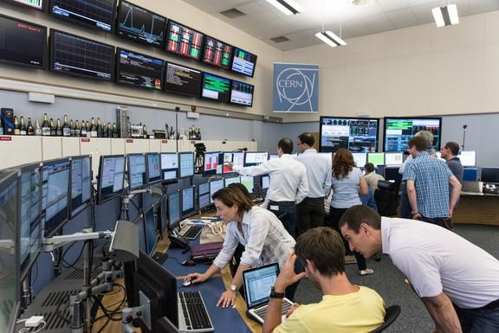

### LHC MAGNET MANUAL

There are **1,232** magnets in the LHC tunnel that are used to bend the particles and keep them inside the accelerator tube.

The magnets used in the LHC were specially designed: they are the blue tubes in the photo, are about **16** meters long, and weigh 35 tons.

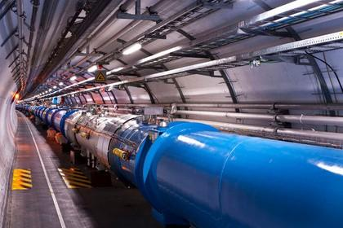

###### VERY IMPORTANT: MAGNET TEMPERATURE

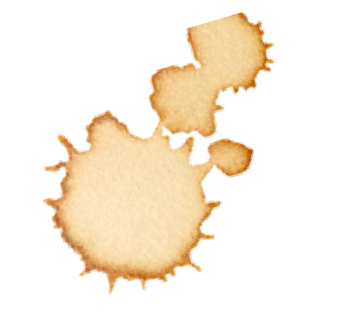First, the **1232** magnets must be cooled to a temperature of Kelvin, i.e. ℃.



###### COOLING THE MAGNETS

The magnets must first be cooled using **10080** tons of liquid nitrogen and then filled with **120** tons of liquid helium to reach the right temperature.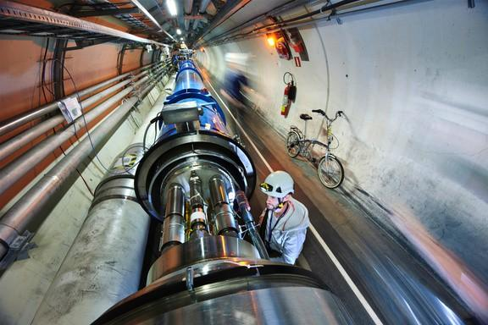

###### ULTRA-HIGH VACUUM

To avoid collisions with gas molecules inside the accelerator, the particle beams travel in a high-vacuum tube, as empty as interplanetary space. The pressure inside the LHC tube is **10⁻¹³** atmospheres, ten times lower than that on the Moon!

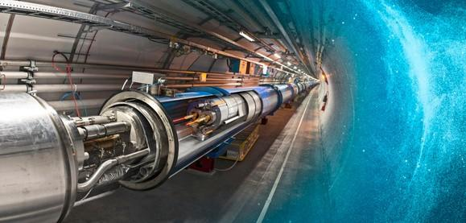

**LHC MAGNET MANUAL**

The hottest spot in the galaxy, but even colder than interstellar space...

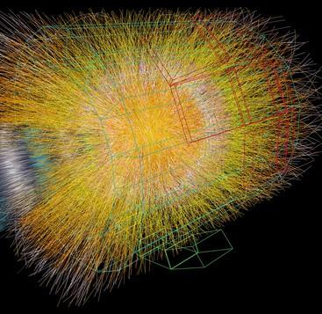

The LHC is a machine of extremes, between hot and cold.

When two beams of lead ions collide, they generate temperatures **100,000** times hotter than the core of the Sun, concentrated in a tiny space.

The “cryogenic distribution system”, which circulates superfluid helium around the accelerator ring, keeps the LHC at a very low temperature, even colder than interstellar space!



**CURRENT OF THE LHC MAGNETS**

At loow temperatures, the electrical cable of the 1232 magnets becomes superconducting, meaning that the electric current passing through it encounters no resistance in the cable, and therefore the cable can carry the necessary current of **12,500** Amps without heating up. The photo shows the superconducting cable and the normal copper electrical cables that would be needed to carry the same current.

###### SPEED OF PARTICLES INSIDE THE LHC

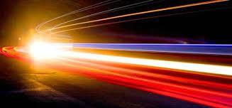

The particles inside the LHC travel at almost the speed of light.

The **2** proton beams each travel at a maximum energy of **7** TeV (teraelectronvolts).

At maximum energy, trillions of protons race around the LHC accelerator ring, circling **11,245** times per second and traveling at **99.9999991%** of the speed of light.

# LHC



## C = 2 x 𝜋 x R

The LHC has an almost circular shape with a circumference of approximately **27 km**.

The radius of curvature is almost **4 km**.

### LHC MANUAL

###### TUNNEL LENGTH

The LHC tunnel is **27** km long and is located

**100** meters underground.

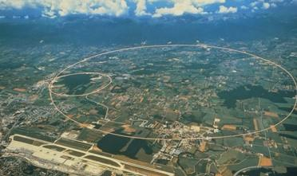

### CERN HISTORY

###### FOUNDATION OF CERN

CERN was founded in **1954** by 12 founding countries.

###### SCIENCE FOR PEACE

CERN, founded in **1954**, conducts basic scientific research on nuclear physics and elementary particles and promotes peaceful scientific collaboration between member countries.

CERN does not engage in any military research, and all research results are made public and accessible to everyone.

###### THE BIRTH OF THE WEB

In 1989, Tim Berners Lee, a British scientist at CERN (founded in 1954), invented the WEB and created the first website. You can check out the CERN website at [www.cern.ch](http://www.cern.ch)

###### FOUNDATION OF CERN

CERN was founded in **1954** by 12 founding countries.

Today there are 23 member states and the director is Mark Thomson.

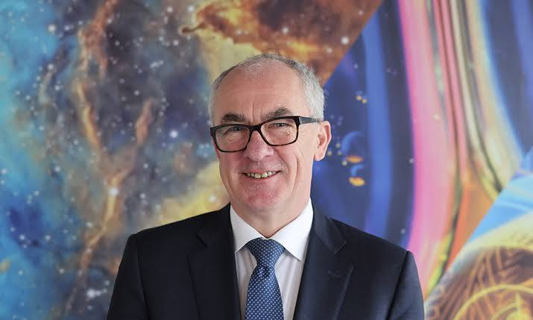

###### CERN MEMBER COUNTRIES

CERN was founded in **1954** by 12 countries, and today there are 23. The photo shows the 23 CERN member states.

Each country contributes to CERN based on its gross domestic product

##### MONT BLANC

MONT BLANC IS THE HIGHEST MOUNTAIN IN THE ALPS. IT IS **4807** METERS ABOVE SEA LEVEL AND IS LOCATED ON THE ITALIAN/FRENCH BORDER.

##### MOUNT CERVINO

MOUNT CERVINO IS **4478** METERS ABOVE SEA LEVEL AND IS LOCATED ON THE BORDER BETWEEN ITALY AND SWITZERLAND IN THE WESTERN ALPS.

##### MONTE ROSA

MOUNT ROSA IS THE SECOND HIGHEST ITALIAN MOUNTAIN, IT IS **4634** METERS ABOVE SEA LEVEL IN THE WESTERN ALPS.

##### MONTE ARGENTERA

MOUNT ARGENTERA IS THE HIGHEST MOUNTAIN OF THE MARITIME ALPS, IT IS **3297** METERS ABOVE SEA LEVEL.

##### ETNA

MOUNT ETNA IS A VOLCANO LOCATED IN SICILY AND IT IS **3403** METERS ABOVE SEA LEVEL.

##### TRE CIME DI LAVAREDO

THE THREE PEAKS OF LAVAREDO ARE THE MOST FAMOUS PEAKS OF THE DOLOMITES. THE HIGHEST IS THE CIMA GRANDE, THE CENTRAL ONE, WHICH IS **2999** METERS ABOVE SEA LEVEL AND IS LOCATED IN THE EASTERN ALPS.

##### GRAN SASSO

GRAN SASSO IS THE HIGHEST MOUNTAIN IN THE APPENNINES. IT IS **2912** METERS ABOVE SEA LEVEL.

##### MAIELLA

THE HIGHEST PEAK IN MAIELLA IS MONTE AMARO, **2793** METERS ABOVE SEA LEVEL. IT IS THE SECOND HIGHEST MOUNTAIN OF THE APPENNINES.

# GEOMETRY



## C = 2 x 𝜋 x R

𝜋 **= 3,14…**

The circumference of a circle is calculated by multiplying its radius by 2 and then by the number pi, which is approximately 3,14



## AREA = R x R x 𝜋

𝜋 **= 3,14…**

The area of a circle is calculated   
by multiplying the radius by itself and   
by the number pi, which is approximately 3.14.

magnets

## C = 2 x 𝜋 x R

LHC is almost circular, with a circumference of about **27 km**. The curvature radius is almost **4 km**.



SIZE

AREA = SIZE x SIZE

The area of a square is calculated by multiplying its size by itself



SIZE

## P = SIZE x 4

The perimeter of a square is calculated by multiplying its size times four.



**HEIGHT**

BASE

AREA = BASE x HEIGHT : 2

The area of a triangle is calculated mnultiplying the base times the height and dividing by two.

# THE LIGHT

#### LIGHT SPEED AND THE LHC

Light in vacuum has a speed of **299792458**

meters/second. The particles in the LHC travel almost at the speed of light.

# SPEEED OF LIGHT

It is not possible to travel faster than light. As the energy of an object increases, so does its mass, and at speeds close to the speed of light, an ever-increasing portion of energy goes into increasing the object’s mass, while the remaining fraction actually contributes to its acceleration.

Therefore, it would require infinite energy to accelerate a massive object to the speed of light.

##### GALILEO GALILEI’S SPEED OF LIGHT MEASUREMENT

Light in a vacuum has a speed of 299,792,458 meters per second. Galileo’s experiment involved placing two lanterns a mile apart and attempting to measure the time it took for light to travel from one point to the other.

Together with an assistant, he took a covered lantern and climbed to the tops of two hills separated by a mile. Galileo uncovered his lantern, and his assistant, upon seeing the light, uncovered the lantern on the other hill.

Galileo then tried to measure the time required to see the light from the other hill, reasoning that he could divide the distance by the time taken to derive the speed of light.

However, the experiment yielded no result: for light to travel a mile, it takes about 0.000005 seconds—a value impossible to measure with the instruments available to Galileo.

##### ROMER’S SPEED OF LIGHT MEASUREMENT

Light in a vacuum has a speed of 299,792,458 meters per second. The Danish scientist Ole Rømer was the first to measure the speed of light in 1676 by observing the difference in the period of Io's orbit around Jupiter, depending on whether Earth was nearer to or farther from Jupiter. His measurement was not very precise.

In 1790, Huygens used the same method and obtained a much more accurate measurement.

#### TRAVELLING TO THE STARS

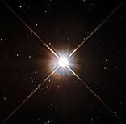

Light in a vacuum travels at 299,792,458 meters per second. The light emitted by the Sun takes about 8 minutes to reach Earth (which is 150 million kilometers away). A light year is the distance that light travels in one year, that is, 9,460 billion kilometers.

The closest star to Earth is Proxima Centauri, which is about 4 light years away—that’s 40,000 billion kilometers, incredibly far! With current rockets, it would take 6,300 years to reach Proxima Centauri.

#### TRAVELLING TO THE STARS

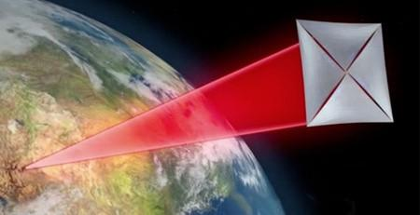

However, if we give up on sending a human and instead settle for a probe, things become more feasible.

Rather than launching heavy equipment, we send thousands of microchips, each about the size of a postage stamp and weighing just a few grams. There are so many because traveling at those speeds is dangerous—a head-on collision with even a tiny speck of interstellar dust would be fatal.

So, we dispatch thousands of these microchips, hoping that at least a few will survive. The total weight would only amount to a few kilograms. And instead of equipping the spacecraft with rockets and impossible amounts of fuel, we push the ship from Earth. From Earth? Yes, using (ultra-powerful) lasers to propel an ultra-light sail a few square meters in area.

With this system, it’s possible to accelerate this unusual starship to about 20 percent of the speed of light and reach Proxima Centauri in 21 years—a time frame within a human lifetime.

If these microchips were to take photos and send them back to Earth, we would receive them after another 4 years and 2 months, because light in a vacuum travels at 299,792,458 meters per second and Proxima Centauri is 4.2 light years away.

In essence, if this turbo-laser-propelled super starship set off now, we could see pictures of Proxima Centauri in about 25 years.