JOB PORTAL WEBSITE  
  
**Technologies Used: React, Spring Boot, MongoDB, Redux, Tailwind, Mantine, Tabler Icons**

**Highlighted Features:**

* **Notification System**
* **Sending OTP via email.**
* **Securing APIs using JSON Web Token (JWT)**
* **Protected routes according to roles.**
* **Responsiveness**
* **Animations**

**1. User Registration and Authentication**

* **User Registration**
  + As a user, I want to register an account using my email and a password.
  + As a user, I want to register an account using my social media accounts (Google, LinkedIn).
* **User Login**
  + As a user, I want to log in using my email and password.
  + As a user, I want to log in using my social media accounts (Google, LinkedIn).
* **Password Management**
  + As a user, I want to reset my password if I forget it.
  + As a user, I want to change my password after logging in.

**2. User Profile Management**

* **Profile Creation and Editing**
  + As a user, I want to create and update my profile with personal details, contact information, and a profile picture.
* **Resume Management**
  + As a user, I want to upload my resume in PDF or DOC format.
  + As a user, I want to update or delete my uploaded resume.
* **Skills, Certifications, and Work Experience**
  + As a user, I want to update my skills, certifications, and work experience in my profile.

**3. Job Search and Application**

* **Job Search**
  + As a user, I want to search for jobs using keywords, location, and job categories.
  + As a user, I want to filter job search results by company, experience level, salary range, and job type (full-time, part-time, contract).
* **Job Details**
  + As a user, I want to view detailed information about a job, including the company, job description, requirements, and application deadline.
* **Job Application**
  + As a user, I want to apply for jobs directly through the portal by submitting my resume and a cover letter.
  + As a user, I want to track the status of my job applications.

**4. Employer Functionality**

* **Job Posting**
  + As an employer, I want to create, update, and delete job postings.
  + As an employer, I want to set the visibility of job postings (public, private).
* **Applicant Management**
  + As an employer, I want to view and manage applications for my job postings.
  + As an employer, I want to contact applicants directly through the portal.

**5. Notifications and Alerts**

* **Job Alerts**
  + As a user, I want to receive email notifications for new job postings that match my search criteria.
* **Application Status Notifications**
  + As a user, I want to receive email notifications about the status of my job applications.

**6. Additional Features**

* **Saved Jobs**
  + As a user, I want to save job postings to view and apply for them later.
* **Company Profiles**
  + As a user, I want to view detailed profiles of companies, including their description, location, and current job postings.
* **User Dashboard**
  + As a user, I want to have a dashboard that summarizes my recent activity, such as saved jobs, applied jobs, and recommended jobs.

Theme

Dark:

App Background => #2D2D2D

'mine-shaft': { '50': '#f6f6f6', '100': '#e7e7e7', '200': '#d1d1d1', '300': '#b0b0b0', : '#888888', '500': '#6d6d6d', '600': '#5d5d5d', '700': '#4f4f4f', '800': '#454545', '900': #3d3d3d', '950': '#2d2d2d', },

Button => #FFD149

'bright-sun': { '50': '#fffbeb', '100': '#fff3c6', '200': '#ffe588', '300': '#ffd149',: #ffbd20', '500': '#f99b07', '600': '#dd7302', '700': '#b75006', '800': '#943c0c', '900': #7a330d', '950': '#461902', },

Font Family : poppins

LanDing Page

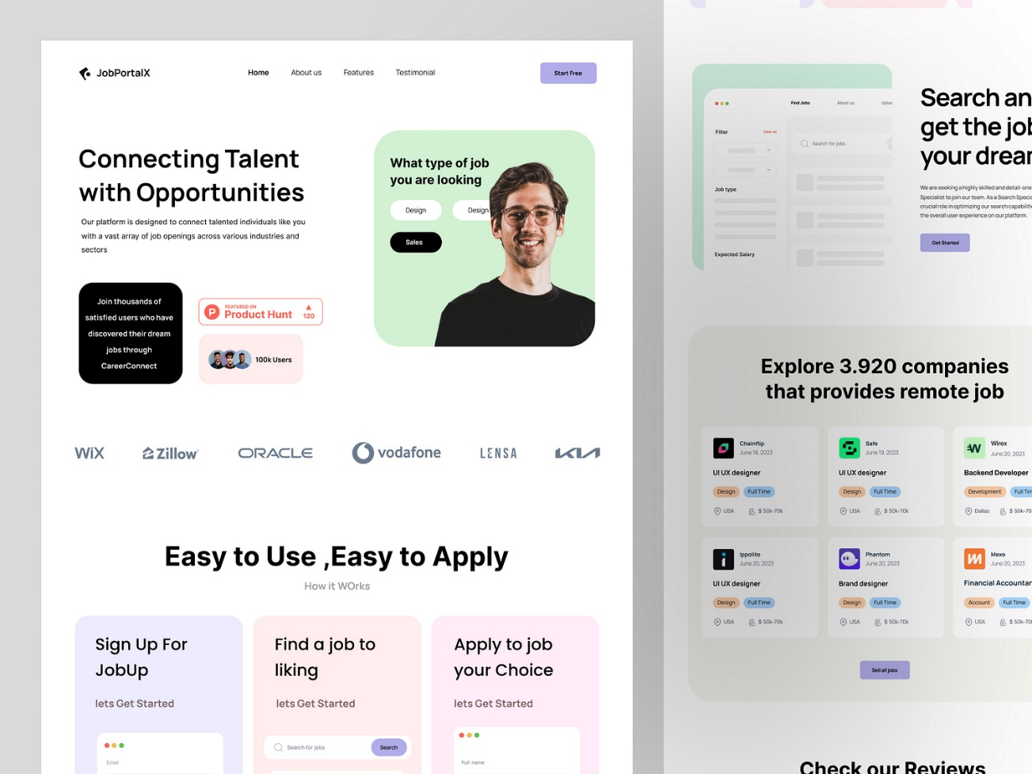

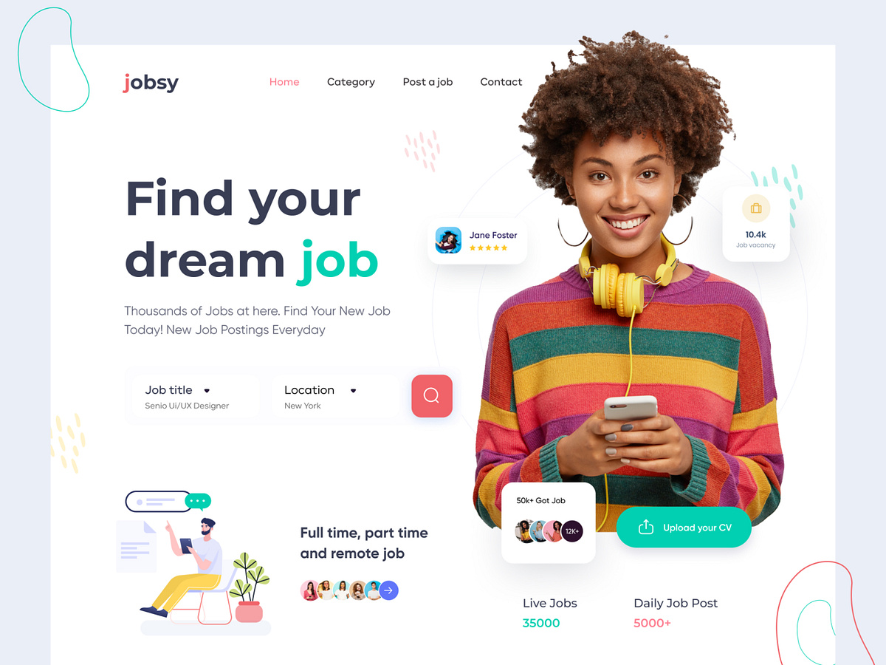

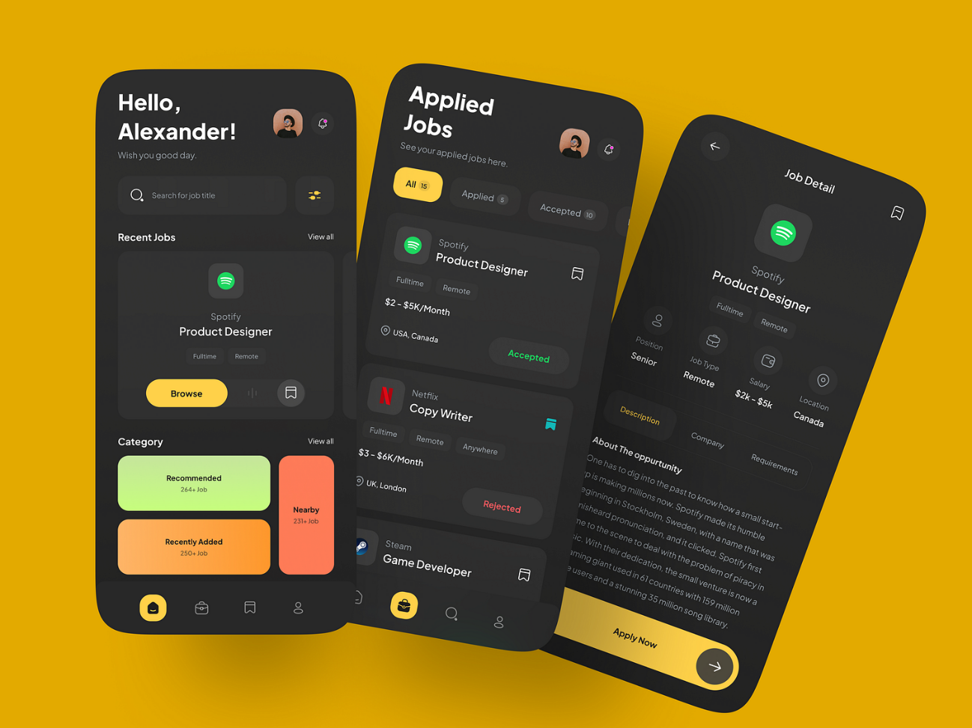

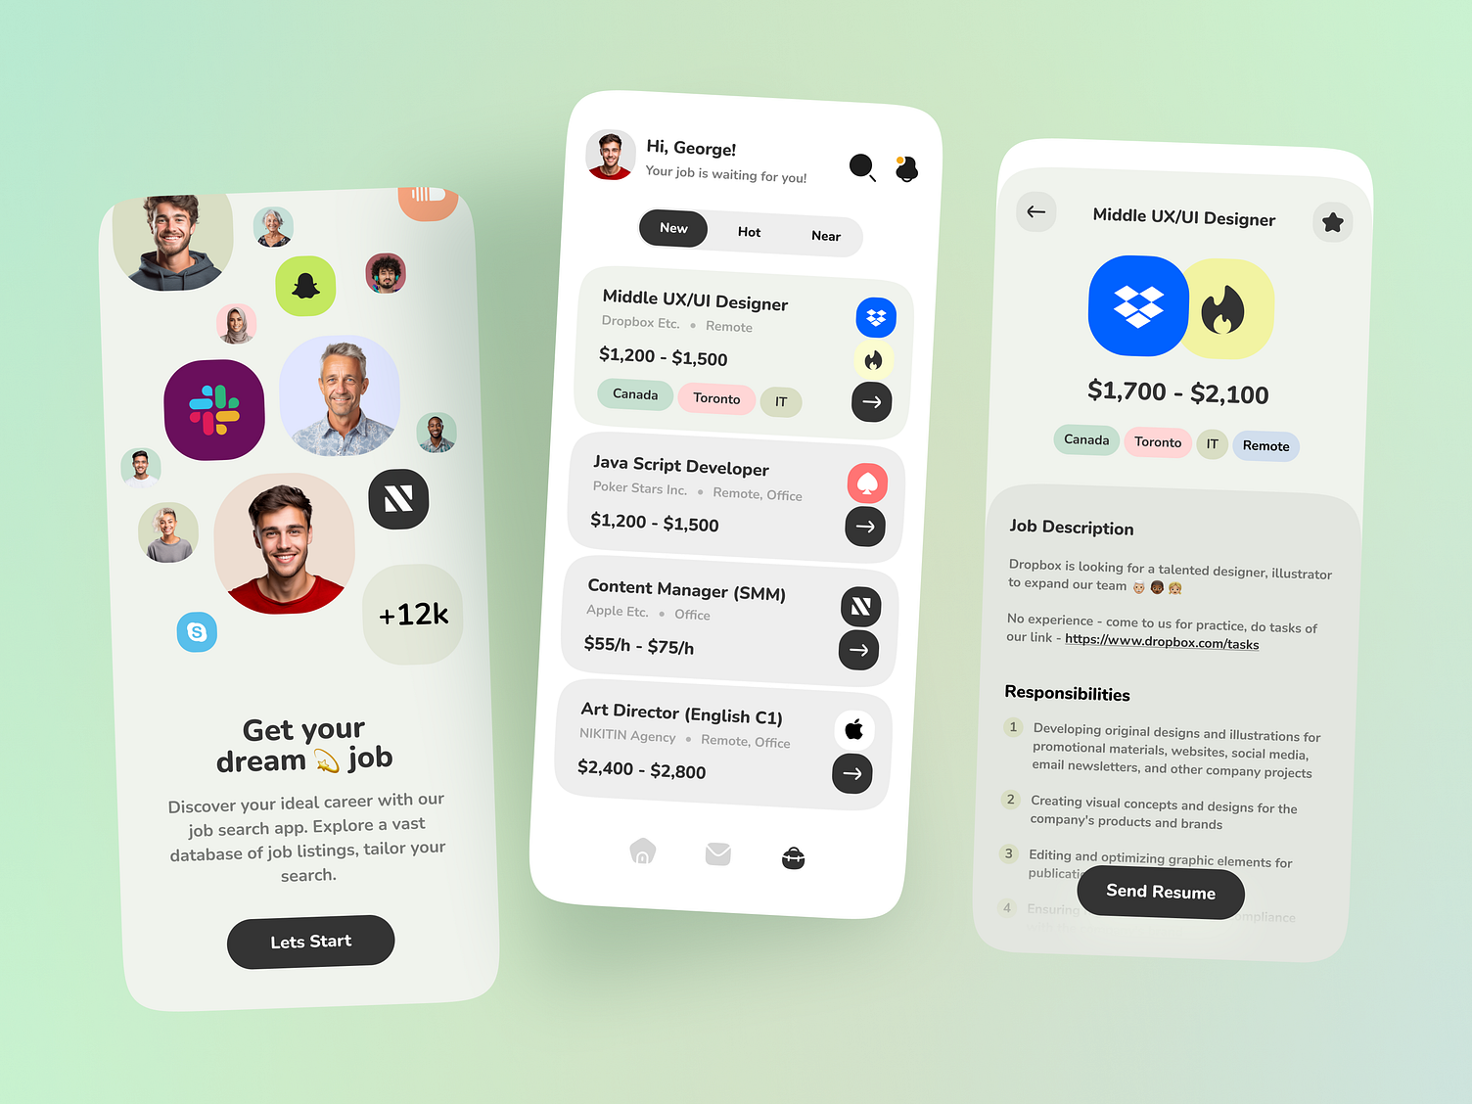

Find Job Page