**Day 2 afternoon ‘pen and paper’ practical**

**Estimands for causal prediction**

**Part 1: QRisk**

*QRisk is a risk prediction model that provides estimates of the 10-year risk of having a heart attack or stroke. The QRisk tool is available online at* [*https://www.qrisk.org/index.php*](https://www.qrisk.org/index.php)

1. Use the online calculator for a person A with the following characteristics (you can leave the other information blank):

Person A: 45 years old, male, Indian ethnicity, non-smoker, without diabetes.

What is this person’s risk of developing a heart attack or stroke over the next 10 years? 3.5%

1. Consider another individual, person B, who is similar to person A, except they are on blood pressure treatment.

Person B: 45 years old, male, Indian ethnicity, non-smoker, without diabetes, on blood pressure medication.

What is this person’s predicted risk of developing a heart attack or stroke over the next 10 years, and how does it differ from the risk for person A? 5.8%

1. Discuss some possible reasons for the differences in the risks for person A and person B.

Person B might be on blood pressure lowering medication due to underlying health issues.

1. Based on these findings, discuss whether you would suggest that person B should stop taking their blood pressure treatment.

The model gives no information on that, person A and B may not be comparable.

1. Suppose person A has a systolic blood pressure of 150, which is considered high. Would you advise against person A initiating blood pressure medication based on the predictions from this model?

Also this can not be decided on based on the model

1. What do you conclude about using this model to inform whether a person should start or stop blood pressure lowering medication?

Not useful for this purpose

**Part 2: Developing an interventional risk prediction model for blood pressure treatment**

*In this part we will suppose that we would like to develop a model that could help individuals to decide about whether they should consider initiating blood pressure medication in order to lower their risk of having a heart attack or stroke.*

1. Discuss what you might want such a risk prediction model to do in more detail by considering the elements in the table below. This table is taken from Luijken et al. 2024. <https://doi.org/10.1002/bimj.70011>.

|  |  |
| --- | --- |
| **Estimand element** | **Questions that help formulate the estimand element** |
| Target population | * To which individuals will the prediction model be applied? * In which health care setting will the prediction model be applied?   Someone who has come to their GP for a general health check, aged >40. Not already on BP medication, no contraindications. |
| Moment(s) of intended use | * At which moment(s) is the prediction model (re)consulted to inform the intervention decision?   At the health check, and subsequent similar appointments. |
| Intervention options | * Which intervention options are relevant at the moment(s) of making the intervention decision? * For how long should the intervention strategy be fixed? * Should the duration to fix the intervention option be aligned with the time till next moment of prediction? * Lifestyle intervention for 3 months. * One of several classes of BP lowering medications – some may have side effects. Start and continue forever. * Do not start now, and review in 3 months. |
| Outcome and prediction horizon | * Which outcome(s) are informative for the intervention decision? * What prediction horizon provides important information for the intervention decision: a short-term or long-term horizon? * Should the outcome be defined differently because of the specified intervention option(s)? * Should the prediction horizon be aligned with the time till next moment of prediction? * CVD, 5-10 year. * Any side effects * Death   Prediction horizon might be different for shorter term outcomes. |
| Predictor(s) | * Which clinical and/or demographic patient factors are predictive of the outcome of interest? * Which measurements are available at the moment(s) of intended use?   Similar to the predictors in QRisk |

1. Thinking about the causal effect of initiating blood pressure treatment on risk of heart attack or stroke, draw (by hand) a simple causal diagram (a directed acyclic graph – DAG) that might be expected to hold in observational data collected. Involve he following variables: sex, smoking status, blood pressure, blood pressure medication use, and having a heart attack or stroke.

In the population to which the diagram refers, you can assume everyone is aged 45 and of the same ethnicity, to avoid needing to include these variables.

Are there any other variables that you would add to the diagram? We could add time-varying variables (blood pressure changes after starting blood pressure medication), but not included in the DAG here.

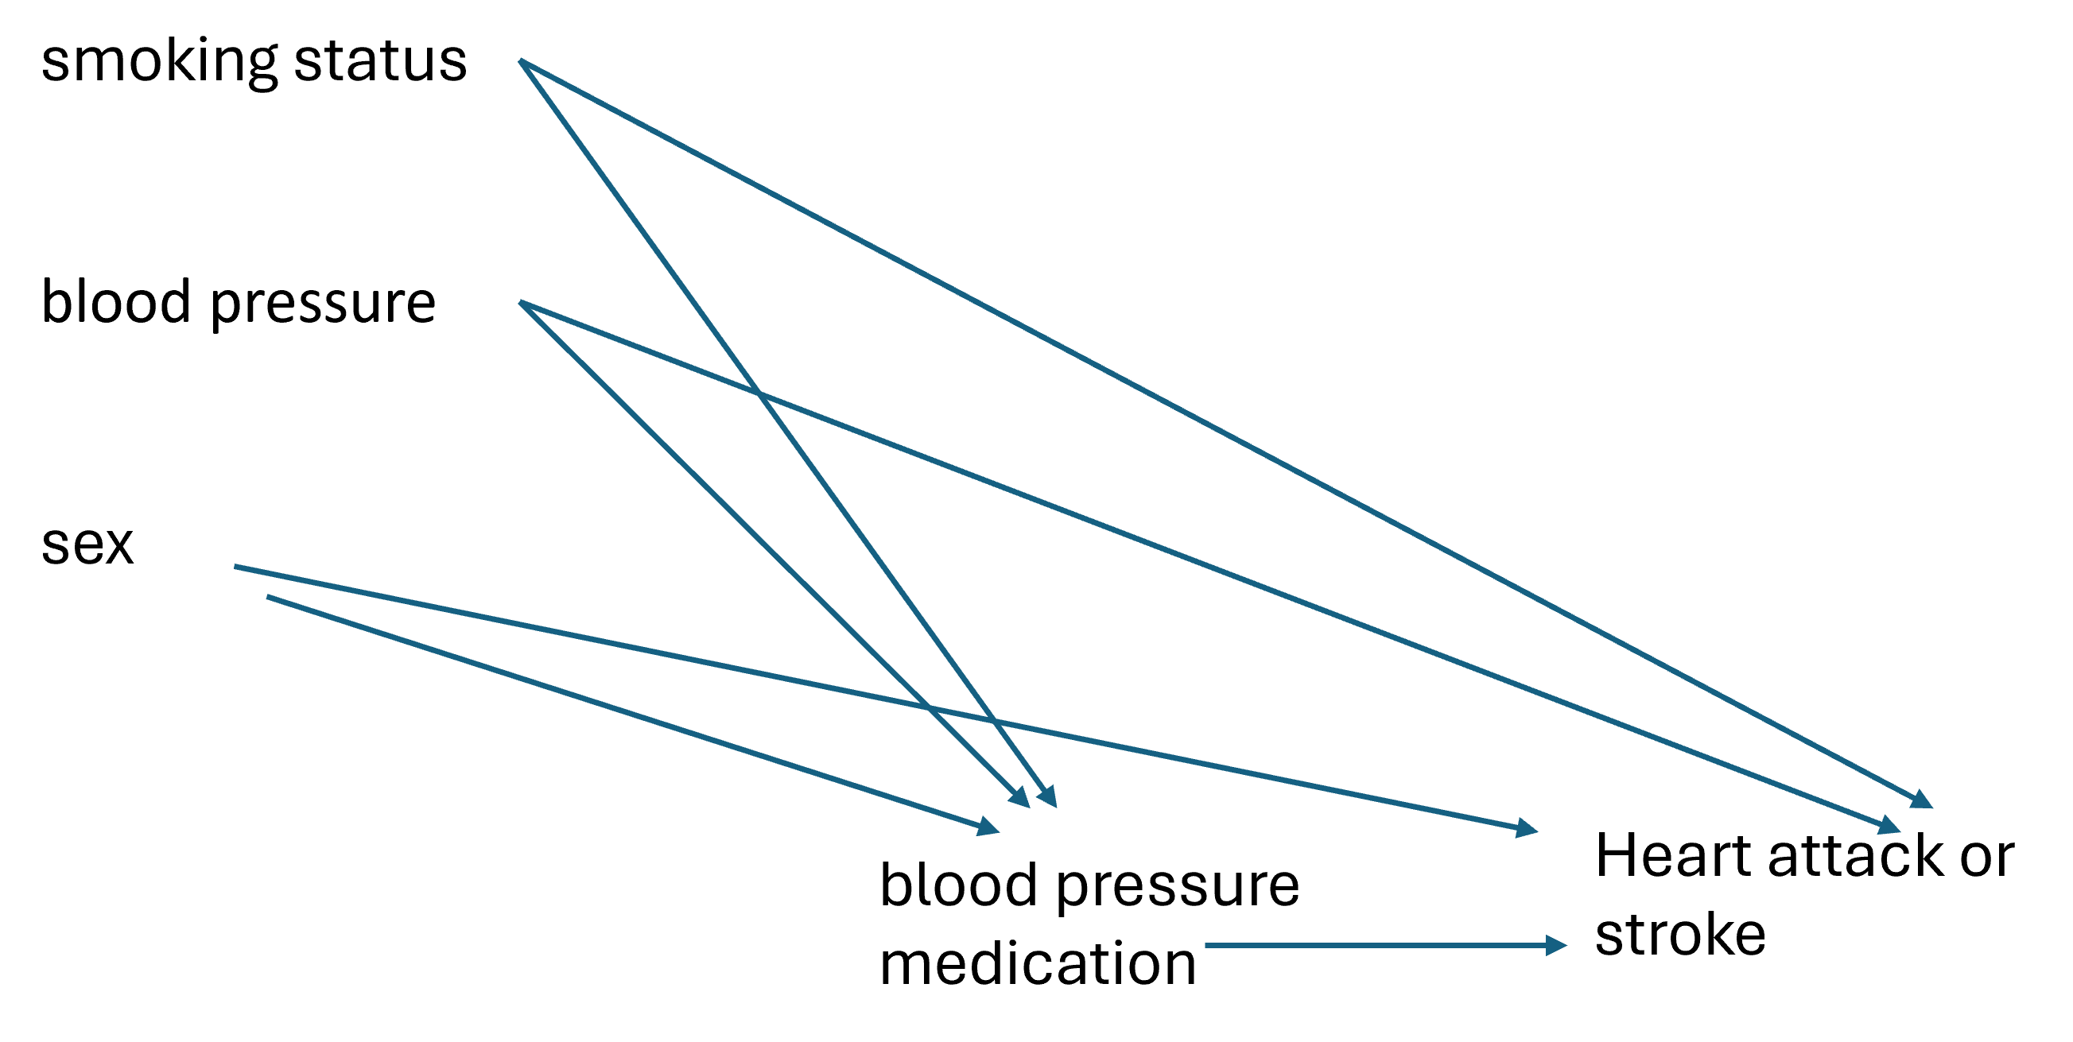

1. Can you indicate which variables would need to be adjusted for when targeting the estimand focused on informing initiation of blood pressure medication?

At least the three variables sex, blood pressure and smoking status, potentially more

**Part 3. Prediction model for successful vaginal delivery**

Several models exist that predict a pregnant woman’s risk of a successful vaginal delivery (versus an emergency c-section), especially in woman who already had a c-section in a previous pregnancy. Here we will look at the MFMU prediction model: [Vaginal Birth After Cesarean (MFMU)](https://www.mdcalc.com/calc/10433/vaginal-birth-after-cesarean-vbac#evidence)

The model development is described in the paper by [Grobman et.a](https://doi.org/10.1016/j.ajog.2021.05.021)l. An annotated version of this paper is available on the course’s github page.

1. Read the relevant parts in the introduction and discussion of the paper (highlighted in yellow in the annotated paper) and determine the treatment decision the model is meant to inform. Which intervention options can patients choose between, and when?

Women can choose whether they attempt a vaginal birth, or choose a planned c-section. The decision is preferably made earlier in pregnancy, using information available ‘ at first prenatal visit’.

1. Now review the relevant parts in the methods section and write down the elements of the estimand targeted by the current model in the second column of the table below.

See table

1. Assess the relevance of the current estimand (question 2) to the treatment decision described in question 1.

Mismatch in target population: all women at first prenatal consult who yet have to make their decision vs all women who chose a TOLAC, reached > 37 week pregnancy and had cephalic presentation.

1. Formulate an alternative estimand that would be better aligned to the treatment decision the model aims to inform by writing down adjusted estimand elements in the third column of the table below.
2. Suggest changes to the design of the study that would allow us to target the estimand chosen in question 4.

See table

|  |  |  |
| --- | --- | --- |
| **Estimand element** | **Current estimand targeted by Grobman et al.** | **Alternative estimand better aligned to treatment decision** |
| Target population | Women admitted at hospital for delivery with a try of vaginal birth, who delivered >37 weeks and with cephalic presentation at time of birth and had history of a cesarean delivery | All pregnant women at first prenatal consult with history of a cesarean delivery |
| Moment(s) of intended use | Unclear | At first (or between first and second) prenatal consult |
| Outcome and prediction horizon | Successful vaginal birth | Successful vaginal birth + risk of competing events such as still birth, delivery before 37 weeks etc. |
| Predictor(s) | demographic characteristics (age,  height, prepregnancy weight, prepregnancy body mass index),  medical conditions existing before  pregnancy (chronic hypertension treated with medication before and during pregnancy, diabetes mellitus, asthma, thyroid disease, seizure disorder, renal disease, cardiac disease, connective tissue  disease), and obstetrical history | Same as left |
| Intervention options | None, as all already chose | Attempt at vaginal delivery vs planned c-section. |