Assignment 1 — Frame Your Project and Prepare Your Corpus
Team of 3 · Milestone 1 of 4 · Type your answers directly in the blank cells — they grow as you type.
Strict compliance: your submission ZIP must exactly match the folder/file structure on the Submission page (near the end). Automated grading rejects anything that doesn't — check it before you submit.

Project name  the short name of your project — the same name all four assignments will use | ATLAS: Adaptive Textbook-Grounded Learning and Assessment System
Team members
In 'Worked sections', list the sections each member led (e.g. 1, 5, 7.1–7.3). Every section must be owned by someone; each member submits the AI-chat behind their own sections (Section 8).
Team member | Full name | Student number | Worked sections
Student 1 | Sakif Naieb Raiyan | 2105065 | Sections 1, 2 & 3
Student 2 | Sayaad Muzahid Masfi | 2105066 | Sections 4 - 7
Student 3 | Omar Abdur Razzaque | 2105094 | Sections 1 - 4

What this assignment is: Everyone builds the same kind of system — an agent that answers questions from scanned book pages: it takes a page image, reads it, finds the relevant text, and gives an answer grounded in that text, with a human in the loop for risky steps. What makes your project unique is your three choices (Section 1). In this milestone you pin down those choices, source and clean your scanned corpus, and design your agent on paper.
What to hand in: One ZIP with the filled form, your configs/task.yaml, your eda.ipynb (runs top-to-bottom), your corpus or a script that recreates it, a short provenance/licence note, and one AI-chat transcript per team member. Exact names are on the Submission page.

Section 1 — Our Problem & Our Three Choices
The task is fixed for everyone: “Given a scanned page image from our corpus, answer a question grounded in the page's text.” You do not choose the problem type. You make it your project through the three choices below — these drive every later design decision and make your work different from every other group. (Two qualities — being faithful and accurate — are required of EVERYONE, so they are not choices; see your NFR below.)
① Domain  your practical, real-user subject and the person who'd use the tool (health worker, farmer, legal-aid worker, …). See Domains-And-Natural-Fit. No two groups share one. | High School STEM Education (Advanced High School & Calculus Mathematics): Serving STEM students and tutors by providing curriculum-aligned practice questions, step-by-step problem-solving guidance, and real-time difficulty adjustment for international curriculums like the A-levels.
② Data speciality  the ONE hard property of the corpus you're handed — e.g. Bangla · Arabic · code-switching · degraded scans · multi-column · handwritten · old orthography · math notation · dirty-OCR (see Data-Speciality Catalog). English is not a speciality; an English corpus takes a data condition. | Math / Scientific Notation: Scanned/PDF STEM textbooks featuring dense mathematical notation, including fractions, multi-line derivations, integrals $\int{}f\left(x\right)dx$, matrices, inline symbols, geometric diagrams, tables and figures with associated captions.
③ Primary NFR + target  the ONE quality you optimise ABOVE baseline, with a concrete target (see the NFR sheet) — e.g. low-latency ≤300ms · memory ≤2GB · calibrated ECE ≤0.05 · private (PII recall ≥0.98) · explainable · auditable · secure · robust · accessible. Faithful & accurate are baseline, NOT choices.  Agentic behaviour (mandatory for everyone, no choice): your agent must do evidence-gated re-search — if the top retrieval score is weak, widen k and retrieve again; abstain once k hits k_max. You build and prove it in A3; nothing to declare here. | Explainable: $100\%$ of generated practice solutions and difficulty transitions accompanied by explicit step-by-step mathematical reasoning chains, source page citations, and retrieval justification; Grounded Explanation Faithfulness Score $≥0.90$.
Justify each of the three choices
A one-liner is not enough here — give reasoning a marker can test against your actual corpus.
Why this DOMAIN  the real decision this tool helps and the person who makes it — not “it is useful”. Why a document-reading agent (not a web search) is the right fit. | High school STEM students require precise, step-by-step reasoning rather than raw answers. Standard web searches or ungrounded LLMs frequently fail by generating incorrect intermediate algebraic steps or referencing non-curriculum syllabus material. A document-reading RAG agent grounded in open-source, peer-reviewed textbooks (Siyavula CAPS & OpenStax) guarantees that practice questions, hints, and worked solutions strictly adhere to formal educational standards.
Why this DATA SPECIALITY  evidence it is genuinely in YOUR corpus — point to a specific page or feature — and the one pipeline stage it will force you to build. | Our open-source STEM textbook corpus contains complex mathematical typography (e.g., OpenStax Calculus Ch. 5 exhibits complex integration problems $\int_{a}^{b}{}x^{2}dx$ and limit definitions $f\left(x\right)$, while Siyavula Grade 11/12 contains quadratic derivations and trigonometry).  Standard OCR engines mangle these into illegible text strings (e.g., rendering $\sqrt{x^{2}+1}$ as v x2+1). This forces us to build a specialized Math-Aware Vision-Language OCR pipeline (using Nougat / LaTeX-OCR) coupled with Math-Aware Semantic Chunking to keep equations and problem statements contextually intact.
Why this NFR + target  why this quality matters for your user, why THAT number is the right target (not a round guess), and the one thing you would trade to hit it. | In STEM education, a solution is useless if the student cannot follow why a step was taken or where the underlying theorem comes from. We target a Grounded Explanation Faithfulness Score $≥0.90$ (measured by LLM-judge step verification) and $100\%$ citation traceability. To achieve complete step-by-step explainability and formula validation, we trade off query latency (accepting up to $2.5 s$ per query instead of sub-second responses).
The rest of the framing
Who would use this  the real person/role who'd use the finished tool and the decision it helps. Not “data scientists” or “the marker”. | High school (like A-levels Cambridge/Edexcel) Mathematics students, AP/Introductory Calculus college students, and STEM tutors structuring diagnostic practice sessions.
How we measure success  pick ONE headline number for answer quality and state your target (e.g. groundedness ≥ 0.9; answer-F1 ≥ 0.7). | Headline Metric: Grounded Explanation Faithfulness Score $≥0.90$ and Symbolic Step Match Accuracy $≥0.85$ on benchmark exercise sets.
Score we want to beat  the laziest baseline, so you can prove value (e.g. “return the top-1 retrieved chunk verbatim = 0.4 answer-F1”). | Lazy Baseline: Naive BM25 retrieval returning the top-1 retrieved chunk verbatim without math formula parsing or step explanation $→$ Answer Math-F1 / Accuracy = 0.35.

Section 2 — Our Corpus
Your knowledge base is scanned book pages — images before they are text. Sourcing and documenting them is graded here.
Corpus name and link  the public source and a working link (e.g. Internet Archive, HathiTrust, Qatar Digital Library). Must be scanned page-images, not pre-typed text, and freely usable. | Siyavula Everything Maths (Grades 11 & 12) + OpenStax Calculus (Vol 1 & 2) Corpus  Links:  CSE 429 Group 15 Project Corpus
Licence, and may we share it  the licence (public-domain / CC-BY / “research only”) and whether you may re-share. If not, write “link only” and hand in a download script. | Open Educational Resources (OER): Creative Commons Attribution (CC BY) (Siyavula) & CC BY-NC-SA 4.0 (OpenStax). 100% legal for educational RAG research and re-sharing.
How big is it  must be ≥ 300 pages AND ≥ 60,000 words of usable text (huge-corpus profile: ≥ 100k pages). State pages, words, and MB on disk. | Size of all corpus pdfs = 398.144MB  Total scanned pages = 2,521  Word Count:  Siyavula Grade 11 = 121,785  Siyavula Grade 12 = 102,669  OpenStax Calculus Vol 1 = 265,533  OpenStax Calculus Vol 2 = 254,105  Total words = 744,092
Scan & script difficulty  what makes these scans hard to read: script (Bangla conjuncts/matras, Arabic ligatures), fonts, faded/skewed pages, mixed scripts, old orthography. | Superscript/subscript collapse: exponents (x^2), indices (a_n), and limit bounds (∫₀^π) sit at a different baseline offset from the main text line. Line-based OCR merges them onto the main baseline, turning x² into x2 or x^2 into x2 with no way to recover which reading is correct.  Fraction bar misinterpretation: a fraction is a 2D spatial relation (numerator above, denominator below, divided by a horizontal rule) not a linear token sequence. Sequential OCR reads top-to-bottom-then-left-to-right within a line band, so it either drops the fraction bar entirely (producing −b±√(b²−4ac)2a with no division marker) or reads numerator and denominator as two unrelated lines.  Multi-line derivation scrambling: a worked derivation (e.g., completing the square across 4 aligned = steps) relies on vertical alignment of the = signs to convey "these are equivalent expressions," which is a layout cue, not a text cue.  Spatial layout vs. sequential reading order: our corpus mixes multi-column problem sets (Siyavula) with single-column proof-heavy prose (OpenStax) on facing pages. A single global reading-order heuristic will interleave column A's Question 4 with column B's Question 4 continuation.  Diagram/inline-symbol conflation: geometric diagrams (Siyavula trigonometry) and function plots (OpenStax) contain embedded labels (angle marks, axis ticks) that a generic OCR engine tries to read as body text, injecting garbage tokens mid-sentence.
How we split it (no leakage)  train/val/test as percentages, split by DOCUMENT (never by page), so no book appears in two splits. | We split by whole document: Train = Siyavula Grade 11 + OpenStax Calculus Volume 1 (52.1% of words), Test = Siyavula Grade 12 + OpenStax Calculus Volume 2 (47.9% of words, fully held out). Validation is a 15% stratified subsample of chunks drawn from the Train documents only (evenly across both books' chapters), used exclusively for tuning retrieval/prompt hyperparameters — it is never reported as a final number, so it does not need document-level isolation the way Test does. Test contains one book from each curriculum (CAPS and OpenStax) so our headline faithfulness metric reflects performance across both domains we serve, not just one.
The one way data could leak, and how we checked  the single most likely leak (e.g. same book in train and test) and how you confirmed it didn't happen. | The real leak in our corpus is between OpenStax Calculus Volume 1 (Train) and Volume 2 (Test): their Integration and Applications of Integration chapters are not merely topically similar — they are the same chapters, reproduced with identical content across both volumes (a known artifact of how OpenStax structured the two-volume split, with Vol 2 opening with a verbatim recap of Vol 1's closing material). Since Vol 1 sits in Train and Vol 2 sits in Test, this means a chunk-for-chunk identical passage can appear in both splits despite the split being document-level and passing the "no book in two splits" rule — the leak isn't from careless splitting, it's from the source documents themselves containing duplicated content across the split boundary.  For Siyavula Grade 11 vs. Grade 12; although they share topic names (quadratics, trigonometric identities, sequences — since CAPS spirals the same strands across grades), the actual chapter content, worked examples, and exercises differ between grades rather than repeating verbatim, so there are minor risks of data leak.  These were found by manually browsing through the table of contents, and respective chapters of the books page by page.
Preparing the scans — answer each for your corpus
Say what you did and its effect. Last 3 rows are blank for anything not listed. Example: “Deskew pages? | rotated by detected angle | OCR word-error 31%→22%”.
Preparation question | What we did about it | Effect on the data
Deskew / rotate crooked pages? | Not applicable — all four sources are born-digital PDFs rasterised directly at 300dpi, so no page carries rotational skew. | 0 pages required deskewing; step is a no-op safety check, not a correction.
Denoise / remove speckle & stains? | Not applicable for the same reason — no scanner artefacts (dust, foxing, ink bleed) exist in a born-digital render. | 0 pages flagged as corrupted across 2,521 pages.
Binarize / boost contrast? | Not applied — pages are kept as 300dpi RGB, not binarized. | Preserves sub-pixel stroke information
Remove blank or non-content pages? | Used https://www.ilovepdf.com/ to manually parse through the books and remove blank or non-content pages. | Removed approximately 80 pages across 4 books.
Normalise the extracted text (Unicode, digits)? | We ran our base OCR on the corpus and did not find any cases where there were non-ASCII characters. | None since non-ASCII characters were written using LaTeX syntax

Section 3 — Corpus Description & Findings (from the notebook)
Data schema — every field you store per page/chunk
List each field: name, type, meaning, and a typical value. E.g. “page_id | string | which scanned page | g07_bk1_p045”.
Field / column | Type | What it means | Typical value
chunk_id | string | Unique identifier for a retrievable unit (page may split into multiple chunks) | “siyavula_gr11_p0142_c02 “
page_id | string | Which scanned page this chunk belongs to | "siyavula_gr11_p0142"
book_id | string (enum) | Source document identifier | "siyavula_gr11" | "siyavula_gr12" | "openstax_calc1"
page_num | integer | 1-indexed page number within the source pdf | 142
split | string (enum) | Which document-level split this chunk belongs to | "train" | "test"
extracted_text | string | Prose/body-text + LaTeX formatted mathematical equations/other notations that our OCR outputs for this chunk | "Solve the following quadratic equation by completing the square: \\frac{-b \\pm \\sqrt{b^2-4ac}}{2a}"
Findings
Three things the exploration showed  e.g. page-length spread, dominant vs rare topics, worst scan-quality band, script/font variety. | - High math density: 16.29% of non-empty lines contain LaTeX math expressions (5,431 of 33,344 lines). 2.19% of pages exceed 50% math-line density.  - OCR Failure & Page Corruption Rate: Across the initial 2,521-page corpus, 196 pages (7.78%) suffered critical OCR corruption post-processing—resulting in blank pages, truncated text blocks, or unreadable outputs (predominantly occurring on pages with complex multi-column exercise layouts or low-contrast vector diagrams).  - High Visual Dependency Rate: Across the 1,542 combined pages of OpenStax Calculus Volumes 1 and 2, the text contains 1,172 embedded figures, graphs, and vector diagrams—an average of 0.76 visual elements per page.
What this means for our build  how a finding changes a downstream choice (e.g. “many faded pages → enhancement matters”). | - High math density: Forces Math-Aware Chunking: Token-based splitters break formulas –> we must chunk at theorem/problem boundaries.  - OCR Failure & Page Corruption Rate: Unchecked blank or corrupted pages introduce dead nodes into the vector index and degrade retrieval accuracy. This forces an ingestion quality gate in Stage 1 to automatically detect and prune unreadable pages (<10 extracted tokens).  - High Visual Dependency Rate:Pure text RAG retrieval will fail when a student asks a practice question that relies on an unextracted graph or geometric diagram. This forces us to extract and store image bounding-box region metadata inside our chunk schema during indexing, enabling the agent's retrieve tool to detect diagram dependencies and invoke read_page / enhance_page to surface the visual context alongside the text explanation.
Three example pages
Show three real pages so a reader sees what one looks like: the page id, a note on scan quality, and the text your pipeline extracted from it.
Page id | Scan-quality note | Extracted text (short excerpt)
openstax_calc2_p0240 | Good extraction. Single-column, dense inline math. Clean font, LaTeX delimiters and inline expressions are correctly bound and nested. | By now we have a fairly thorough procedure for how to evaluate many basic integrals. However, although we can integrate \(\int x\sin(x^{2})dx\) by using the substitution, \(u=x^{2}\), something as simple looking as \(\int x\sin x\,dx\) defies us. Many students want to know whether there is a product rule for integration. There isn't, but there is a technique based on the product rule for differentiation that allows us to exchange one integral for another. We call this technique **integration by parts**.  **The Integration-by-Parts Formula**  If, \(h(x)=f(x)g(x)\), then by using the product rule, we obtain \(h^{\prime}(x)=f^{\prime}(x)g(x)+g^{\prime}(x)f(x)\). Although at first it may seem counterproductive, let's now integrate both sides of this equation: \(\int h^{\prime}(x)dx=\int\left(g(x)f^{\prime}(x)+f(x)g^{\prime}(x)\right)dx\). This gives us  \[h(x)=f(x)g(x)=\int g(x)f^{\prime}(x)dx+\int f(x)g^{\prime}(x)dx.\]  Now we solve for \(\int f(x)g^{\prime}(x)dx:\)  \[\int f(x)g^{\prime}(x)dx=f(x)g(x)-\int g(x)f^{\prime}(x)dx.\]  By making the substitutions \(u=f(x)\) and \(v=g(x)\), which in turn make \(du=f^{\prime}(x)dx\) and \(dv=g^{\prime}(x)dx\), we have the more compact form  \[\int u\,dv=uv-\int v\,du.\]
siyavula_gr12_p0017 | Good extraction. Single-column, four-step worked example ("Arithmetic sequence") chaining multiple aligned equation lines — a harder case than a single formula because the OCR has to keep Step 1 → Step 4 and each line's substitution logically ordered without interleaving them with the surrounding prose. All four steps land correctly, in order, with consistent subscript notation (T_2, T_1, etc.) throughout. | **Step 1: Check if there is a common difference between successive terms**  \[T_{2}-T_{1}=-11-(-15)=4\] \[T_{3}-T_{2}=-7-(-11)=4\] \[\therefore\text{This is an arithmetic sequence with }d=4\]  **Step 2: Determine the formula for the general term**  Write down the formula and the known values:  \[T_{n}=a+(n-1)d\] \[a=-15;\qquad d=4\] \[T_{n}=a+(n-1)d\] \[=-15+(n-1)(4)\] \[=-15+4n-4\] \[=4n-19\]  A graph was not required for this question but it has been included to show that the points of the arithmetic sequence lie in a straight line.  Note: The numbers of the sequence are natural numbers (\(n\in\{1;2;3;\ldots\}\)) and therefore we should not connect the plotted points. In the diagram above, a dotted line has been used to show that the graph of the sequence lies on a straight line.  **Step 3: Determine the number of terms in the sequence**  \[T_{n}=a+(n-1)d\] \[173=4n-19\] \[192=4n\] \[\therefore n=\frac{192}{4}\] \[=48\] \[\therefore T_{48}=173\]  **Step 4: Write the final answer**  Therefore, there are \(48\) terms in the sequence.
openstax_calc1_p0140 | Bad extraction — repetition/hallucination loop. Follows a Section 2.2 exercise set with a table and an Einstein's-mass-equation worked example directly above it. The OCR correctly reads exercises 30–33, then on exercise 34 the sentence itself garbles ("does the limit in exercise indicate" — missing the referenced exercise number and part of the clause), and the model then enters a decode loop: it re-emits the same malformed sentence roughly a dozen times, interspersed with [MISSING_PAGE_POST] tags, while the exercise numbers drift (34, 34, 34, 35, 36, 37, 38, 39, 39, 30 — resetting rather than incrementing). | Thus, according to Table 2.8, if an object with mass 100 kg is traveling at 0.9999\(c\), its mass becomes 7071 kg. Since no object can have an infinite mass, we conclude that no object can travel at or more than the speed of light.  **SECTION 2.2 EXERCISES**  _For the following exercises, consider the function \(f(x)=\frac{x^{2}-1}{|x-1|}\)._  **30. [T]** Complete the following table for the function. Round your solutions to four decimal places.  **31. What do your results in the preceding exercise indicate about the two-sided limit \(\lim_{x\to 1}f(x)\)? Explain your response.  _For the following exercises, consider the function \(f(x)=(1+x)^{1/x}\)._  **32. [T]** Make a table showing the values of \(f\) for \(x=-0.01,-0.001,-0.0001,-0.00001\) and for \(x=0.01,0.001,0.0001,0.00001\). Round your solutions to five decimal places.  **33. What does the table of constant does the limit in exercise indicate about the function \(f(x)=(1+x)^{1/x}\)?**  **34. To which mathematical constant does the limit in the preceding exercise indicate about the function \(f(x)=(1+x)^{1/x}\)?**  [MISSING_PAGE_POST]  **34. To which mathematical constant does the limit in exercise indicate about the function \(f(x)=(1+x)^{1/x}\)?**

Page 1:
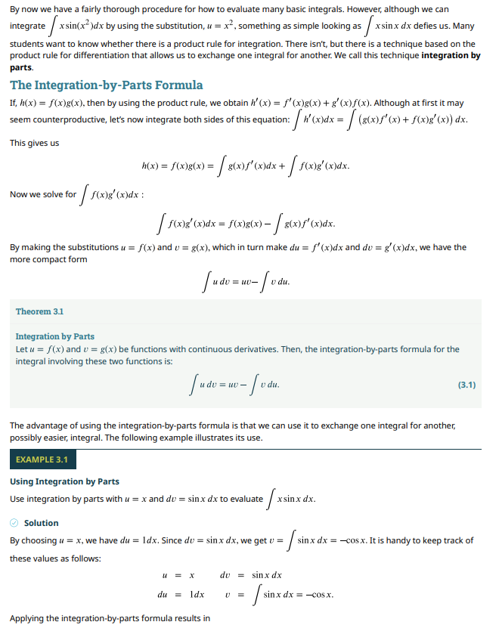

Page 2:
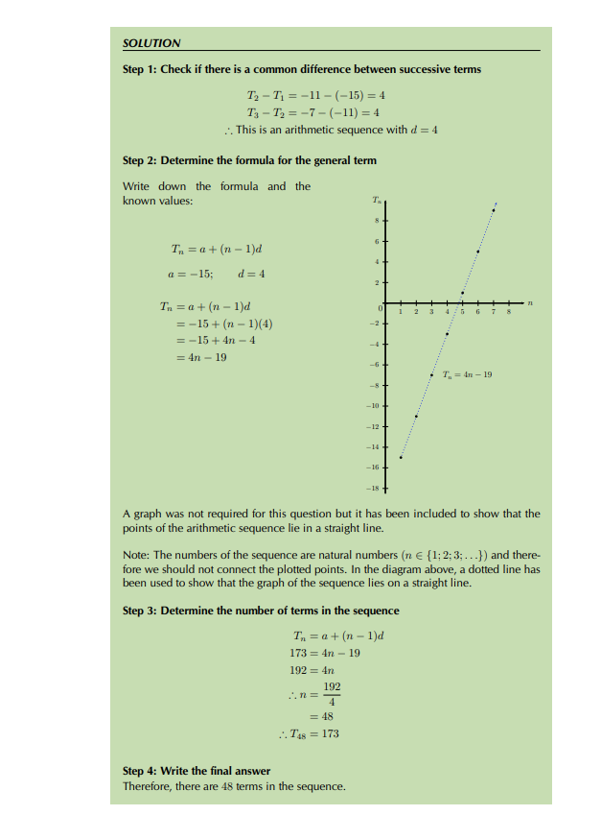

Page 3:
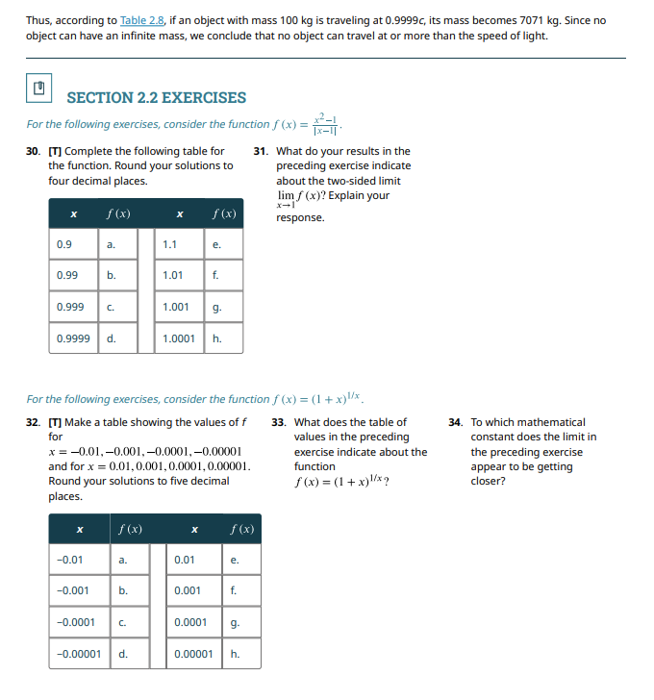

Section 4 — Risks
Answer each honestly — write “N/A” only if it truly doesn't apply (rare for historical books).
Personal data (PII)  do the books name living or identifiable people (letters, records, biographies)? How will you detect and redact it? | Low but not zero: word problems occasionally use invented names (e.g. ‘Thabo buys 3 apples’), and front-matter lists real author/contributor names. Neither is sensitive personal data about a private individual, but front-matter/author pages are excluded from the retrievable corpus entirely, and any flagged name inside a worked example is left in place (fictional, non-identifying)
Licensing / copyright  are all pages genuinely public-domain or openly licensed? What's your evidence? | All four sources are openly licensed: the two Siyavula texts (Gr11 and Gr12 Mathematics) are released under Creative Commons Attribution (CC BY), and OpenStax Calculus Volume 1 &2 is CC BY 4.0. Evidence is the licence statement on each PDF's copyright page, which we screenshot and cite verbatim in data/provenance.md alongside the direct download links; both publishers explicitly permit redistribution and derivatives with attribution, so we may re-share the corpus, not just link to it.
OCR failure  where will reading fail worst (script, fonts, damage)? What's your fallback (re-OCR, enhance, abstain)? | Reading will fail worst on the diagrams — e.g. graphs of straight lines, parabolas or figures of triangles and other geometrical shape like the one in pg.85 of Gr11 Mathematics. The fallback in this case will be to drop(abstain) such cases as the OCR cannot feasibly transcribe the figures into text in any way
Hallucination  how could the agent answer things not in the text, and how will you stop it (grounding, abstention)? | Because the underlying LLM already ‘knows’ a lot of general maths from pretraining, it could answer with a plausible-looking derivation or formula that isn't actually the one in our textbooks (different notation, different proof strategy, or simply wrong for our curriculum). We stop this by requiring extract (a verbatim/near-verbatim span from a retrieved chunk) before cite can run: if no chunk supports a claim, the agent abstains instead of falling back on parametric knowledge, and the explainability trace records which chunk justified each step.
Bias across your corpus  which fonts/regions/subgroups might the system read worse, given your data speciality and NFR? | Our corpus mixes South African CAPS-curriculum texts (Siyavula Gr11/Gr12, using conventions like ‘gradient’) with a US-oriented OpenStax calculus text (using ‘slope’, more proof-heavy prose). Notation-dense chapters (limits, integrals) are harder to OCR and retrieve correctly than text-dense algebra chapters, so we expect worse performance on calculus content and on whichever book's convention a question doesn't match.

Section 5 — Design Choices & Justification (the corpus/ingest stage)
State your choice across the eight facets for the stages you touch in A1 (Stage 0 framing, Stage 1 ingest/enhance). You'll extend this table each milestone — it's the graded design artifact (configs/design_choices.md).
Facet | Our choice (this stage) |  | Why — fits our corpus · what it costs · what would change it
Problem statement | Stage 1 must turn each of our 3 source PDFs into a complete, ordered set of page images ready for OCR, with zero silently-dropped or corrupted pages. Success metric: 100% of pages render (extracted page count == PDF-reported page count), verified in eda.ipynb. |  | A hard page-count check is cheap to run and catches the single most damaging ingest failure — a silently dropped page that later makes the agent unable to ever cite that page's content. Cost: negligible compute. We'd relax it only if a source PDF had deliberately blank pages we want to skip.
Data | Inputs: 4 born-digital PDFs (Gr11 Mathematics, Gr12 Mathematics, Calculus Volume 1&2), ~1,400 pages combined. Train = Siyavula Grade 11 + OpenStax Calculus Volume 1 (52.1% of words), Test = Siyavula Grade 12 + OpenStax Calculus Volume 2 (47.9% of words, fully held out). Validation is a 15% stratified subsample of chunks drawn from the Train documents only (evenly across both books' chapters), used exclusively for tuning retrieval/prompt hyperparameters — it is never reported as a final number, so it does not need document-level isolation the way Test does. Test contains one book from each curriculum (CAPS and OpenStax) so our headline faithfulness metric reflects performance across both domains we serve, not just one. Each page is rasterised to a 300dpi RGB PNG plus a JSON sidecar (book_id, page_num, source_url). No manual labels at this stage. |  | Using Gr12 Mathematics and Calculus Volume 2 as the whole held-out test book (instead of mixing pages from all three) is the cheapest way to guarantee zero document-level leakage, at the cost of a test set with a different style (SA calculus) and content(e.g.Finance) than most of training (SA CAPS algebra). We'd change this if it proved too different in topic coverage for a fair test.
Model | No learned model at ingest itself — a deterministic PDF rasteriser (PyMuPDF / pdf2image), not a trained model, since our sources are clean born-digital PDFs rather than photographed scans, so there's nothing to repair here. |  | Skipping a learned enhancement model saves training time and a dependency we don't need — our PDFs render cleanly at 300dpi with no skew, speckle, or fading. We'd introduce one immediately if we found pages with corrupted embedded diagrams or compression artefacts.
Methods | Render every page at 300dpi, RGB, save as PNG; deliberately discard the PDF's embedded selectable-text layer so downstream OCR has to genuinely read the pixels (see trade-off below). Hyperparameters: DPI and page-range only; validated by re-counting pages after render |  | 300dpi is the standard threshold for reliable OCR without exploding storage; deliberately discarding the embedded text layer costs us a 'free' ground-truth transcription channel, but keeps the project honest to the task ('read a scanned page'). We'd keep that layer only for building automatic ground-truth labels, never as an OCR shortcut.
Design | Stage 1, immediately after raw PDF download (scripts/get_data.sh) and before Stage 2 Layout. Writes data/processed/pages/<book_id>/<page_num>.png plus a manifest.jsonl that Layout reads. No enhancement sub-step is invoked for this project (Section 6) since scans are already clean. |  | Keeping ingest as a single-responsibility stage (PDF → page images + manifest) lets Layout and OCR be developed and tested independently, at the cost of one extra disk-write step per page. We'd merge ingest and layout only if storage became a real constraint.
Development | Unit tests assert: (a) rendered page count matches the PDF's reported page count, (b) every PNG opens without corruption, (c) DPI/colour-mode is consistent across the corpus. Config (DPI, output path, book list) lives in configs/task.yaml; each run logs a manifest checksum so eda.ipynb is reproducible from a fixed snapshot. |  | Automated page-count and corruption checks are the cheapest possible regression test for this stage and would catch real bugs (e.g. pages flattened wrongly). Cost: a few seconds per run. We'd add DPI/colour-histogram checks too if we mixed in a lower-quality fourth source.
Deployment | Runs once, offline, as a batch job at corpus-prep time — not at serving time. Output (page images + manifest) is cached to disk and reused by every later milestone; it never re-runs per user query. |  | Batch/offline is the only sensible choice — a student's question shouldn't wait on PDF rendering. Cost: a one-off preprocessing budget before the system is usable at all. We'd move to on-demand rendering only if we needed to support arbitrary user-uploaded textbooks.
MLOps | Corpus is versioned by a manifest.jsonl checksum committed to the repo; if either publisher ships a new textbook edition, the checksum mismatch is our re-ingest trigger. Not monitored at serving time, since it isn't in the online query path. |  | A checksum-based trigger is lightweight and needs no separate monitoring infrastructure, which fits a 3-person team; the cost is we won't notice a stealth-edited PDF unless we explicitly re-check. We'd move to scheduled re-scraping only for a source that updates silently (ours don't).
One decision where we chose one option over another  show one place you picked one option and rejected another, and why (e.g. “diffusion enhancement over classical denoise — because our scans are badly faded”). |  | We deliberately chose to rasterise our born-digital PDFs to images and discard their embedded, perfectly-typed text layer, instead of taking the easier route of extracting that text layer directly. Extracting it directly would have trivialised the whole project (no OCR/math-recognition problem left to solve) and violated the task definition (‘read a scanned page image’). The cost is real: we give up a free, perfect ground-truth transcription source, and our OCR stage now has real work — and real failure modes — to deal with, exactly as intended.

Section 6 — Our Pipeline & Scope
Everyone builds the same 9-stage pipeline. Mark which tier each stage is for your group: ⭐ core (all groups) · ▲ gated (required only if your NFR/data-speciality triggers it — see codebase-guide.md) · ➕ bonus. Then name the one model/tool you expect to use per stage.
Stage | What it does | Tier for us (⭐/▲/➕) | Our planned model/tool
0 Frame | the three choices + success metric | ⭐ | configs/task.yaml + this form
1 Ingest + Enhance | load, clean, (VAE/diffusion) repair scans | ⭐(ingest core) — Enhance: out of scope for us | PyMuPDF / pdf2image rasteriser (300dpi); no enhancement model used
2 Layout | find text/table/figure regions | ⭐ | LayoutParser (PubLayNet-pretrained) to separate prose, equations, and figures
3 OCR / HTR | read the text (pretrained, fine-tuned) | ⭐ | Math-aware OCR: LaTeX-OCR / Nougat-style model, outputting LaTeX for equations and plain text for prose
4 Index | chunk, embed, store vectors | ⭐ | Semantic chunking (bonus) + a math-aware sentence embedder (e.g. multi-qa-mpnet fine-tuned on LaTeX snippets) + FAISS vector store
5 Retrieval | find relevant chunks (+rerank) | ⭐ | Dense retrieval over FAISS + a cross-encoder reranker
6 Agent | reason, use tools, answer grounded | ⭐ | Prompted LLM tool-using agent loop, e.g. Llama-3-8B-Instruct or GPT-4o-mini
7 RL / RLVR | train tool-choice + verifiable reward | ➕(bonus — not attempted this milestone) | n/a this milestone
8 Serve | API + UI (+ adapt/quantize) | ⭐ | FastAPI backend + a minimal web UI, containerised with Docker
9 Evaluate | metrics, fairness, calibration, explain | ⭐ | Custom eval harness: groundedness, answer-F1, and an explainability / citation-accuracy metric (our primary NFR)
Beyond the tiers above, these are bonus opportunities (extra credit): handwriting/HTR, a real-world messy corpus, an actual external client, agent-policy training (RL/RLVR), and multi-agent. Aim for the core build first; attempt bonuses if you have room.

Section 7 — The Agent Layer (on paper)
The agent is the heart of the system. Design it here against the fixed repo interface; you'll implement it in A3.
7.1 The agent and its brain
The brain(s)  which trained/pretrained models power perception and answering (OCR reader, embedder, LLM). | Perception: a math-aware OCR/HTR model (LaTeX-OCR or Nougat) converting each page image into text + LaTeX. Retrieval: a sentence-embedding model fine-tuned to treat LaTeX and prose consistently. Answering: a prompted, tool-using LLM (e.g. Llama-3-8B-Instruct or GPT-4o-mini) driving the agent loop, required to justify each step in plain language to satisfy our Explainable NFR.
What one step looks like  one loop: perceive the query → decide a tool → act → observe → (stop or repeat). | The agent perceives the student's question, decides which tool to call next (e.g. retrieve, then rerank), observes the returned chunks and their confidence scores, and either calls another tool (read_page for full context, calculator to verify arithmetic, extract to pull the exact formula) or stops and calls cite to attach the page/section used — at every step it logs a short natural-language reason for the choice, which is what makes the trace explainable.
7.2 Its tools (fixed interface)
The tool set is fixed in the repo. For each, say how your project uses it, and mark read-only vs. acts.
Tool (fixed) | How our project uses it | Reads / Acts
retrieve | Searches the embedded chunks of all three textbooks for the passage most relevant to the student's question or the formula they've mentioned. | Reads
rerank | Reorders retrieved chunks so the one containing the exact theorem/formula/worked example the question needs comes first, favouring chunks whose LaTeX matches key terms in the question. | Reads
read_page | Opens the full page around a promising chunk, since maths derivations and multi-part worked examples often span more lines than a single chunk contains. | Reads
enhance_page | Rarely invoked — only as a fallback if a specific page fails to rasterise cleanly (e.g. a corrupted embedded diagram); re-renders that one page at higher DPI. | Acts
extract | Pulls out the precise formula, definition, or worked-example step that answers the question, preserving its LaTeX exactly as printed in the textbook. | Reads
aggregate | Combines information across pages/sections — e.g. chaining a formula from one chapter with a value worked out in another, or summing marks across a multi-part question. | Reads
cite | Attaches the book, chapter, and page number the answer came from to every response — the core mechanism behind our Explainable NFR. | Reads
calculator | Does exact arithmetic to verify a worked solution's final numeric answer, or evaluates a formula for the specific values in the student's question. | Acts
escalate_to_human | Hands off to a tutor/teacher when retrieval confidence stays low after widening k, or the question falls outside our three textbooks (e.g. asks about a topic not covered). | Acts
7.3 Autonomy, humans, and budget
Autonomy level  read-only · act-with-approval · act-then-log. Which, and why for your NFR? | act-then-log: the agent freely calls retrieve/rerank/read_page/extract/calculator/cite without asking permission first, but every call and its reasoning is logged. This fits our Explainable NFR — a reviewer needs to see the whole trace afterwards, but a student shouldn't have to approve each retrieval step of a tutoring session.
Human-in-the-loop  which cases escalate to a human (via escalate_to_human), and what they decide. | escalate_to_human fires when retrieval confidence stays below threshold after k is widened to k_max, or the question is judged out-of-corpus (e.g. differential equations, which none of our three textbooks cover). A teacher/tutor then supplies the correct answer, logged as a new eval example rather than letting the agent guess.
Budget  max steps and cost per query (agent.max_steps, budget). What happens at the limit? | Max 6 tool calls per query (retrieve → rerank → read_page → extract → optional calculator → cite), with retrieval widened at most 3 times (k, 2k, 4k) before forced abstention. At the limit, the agent stops and calls escalate_to_human instead of returning an ungrounded guess.
7.4 How we'll test it, and how it improves
Our eval questions  how you'll build tasks.jsonl for YOUR domain — the questions your real user would ask. Include enough checkable (verifiable) items and abstention cases so grading stays objective. | tasks.jsonl is built from real end-of-chapter exercises across all three books: definitional questions (‘state the quotient rule’), procedural questions with a checkable numeric answer (‘solve for x’), formula-recall questions, and multi-hop questions chaining two concepts (e.g. apply a derivative rule then evaluate at a point). We deliberately include out-of-corpus questions (e.g. on differential equations) as abstention cases, so we can score whether the agent correctly abstains instead of guessing.
How it improves  rule-based policy first; if you attempt RL (bonus), the reward is RLVR on your verifiable questions (checkable answers), which sharpens a GENERAL system. | We start with a rule-based tool-routing policy (fixed thresholds on retrieval confidence trigger re-search or escalation). As a bonus attempt, we'd apply RLVR using the procedural/numeric questions as a verifiable reward: +1 if the agent's final numeric answer (checked via the calculator tool) exactly matches the textbook's worked answer, 0 otherwise — an automatically checkable signal that sharpens general tool-use rather than memorising specific answers.
7.5 Agent-specific risks
These exist because the agent ACTS over many steps — they don't apply to a plain model.
Prompt injection from documents  a scanned page could contain “ignore your instructions”. How do you isolate content from commands? | A textbook page is unlikely to contain adversarial text, but as a hard rule we treat all OCR'd page content as untrusted data, never as instructions: it is wrapped in clearly delimited data tags in the prompt, and any span that reads like a system/role instruction (e.g. ‘ignore previous instructions’) is stripped before the page text reaches the LLM's context.
Wrong tool / runaway loop  how budgets and guardrails stop it. | The 6-step budget and the 3x k-widening cap (Section 7.3) hard-stop any loop; additionally, if the same tool is called 3 times in a row without the retrieval score improving, the agent is forced to stop and escalate rather than keep retrying.
Ungrounded answer  how the grounding gate forces abstention when evidence is missing. | cite is mandatory before any answer is returned to the student; a grounding checker verifies that the specific formula/claim in the answer actually appears (above a similarity threshold) in the page extract cited. If it doesn't, the agent abstains instead of releasing the answer — this is what keeps ‘explainable’ meaningful, since every claim has a traceable source.

Section 8 — How We Worked With AI
One transcript per team member. Each member submits one plain-text file named exactly <their student number>.txt, containing the full AI conversation behind the sections they led.
Each .txt file must contain | In this order
Header | member name, student number, sections led
The full conversation | every prompt and every AI reply, unedited
A short reflection | what you accepted, changed, or rejected from the AI, and why

Submission — Required Folder Structure
The autograder enforces this exactly. ZIP named A1_<your team id>.zip, containing:
Path | What it is
A1_form.docx | this filled form
configs/task.yaml | your three choices, filled in
notebooks/eda.ipynb | corpus exploration; runs top-to-bottom (a stub is in the repo — you edit it)
scripts/get_data.sh | fills data/raw/ with your corpus (edit the stub)
data/provenance.md | source, licence, page/word counts (edit the stub)
grading_kit/manifest.yaml | declares your three axes + points to corpus/heldout/build (edit the stub)
grading_kit/heldout_pages/ + labels.jsonl | a few set-aside pages + their ground-truth transcriptions
transcripts/<student number>.txt ×3 | one AI-chat transcript per member

How You'll Be Graded (100 points)
Grounding gate: every answer in the form must match your own corpus, notebook, and configs. Unsupported or generic answers score zero for that item.
What we assess | Points
Section 1 — the three choices are specific, valid, and distinct | 20
Section 2 — corpus sourced, licensed, ≥300 pages/≥60k words, split without leakage | 20
Section 3 — schema, findings, and three real example pages | 15
Section 4 — risks answered honestly (PII, licence, OCR, hallucination, bias) | 10
Section 5 — eight-facet design table + one real trade-off | 15
Section 6 — pipeline scope and tiers correct for your profile | 5
Section 7 — agent designed against the fixed tool interface | 10
Section 8 + submission structure correct | 5

