OpCon Commvault Connector

User Guide

2.0.0

|  |  |  |
| --- | --- | --- |
| Version | Date | Description |
| 2.0.1 | 15 March 2017 | Initial Commvault Connector Release for Innovation Lab |
|  |  |  |
|  |  |  |
|  |  |  |
|  |  |  |

#### Table of Contents

General Information 5

Connector Implementation 6

OpCon Commvault Connector Installation. 7

Supported Software Levels 7

Migration Considerations from previous versions 7

Connector Installation 7

Connector Configuration 8

Install the EMPlugin 9

Defining Commvault Jobs using Enterprise Manager 10

Commvault Job definitions 10

Logging 12

APPENDIX A 13

Table 1 : Connector.config definitions 9

Table 2 : Commvault Job definitions 10

Table 3 : Commvault Job Definitions TAB 11

Figure 1 : Commvault Connector Overview 6

Figure 2 : Connector installed infrastructure 7

Figure 3 : Connector.config file sample 8

Figure 4 : Windows Job Definition showing Commvault Job SubType selection 10

Figure 5 : Commvault JOB Definition Screen 10

Figure 6 : Commvault Failure Criteria TAB 11

Figure 7 : Sample Connector.log file 12

# General Information

The Commvault software platform delivers the unparalleled advantage and benefits of a truly holistic approach to data and information management. Within the platform, tightly integrated, powerful software delivers functionality throughout your physical and virtual environments to protect and recover data, manage costs and complexity, and gain better insight into your information.

# Connector Implementation

The current connector implementation is installed on a Windows environment. It communicates with the Commvault System using the Commvault Rest API. Job definitions are passed to the connector as arguments on the command line.



Figure 1 : Commvault Connector Overview

The Commvault connector receives the arguments from OpCon and then reads the defined XML template updating the attributes in the XML template associated with the received arguments. The connector then uses the QCommand/qoperation execute function to submit the request including the XML template to Commvault.

The connector then tracks the progress of the task in Commvault, updated the status of the task in the OpCon Operations Views as the status of the Commvault task changes.

When the task is completed, the Job Summary associated with the task is retrieved and added to the OpCon Job Log.

# OpCon Commvault Connector Installation.

The OpCon Commvault Connector installation consists of multiple steps. The steps that are required to complete the installation successfully consist of the following:

* Installing a Windows Agent if not already installed.
* Installing the OpCon Commvault Connector.
* Configuring the OpCon Commvault connector.
* Installing the OpCon Commvault Windows job subtype.

## 

## Supported Software Levels

The following software levels are required to implement the OpCon Commvault Connector.

* OpCon Release 16.2 or higher.
* No Java restrictions as the connector uses an embedded OpenJDK 1.8 which is installed during the connector installation.
* Commvault version 11 or greater.

## Migration Considerations from previous versions

The CommVault connector has been rebuilt to use embedded Open JDK and adopt SMA Connector naming standards as well as a simplified installation process.

* Executable name has changed from cvault.exe to CVault.exe.
* Java version has been changed to use embedded OpenJDK 1.8 referenced from <installation root>/java directory.
* After Enterprise Manager plugin installation will need check job definitions as connector name has changed. Contact SMA for SQL script to change definitions.
* Configuration filename was changed from Agent.config to Connector.config. Before installation save the Agent.config file and copy it into the new <installation root> renaming it as Connector.config.

### Connector Installation

From the main SMATechnologies / Commvault-java, select the release tab.

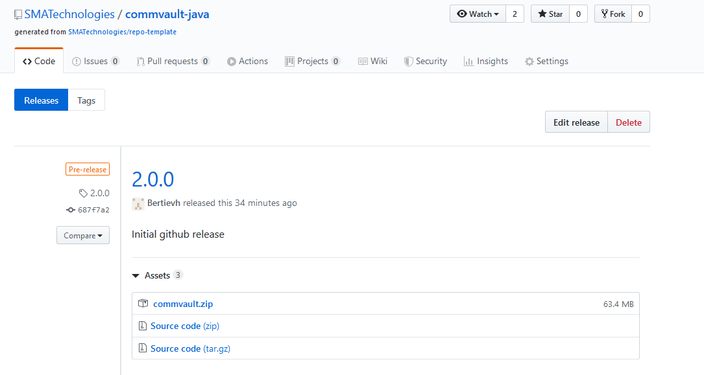

Download the CommVault_Windows.zip file.

Create an installation directory (example c:\connectors\commvault).

Extract the files from the commvault.zip file into this directory.

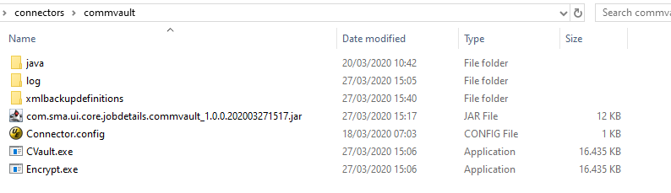

Figure 2 : Connector installed infrastructure

* **<install directory>** contains:
  + Connector.config
  + CVault.exe
  + Encrypt.exe
  + com.sma.ui.core.jobdetails.commvault_1.0.0.nnnnnnnnnnnn.jar
* **java** contains:
  + the embedded open JDK required by the connector
* **log** contains:
  + empty, but will contain logs after connector has been started.
* **xmlbackupdefinitions** contains:

contains three templates that can be used to execute backup tasks.

file_system.xml

script_incr.xml

script_synthetic_full.xml

### 

### Connector Configuration

The configuration of the OpCon Commvault Connector requires setting the required values in the Agent.config file. The Agent.config file contains information about the Commvault system that the connector will communicate with via web services.

#### Connector Config

Configure the Connector.config file in the install directory setting the required information.

[CONNECTOR]

CONNECTOR_NAME=Commvault Connector

CONNECTOR_SERVER_ADDRESS=commvault.infra.sma.local

CONNECTOR_SERVER_NAME=commvault.infra.sma.local

CONNECTOR_USE_TLS=False

CONNECTOR_COMM_VAULT_USER_DOMAIN=smaeurope

CONNECTOR_COMM_VAULT_USER=yEhRqH//yG4Ym3gqZ/RhoA==

CONNECTOR_COMM_VAULT_USER_PASSWORD=QlkY4l6n2LwbwqYviHofUA==

CONNECTOR_MSLSAM_ROOT_DIRECTORY=c:\\test\mslsam

CONNECTOR_POLL_INTERVAL=5

CONNECTOR_INITIAL_POLL_DELAY=10

CONNECTOR_DEBUG=OFF

Figure 3 : Connector.config file sample

The Connector.config contains the following values

|  |  |
| --- | --- |
| Property Name | Value |
| **[CONNECTOR]** | header |
| CONNECTOR_NAME | The name of the connector. This value should not be changed. |
| CONNECTOR_SERVER_ADDRESS | The address of the Commvault system that the connector must communicate with. |
| CONNECTOR_SERVER_NAME | The name of the Commvault server. This is used for the HOST parameter in the web services header record. |
| CONNECTOR_USE_TLS | If the link between the connector and the Commvault server requires TLS, then set this to true. |
| CONNECTOR_COMM_VAULT_USER_DOMAIN | If the Commvault user defined for the connector requires a domain name, then enter the domain name. |
| CONNECTOR_COMM_VAULT_USER | The Commvault user defined with the appropriate privileges so it can start backup jobs. The user code must be encrypted using the Encryption Tool supplied with Enterprise manager. |
| CONNECTOR_COMM_VAULT_USER_PASSWORD | The Commvault user password. The password must be encrypted using the Encryption Tool supplied with Enterprise manager. |
| CONNECTOR_MSLSAM_ROOT_DIRECTORY | While jobs are running the status of the job is displayed in OpCon. The connector uses the capability of the Windows Agent to submit a status message to OpCon. |
| CONNECTOR_POLL_INTERVAL | The time in seconds between checks to determine the status of a request  Value: decimal number representing  seconds (default value is 5  seconds).  Must not be set to 0. |
| CONNECTOR_INITIAL POLL_DELAY | The time in seconds before the first check is made to determine the status of a request.  Value: decimal number representing  seconds (default value is 5  seconds).  Must not be set to 0. |
| DEBUG | The Connector supports a debug mode which can be enabled by setting the value to ON. The connector should be run DEBUG disabled (OFF) and enabled (ON) when requested to capture an error condition.  Value: either ON or OFF (default OFF). |

Table 1 : Connector.config definitions

#### Define the CommvaultPath Global Property

Create the CommvaultPath global property containing the root installation directory of the connector.

#### Create Commvault special properties

The Commvault connector uses a global property to hold the values of backup types that are supported by the connector.

* CV_BACKUP_TYPES

Create the global property and add the values contained in Appendix A using a comma to

separate them. The doubles quotes surrounding the values must be retained. These values will then be visible in the drop-down list.

### Install the EMPlugin

Copy the Enterprise Manager plug-in com.sma.ui.core.jobdetails.commvault_1.0.0.nnn.jar from the install directory to the dropins directory of the Enterprise Manager installation. If the dropins directory does not exist, create the dropins directory in the Enterprise Manager root directory.

Restart Enterprise Manager and a new Windows Job SubType Commvault will be visible.

# Defining Commvault Jobs using Enterprise Manager

The Enterprise Manager includes Job SubType definitions for the Commvault Connector. The Job SubType can be accessed by selecting the Commvault Job SubType from the dropdown list when the Windows Job Type has been selected.

Before defining jobs, the global property CV_BACKUP_TYPES should be completed. The global property holds the definitions that populate the drop-down list when creating the job definitions.

* CV_BACKUP_TYPES
  + This contains a list of backup types that can be selected when defining jobs (see ‘Create Commvault special properties’ section).

## Commvault Job definitions

When defining a Commvault job, select a Job Type of Windows and then a Job SubType of Commvault. The Commvault Definition screen will then appear.

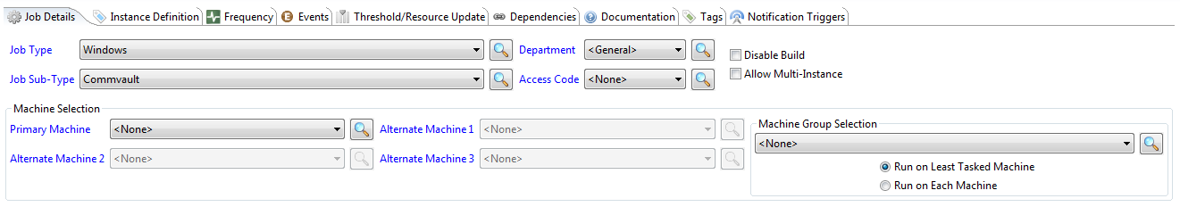

Figure 4 : Windows Job Definition showing Commvault Job SubType selection

Once the Job SubType has been selected, the Commvault Definition will appear. The job definition details consist of a Windows Batch User and the Job Definition and Failure Criteria TABs.

The Job Definition TAB is used to define parameters that are passed to the Commvault Connector and replaced in the template xml before the job request is submitted to Commvault. The XML template itself not updated, only the template in memory.

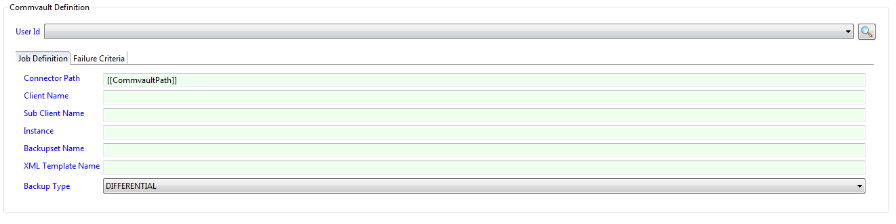

Figure 5 : Commvault JOB Definition Screen

The Commvault definitions are used to define the arguments that are submitted to the job.

|  |  |
| --- | --- |
| ***Field*** | ***Description*** |
| User Id | Required field that contains the name of the Windows Batch user that the Commvault Connector will be execute on the Windows system. |

Table 2 : Commvault Job definitions

The Job Definition TAB field definitions are used to define the arguments that are submitted to the job.

|  |  |
| --- | --- |
| ***Field*** | ***Description*** |
| Connector Path | Required field that contains the installed location of the Commvault Connector. This should not be changed and the location should be defined in the CommvaultPath property. If more than one Connector is installed on the same system, then a new global property should be defined and the entry in this field updated. |
| Client Name | Required field that contains the name of the computer on which the required commvault agent is installed. The value is inserted into the XML template associated with the request. |
| Sub Client Name | Optional field that defines a logical container that identifies and manages production data to be protected. When not present, the default value in the XML template is used otherwise the value is inserted into the XML template associated with the request. |
| Instance | Optional field that contains the name of an instance that is associated with the job. When not present, the default value in the XML template is used otherwise the value is inserted into the XML template associated with the request. |
| BackupsetName | Required field that contains the name of a backup set that contains the logical grouping of the sub clients which are the containers of all data managed by the agent. The value is inserted into the XML template associated with the request. |
| XML Template Name | Required field that contains the name of the XML template to use for the request. |
| Backup Type | Required field that contains the backup type to use. The value is selected from the dropdown list (DIFFERENTIAL, INCREMENTAL, FULL or SYNTHETIC_FULL. The value is inserted into the XML template associated with the request. |

Table 3 : Commvault Job Definitions TAB

The Failure Criteria TAB field definitions are used to define the successful completion of the job.

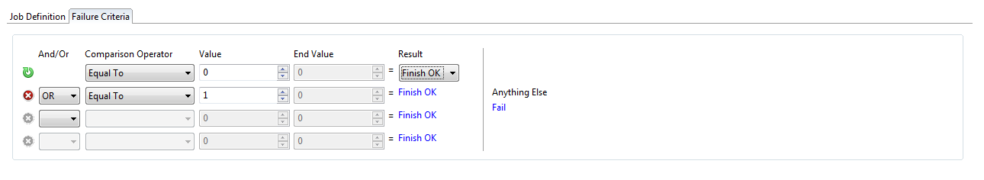

Figure 6 : Commvault Failure Criteria TAB

Completion Codes supported by the Commvault Connector.

0 COMPLETED, the job completed processing.

1 COMPLETED_WITH_WARNINGS, the job completed processing, but contains

warnings.

2 COMPLETED_WITH_ERRORS, the job completed processing, but contains

errors.

3 FAILED, the job failed.

4 FAILED_TO_START, the job did not start.

18 WEB_SERVER_ERROR, an error occurred when communicating with the

Commvault web server.

This means that to check for a successful completion, the Failure Criteria should be set to NE (Not Equal) to 0 means a Fail condition.

Figure 9 shows a failure criteria definition where COMPLETED and COMPLETED_WITH_WARNINGS is accepted as successful completion.

# Logging

The default logging implemented by the connector consists of a maximum cycle of five log files. The log files contain information about the Commvault Connector and any jobs run by the Commvault Connector. The log files (Agent.log - Agent.log.5) are located in the <installation root>\log directory. Information is appended into the log files and any error messages, return codes can be viewed in these log files.

2017-03-14 16:07:08,923 [main] INFO Logger - [CommVaultConnector] 20170314 16:07:08 : ----------------------------------------------------------------------------

2017-03-14 16:07:08,923 [main] INFO Logger - [CommVaultConnector] 20170314 16:07:08 : CommVault Job Completed with status 0 - (Completed)

2017-03-14 16:07:08,923 [main] INFO Logger - [CommVaultConnector] 20170314 16:07:08 : ----------------------------------------------------------------------------

2017-03-14 16:21:35,676 [main] INFO Logger - [CommVaultConnector] 20170314 16:21:35 : ----------------------------------------------------------------------------

2017-03-14 16:21:35,678 [main] INFO Logger - [CommVaultConnector] 20170314 16:21:35 : CommVault Connector : 16.2.01

2017-03-14 16:21:35,678 [main] INFO Logger - [CommVaultConnector] 20170314 16:21:35 : ----------------------------------------------------------------------------

2017-03-14 16:21:35,678 [main] INFO Logger - [CommVaultConnector] 20170314 16:21:35 : Server Address : commvault.infra.alptis.local

2017-03-14 16:21:35,678 [main] INFO Logger - [CommVaultConnector] 20170314 16:21:35 : Server Name : commvault.infra.alptis.local

2017-03-14 16:21:35,679 [main] INFO Logger - [CommVaultConnector] 20170314 16:21:35 : -xt (XML Template) : script_nutanix_prism_incr.xml

2017-03-14 16:21:35,679 [main] INFO Logger - [CommVaultConnector] 20170314 16:21:35 : -bsn (Backupset Name) : defaultBackupSet

2017-03-14 16:21:35,679 [main] INFO Logger - [CommVaultConnector] 20170314 16:21:35 : -c (client) : vcenter-ntx-dc1

2017-03-14 16:21:35,679 [main] INFO Logger - [CommVaultConnector] 20170314 16:21:35 : -sc (Subclient) : null

2017-03-14 16:21:35,680 [main] INFO Logger - [CommVaultConnector] 20170314 16:21:35 : -i (Instance) : VMware

2017-03-14 16:21:35,680 [main] INFO Logger - [CommVaultConnector] 20170314 16:21:35 : -t (Backup Type) : INCREMENTAL

2017-03-14 16:21:35,680 [main] INFO Logger - [CommVaultConnector] 20170314 16:21:35 : ----------------------------------------------------------------------------

2017-03-14 16:21:35,886 [main] INFO Logger - [CommVaultConnectionFactory] 20170314 16:21:35 : Authenticating User opcon_commvault to Server http://commvault.infra.alptis.local/webconsole/api/Login

2017-03-14 16:21:36,352 [main] INFO Logger - [CommVaultConnectionFactory] 20170314 16:21:36 : Authenticating for User opcon_commvault successful

2017-03-14 16:21:36,415 [main] INFO Logger - [CommVaultConnectionFactory] 20170314 16:21:36 : QCommand

2017-03-14 16:21:37,874 [main] INFO Logger - [CommVaultConnectionFactory] 20170314 16:21:37 : QCommand successful TaskId 7351 JodId 19259

2017-03-14 16:21:47,876 [pool-2-thread-1] INFO Logger - [CommVaultConnectionFactory] 20170314 16:21:47 : Get Job Summary for JobId 19259

2017-03-14 16:21:48,093 [pool-2-thread-1] INFO Logger - [CommVaultConnectionFactory] 20170314 16:21:48 : Get Job Summary for JobId 19259 successful

2017-03-14 16:21:48,148 [pool-3-thread-1] ERROR Logger - [ExecuteSMAStatus] 20170314 16:21:48 : Exception Cannot run program "c:\testmslsam\SMAStatus.exe": CreateProcess error=2, The system cannot find the file specified

2017-03-14 16:21:55,629 [main] INFO Logger - [CommVaultConnector] 20170314 16:21:55 : ----------------------------------------------------------------------------

2017-03-14 16:21:55,631 [main] INFO Logger - [CommVaultConnector] 20170314 16:21:55 : CommVault Connector : 16.2.01

2017-03-14 16:21:55,631 [main] INFO Logger - [CommVaultConnector] 20170314 16:21:55 : ----------------------------------------------------------------------------

2017-03-14 16:21:55,631 [main] INFO Logger - [CommVaultConnector] 20170314 16:21:55 : Server Address : commvault.infra.alptis.local

2017-03-14 16:21:55,631 [main] INFO Logger - [CommVaultConnector] 20170314 16:21:55 : Server Name : commvault.infra.alptis.local

2017-03-14 16:21:55,632 [main] INFO Logger - [CommVaultConnector] 20170314 16:21:55 : -xt (XML Template) : script_nutanix_prism_incr.xml

2017-03-14 16:21:55,632 [main] INFO Logger - [CommVaultConnector] 20170314 16:21:55 : -bsn (Backupset Name) : defaultBackupSet

2017-03-14 16:21:55,632 [main] INFO Logger - [CommVaultConnector] 20170314 16:21:55 : -c (client) : vcenter-ntx-dc1

2017-03-14 16:21:55,633 [main] INFO Logger - [CommVaultConnector] 20170314 16:21:55 : -sc (Subclient) : null

2017-03-14 16:21:55,633 [main] INFO Logger - [CommVaultConnector] 20170314 16:21:55 : -i (Instance) : VMware

2017-03-14 16:21:55,633 [main] INFO Logger - [CommVaultConnector] 20170314 16:21:55 : -t (Backup Type) : INCREMENTAL

2017-03-14 16:21:55,634 [main] INFO Logger - [CommVaultConnector] 20170314 16:21:55 : ----------------------------------------------------------------------------

2017-03-14 16:21:55,845 [main] INFO Logger - [CommVaultConnectionFactory] 20170314 16:21:55 : Authenticating User opcon_commvault to Server http://commvault.infra.alptis.local/webconsole/api/Login

2017-03-14 16:21:56,246 [main] INFO Logger - [CommVaultConnectionFactory] 20170314 16:21:56 : Authenticating for User opcon_commvault successful

2017-03-14 16:21:56,314 [main] INFO Logger - [CommVaultConnectionFactory] 20170314 16:21:56 : QCommand

2017-03-14 16:21:57,944 [main] INFO Logger - [CommVaultConnectionFactory] 20170314 16:21:57 : QCommand failed : message (Error 0x10c: Another backup is running for client [vcenter-ntx-dc1], iDataAgent [Virtual Server], Backup Set [defaultBackupSet], Subclient [Nutanix PRISM].

) return code (2)

2017-03-14 16:21:57,945 [main] INFO Logger - [CommVaultConnectionFactory] 20170314 16:21:57 : Logout

2017-03-14 16:21:57,984 [main] INFO Logger - [CommVaultConnectionFactory] 20170314 16:21:57 : Logout completed : User logged out

2017-03-14 16:21:57,985 [main] INFO Logger - [CommVaultConnector] 20170314 16:21:57 : ----------------------------------------------------------------------------

2017-03-14 16:21:57,985 [main] INFO Logger - [CommVaultConnector] 20170314 16:21:57 : CommVault Job Completed with status 4 - (Failed to Start)

2017-03-14 16:21:57,985 [main] INFO Logger - [CommVaultConnector] 20170314 16:21:57 : ----------------------------------------------------------------------------

Figure 7 : Sample Connector.log file

# APPENDIX A

List of backup types.

"DIFFERENTIAL"

"INCREMENTAL"

"FULL"

"PRE_SELECT"

"SYNTHETIC_FULL"