Github Qs.

Q.1] 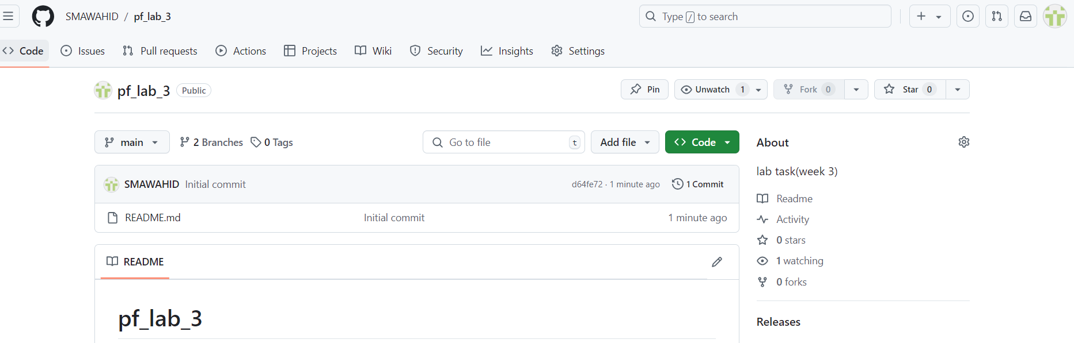

Q.2]

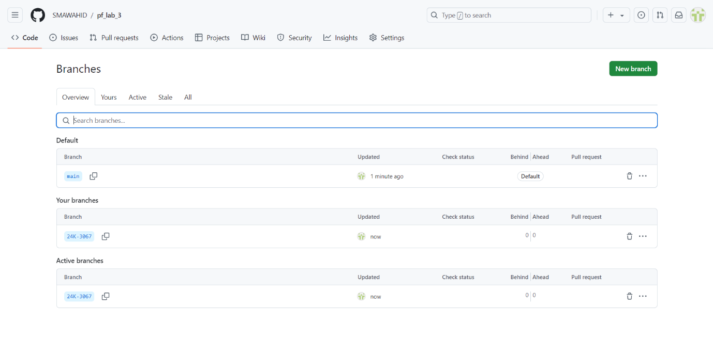

Q.3 & Q.4]

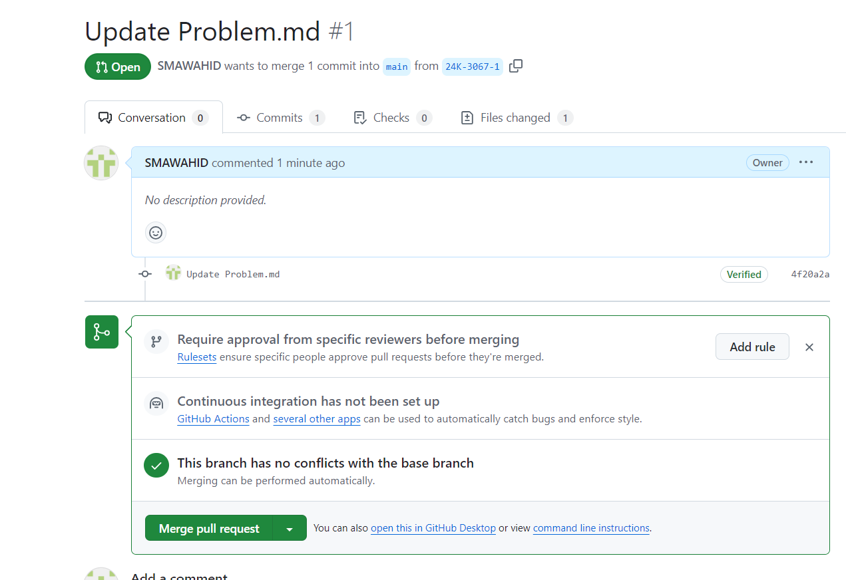

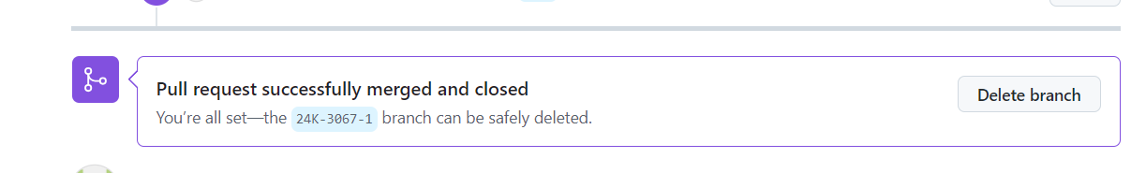

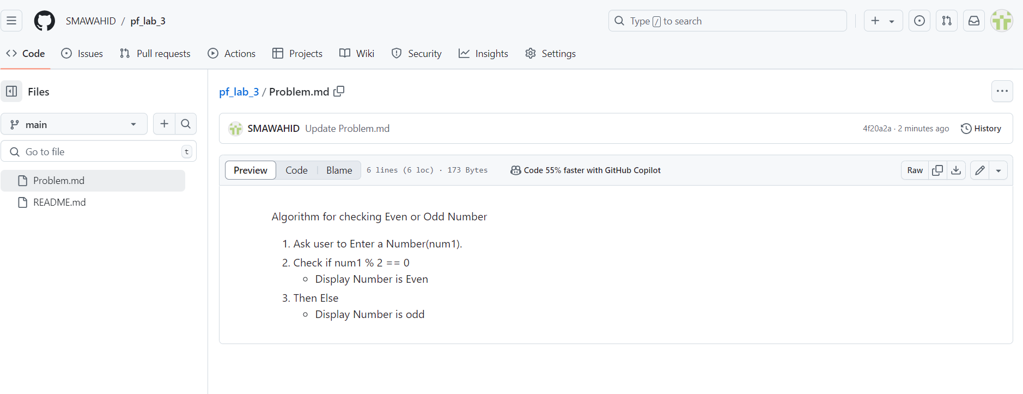

C programming Qs.

Q.1] The data entered is too large for the data type that’s why its giving an error.

Q.2] 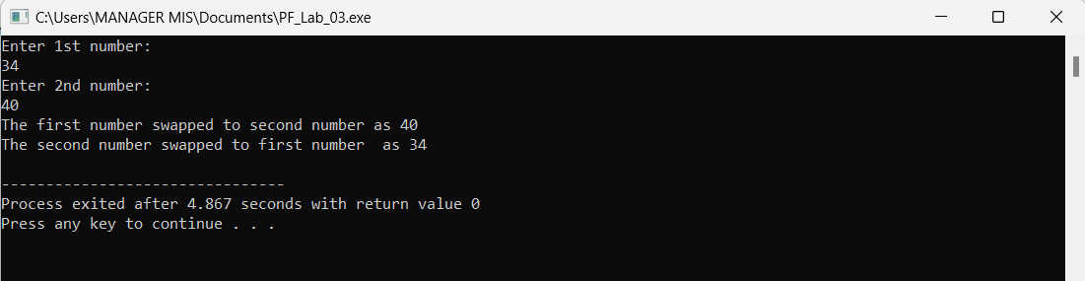

Q.3] 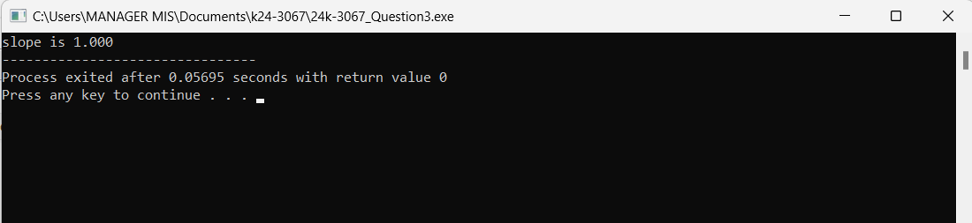

Q.4] 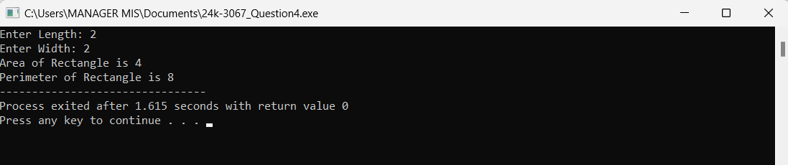

Q.5] 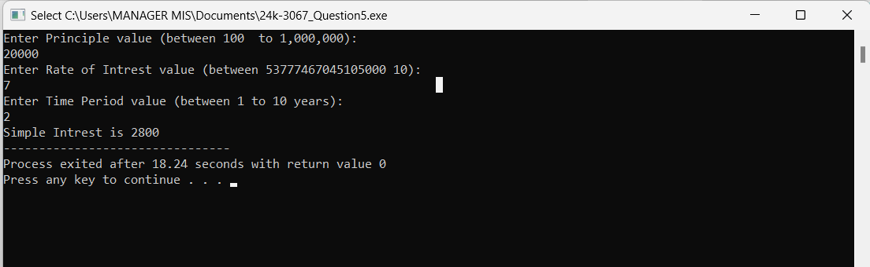

Q.6] 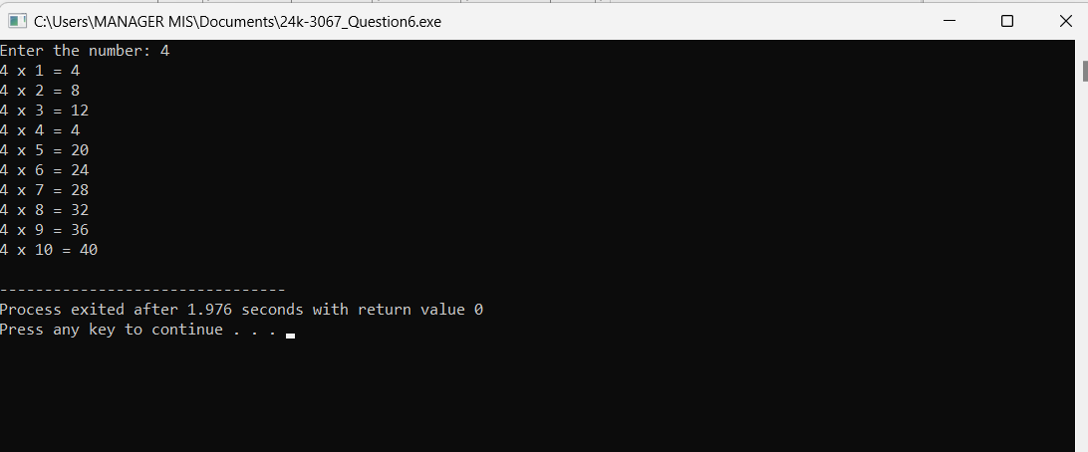

Q.7] 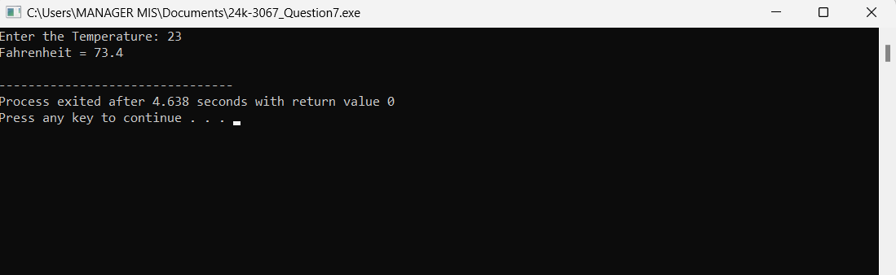

Q.8] 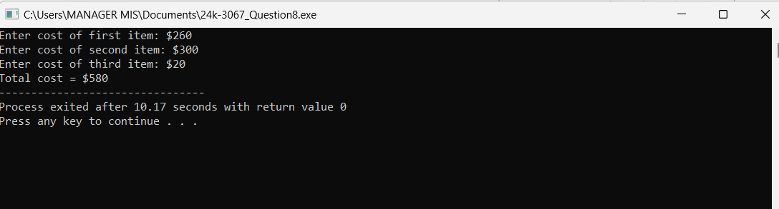

Q.9] 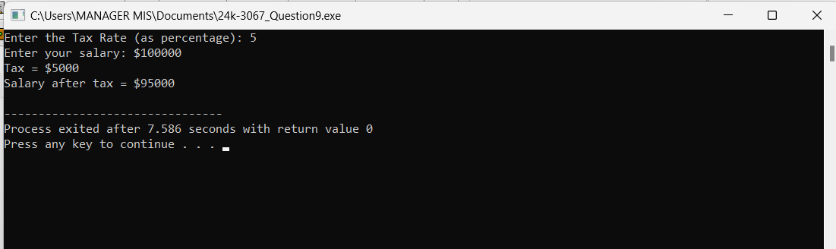

Q.10] 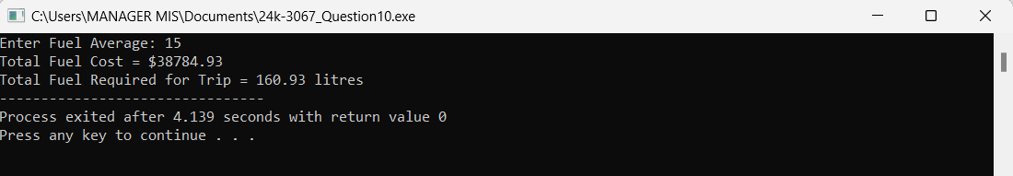

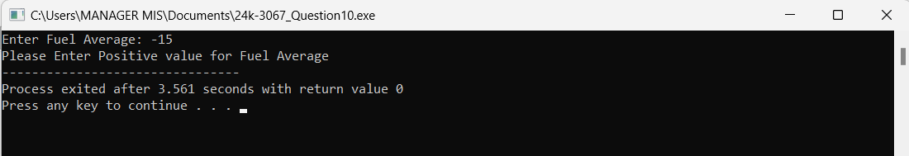

Q.11]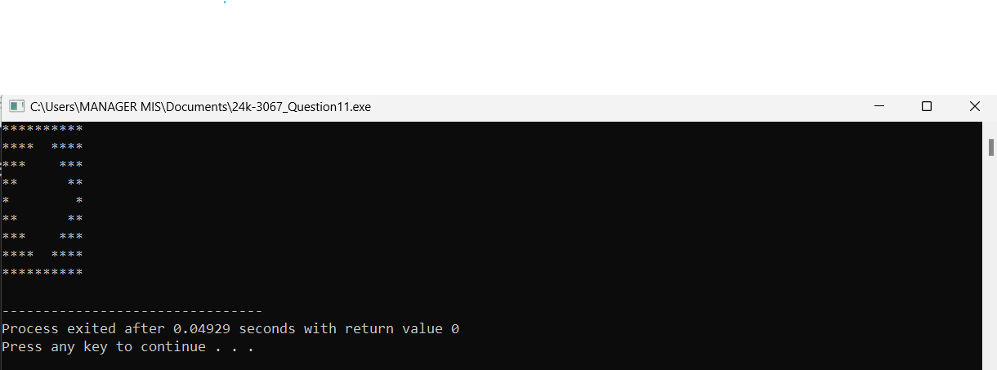

Q.12]

There are three variables included which are x , y, z. and y is assigned with value of 7 and z is assigned with value 5. Then statement is given as x = y== z , that means first check that if y is equals to z, in this case it is not equal meaning false so program will give 0 value which will be assigned to x. Then print statement for x is given so 0 will be the output.