Course Project
Programmable Processor
TCES330 Digital System Design
Spring 2026

Authors:
Student A: Seth Amico

Student B: John R Teal Jr.

Submission Date: June 10, 2026

Contents
Project Overview 2
1. Requirements 3
1.1 Requirements for Controller 4
1.2 Requirements for Datapath 4
1.3 Requirements for Processor 4
1.4 Requirements for Project 4
2. Design 5
2.1 Controller.sv 5
2.2 Datapath.sv 8
2.3 Processor.sv 9
2.4 Project.sv 10
3. Test Procedures and Results 11
3.1 FSM_tb 11
3.2 Controller_tb 11
3.3 Datapath_tb 12
3.4 testProcessor, Processor_tb 12
4. DE Board Test Results 13
5. Conclusion 13
6. References 14
Appendix 14

Project Overview

The purpose of this course project was to design, simulate, integrate, and test a small programmable processor using SystemVerilog. The processor was built from several smaller modules, including a finite state machine, program counter, instruction register, ROM, RAM, register file, ALU, controller, datapath, and top-level board interface. By completing the project in stages, the design process reinforced how individual digital system components work together to form a functioning processor. The final processor was verified through ModelSim simulations and then tested on the DE10 board using manual clock stepping, synchronous reset, switch-controlled debug output, and seven-segment displays.
Our team members for this project were Seth Amico and John Teal. We managed the workload by dividing the processor into smaller design and verification tasks, then combining those pieces through several stages of integration. Seth contributed to the early project structure and module development, including the initial datapath work, RAM and ROM setup, control unit development, program counter work, and early integration between the controller-related modules. John contributed to module refinement, interface corrections, FSM updates, datapath debugging, testbench creation, simulation setup, processor integration, top-level Project.sv board integration, Decoder and KeyFilter support, Quartus cleanup, timing constraints, and DE10 board testing. Both team members contributed to debugging and integration as the design moved from individual modules to the final processor and board-level demonstration.

Requirements
The project required the design, simulation, integration, and board testing of a small programmable processor in SystemVerilog. The required instruction set included ADD, SUB, LOAD, STORE, HALT, and NOOP. The processor was divided into two primary modules: the Controller and the Datapath. These were then connected in Processor.sv and mapped to the DE10 board through the top-level Project.sv file. The ROM and RAM were preloaded with test instructions and data, and the completed processor was verified using ModelSim simulations and DE10 board testing. Optional extra credit instructions included JNZ and JLT.

1.1 Requirements for Controller
The controller was required to manage instruction fetch, instruction decode, and control-signal generation. It included the finite sate machine (FSM), Program Counter (PC), Instruction Register (IR), and Instruction Memory (ROM). The PC selected the instruction address, the ROM provided the instruction, the IR stored the current instruction, and the FSM decoded it into control signals for the Datapath.

1.2 Requirements for Datapath
The Datapath was required to perform memory access, register movement, and ALU operations. It included the Data Memory (RAM), Register File (RF), ALU, and source-select mux. The Controller provided the Datapth control singals, including RAM address, RAM write enable, Register File addresses, Register File write enable, mux select, ALU function select.

1.3 Requirements for Processor
The Processor Module was required to connect the Controller and Datapath into one complete system. It exposed key internal signals for simulation and testing, including the PC, IR, ALU inputs, ALU outputs, current FSM state, and next FSM state. It also included clock and ResetN inputs to control processor operation.

1.4 Requirements for Project
The Project Module was required to connect the processor to the DE10 Board. The design used KEY[1] and KEY[2] for manual processor control, while KEY[0] was note used for the processor clock. One key was used as the manual clock input, and the other was used as ResetN. A KeyFilter module was used on the manual clock input to reduce button debounce. Decoder modules converted binary values into seven-segment HEX display outputs. Switches SW[9:7] were used to select which internal processor value appeared on the HEX displays, including the IR, PC, NextState, State, ALU inputs, ALU output, and two blank reserved slots.

2. Design
The processor design was divided into four major SystemVerilog sections: The Controller, the Datapath, the Processor integration module, and the top-level Project module for the DE10 Board. The Controller is responsible for fetching and decoding instructions, while the Datapath performs data movement, memory access, and ALU operations. The Processor module connects the Controller and Datapath into one complete processor, and Project.sv connects the processor to the physical switches, keys, LEDs, and HEX displays on the DE10 board.

2.1 Controller.sv
The Controller contains the FSM, Program Counter (PC), Instruction Register (IR), and the Instruction Memory (ROM). The PC Supplies the ROM address, the ROM outputs the current 16-bit instruction, and the IR stores that isntruction for the FSM to decode. After decoding the FSM generates the control signals needed by the DataPath.
The FSM controls the Data Memory address, Data Memory write enable, Register File source select, Register File read/write addresses, Register File write enable, and ALU function select. It also receives the ALU flags Z, N, and V from the Datapath. These flags are used for conditional jump instructions such as JNZ and JLT.
The FSM begins in INIT after reset, then moves through FETCH and DEC before branching to the correct instructions state. ADD and SUB perform ALU operations, LOAD moves RAM data into the Register File, STORE writes Register File data into RAM, NOOP returns to FETCH without changing data, and HALT holds the processor in the halt state. Figure 1 shows the Controller layout, and Figure 2 shows the simplified FSM flowchart.

16
8
8
PC
State Machine
IR
Instruction memory (ROM)
16
addr
w_en
select
R/W controls
function select
ALU flags
Figure 1: Controller Module subview showing State Machine, Program Counter, Instruction register, and Instruction Memory. Seth Amico, 6/4/2026. University of Washington
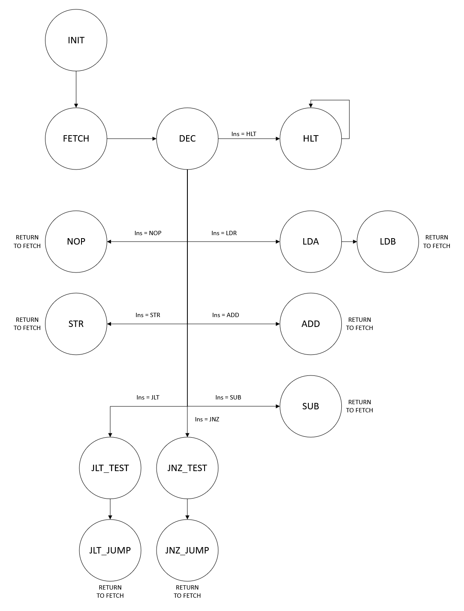

Figure 2: simplified FSM flowchart depicting states with instruction inputs. Seth Amico and John Teal, 6/4/2026. University of Washington

Figure 3: Datapath module flowchart depicting Data Memory, source mux, Register file, and ALU. Seth Amico, 6/4/2026. University of Washington
Data Memory RAM
Register File
Arithmetic Logic Unit
addr
w_en
select
R/W controls
function select
16-bit 2-1 mux
16
16
16
16
16
16
ALU flags

2.2 Datapath.sv
The Datapath module is one of the two critical sections of the processor. It houses the Arithmetic Logic Unit (ALU), the Register File (RF) and the Data Memory (RAM). The Data Memory acts as the Random Access Memory (RAM) of the processor, holding 256 16-bit values. It can either be read from or written to synchronously, copying values to or from the Register File. The Register File houses 16 16-bit registers, allowing 2 simultaneous synchronous read operations or one synchronous write operation. Both of the RF’s output ports are wired as inputs to the ALU, with output A being connected to the data input of the RAM additionally. The RF takes data in from the the ALU’s output port or the RAM’s output port. The ALU submodule reads data from two 16-bit input register buses and asynchronously performs one of 8 operations based on the state of the 3-bit function select bus. Additionally, it sets three output flags based on the result of the operation. These three modules are augmented by a 16-bit two-to-one mux, which selects the input of the RF from the ALU output or the RAM output.
The Datapath module is interfaced with by the following wires. The RAM submodule exposes an 8-bit data address line, a write enable line, and a global clock input. The control mux exposes its select line, with a logic high selecting the RAM as a source. The RF submodule exposes 3 3-bit address select lines: one read and two write. This is joined by a write enable line and clock input. The ALU submodule exposes a 3-bit function select line, as well as 3 individual flags: Z, N, and V.

2.3 Processor.sv
The Processor module connects the Controller and Datapath into one complete processor. Internal wires carry the Controller outputs into the Datapath, including the RAM address, RAM write enable, Register File controls, mux select, and ALU function select. The ALU flags return from the Datapath to the Controller so the FSM can make conditional decisions.
The Processor module also exposes key internal signals for simulation and board testing. These include the PC, IR, ALU inputs, ALU outputs, current FSM state, and next FSM state. These outputs made it easier to verify the processor in ModelSim and display selected values on the DE10 board. Figure 4 shows the combined Controller and Datapath layout.

Data Memory (RAM)
Register File
Arithmetic Logic Unit
16-bit 2-1 mux
16
16
16
16
16
16
16
8
8
PC
State Machine
IR
Instruction memory (ROM)
16
Figure 4: Combined Processor layout with Datapath and Controller. Seth Amico, 6/4/2026. University of Washington
3x4 + 1
3
8

2.4 Project.sv
Project.sv is the top-level module used for the DE10 board testing. It instantiates the Processor, KeyFilter, and Decoder modules. KEY[1] is used as ResetN, while KEY[2] is passed through the KeyFilter and used as a manual clock. The KeyFilter reduces button bounce so that one button press is less likely to create multiple clock pulses.
The Decoder modules convert 4-bit binary values into 7-segment HEX to display outputs. SW[9:7] selects which internal processor value is shown on the HEX displays. The display options include the PC, current FSM state, ALU input A, ALU input B, ALU output, and next FSM state. This allowed the processor to be stepped manually and observed on the board during testing.

3. Test Procedures and Results
The processor modules were verified using SystemVerilog testbenches in ModelSim. Each testbench was used to confirm that the module met its design requirements before the full processor was tested as an integrated system. The simulations checked state transitions, control signals, memory/register operations, ALU outputs, and processor-level execution.
Simulation results are included for each testbench. These results are used to show whether the tested modules satisfied the requirements described in Section 1.

3.1 FSM_tb
The FSM testbench verified that the FSM moved through the correct states and produced the expected control outputs. The testbench used three SystemVerilog tasks to organize the simulation. The first task, check_value(), compared an output signal against its expected value and recorded whether the test passed or failed. The second task, reset_fsm_with_instruction(), reset the FSM, loaded a selected instruction, and verified that the FSM restarted correctly by moving through the INIT, FETCH, and DEC states. This placed the FSM one clock cycle before the execution state being tested. The third task, tick(), advanced the simulation to the next positive clock edge.
Each FSM state was tested by first resetting the FSM with a relevant instruction. The simulation was then advanced on clock cycle so the FSM moved from DEC into the target execution state. The control outputs were compared against the expected values using check_value(). Passing checks were added to the total pass count, while failed checks displayed a debug message showing the expected and actual values. After each state was checked, the simulation advanced one additional clock cycle to confirm that the FSM returned to FETCH when expected.

3.2 Controller_tb
The Controller testbench verified the basic operation of the control unit over multiple clock cycles. The simulation stepped the Controller through 34 cycles with blank input conditions and printed the output values for each cycle. These outputs were used to observe the Controller state progression, PC behavior, IR output, and generated datapath control signals.
Because the FSM testbench already verified the detailed state transitions and control outputs, this testbench was kept simple. Its purpose was to confirm that the full Controller module could run continuously and produce stable output behavior when its submodules were connected together.

3.3 Datapath_tb
The Datapath testbench used four tasks to reduce repeated code and make the simulation easier to follow. Check16() task compared a 16-bit output value against an expected value, logged the result, and reported any errors to the console. The load_ram_to_reg() task loaded data from RAM into a selected register and used check16() to verify that the loaded value matched the expected value.
The alu_ write_ reg() task selected two Register File read addresses, sent those values to the ALU, selected the LAU as the Register File write source, and wrote the ALU result into a destination register. The ALU output and written register value were then compared against the expected result. The store_ reg_ to_ ram() task selected as Register File output, passed it through the ALU, and wrote the value into a selected RAM address. The RAM output was then checked with check16().
Together, these tasks simulated the Datapath control signals used during LOAD, STORE, and ALU-based instructions. The result confirmed that the Datapath could move data between RAM and the Register File, perform ALU operations, and store results correctly.

3.4 testProcessor, Processor_tb
The provided processor testbench, testProcessor.sv, instantiates a Processor module and connects its inputs and output wires. The testbench steps the processor through 30 clock cycles, or until the IR reaches a blank instruction. At each cycle, it prints the processor output values to the console so the PC, IR, ALU output, and FSM states can be observed.
An additional processor testbench, designed by John, focused on verifying RAM writes during processor execution. This testbench reused check16() to compare 16-bit values and added check1(), which performs the same type of comparison for 1-bit signals. The testbench ran the processor through a preprogrammed instruction sequence, monitored the processor outputs, and checked whether the values written to RAM matched the expected results.
This alternate testbench was useful for debugging specific processor behavior, especially memory writes. It also printed the processor state at each clock cycle. However, it was designed as a focused debugging testbench rather than a broad testbench for every processor function.

4. DE Board Test Results
The completed processor was tested on the DE10 board after successful Quartus compilation and programming. The board test used manual clock stepping so each processor cycle could be observed one step at a time. The reset key returned the processor to its starting state, and the clock key advanced the processor through the loaded ROM instructions. Switches were used to select which internal processor value appeared on the HEX display.
During testing, the HEX displays were used to observe the PC, current FSM state, next FSM state, ALU input values, and ALU outputs. This allowed the processor’s behavior to be checked against the expected instruction sequence. The board output matched the expected behavior from the ModelSim simulations, showing that the processor could fetch instructions, move through the FSM state, perform ALU operations, and display internal debug values correctly.
Several Quartus warnings appeared during the compilation. Some warnings were caused by unused board inputs or outputs, since not every DE10 switch, key, LED, or display was needed for the project. These warnings were expected and did not affect processor operation. The project also required checking the pin assignments and voltage settings to make sure the board I/O used the correct 3.3 V standard. After the pin assignments and top-level module connections were corrected, the design was compiled and programmed successfully.

5. Conclusion
At a cursory summation, this project gave us an understanding of hierarchical module-based SystemVerilog design through the creation of a rudimentary processor. When designing the Controller, we gained a better understanding of FSM design through the state diagram creation and timing analysis through our PC/IR implementation. Our design of the RAM and ROM used a predesigned, parameterized module from Quartus’ IP Catalog which we then used a Memory Information File (.mif) to initialize values into. Our design of the datapath required many iterations, and created an opportunity to rapidly through multiple improved designs. As we developed the project, we learned numerous intersecting facets of the team-centered design method and the iterative process. Through the early phases of processor design, we created multiple modules—one for each of the subsections. This method proved invaluable for testing and error correction. If a bug was found within one module, it could easily be fixed without needing to update the entire project. Seth created a GitHub repository for this project, which we found effective for maintaining a unified project, keeping individual members up to speed, and letting us work on multiple modules asynchronously. Teal’s talent in writing testbenches and extensive documentation made the code easy to clean up old code, expand pre-existing code, and diagnose modules for patching. We found that while both of us were capable of adding to the project on our own, working in tandem in person or over voice call let us catch problems and understand the project faster and to a more complete degree.

6. References
ModelSim Download Page. (2026, June 4). Retrieved from altera.com: https://www.altera.com/downloads/simulation-tools/modelsim-fpgas-standard-edition-software-version-20-1-1
Quartus Prime Download Page. (2026, June 4). Retrieved from altera.com: https://www.altera.com/products/development-tools/quartus
Sheng, J. (2026, June 04). TCES330 Course Materials. Retrieved from University of Washington Canvas: https://canvas.uw.edu/courses/1894518/files
Stephen Brown, Z. V. (2014). Fundamentals of Digital Logic with Verilog Design, 3rd Ed. New York, NY: McGraw-Hill.
Sutherland, S. (2007). Verilog HDL Quick Reference Guide. Tualatin, OR: Sutherland HDL, Inc.
Terasic. (2017). DE10 Standard User Manual. Terasic Inc.

Appendix
The project offered extra credit opportunities by allowing us to implement two new instructions: Jump if less than (JLT) and Jump if not zero (JNZ). These required some modifications to the processor design. First, the ALU submodule had to be modified to output state flags V (Overflow bit, for Addition operations), N (Negative, if signed), and Z (Zero). These flags get set after one cycle, hence both extra instructions require two extra states in the FSM. One state would test the value of two registers, and the second executes the jump command if the condition are met. Jump commands directly write to the PC to change the instruction address, so the Controller had to be changed to include a PC write enable line and a PC write data bus. The end result met the extra credit requirements, but did not have any instructions within the provided testbench, so were not verified.

