**Mechanics**

**Graded Homework 3**

**Smbat Gardilyan**

**AUA ID: A09170089**

From my ID card number, we get **k1=9 N/m k2=17 N/m k3 = 1 N/m k4 = 89 N/m.**

1. For the first task we should get maximal effective stiffness, so the best solution will be to combine it in parallel way.

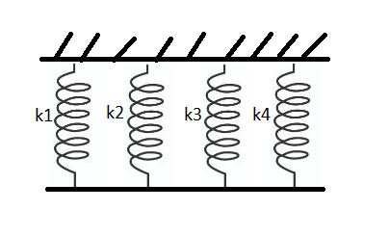

As we know Kparallel = k1 + k2 + k3 + k4 = 9 + 17+ 1+89 = 116 N/m.

1. For the second task we should get minimal effective stiffness, so best solution will be to combine it in series way.

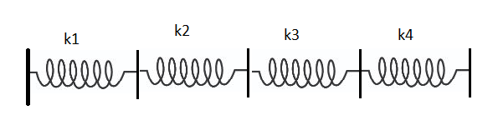

**K**series =1/( 1/k1 + 1/k2 + 1/k3 + 1/k4 )= 1/(1/9+1/17+1+1/89) = 0.84661775677 N/m.

1. We get k0 =( Kparallel + Kseries)/2 = 58.423 N/m.

As my ID card number is not good enough the best way that I can get combination close to K0 is

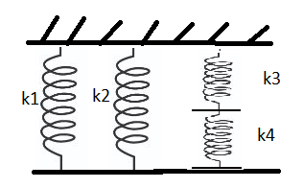

Here we get **K**total =k1+k2+(k3*k4/k3+k4) = 9+17+(89/90) = 26.988 N/m

Better solution is:

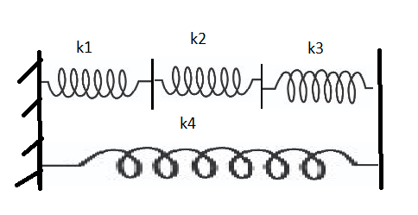

Here we get

**K**total = (1/(1/k1+1/k2+1/k3))+k4 = (1/(1/9 + 1/17 + 1))+89 = 89.854 N/m

Error for the first one is |58.423 - 26.988| = 31.435

And for second one is |58.423 - 89.854| = 31.431

Difference is small, but it is more effective.