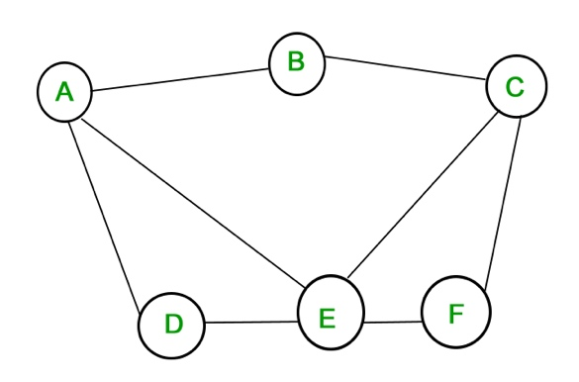

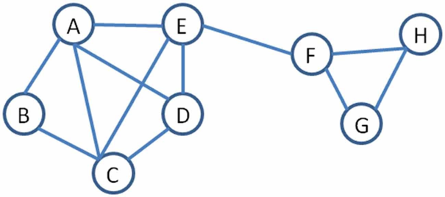

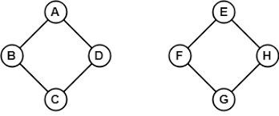
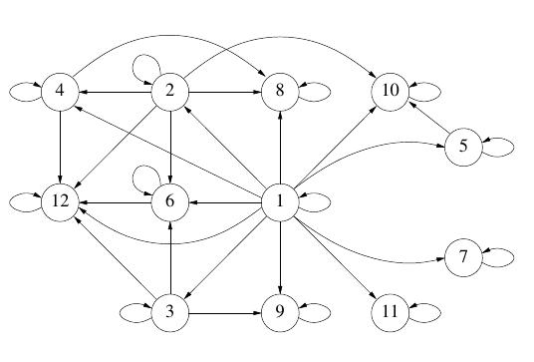

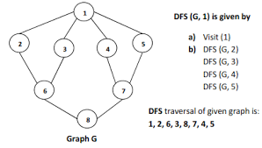










- Given pre-order and in-order traversals of a binary tree, is it possible to reconstruct the tree? If so, sketch an algorithm to do it. If not, give a counterexample.

Repeat the problem if you are given the pre-order and post-order traversals.

- The Chutes and Ladders game has a board with n cells where you seek to travel from cell 1 to cell n. To move, a player throws a six-sided dice to determine from how many cells forward they move. A player who lands on the mouth of a chute immediately falls back down to the cell at the other end. A player who lands on the base of a ladder immediately travels up to the cell at the top of the ladder.

Suppose you have rigged the dice to give you full control of the number for each roll. Give an efficient algorithm to find the minimum number of dice throws to win.

- You are planning the seating arrangement for a wedding, and are given a list of guests, V. For each guest g, you have a list of all other guests who are on bad terms with them.
Feelings are reciprocal: if h is on bad terms with g, then g is on bad terms with h.
Your goal is to arrange the seating such that no pair of guests sitting at the same table are on bad terms with each other. There will be only two (perhaps very large) tables at the wedding. Give an efficient algorithm to find an acceptable seating arrangement, if one exists.

- Consider a set of movies M1, M2, …, Mk. There is a set of customers, each one of which indicates the two movies they would like to see this weekend. Movies are shown on Saturday evening and Sunday evening. Multiple movies may be screened at the same time.
You must decide which movies should be shown on Saturday and which on Sunday, so that every customer gets to see the two movies they desire. Is there a schedule where each movie is shown at most once? Design an efficient algorithm to find such a schedule if one exists.

- Your job is to arrange n ill-behaved children in a straight line, facing front. You are given a list of statements of the form “i hates j.” If i hates j, then you do not want to put i somewhere behind j, because then i is capable of throwing something at j.
  - Give an algorithm that orders the line (or says that it is not possible) in O(n+m) time.
  - Suppose instead you want to arrange the children in rows such that if i hates j, then i must be in a lower numbered row than j. Give an efficient algorithm to find the minimum number of rows needed, if it is possible.

- A particular academic program has n required courses, certain pairs of which have prerequisite relations so that (x,y) means you must take course x before y. How would you analyze the prerequisite pairs to make sure it is possible for people to complete the program?

- You are given a list of n words each of length k in a language you don’t know, although you are told that words are sorted in lexicographic (alphabetical) order. Reconstruct the order of the α (Greek alpha) alphabet letters (characters) in that language.
For example, if the strings are {QQZ, QZZ, XQZ, XQX, XXX}, the character order must be Q before Z before X.
  - Give an algorithm to efficiently reconstruct this character order. (Hint: use a graph structure, where each node represents one letter.)
  - What is its running time, as a function of n, k, and α?

Leetcode problems (space provided for scratch work)
- https://leetcode.com/problems/cheapest-flights-within-k-stops

- https://leetcode.com/problems/network-delay-time

- https://leetcode.com/problems/find-the-city-with-the-smallest-number-of-neighbors-at-a-threshold-distance

- https://www.hackerrank.com/challenges/jack-goes-to-rapture/problem

