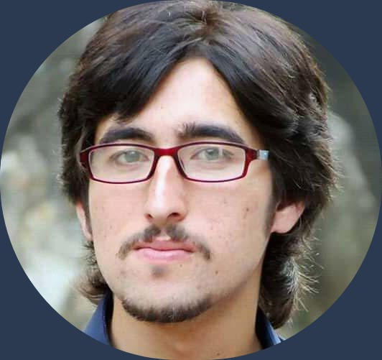

Result-oriented Software Engineer with 2+ years of experience in designing, development, testing, and deployment of mobile and web-based applications. Proficient in various platforms, tools, debugging, and programming languages. Skilled at team collaboration while working independently in remote environment

**EDUCATION**

**Languages**

* English – Fluent
* Urdu – Fluent
* Pashto - Native

**Technical Skills:**

* PostgreSQL
* MongoDB
* Node.js
* jQuery
* Vue.js
* Angular.js
* React and React Native
* Sqlite

**Programming Languages:**

* C / C++
* PHP
* HTML / CSS
* Javascript

**Soft Skills:**

* Agile Development
* Collaboration
* Problem Solving
* Strategic Planning

**EXPERTISE**

* Helped build and enhance highly available, scalable, real-time and secure systems used by customers.
* Completed three major projects, working closely with agile development team to develop, test and maintain Web- based software applications.
* Adhered to high-quality development standards while delivering solutions on-time and on-budget.

Collaborated in a team-focusedenvironment providing software solutions to diverse industry clients.

15 Jan, 2019 to 25 Aug, 2019 | Techsoft International– Sometown, NC

**WEB PROGRAMMER**

Work as a back-end Developer.

01 Nov, 2019 to present | DYNAMIC CONSULTING SERVICE– Sometown, NC

**WEB DEVELOPER**

**EXPERIENCE**

* **CGPA 3.1 / 4.0**
* **Major Project:** 3D Video Game in UNITY Game Engine
* **Course Work:** Software Design, Cloud Computing, Artificial Intelligence, Software testing, Database Design, Computational Theory, Visual Programming, Modern Programming Languages, Object-OrientedProgramming, Human-Computer Interaction, Data Structures and algorithm Analysis and Software Project Management

**BS SOFTWARE ENGINEERING**

Udhyana Model School, Swat.

**Matriculation**

Govt. PG Jehanzeb College Saidu Sharif Swat.

**Intermediate**

University of Swat

Bachelor of Software Engineering

**BACHELOR DEGREE**

**WEB DEVELOPER**

asifu6698@gmail.com

Date of Birth: March 24, 1996Age: 24Gender: MaleBirth Place: Saidu Sharif Swat,KP

Saidu Sharif, Swat, KP, Pakistan

+92-346-097 39 06

Books

Machines

Coffee

Online Games

Problem Solving

Physical Activities

**ABOUT ME**

**CONTACT**

**INTERESTS**

**HOBBIES**

**PERSONAL PROFILE**

ASIF ULLAH