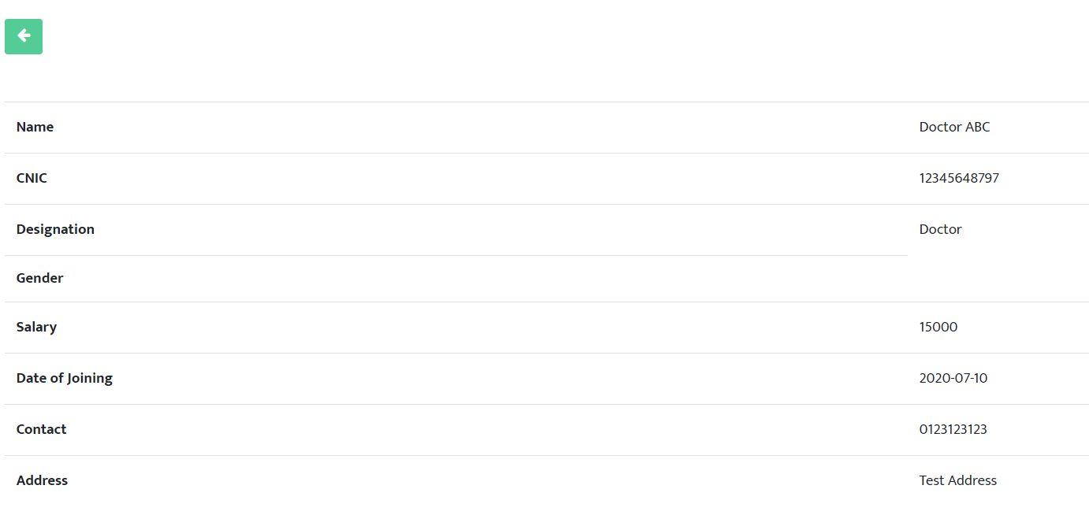Gender

Can’t see employees in Advance Payment

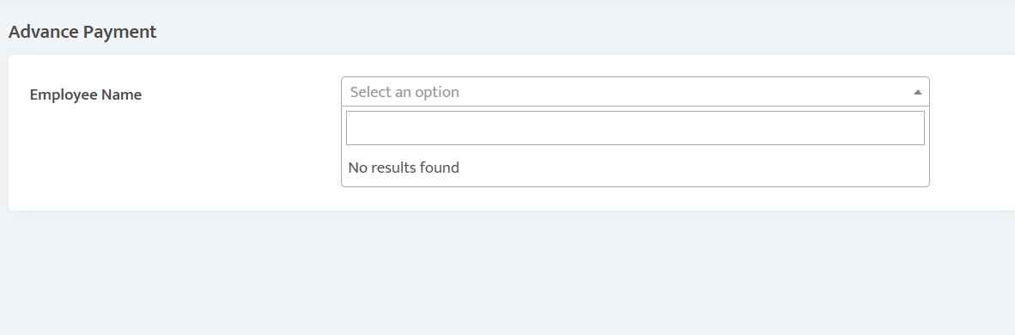

<http://babar-ali.com/SMC/pages/employee_salary.php> not found

No surgery in Surgeries but surgery can be added to patient

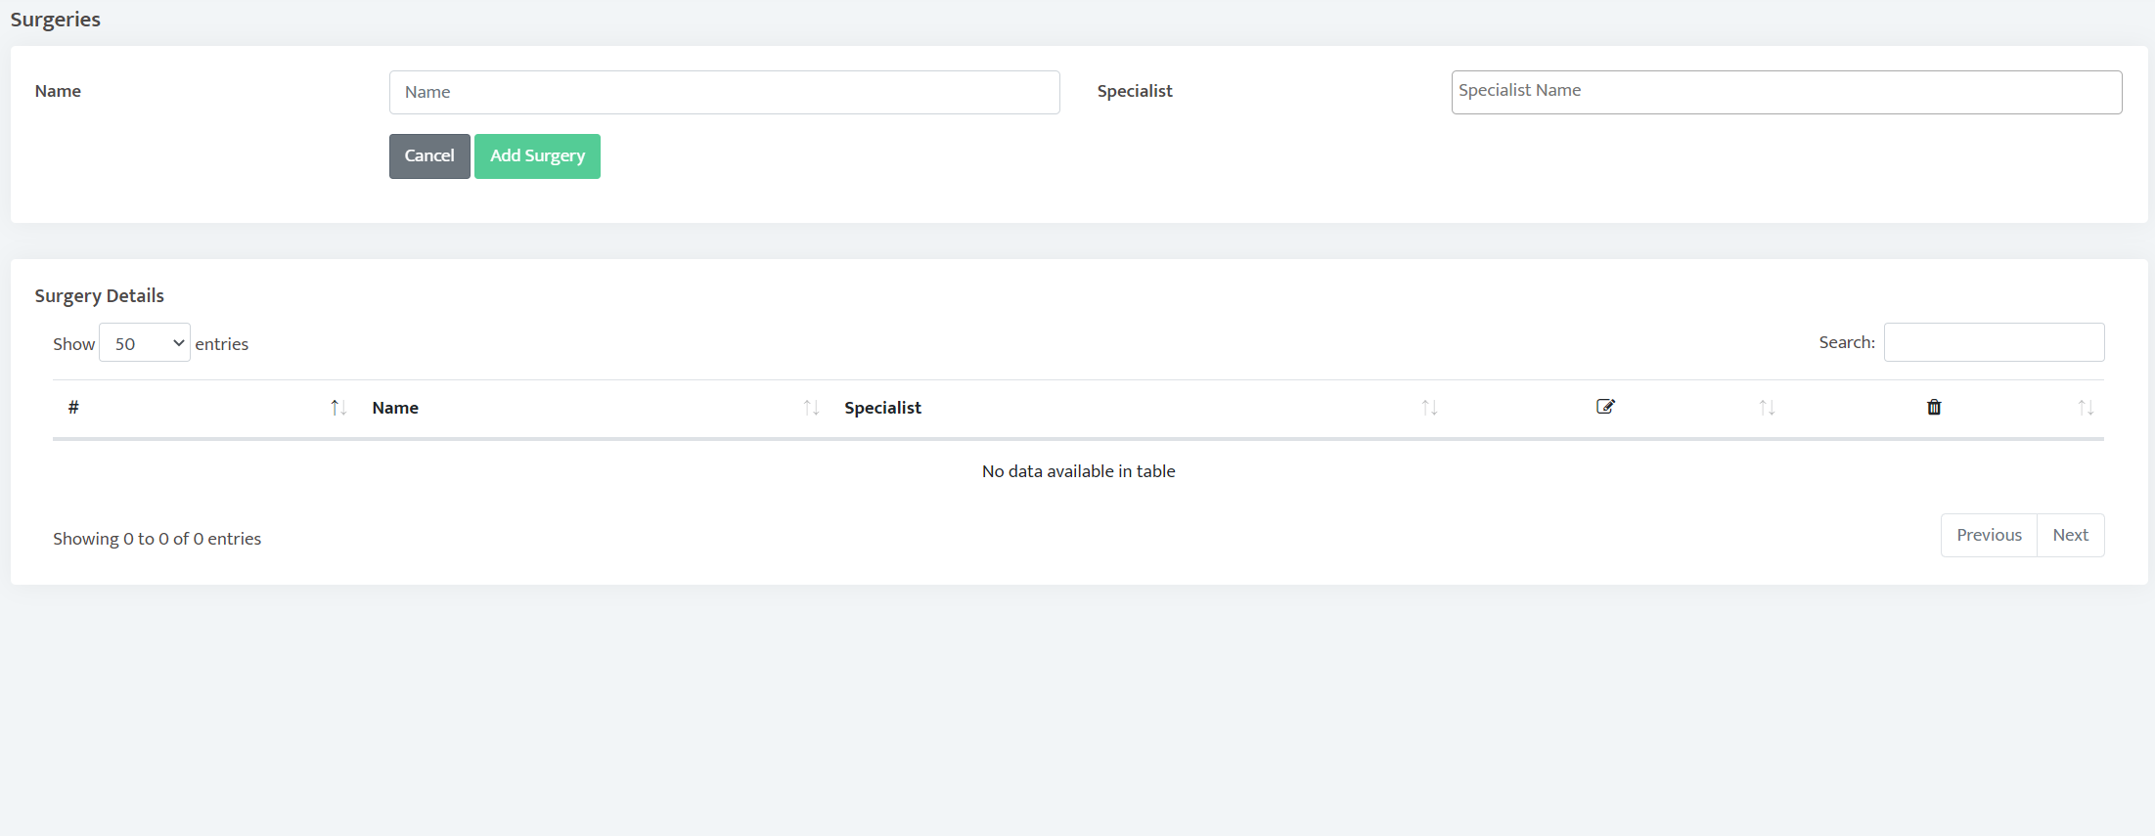

<http://babar-ali.com/SMC/pages/Lab_test_list.php> not found

Postponed patients data is not shown anywhere

Date and Time issue

Autofill date