INTERNAL · PRESENTER REFERENCE · WHITEBOARD DRAWINGS

IOS+ Lamar Edition
Whiteboard Drawings.
Three reference drawings the presenter will reproduce live on the whiteboard during the deep dive with Patrick Stewart, Sri Varadaraj, and Steven Veron. Each drawing has an anchor phrase to speak while drawing and a structural note set for morning-of preparation.
Purpose. Drawing the architecture live at the whiteboard demonstrates fluency in a way no slide deck can. These three drawings are the anchors of the 20-minute architectural segment. Study them, internalize them, then close this document and draw from memory.
Use. Reviewed the morning of the meeting. Carried in the folder but not consulted at the whiteboard. The room watches whether you are drawing from preparation or from the page.

DRAWING SEQUENCE
Three drawings, in order, each 5–7 minutes. Total architectural segment: 20 minutes including questions. The drawings build on each other — Drawing 1 establishes the deployment topology, Drawing 2 establishes the data boundary, Drawing 3 establishes the change-control pipeline.

DRAWING 1 — FOUR-TIER DEPLOYMENT TOPOLOGY
Drawing 1 — Four-tier deployment topology
The four-tier topology is the structural backbone. It establishes the network segmentation that Lamar IT needs to see before any other architectural claim is made. Draw four horizontal bands stacked vertically. Color-code with markers: red border on DMZ, blue on Application, green on Data, navy on Identity.
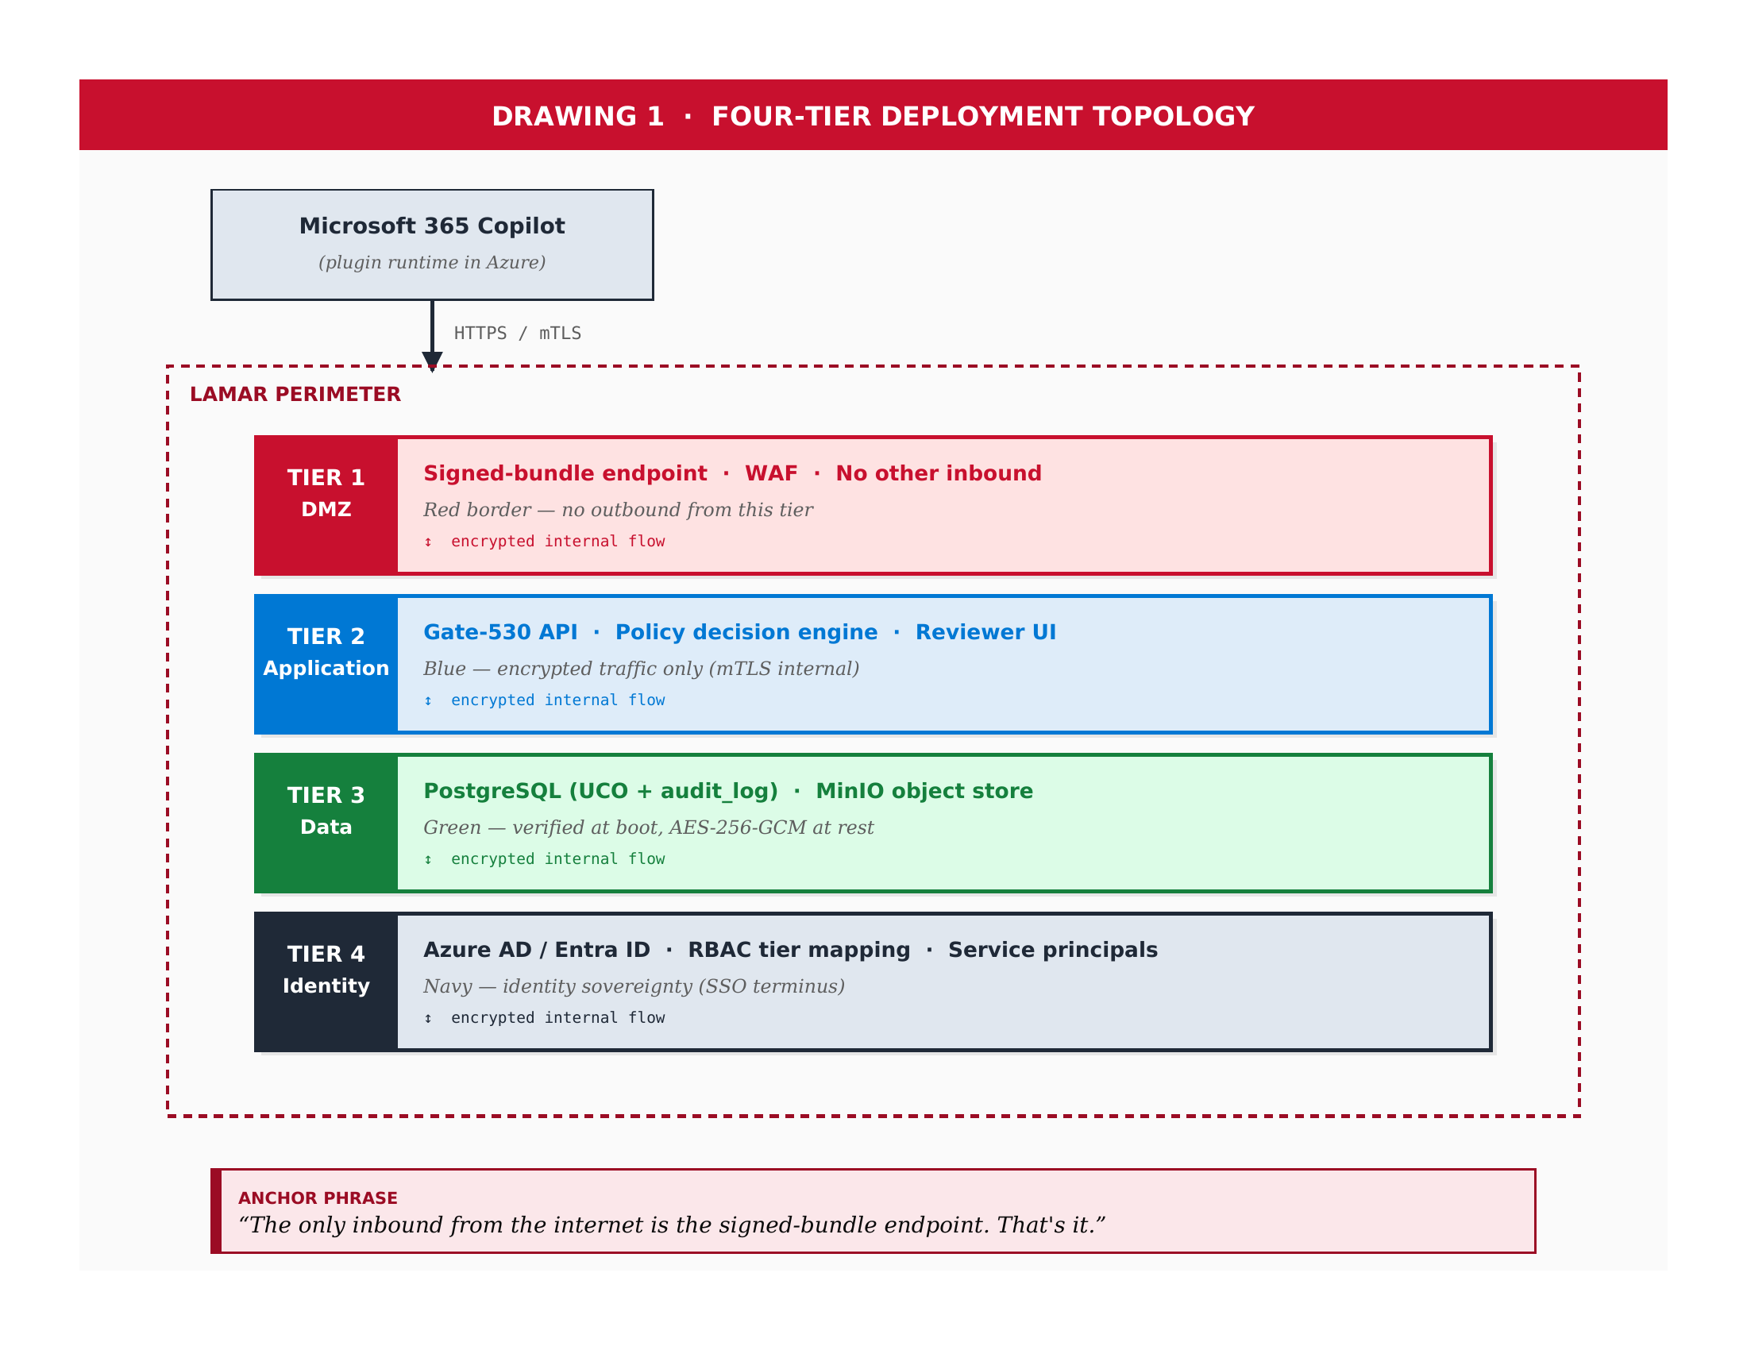
Anchor phrase — say while drawing the DMZ tier:
“The only inbound from the internet is the signed-bundle endpoint. That's it.”
How to reproduce on the whiteboard
STEP | ACTION
1 | Draw a small box labeled 'Microsoft 365 Copilot (plugin runtime in Azure)' at the top of the board. Outside the perimeter.
2 | Draw a vertical arrow down from Copilot to the perimeter, annotated 'HTTPS / mTLS'.
3 | Draw a large dashed-line rectangle labeled 'LAMAR PERIMETER' occupying the lower 3/4 of the board. This is the air-gap indicator.
4 | Inside the perimeter, draw four horizontal bands stacked top-to-bottom: DMZ (Tier 1), Application (Tier 2), Data (Tier 3), Identity (Tier 4).
5 | Color the left edge of each tier: red for DMZ, blue for App, green for Data, navy for IdP. Write the tier label and name in the colored stripe.
6 | Inside each tier, write the service line: DMZ = 'Signed-bundle endpoint, WAF, no other inbound.' App = 'Gate-530 API, PDP, Reviewer UI.' Data = 'PostgreSQL UCO + audit_log, MinIO.' IdP = 'Azure AD / Entra ID, RBAC, service principals.'
7 | Drop the anchor phrase as soon as the DMZ tier is drawn. Don't wait until the diagram is complete.

DRAWING 2 — FERPA BOUNDARY BY ARCHITECTURE
Drawing 2 — FERPA boundary by architecture
The FERPA boundary drawing is what Sri will photograph and carry into the next conversation. It is the architectural answer to the question 'does student data leave Lamar's environment?' — and the answer must be visibly, structurally no, demonstrated in the drawing, not asserted in prose.
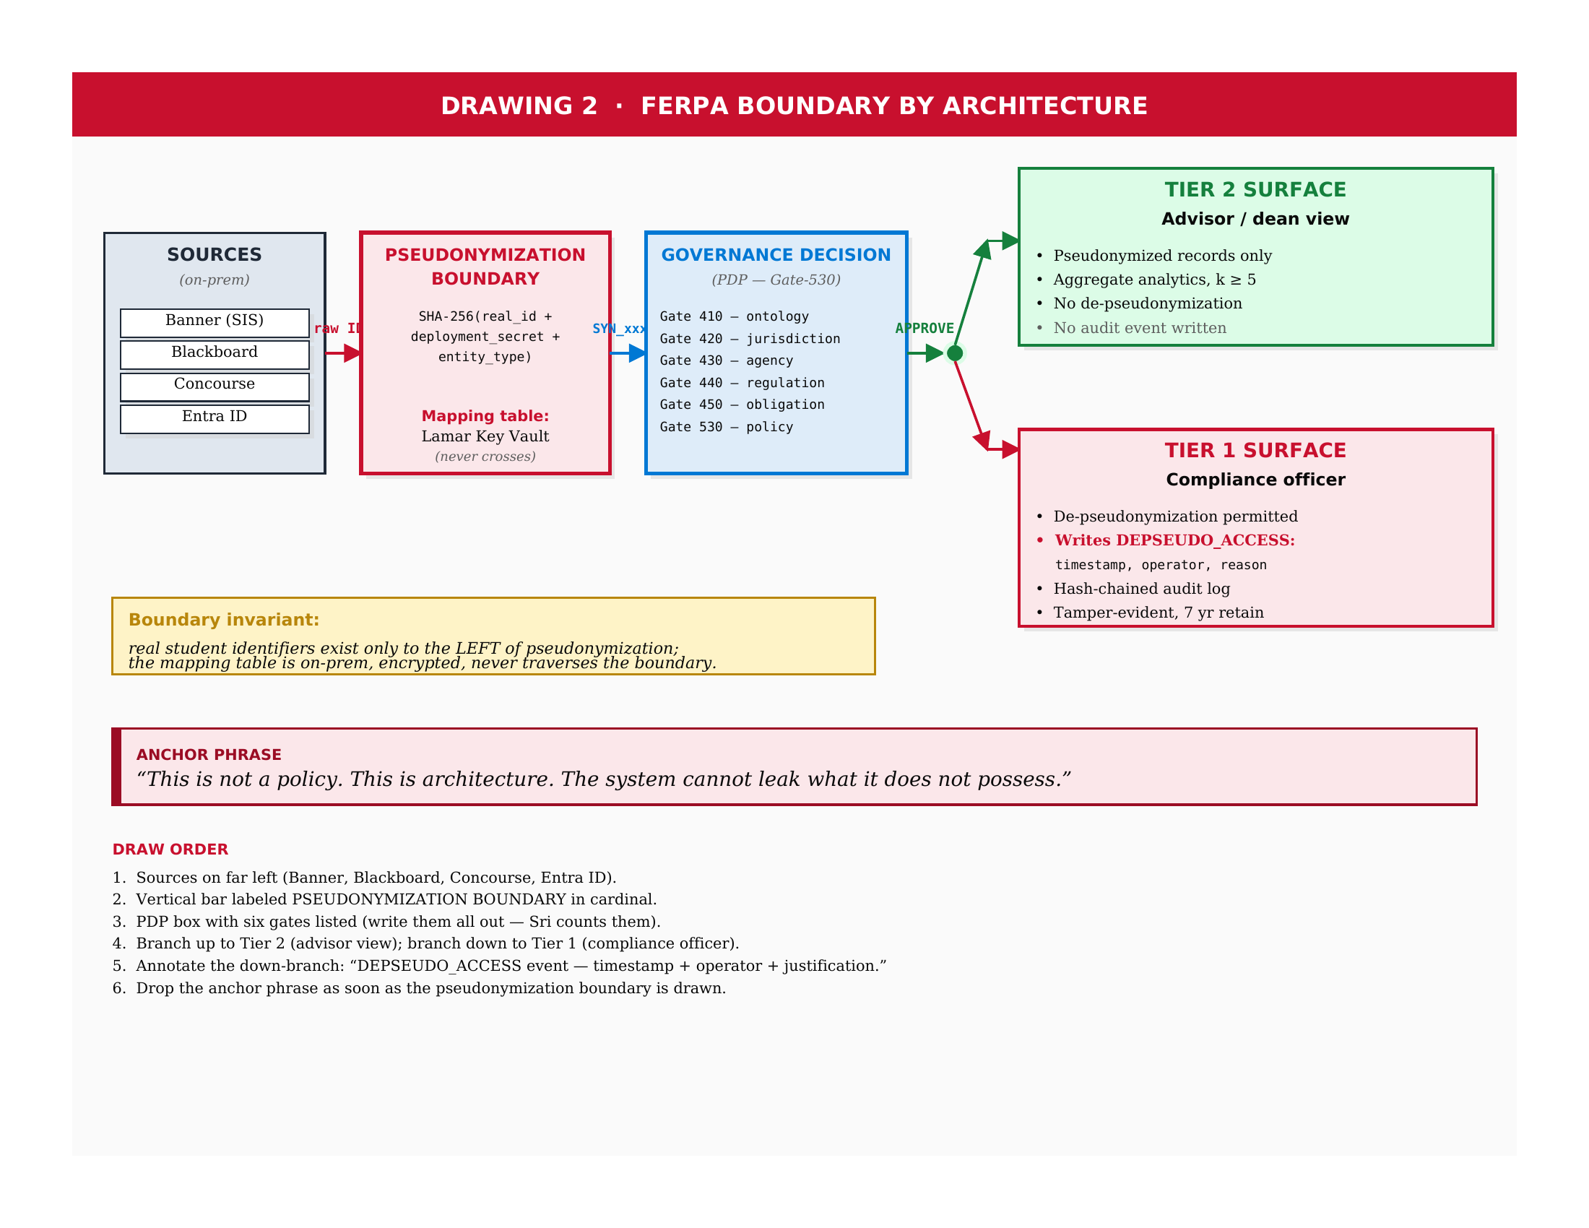
Anchor phrase — say while drawing the pseudonymization layer:
“This is not a policy. This is architecture. The system cannot leak what it does not possess.”
How to reproduce on the whiteboard
STEP | ACTION
1 | Draw the source systems on the far left as a stacked column: Banner (SIS), Blackboard (LMS), Concourse, Entra ID. Annotate as 'on-prem.'
2 | Draw a vertical bar to the right of the sources, labeled 'PSEUDONYMIZATION BOUNDARY' in cardinal red. Write the generation formula: SHA-256(real_id + deployment_secret + entity_type).
3 | Below the formula, note: 'Mapping table: Lamar Key Vault. Never crosses perimeter.'
4 | Draw an arrow leaving the boundary labeled with a sample SYN identifier. This signals what is on the right side of the boundary.
5 | Draw the PDP box (Gate-530) and write all six gates explicitly: 410 ontology, 420 jurisdiction, 430 agency, 440 regulation, 450 obligation, 530 policy. Sri counts them — write all six.
6 | Branch the PDP output: up-arrow to Tier 2 Surface (advisor / dean view, pseudonymized only, k≥5 aggregate); down-arrow to Tier 1 Surface (compliance officer, de-pseudonymization permitted).
7 | Annotate the down-arrow with: 'Writes DEPSEUDO_ACCESS event — timestamp, operator, justification.' This is the audit primitive Sri will probe.
8 | Below the diagram, write the boundary invariant: 'Real student identifiers exist only to the LEFT of pseudonymization. The mapping table is on-prem, encrypted, and never traverses the boundary.'
9 | Drop the anchor phrase as soon as the pseudonymization boundary is drawn — before completing the PDP and surfaces.

DRAWING 3 — SIGNED-BUNDLE PIPELINE
Drawing 3 — Signed-bundle pipeline
The signed-bundle drawing demonstrates how regulatory updates and policy changes enter the on-prem system without compromising the air-gap posture. It is the architectural answer to 'how do you keep the system current without opening a back door?'
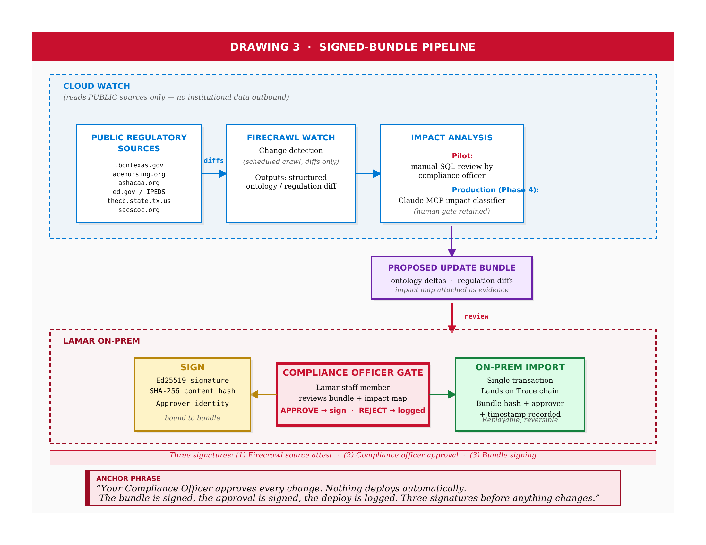
Anchor phrase — say while drawing the compliance-officer gate:
“Your Compliance Officer approves every change. Nothing deploys automatically. The bundle is signed, the approval is signed, the deploy is logged. Three signatures before anything changes.”
How to reproduce on the whiteboard
STEP | ACTION
1 | Draw a dashed rectangle across the top of the board labeled 'CLOUD WATCH (reads PUBLIC sources only — no institutional data outbound).'
2 | Inside the cloud zone, draw three boxes left to right: Public Regulatory Sources (tbontexas.gov, acenursing.org, ashacaa.org, ed.gov, thecb.state.tx.us, sacscoc.org); Firecrawl Watch; Impact Analysis.
3 | Under Impact Analysis, write the pilot-vs-production distinction: 'Pilot: manual SQL review by compliance officer. Production (Phase 4): Claude MCP impact classifier, human gate retained.'
4 | Draw a downward arrow from Impact Analysis to a purple-outlined box in the middle of the board labeled 'PROPOSED UPDATE BUNDLE — ontology deltas, regulation diffs, impact map attached.'
5 | Below the bundle, draw a second dashed rectangle labeled 'LAMAR ON-PREM.' This is the on-prem zone.
6 | Inside the on-prem zone, draw the Compliance Officer Gate in the center, in cardinal. Annotate: 'APPROVE → sign. REJECT → logged.'
7 | To the left of the gate, draw the SIGN box (gold). Annotate: 'Ed25519 signature, SHA-256 content hash, approver identity bound to bundle.'
8 | To the right of the gate, draw the ON-PREM IMPORT box (green). Annotate: 'Single transaction, lands on Trace chain, bundle hash + approver + timestamp recorded. Replayable, reversible.'
9 | At the bottom of the on-prem zone, write the three-signature emphasis: '(1) Firecrawl source attest, (2) compliance officer approval, (3) bundle signing.'
10 | Drop the anchor phrase as soon as the Compliance Officer Gate is drawn.

SEQUENCING DISCIPLINE
Sequencing discipline
The three drawings have a fixed order. Each builds on what came before. Drawing them out of sequence undermines the architectural narrative. Drawing too quickly defeats the demonstration of fluency. Drawing too slowly loses the room. The pacing target is 5 to 7 minutes per drawing, with the anchor phrase delivered approximately one-third of the way through each drawing — not at the end.
DRAWING | ESTABLISHES | OPEN QUESTIONS IT INVITES
Drawing 1 | The physical deployment topology and the inbound/outbound boundary. | What goes through the signed-bundle endpoint? How do the tiers communicate internally? (Drawing 3 answers the first; Drawing 2 begins to answer the second.)
Drawing 2 | The data boundary — what crosses pseudonymization and what does not. | How are synthetic IDs generated, and what happens if the mapping leaks? (Pre-Meeting Q&A concern #2.) How do regulatory updates affect the PDP gates? (Drawing 3 answers.)
Drawing 3 | The change-control pipeline for regulatory updates. | What is the compliance officer's actual workflow? (Operational runbook in the leave-behind.) How does Lamar reject a proposed update? (REJECT path; logged.)
Marker discipline
Use fresh markers. Three colors minimum: cardinal red, navy blue, forest green. Optional: gold for the SIGN box in Drawing 3. Test markers on a corner of the board before starting. Faded markers signal lack of preparation; specifically, they signal that the presenter does not draw architecture often enough to have a markers-ready habit. Sri will notice. Patrick will notice. Steven will notice and probably not say anything.
Internalize the three drawings, the anchor phrases, and the step sequences. Close this document the morning of the meeting. When you stand at the whiteboard, the architecture should come from memory, not from the page. The room watches the difference.

