COMP5318 Assignment 2 – Member C report sections (CNN)
Draft for merging into the group report. Headings follow the structure required by the specification. Figure and table numbers carry a “C” prefix so they can be renumbered when merged. All numbers come from memberC_cnn.ipynb and the CSV files in results_cnn/.

Data – Pre-processing (CNN part, for Member A's section)
The CNN uses the original 28×28×3 images rather than the 357 extracted features. The features summarise colour over 4×4 blocks and lose the pixel layout that convolutional filters rely on. The images are pre-processed in two steps, and the 28×28×3 layout is kept throughout:
- Scaling: the 8-bit pixels are converted to floating point and divided by 255, so every value lies in [0, 1].
- Per-channel standardisation: the mean is subtracted from each colour channel and the result divided by the channel's standard deviation. The statistics are computed on the training subset only and reused unchanged for the validation images. For the final model they are recomputed on all 32,000 training images and applied to the test set, which avoids information leakage.
Standardisation was justified by both theory and evidence. H&E images are mostly pink/white, so the scaled channel means are far from zero (0.74, 0.53 and 0.71). Non-centred inputs make gradient descent poorly conditioned and slow it down [10]. Our first full CNN search used only the [0, 1] scaling. The best configuration reached a validation macro F1 of just 0.821, with training accuracy still around 0.87 at the best epoch. Validation tracked training closely, so the network was learning too slowly rather than overfitting. In a 6-epoch check with an identical network, standardising raised validation accuracy from 0.733 to 0.814.
Considered but not used: resizing or cropping (the images are already small, uncentred tissue patches); and rotation/flip augmentation. Augmentation would be valid for histology, but it would multiply the CPU training time and break the like-for-like comparison with the other models, so it is proposed as future work.

Methods

Theory – Convolutional neural network (CNN)
A convolutional neural network is a feedforward neural network designed for data with a grid structure, such as images [1], [2]. Instead of connecting every input pixel to every unit, a convolutional layer slides a small set of learnable filters (kernels, here 3×3 pixels × all input channels) across the image. At every position, each filter computes a weighted sum of the local neighbourhood plus a bias. The result is passed through a non-linear activation (ReLU, max(0, z)), producing one feature map per filter. Three ideas make this effective for images:
- Local connectivity: each unit only looks at a small neighbourhood (its receptive field), matching the fact that informative image structure such as edges, nuclei and fibres is local.
- Weight sharing: the same filter is applied at every position, so a pattern learned in one place is recognised anywhere (translation equivariance). The number of parameters of a convolutional layer, k×k×C_in×C_out + C_out, does not depend on the image size.
- Pooling and hierarchy: max pooling keeps the strongest response in each 2×2 window. This halves the resolution, adds tolerance to small shifts and enlarges the receptive field of later layers. Stacked layers therefore build a hierarchy, from colour blobs and edges to textures and tissue structures.
After the convolutional blocks, the feature maps are flattened and passed to fully connected layers. A softmax output layer turns the scores into a probability for each of the nine classes. All weights are learned end-to-end by back-propagation, minimising the cross-entropy loss with mini-batch gradient descent; we use the Adam optimiser [3]. Dropout [4] randomly sets a fraction of activations to zero during training. This discourages co-adaptation of units and acts as a regulariser; at test time all units are used. Early stopping [5] monitors the validation loss and keeps the weights from the best epoch, which is a second guard against overfitting.

Strengths and weaknesses (CNN contribution)
Member C's points for the joint comparison section; to be merged with Members A and B.
Strengths.
- Uses the spatial structure of the images. PathMNIST classes are defined by tissue texture and cell arrangement: dense dark nuclei for lymphocytes, large empty cells for adipose tissue, fibrous strands for stroma and smooth muscle, and glandular epithelium for adenocarcinoma. These are local patterns that can appear anywhere in a patch. Local filters with shared weights are designed for exactly this, whereas an MLP treats every input independently and has to learn the same pattern separately for each position.
- Learns its own features. In our study, the MLP and the Random Forest both use 357 fixed features (colour mean/std over 4×4 blocks, histograms, quantiles). These describe colour but discard the texture inside each block. The CNN learns which local patterns are discriminative directly from the raw pixels.
- Parameter efficient. Because of weight sharing, the three convolutional layers have only 23,584 (16 base filters) or 93,248 (32 base filters) parameters, however large the image is. A dense layer connected to all 2,352 input values would need 2,352 weights per unit.
- Tolerant to small shifts because of pooling. This suits tissue patches, which are not centred on a single object.
Weaknesses.
- Computational cost. Every filter is evaluated at every spatial position, so the cost grows with image size × number of filters. On our CPU, one CNN epoch took ≈4 s (16 filters) to ≈10 s (32 filters). The MLP trains on 357 features in a few seconds in total. Tuning is therefore far more expensive.
- Many design choices and hyperparameters (depth, filters, kernel size, pooling, regularisation, optimiser), and training is sensitive to them. In our experiments, the network underfitted badly until its inputs were standardised. On unstandardised inputs, batch normalisation also gave very different results in training and inference mode.
- Overfitting risk when the dense layer is large compared with the training data. Regularisation such as dropout and early stopping is needed.
- Low interpretability. Learned filters and feature maps are hard to explain, whereas a Random Forest gives feature importances over named features.
- No built-in rotation invariance. Histology patches have no canonical orientation, but convolution is only equivariant to translation, so rotated versions of a pattern must be learned separately unless augmentation is used.

Architecture and hyperparameters – CNN
The CNN takes the standardised 28×28×3 images. Its architecture is a deliberately small three-block network (Table C1). Each block has one 3×3 convolution (same padding, ReLU), 2×2 max pooling and dropout. Each block also doubles the number of filters while halving the resolution (28 → 14 → 7 → 3), the standard way to trade spatial resolution for more feature channels. After three blocks, the last convolution sees most of the tissue patch. The classifier is one hidden dense layer of 128 ReLU units and a 9-unit softmax output. The model is trained with Adam on sparse categorical cross-entropy (integer labels) and a batch size of 128, the same settings as the MLP.
Table C1. CNN architecture and trainable parameters for the two filter settings (for comparison, Member B's selected MLP has 125,705 parameters).
Layer | Output shape | Params (f = 16) | Params (f = 32)
Input (standardised) | 28×28×3 | 0 | 0
Conv2D 3×3, same, ReLU (f filters) | 28×28×f | 448 | 896
MaxPool 2×2 + Dropout | 14×14×f | 0 | 0
Conv2D 3×3, same, ReLU (2f filters) | 14×14×2f | 4,640 | 18,496
MaxPool 2×2 + Dropout | 7×7×2f | 0 | 0
Conv2D 3×3, same, ReLU (4f filters) | 7×7×4f | 18,496 | 73,856
MaxPool 2×2 + Dropout | 3×3×4f | 0 | 0
Flatten | 576 / 1,152 | 0 | 0
Dense 128, ReLU + Dropout | 128 | 73,856 | 147,584
Dense 9, softmax | 9 | 1,161 | 1,161
Total |  | 98,601 | 241,993

The architecture was chosen from short trial runs on the shared split (6 epochs, 32 base filters, learning rate 0.001), summarised in Table C2.
Table C2. Rough design experiments (standardised inputs unless stated).
Variant | Params | s / epoch | Val acc (epoch 6)
2 blocks, 1 conv each, unstandardised inputs | 422k | 8.6 | 0.733
2 blocks, 1 conv each | 422k | 8.5 | 0.814
3 blocks, 1 conv each (chosen) | 242k | 9.8 | 0.870
2 blocks, 2 convs each | 468k | 16.2 | 0.861
2 blocks + batch normalisation | 422k | 23.4 | 0.855

The third block gave the highest validation accuracy, in about 60% of the time per epoch of two convolutions per block. It also has fewer parameters, because the flattened map is 3×3 rather than 7×7. Batch normalisation (BN) was not used. With unstandardised inputs, its inference-mode accuracy collapsed to about 0.61, even on the training images, while the same network scored about 0.80 on validation when using per-batch statistics. That is a mismatch between BN's running and batch statistics [6], not overfitting. With standardised inputs BN worked, but it was nearly three times slower per epoch on our CPU and still below the three-block network.
Table C3. CNN hyperparameters searched, values, and predicted effects.
Hyperparameter | Values | What it controls | Expected effect (prediction)
Number of filters (base_filters; blocks 2 and 3 use 2× and 4×) | 16, 32 | Number of local patterns each layer can detect, i.e. model capacity. | More filters → richer texture features and better fit, but ≈2× runtime and more parameters (overfitting risk).
Dropout rate (after each block and the dense layer) | 0.0, 0.3 | Fraction of activations dropped during training (regularisation). | Smaller train–validation gap and better validation score if the model overfits; may need more epochs.
Learning rate (Adam) | 0.001, 0.0003 | Step size of the weight updates. | 0.001 converges in fewer epochs; 0.0003 is slower but steadier and may reach a slightly better minimum.

Search method. We ran a full grid search over the 8 combinations, evaluated on the shared stratified validation split: 25,600 training and 6,400 validation images, recreated with the same function and seed as Members A and B. We did not use k-fold cross-validation because each CNN fit takes minutes on a CPU, so five folds would multiply the cost by five. Using the same validation images for every model also keeps the three algorithms directly comparable. Each configuration was trained for up to 30 epochs. Early stopping (patience 5) monitored the validation loss and restored the best weights. Configurations were ranked by validation macro F1, which weights all nine classes equally despite the class imbalance, with accuracy as the tie-breaker. Dropout and learning rate use the same kind of values as the MLP search, so their effect can be compared across the two networks, and the number of filters is the CNN's counterpart to the MLP's hidden-layer width. The final model was retrained from scratch on all 32,000 training images for the number of epochs at which the selected configuration reached its lowest validation loss. It was then evaluated once on the 8,000 test images.

Results and discussion

CNN hyperparameter tuning results
Table C4. CNN grid search on the validation split (selected configuration highlighted). *Training accuracy at the best epoch, measured with dropout active. Total search time 23 min.
Trial | Filters | Dropout | LR | Best / run epochs | Train acc* | Val acc | Val macro F1 | Fit time (s) | s / epoch
1 | 16 | 0.0 | 0.001 | 11 / 16 | 0.895 | 0.8677 | 0.8653 | 65 | 4.1
2 | 16 | 0.0 | 0.0003 | 29 / 30 | 0.905 | 0.8522 | 0.8480 | 118 | 3.9
3 | 16 | 0.3 | 0.001 | 30 / 30 | 0.888 | 0.8961 | 0.8934 | 142 | 4.7
4 | 16 | 0.3 | 0.0003 | 28 / 30 | 0.830 | 0.8317 | 0.8288 | 145 | 4.8
5 | 32 | 0.0 | 0.001 | 6 / 11 | 0.888 | 0.8698 | 0.8668 | 99 | 9.0
6 | 32 | 0.0 | 0.0003 | 13 / 18 | 0.877 | 0.8345 | 0.8297 | 167 | 9.3
7 | 32 | 0.3 | 0.001 | 29 / 30 | 0.937 | 0.9284 | 0.9268 | 317 | 10.6
8 | 32 | 0.3 | 0.0003 | 28 / 30 | 0.889 | 0.8942 | 0.8931 | 323 | 10.8

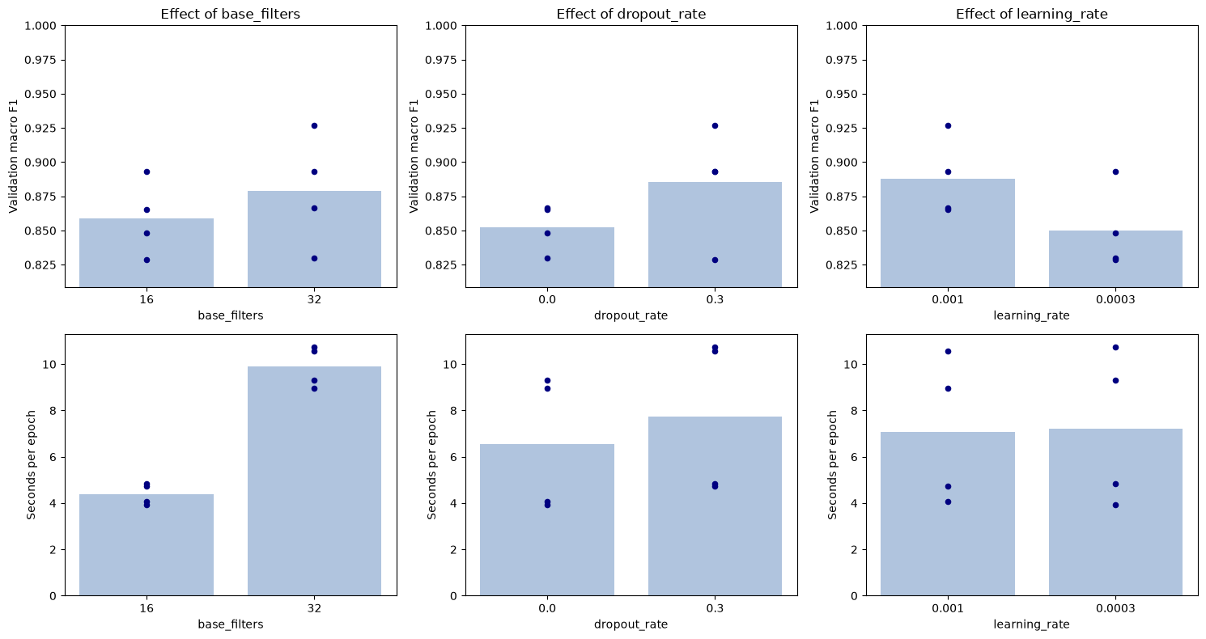
Figure C1. Mean validation macro F1 (top) and seconds per epoch (bottom) for each hyperparameter value; dots are the four individual configurations sharing that value.
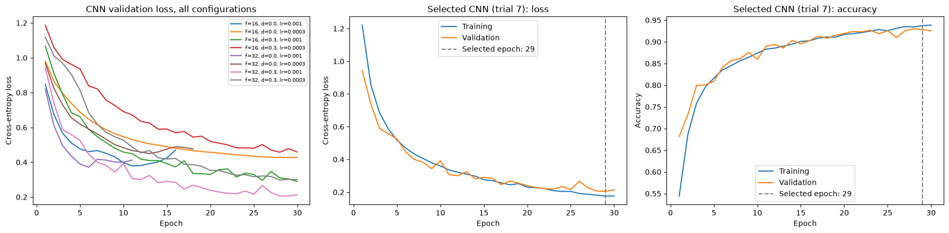
Figure C2. Left: validation loss of all eight configurations. Middle and right: learning curves of the selected configuration, with the selected epoch marked.
The search selected 32 base filters, a dropout rate of 0.3 and a learning rate of 0.001 (trial 7). It reached a validation macro F1 of 0.927 (accuracy 0.928), well ahead of the next-best configurations (0.893 for both trials 3 and 8). The whole search took about 23 minutes on a CPU (Table C4). The trends for each hyperparameter are shown in Figure C1, and the learning curves in Figure C2.
Learning rate had the most consistent effect: 0.001 beat 0.0003 in all four matched comparisons, by 0.017–0.065 macro F1. We had predicted that the smaller step size might reach a slightly better minimum. Within the 30-epoch budget, however, it had not converged: three of the four 0.0003 runs had their best epoch at 28–29, and their validation losses in Figure C2 are still falling. This contrasts with the MLP, where 0.0003 was better. A CNN epoch costs far more, so under a fixed epoch budget the faster rate is more valuable.
Dropout improved validation macro F1 in three of the four matched comparisons, in line with our prediction. The learning curves show why. Without dropout, three of the four runs reached their lowest validation loss early (epochs 6–13) and then overfitted, so early stopping ended them after 11–18 epochs. With dropout, the validation loss kept decreasing until the epoch limit. The one exception (16 filters, learning rate 0.0003) is the slowest-learning combination: slow learning plus regularisation had not converged in 30 epochs.
The number of filters interacted with dropout. With dropout, 32 filters improved macro F1 by 0.033 and 0.064. Without dropout, the gain was negligible or negative (+0.002 and −0.018), because the extra capacity mainly made the network overfit sooner. This only partly matches our prediction that more filters would simply fit better. As predicted, the cost roughly doubled: about 9.9 s per epoch versus 4.4 s, with 2.5× the parameters. Dropout itself added about 15–20% to the time per epoch.
For the selected configuration, training and validation losses decrease together with almost no gap (Figure C2), and the lowest validation loss is at epoch 29 of 30. The model is therefore well regularised, but probably not fully converged. The final model was trained for 29 epochs.

Final CNN model – test set performance
Table C5. Test-set comparison of the final models. RF and MLP values are copied from Members A and B; Member B will produce the final combined table. Times are on each member's local CPU, so they are only roughly comparable.
Model | Best hyperparameters | Test acc | Test macro F1 | Test weighted F1 | Train time (s) | Predict time (s)
Random Forest (Member A) | n_estimators=400; max_features=0.3; max_depth=None; min_samples_leaf=1 | 0.8606 | 0.8562 | — | 300.0 | 0.15
MLP (Member B) | hidden=(256,128); dropout=0.2; lr=0.0003; 33 epochs | 0.8772 | 0.8737 | 0.8770 | 6.4 | 0.09
CNN (Member C) | filters=32/64; dropout=0.3; lr=0.001; 29 epochs | 0.9364 | 0.9343 | 0.9358 | 371.4 | 1.29

The final CNN was retrained on all 32,000 training images for 29 epochs. It reached a test accuracy of 0.936 and a macro F1 of 0.934 (Table C5). This is close to its validation accuracy (0.928), which indicates that model selection did not overfit the validation split. The slight increase is consistent with the 25% larger training set used for the final fit. The CNN clearly outperforms the MLP (0.877 / 0.874) and the Random Forest (0.861 / 0.856): it makes 509 test errors against the MLP's 982. This matches the theory in the Methods section. The CNN learns local texture filters directly from the pixels and shares them across positions, whereas the MLP and the Random Forest only see fixed colour summaries of 4×4 blocks, which discard the texture inside each block.
The price is runtime. Training took 371 s (12.8 s per epoch; more than during tuning because each epoch processes 25% more images). That is about 58 times longer than the MLP's 6.4 s, plus about 23 minutes of hyperparameter search. Prediction for 8,000 images took 1.3 s against 0.09 s for the MLP. The CNN applies every filter at every position of the image, while the MLP multiplies a 357-value feature vector by small weight matrices. The CNN also has more parameters (242k vs 126k), most of them in the dense layer after flattening. The Random Forest's 300 s of training was measured on a different machine, so it is only roughly comparable.

CNN error analysis
Table C6. Per-class test performance of the CNN, with the MLP's F1 (from Member B's notebook) for comparison.
Class | Precision | Recall | F1 (CNN) | F1 (MLP) | Δ F1 | Support
0 adipose | 0.9719 | 0.9920 | 0.9819 | 0.9718 | +0.0101 | 873
1 background | 0.9895 | 0.9872 | 0.9883 | 0.9866 | +0.0017 | 858
2 debris | 0.8547 | 0.9122 | 0.8825 | 0.7912 | +0.0913 | 877
3 lymphocytes | 0.9529 | 0.9967 | 0.9743 | 0.9600 | +0.0143 | 914
4 mucus | 0.9525 | 0.9254 | 0.9387 | 0.8644 | +0.0743 | 737
5 smooth muscle | 0.9214 | 0.9515 | 0.9362 | 0.8651 | +0.0711 | 1072
6 normal colon mucosa | 0.9474 | 0.8988 | 0.9225 | 0.7896 | +0.1329 | 682
7 cancer-assoc. stroma | 0.9050 | 0.7847 | 0.8406 | 0.7543 | +0.0863 | 813
8 colorectal adenocarcinoma epith. | 0.9393 | 0.9489 | 0.9441 | 0.8802 | +0.0639 | 1174

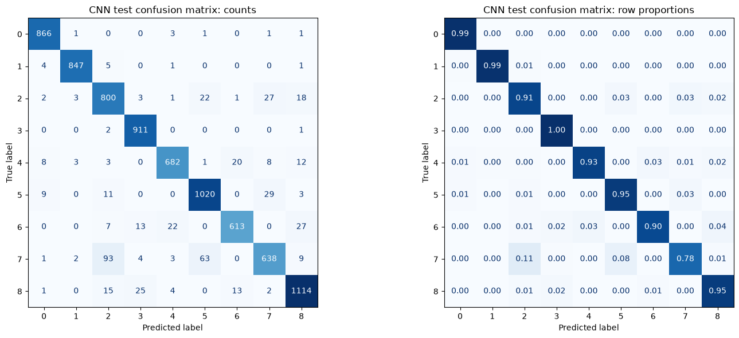
Figure C3. CNN test confusion matrices: counts (left) and row-normalised recall (right). Class IDs: 0 adipose, 1 background, 2 debris, 3 lymphocytes, 4 mucus, 5 smooth muscle, 6 normal colon mucosa, 7 cancer-associated stroma, 8 colorectal adenocarcinoma epithelium.
Table C7. The eight most frequent CNN confusions on the test set.
True class | Predicted as | Count | % of true class
7 cancer-assoc. stroma | 2 debris | 93 | 11.4%
7 cancer-assoc. stroma | 5 smooth muscle | 63 | 7.7%
5 smooth muscle | 7 cancer-assoc. stroma | 29 | 2.7%
2 debris | 7 cancer-assoc. stroma | 27 | 3.1%
6 normal colon mucosa | 8 colorectal adenocarcinoma epith. | 27 | 4.0%
8 colorectal adenocarcinoma epith. | 3 lymphocytes | 25 | 2.1%
2 debris | 5 smooth muscle | 22 | 2.5%
6 normal colon mucosa | 4 mucus | 22 | 3.2%

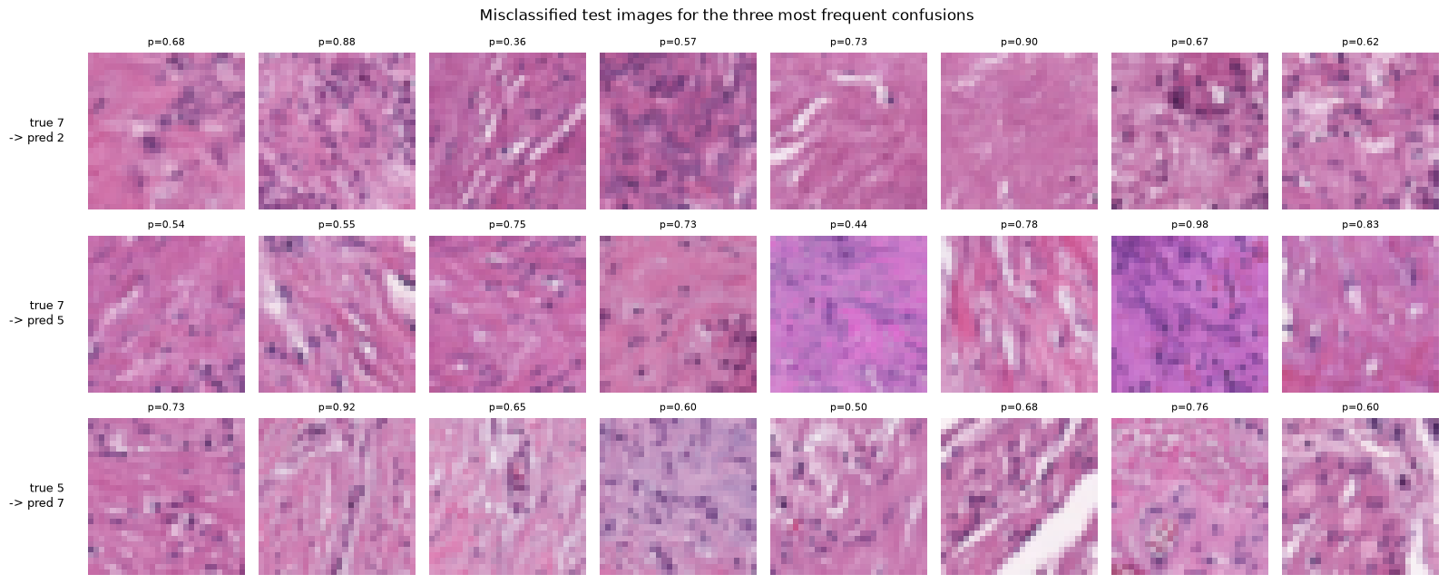
Figure C4. Misclassified test images for the three most frequent confusions; p is the CNN's confidence in its (wrong) prediction.
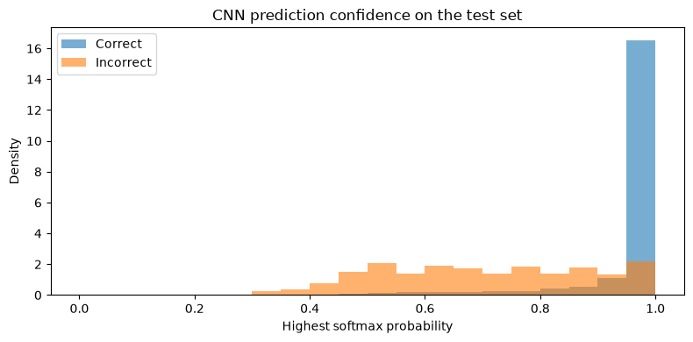
Figure C5. Distribution of the CNN's highest softmax probability for correct and incorrect test predictions.
Per-class results (Table C6, Figure C3) show three groups. Adipose, background and lymphocytes are almost perfect (F1 ≥ 0.97). These classes can be identified by colour alone (white fat, empty background, dense purple nuclei), which is also why the colour-feature MLP does well on them. Mucus, smooth muscle, normal mucosa and adenocarcinoma epithelium reach F1 of 0.92–0.94. Debris (0.88) and cancer-associated stroma (0.84) are the hardest classes. Stroma has the lowest recall (0.78): 11% of stroma images are predicted as debris and 8% as smooth muscle. Smooth muscle and debris are in turn the classes most often mistaken for stroma (Table C7). All three are pink, eosinophilic tissues with a fibrous texture, and the examples in Figure C4 show how similar they look at 28×28 pixels. Other frequent errors are also plausible histologically. Normal mucosa is predicted as adenocarcinoma epithelium (both are glandular epithelium), and adenocarcinoma as lymphocytes (both are dominated by dense dark nuclei).
Compared with the MLP, F1 improves for every class. The largest gains are for normal mucosa (+0.13), debris (+0.09), stroma (+0.09) and mucus (+0.07), the classes defined by texture rather than colour. The gains are smallest for the colour-defined classes (+0.002 to +0.014). This supports the explanation that the CNN's advantage comes from learning spatial texture. The stroma–debris–muscle confusion is the dominant error for both networks, which suggests these classes are intrinsically hard at this resolution rather than a weakness of one model.
Confidence (Figure C5) is informative but imperfect. Correct predictions have a mean highest-softmax probability of 0.96, compared with 0.70 for errors, so a low-confidence flag would catch many mistakes. However, 17.5% of the errors are made with confidence above 0.9. In a clinical screening setting, these confident mistakes are the most dangerous and would still require pathologist review.

Conclusion
Member C coordinates this section. Draft based on all three members' results; please check the RF and MLP statements with Members A and B.

Summary of main findings
This study compared a Random Forest, an MLP and a CNN on a nine-class subset of PathMNIST, tuning each model on the same stratified validation split. The CNN, trained on standardised raw pixels, was the most accurate model (test accuracy 0.936, macro F1 0.934). It was followed by the MLP (0.877 / 0.874) and the Random Forest (0.861 / 0.856), both trained on 357 hand-crafted colour features. The CNN's advantage was concentrated in the texture-defined tissue classes. All three models struggled most with cancer-associated stroma, which is easily confused with debris and smooth muscle.
Accuracy is not the only consideration. The MLP trained in seconds and predicted almost instantly, which makes it a strong, cheap baseline. The CNN needed about six minutes of CPU training, plus a search of about 23 minutes and several design iterations, and its performance depended heavily on input standardisation. The Random Forest is the most interpretable: its feature importances refer to named colour features, whereas the CNN's learned filters are hard to explain. For this task, the CNN's halving of the error count justifies its moderate cost: training once and predicting 8,000 patches in about a second are both practical. However, its confident mistakes mean it should support rather than replace expert review.

Limitations
- Single split and single seed. Every configuration was evaluated once, on one validation split with one random seed, so small differences between configurations (and between models) may be within run-to-run noise. No variance estimate is available.
- Small, coarse search with an epoch cap. Only two values for each of three hyperparameters were tried for the CNN (and the MLP), because of the CPU runtime. The selected CNN was still improving at the 30-epoch limit, so it is probably not fully converged. Depth, kernel size and dense-layer width were fixed after short trials, not tuned.
- Input representation is confounded with the algorithm. The CNN learns from raw pixels, while the MLP and Random Forest use Member A's 357 hand-crafted colour features. The comparison therefore measures “algorithm + input representation”, not the algorithms alone.
- Test set exposure. Member A's early Random Forest experiments had already evaluated the provided test set before the final selection procedure was fixed. The first CNN version (without input standardisation) was also evaluated once on the test set before its underfitting was diagnosed. The CNN redesign was based only on its training and validation curves, but the test set is not strictly unseen for these two models.
- Low resolution and no augmentation. At 28×28 pixels much of the cellular detail pathologists rely on is lost, which is the likely cause of the stroma–debris–muscle confusion. Rotations and flips, which do not change the tissue class, were not used to enlarge the training data.
- Runtime measurements are machine-dependent. Each member trained on a different local CPU, so absolute training times are only roughly comparable across models.

Future work
- Repeat the final comparison over several seeds and stratified folds (e.g. 3 seeds × 5 folds) and report mean ± standard deviation. This would show whether the gaps between the three models are larger than the run-to-run noise, which directly addresses the single-split limitation.
- Train the MLP (and RF) on raw pixels as well as on the extracted features. Comparing MLP-on-pixels with the CNN separates the effect of the convolutional architecture from the effect of the input representation.
- Add rotation/flip augmentation and a longer, scheduled training run for the CNN. Tissue patches have no natural orientation, so the eight 90° rotations and flips of each image are equally valid samples. Combined with more epochs and a decaying learning rate, this targets both the unconverged training and the texture confusions between stroma, debris and smooth muscle.
- Use the higher-resolution MedMNIST+ versions of PathMNIST (64×64 or 128×128) [7]. The dominant errors are between fibrous tissues whose distinguishing cell morphology is lost at 28×28. Higher resolution addresses this directly, at the cost of runtime; a GPU would make that cost manageable.
- Apply stain normalisation (e.g. Macenko [9]). H&E colour differs between laboratories and slides. Normalising it would reduce colour-driven errors and matters most for the colour-based features used by the MLP and RF.
- Calibrate the CNN's probabilities (e.g. temperature scaling) and add a rejection threshold. 17.5% of the CNN's errors were made with confidence above 0.9. Calibrated confidence would let uncertain patches be referred to a pathologist, which is how such a model would realistically be used.

Reflection – Member C
To be written by Member C personally (the specification requires every student to write their own reflection, one or two paragraphs on the most important thing learned).

AI Acknowledgement (Member C's part)
Claude (Anthropic), used through Claude Code, assisted Member C with setting up the Python environment, writing and debugging the CNN notebook code, running the experiments locally, diagnosing the underfitting of the first CNN version, and drafting these report sections from the experiment outputs. All reported numbers come from the executed notebook. Member C reviewed and edited the code and text. [Member C: please check this statement matches how you used AI tools and edit as needed.]

References (cited in Member C's sections)
[1] Y. LeCun, L. Bottou, Y. Bengio, and P. Haffner, “Gradient-based learning applied to document recognition,” Proc. IEEE, vol. 86, no. 11, pp. 2278–2324, 1998.
[2] I. Goodfellow, Y. Bengio, and A. Courville, Deep Learning. MIT Press, 2016, ch. 9.
[3] D. P. Kingma and J. Ba, “Adam: A method for stochastic optimization,” in Proc. ICLR, 2015.
[4] N. Srivastava, G. Hinton, A. Krizhevsky, I. Sutskever, and R. Salakhutdinov, “Dropout: A simple way to prevent neural networks from overfitting,” JMLR, vol. 15, pp. 1929–1958, 2014.
[5] L. Prechelt, “Early stopping – but when?,” in Neural Networks: Tricks of the Trade, Springer, 1998, pp. 55–69.
[6] S. Ioffe and C. Szegedy, “Batch normalization: Accelerating deep network training by reducing internal covariate shift,” in Proc. ICML, 2015, pp. 448–456.
[7] J. Yang et al., “MedMNIST v2 – A large-scale lightweight benchmark for 2D and 3D biomedical image classification,” Scientific Data, vol. 10, art. 41, 2023.
[8] J. N. Kather et al., “Predicting survival from colorectal cancer histology slides using deep learning: A retrospective multicenter study,” PLOS Medicine, vol. 16, no. 1, e1002730, 2019.
[9] M. Macenko et al., “A method for normalizing histology slides for quantitative analysis,” in Proc. IEEE ISBI, 2009, pp. 1107–1110.
[10] Y. LeCun, L. Bottou, G. B. Orr, and K.-R. Müller, “Efficient BackProp,” in Neural Networks: Tricks of the Trade, Springer, 1998, pp. 9–50.

