Random Forest Classification of PathMNIST
  - COMP5318 Assignment 2 | Traditional model contribution

Introduction
This study evaluates a Random Forest classifier as the traditional learning component of the assignment comparison with MLP and CNN models [5]. The aim is to examine how image representation and model complexity affect classification performance and computational cost. On the supplied nine-class dataset, the selected forest achieved 86.06% test accuracy and a macro-F1 of 0.8562. The largest validation improvement came from fixed colour and local texture descriptors, rather than increasing the number of trees. This establishes a classical reference point for evaluating the benefits and costs of learned neural representations.

Data

Data description and exploration
PathMNIST is a nine-class colon histopathology benchmark derived from stained tissue images [1]. We used the assignment-provided subset and splits, rather than downloading the original benchmark: 32,000 training images and 8,000 test images, each with 28 by 28 RGB pixels stored as uint8 values from 0 to 255. The original benchmark split sizes therefore do not describe this experiment. Numeric labels 0 to 8 are retained to match the supplied arrays.
Class | 0 | 1 | 2 | 3 | 4 | 5 | 6 | 7 | 8
Training count | 3,490 | 3,431 | 3,505 | 3,656 | 2,950 | 4,290 | 2,728 | 3,253 | 4,697

Table 1. Class counts in the supplied training set. The largest class is about 1.72 times the smallest.
The examples in Figure 1 differ in colour intensity, local variation and coarse tissue organisation. Some classes share pink and purple appearances, making colour alone an incomplete description. Individual pixel positions can also vary across tissue patches. These observations motivate comparing raw pixels with spatial summaries and colour distributions; the examples illustrate the motivation, rather than proving that a representation is superior.
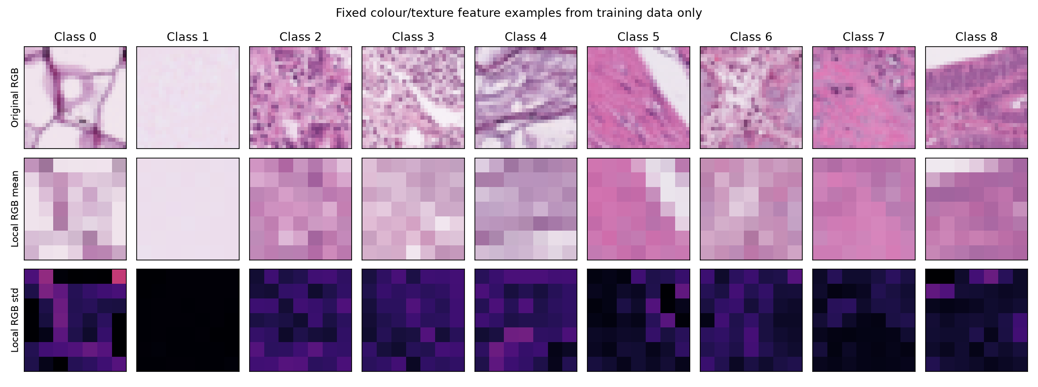
Figure 1. Training examples, 7 by 7 maps of local RGB means, and local standard deviations. Descriptor parameters are fixed; no validation or test statistics are fitted.
A stratified 80/20 split of the supplied training data produced 25,600 fitting samples and 6,400 validation samples, using random_state=42. The same indices were used in every search experiment. Macro-F1, the unweighted mean of the nine class F1 scores, was the selection metric; accuracy was recorded alongside it.

Data

Preprocessing
We compared three representations after dividing pixel intensities by 255. Raw RGB preserves 2,352 pixel features. Average pooling replaces each 2 by 2 region with its RGB mean, producing 588 features; this reduces dimensionality but may remove small structures. The selected descriptor divides the image into 49 non-overlapping 4 by 4 blocks. RGB means and standard deviations give 49 x 3 x 2 = 294 features. Three normalised 16-bin colour histograms contribute 48 features, and five quantiles per channel (10%, 25%, 50%, 75% and 90%) contribute 15, giving 357 features in total.
Block means retain coarse spatial colour information, block standard deviations summarise local variation, and global histograms and quantiles reduce dependence on the exact position of coloured regions. These statistics cannot represent all tissue morphology. Scaling is convenient for histogram bins and interpretation, rather than a necessary correction for tree thresholds. No PCA, augmentation, class reweighting or learned normalisation was used. The fixed transforms require no fitting on validation or test samples.

Methods

Theory
Random Forest was selected because it was covered in Week 5B and provides a nonlinear, non-neural classifier [2, 3]. Each tree is fitted to a bootstrap sample. At a node, a random subset of features is considered and a threshold is chosen to reduce class impurity. Bootstrap sampling and feature randomisation diversify the trees, allowing aggregation to reduce variance relative to a single unstable tree. The implementation uses Gini impurity and predicts the class with the largest mean tree probability, as implemented by scikit-learn [4].

Strengths and weaknesses
The forest captures nonlinear feature interactions without backpropagation or feature standardisation. Its capacity grows through the number and size of trees, rather than a fixed neural weight architecture. However, many deep trees increase memory and computation, and the ensemble is harder to explain than a single tree. It relies on the chosen descriptors: unlike a CNN, it does not learn shared local filters; unlike an MLP, it does not jointly optimise a hierarchy of differentiable transformations. These are theoretical contrasts, not evidence that one of the unreported neural models performs better.

Architecture and hyperparameters
Parameter | Values searched | Expected effect
max_features | sqrt, 0.1, 0.3 | More candidates can strengthen trees, but increase correlation and cost.
max_depth | 16, unlimited | A depth limit restricts fine partitions; unlimited depth increases flexibility.
min_samples_leaf | 1, 4 | Larger leaves smooth partitions and may reduce overfitting.
n_estimators | 100, 200, 400 | More trees stabilise averaging, with diminishing returns and greater cost.

Table 2. Search settings. Fractional max_features values refer to the proportion of input features considered at a split. Bootstrap sampling remained enabled.
A staged hold-out search limited computation: six representation experiments; twelve structural combinations on the best representation, including two reused trials; four tree-count experiments on the two best structures; and four additional seed runs for the two best tree-count candidates. This yielded 24 new fits, in addition to eight archived preliminary fits. Final selection used mean validation macro-F1 over seeds 42, 17 and 73; accuracy broke ties. This design trades search breadth for cost and is not an exhaustive search across all representations and settings.

Results and discussion

Hyperparameter tuning results
Table 3 controls the tree settings while comparing representations. With a minimum leaf size of one, colour and local texture features improved validation macro-F1 by 0.2026 over pooled RGB. Raw pixels performed worse than either alternative in these trials. The result supports the usefulness of explicit summaries for this forest; it does not establish that raw inputs are inferior for a CNN, which can learn different representations.
Representation | Dimensions | Macro-F1 leaf 1 | Macro-F1 leaf 4
Raw RGB | 2,352 | 0.6000 | 0.6011
Pooled RGB | 588 | 0.6216 | 0.6145
Colour and local texture | 357 | 0.8242 | 0.8215

Table 3. Validation macro-F1 with 100 trees, unlimited depth, max_features=sqrt and seed 42.
The 357-dimensional descriptor was then retained for structural tuning. Increasing max_features improved the observed scores across all four depth and leaf combinations (Figure 2). For unlimited depth and leaf size one, macro-F1 increased from 0.8242 with sqrt to 0.8463 with 0.3, while fitting time rose from 9.26 to 60.38 seconds. For this feature count, these settings consider approximately 18 and 107 features per split. Access to more informative split candidates plausibly outweighed increased tree correlation; correlations were not directly measured.
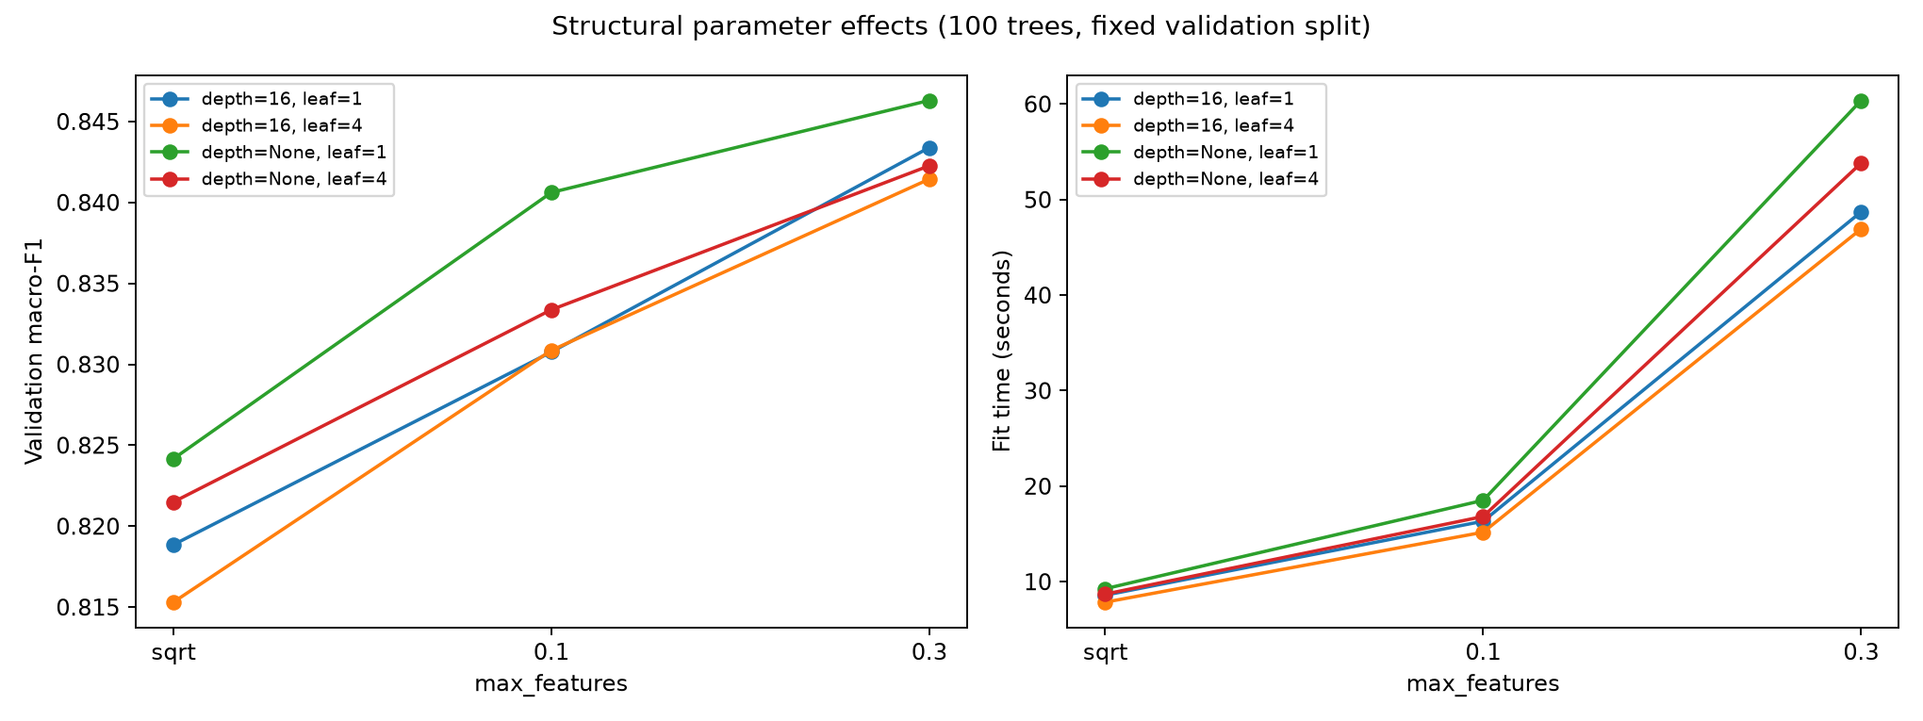
Figure 2. Validation performance and fitting time for the structural grid. All runs use 100 trees, the same fitting subset and seed 42.
Restricting depth to 16 reduced macro-F1 from 0.8463 to 0.8434 when max_features=0.3 and leaf size was one. Increasing the leaf size to four gave 0.8423 with unlimited depth. Thus stronger regularisation did not improve this comparison, despite perfect fitting-set accuracy for the unrestricted forest. A training-validation gap indicates limited generalisation, but does not by itself show that every complexity restriction will improve validation performance.
The original eight trials are preserved separately. Small differences between the original and repeated pooled baselines can arise because normalisation was moved before pooling in the expanded implementation, changing float32 rounding. Claims about representation gains above therefore use the controlled expanded experiments, not an assumed exact replication of the earlier baseline.

Results and discussion

Tree count and stability
Depth | Trees | Val accuracy | Val macro-F1 | Fit seconds
Unlimited | 200 | 0.8536 | 0.8487 | 123.67
Unlimited | 400 | 0.8541 | 0.8493 | 242.01
16 | 200 | 0.8469 | 0.8419 | 95.34
16 | 400 | 0.8483 | 0.8434 | 189.61

Table 4. Tree-count experiments with max_features=0.3, leaf size one and seed 42.
At unlimited depth, increasing the forest from 200 to 400 trees improved macro-F1 by only 0.0007 in the seed-42 run, while fitting time nearly doubled. Repeating the two leading candidates gave the following results on the same validation split.
Trees | Mean val accuracy | Mean val macro-F1 | SD of macro-F1
200 | 0.853646 | 0.848926 | 0.000327
400 | 0.854427 | 0.849764 | 0.000375

Table 5. Means and sample standard deviations across seeds 42, 17 and 73. These measure forest randomness, not uncertainty across different dataset splits.
The 400-tree forest was selected by the predefined mean macro-F1 criterion. Its advantage of 0.000838 over 200 trees is small, so the evidence also supports 200 trees as a lower-cost practical alternative. Three runs on a shared split do not establish statistical superiority across new populations.

Final model performance
The frozen configuration was 400 trees, max_depth=None, max_features=0.3 and min_samples_leaf=1, using the 357-dimensional descriptor. It was refitted on all 32,000 training samples with seed 42, including the previous validation subset, before evaluating the supplied 8,000 test samples.
Measure | Observed value
Test accuracy | 0.860625
Test macro-F1 | 0.856244
Test weighted F1 | 0.859497
Final model fitting | 300.02 s
Training feature extraction | 5.62 s
Test feature extraction | 1.19 s
Test prediction only | 0.151 s

Table 6. Final Random Forest results. Feature extraction, fitting and prediction are timed separately.
Experiments used an Intel Core i7-11800H CPU and n_jobs=4, with scikit-learn 1.9.1 and NumPy 2.3.5. The 24 new search fits totalled 28.60 minutes of fitting time, excluding preprocessing, predictions and persistence. Timing is machine-specific. The final test score is not directly comparable to validation scores as a learning-curve estimate because both the fitted sample count and evaluated samples differ.

Results and discussion

Class level errors
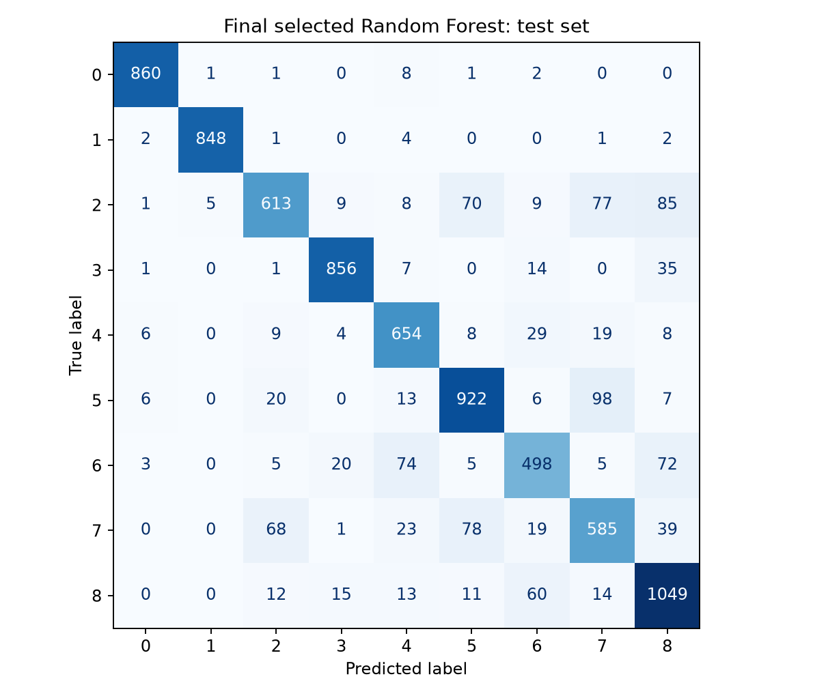
Figure 3. Final test confusion matrix. Rows are true labels and columns are predicted labels.
Class | Precision | Recall | F1 | Support
0 | 0.978 | 0.985 | 0.982 | 873
1 | 0.993 | 0.988 | 0.991 | 858
2 | 0.840 | 0.699 | 0.763 | 877
3 | 0.946 | 0.937 | 0.941 | 914
4 | 0.813 | 0.887 | 0.849 | 737
5 | 0.842 | 0.860 | 0.851 | 1072
6 | 0.782 | 0.730 | 0.755 | 682
7 | 0.732 | 0.720 | 0.726 | 813
8 | 0.809 | 0.894 | 0.849 | 1174

Table 7. Per-class test performance using the supplied numeric class identifiers.
Classes 0 and 1 were recognised particularly well, with F1 scores above 0.98. Class 7 had the lowest F1 (0.726); classes 6 and 2 also remained difficult. The largest individual confusion was class 5 predicted as class 7 (98 images), with 78 errors in the reverse direction. Class 2 was predicted as class 8 in 85 cases and as class 7 in 77 cases. These patterns show that the strong overall accuracy hides uneven performance. Similar descriptor values are a plausible explanation, but a targeted review of these error images is needed before attributing errors to a specific tissue property.

Conclusion
A Random Forest with fixed colour and local texture descriptors provided an effective traditional baseline, reaching 86.06% accuracy and 0.8562 macro-F1 on the supplied test set. Representation choice accounted for the largest observed validation gain. Increasing the candidate feature fraction also improved performance at a substantial computational cost, whereas doubling the final forest from 200 to 400 trees gave only a small gain. The selected configuration prioritised the recorded validation metric; a smaller forest may be preferable when computation or model storage matters.
The experiment has several limitations. Reusing a single validation split across adaptive stages can make model selection optimistic. Seed repetitions assess algorithmic randomness but not split uncertainty. The test set had already been evaluated during the preliminary experiment; the expanded search used validation results only, but the final test set cannot be described as never previously examined. The supplied arrays contain no patient identifiers, so patient-level independence could not be verified. The search was limited to selected settings, and feature choices were not exhaustively tuned. No claim of clinical readiness or of empirical superiority over MLP/CNN follows from these results.
Useful next steps are to evaluate the frozen candidate pipelines with repeated stratified splits within the training data, or patient-grouped splits if identifiers become available; to ablate local means, standard deviations, histograms and quantiles on the same folds; and to inspect class 5/7 and class 2/8 errors before testing richer spatial descriptors. These experiments would distinguish feature contributions and assess whether small tree-count gains persist. The group comparison should use the same supplied test set, consistent metrics and clearly separated preprocessing and inference times.

AI Acknowledgement
OpenAI Codex was used to inspect the assignment and lecture materials, assist with implementation of the Random Forest pipeline, execute and log the experiments, validate saved predictions and metrics, and draft this report and its figures. The experiment results reported here are derived from the saved runs.

References
[1] J. Yang et al., “MedMNIST v2: A large-scale lightweight benchmark for 2D and 3D biomedical image classification,” Scientific Data, vol. 10, article 41, 2023. doi:10.1038/s41597-022-01721-8. Dataset overview: https://medmnist.com/v2 (accessed 20 October 2026).
[2] I. Ullah, “Ensemble Methods,” COMP5318/COMP4318, Semester 2, Week 5B, 2026, slides prepared by I. Koprinska, pp. 29-32.
[3] L. Breiman, “Random Forests,” Machine Learning, vol. 45, pp. 5-32, 2001. doi:10.1023/A:1010933404324. Author manuscript: https://www.stat.berkeley.edu/users/breiman/randomforest2001.pdf.
[4] Scikit-learn developers, “RandomForestClassifier,” scikit-learn documentation. https://scikit-learn.org/stable/modules/generated/sklearn.ensemble.RandomForestClassifier.html (accessed 20 October 2026).
[5] University of Sydney, “COMP5318/COMP4318 Assignment 2: Image Classification,” Semester 2, 2026, assignment specification.

