[Quantum Portfolio] Site Plan

[Sam Geyser]

WDD 130

Overview

Purpose
To provide a space where I can display my work and experience in a stylish way that I will be able to add on to in the future.

Audience
Future Employers

Branding

Website Logo


Style Guide

Color Palette
Primary | Secondary | Accent 1 | Accent 2
#080808 | #1A1612 | #D4AF37 | #E2725B

Typography

Heading Font: Exo 2

Paragraph Font: Open Sans

Navigation
Home Experience Software

Content
<Home Page>


[header] home research/projects about me contact

[heading] Samuel Geyser
[second heading] CS & Quantum Computing Student

[subheading] I am a Computer Science student at Brigham Young University - Idaho, where I am laying the groundwork for a career in Quantum Computing
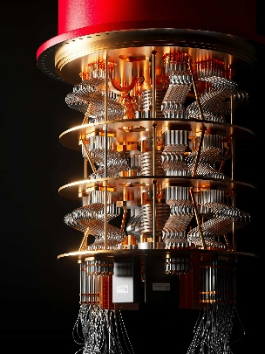
[button 1] DOWNLOAD RESUME
[button 2] ABOUT ME

[subheading] About Me
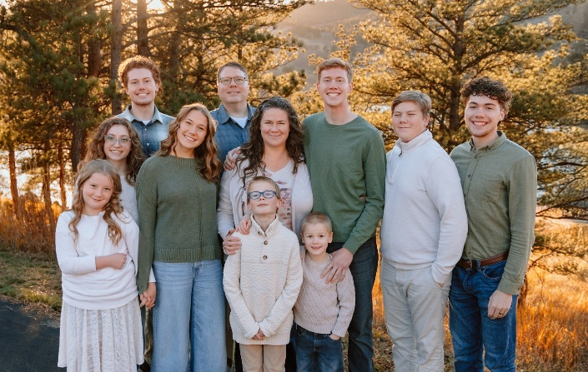
[paragraph] My name is Sam Geyser. I was born in Provo, Utah and raised in Fort Collins, Colorado. I am currently a student at BYU-Idaho studying Computer Science. My hobbies include video games, working on cars, and just about anything outside. I am very interested in computers and how Quantum Physics will soon change the way we think about computing.
[subheading] Experience
[paragraph] My professional experience
[tile 1] Full-Time Missionary
[tile 2] BYU-Idaho Student
[tile 3] Discount Tire
[subheading] Software
[paragraph] A list of my most notable programming projects

[subheading] Contact
[unorder list] samgeyser@gmail.com
(970) 218-0851
[logo external links]
https://app.joinhandshake.com/profiles/geyser-samuel

https://www.linkedin.com/in/samuel-geyser-396847393/

https://github.com/SMGeyser

[footer] home research/projects about me contact

<Experience (Child Page)>

[header] home research/projects about me contact
[heading] Experience
[subheading] Full-Time Missionary
[paragraph] From October 2023 to October 2025 I served as a Full-Time Missionary for the Church of Jesus Christ of Latter-Day Saints in Sacramento, California. As a missionary I learned how to lead and organize groups of people. I served the people of Sacramento, teaching them about the Gospel of Jesus Christ and helping them to plan and set goals to progress spiritually. As a missionary, I served on multiple leadership councils and led meetings for 20+ missionaries to train and teach them how to improve their missionary efforts.
[subheading] CS Student at BYU-Idaho
[paragraph] Starting in January 2026 I became a student at Brigham Young University - Idaho. At school I am majoring in Computer Science and focusing on math and physics in hopes to eventually become a quantum engineer. So far I have learned about Python, HTML5, and CSS in my computer science courses and outside of that I have been learning about Calculus and other general education courses.
[subheading] Discount Tire
[paragraph] I worked at Discount Tire from June 2022 to September 2023. In my time there, I was promoted to Crew Chief and then finally to Service Coordinator. As a Crew Chief, I managed a team of Special Technicians to complete efficient and quality jobs on customers’ vehicles. As a Service Coordinator, I was the middle man between the shop crew and the customer. I ensured customer satisfaction and workplace safety.
[footer] home research/projects about me contact

<Software (Child Page)>

[header] home research/projects about me contact
[subheading] Software

[subheading] WDD 130
[paragraph] I took WDD 130 (Web Fundamentals) in my freshman year in college. In Web Fundamental, I learned the basics of HTML5 and CSS to acquire skills in front end web page development. I learned basic skills that I plan to build on in further programming courses.
See my GitHub for a repository of all of my projects from WDD 130. Most notable from this class is my “Portal Page” and also the website you are on right now!
[subheading] CSE 110
[paragraph] I took CSE 110 (Intro to Programming) my freshman year of college. In this class I learned the basics of Python and developed multiple small projects on Python both individual projects and some in a team with other class members.
See my GitHub for a repository of everything I worked on in that class. Most notable of these projects was an adventure game (week5_prove.py), my own custom “WORDLE” game (week7_prove.py), and a functioning shopping cart program (week9_prove.py)
[subheading] High-School
[paragraph] In High-School, I took multiple Computer and Electrical Engineering classes as well as Bioengineering and Intro to Programming. These classes gave me a good foundation for later programming courses and a base for learning new programming languages. As well in High-School, I took AP Physics, AP Statistics and 3 years of honors Latin. These courses provided me with the work ethic and study skills that I need to be successful both in college and in the career field.
[footer] home research/projects about me contact

Wireframes

Home
