Site Amplification Factors Using 1D Seismic Site Response Analysis in Islamabad: An Application of Building Code of Pakistan 2021
Supervisor
Dr. Muhammad Aqib
Project Team
Ali Hamiz Khan
Jahazaib Gul Abbasi
Hafiz Muhammad Kamran Idrees
Introduction
Building codes use generic seismic design, but site amplification factors consider specific soil conditions to create more earthquake-resistant structures. This project thus delves into earthquake hazards within Islamabad. By collecting data from various sites and classifying them according to the latest Building Code of Pakistan (BCP, 2021), the aim is to develop an understanding of site amplification factors, which indicates how much earthquake shaking intensifies as it travels from firm bedrock to softer surface soils. These factors significantly help understand the influence of earthquakes on structures.
Methodology
Literature Review | Data Collection (Standard Penetration Test and Shear wave velocity) | Data Organization | Classification of Soil according to BCP | Performing One Dimensional Seismic Site Response Analysis on Deepsoil | Site Amplification Factors from the results | BCP Recommendations
Applications
- The findings about the site amplification factors are directly applied to the structures design helping engineers design safer buildings.
- Site amplification data can be used to refine seismic zoning maps, providing a more accurate picture of ground shaking intensity across Islamabad.
- Earthquake hazard mitigation strategies can lead to safer communities and a stronger economy by minimizing building damage and downtime.
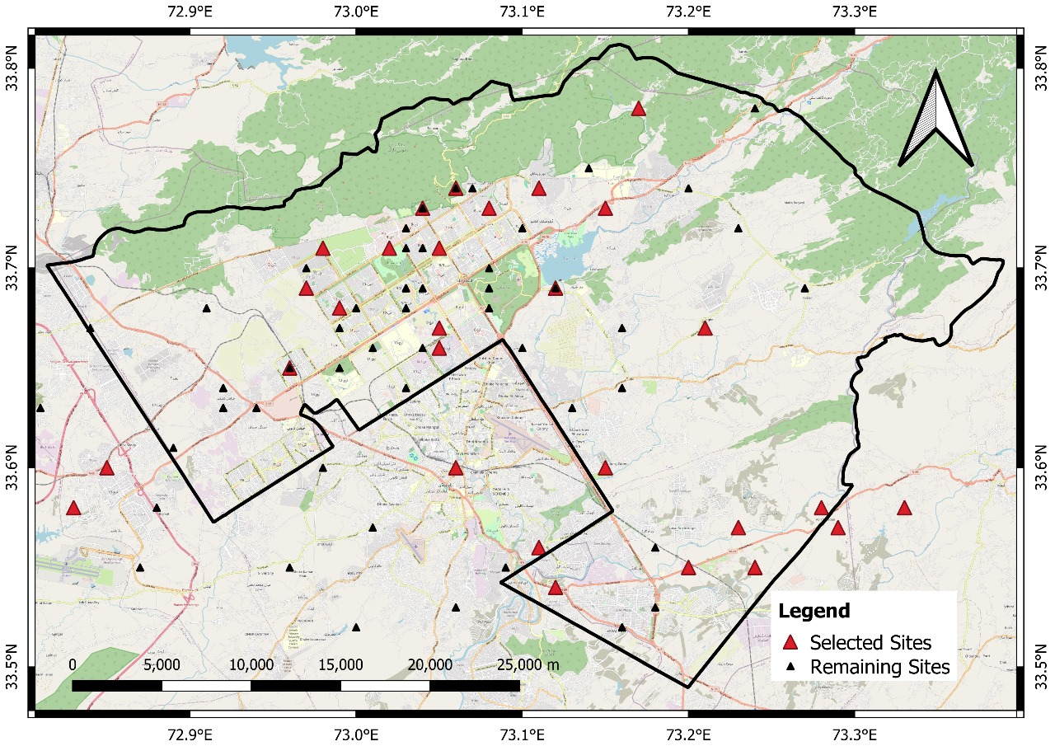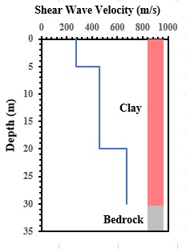
Figure 1. Selected sites of islamabad Figure 2. Shear Wave Velocity(m/s)

