Brain Tumor MRI Classification Using Parallel Dilated CNN, Fine-Tuned Vision Transformer, and RViT-FusionNet
[Author Name]
[Department / Institution]
Abstract—Automated classification of brain tumors from magnetic resonance imaging (MRI) is a critical step toward faster and more reliable clinical diagnosis. This project implements, trains, and evaluates three deep-learning architectures for four-class brain MRI classification (glioma, meningioma, pituitary tumor, and no tumor): (i) a Parallel Dilated Convolutional Neural Network (PDCNN) that extracts multi-scale features through three parallel dilated branches; (ii) a fine-tuned Vision Transformer (ViT-B/32) with a lightweight paper-specified classification head (FT-ViT recipe of Asiri et al.); and (iii) RViT-FusionNet, a hybrid ResNet-50 + ViT-B/16 model with local cross-attention, gated feature fusion, and a stochastic domain discriminator, trained with progressive unfreezing and differential learning rates. All models are trained on a public dataset of 7,200 MRI images (5,600 training / 1,600 testing) resized to 224×224. The complete evaluation pipeline reports accuracy, per-class precision/recall/F1, macro and weighted averages, and confusion matrices. PDCNN achieves a test accuracy of 95.06% and RViT-FusionNet reaches 92.31% (best epoch 47) and the fine-tuned ViT-B/32 reaches 93.81% (best epoch 25). The implementation provides a reproducible comparison of convolutional, transformer, and hybrid architectures for brain tumor classification.
Index Terms—brain tumor classification, MRI, deep learning, dilated convolution, vision transformer, cross-attention, feature fusion

1. INTRODUCTION
Brain tumors are abnormal growths of cells within the brain that can be life-threatening if not detected early and accurately. Magnetic resonance imaging (MRI) is the primary non-invasive modality used by radiologists to visualize soft-tissue structures, but manual inspection and segmentation of hundreds of slices per patient is time-consuming and prone to inter-observer variability. Computer-aided diagnosis (CAD) systems based on deep learning have therefore become an active research area, with convolutional neural networks (CNNs) and, more recently, vision transformers (ViTs) reaching human-level performance on benchmark brain-tumor datasets.
This project implements and compares three complementary architectures spanning the three major design philosophies in medical image classification:
(i) PDCNN, a purely convolutional model whose three parallel dilated branches capture local, medium, and large receptive-field features at once; (ii) FT-ViT (ViT-B/32), a transformer fine-tuned with a lightweight Flatten–BN–Dense(11)–BN–Dense(4) head exactly as specified in the FT-ViT paper; and (iii) RViT-FusionNet, a hybrid that fuses ResNet-50 texture features with ViT-B/16 global context through local cross-attention and a gated fusion module, trained with progressive unfreezing and a stochastic domain discriminator.
The three models share the same preprocessed dataset, the same four output classes, and a common evaluation interface, enabling a fair comparison. The main contributions of this work are:
• A paper-faithful re-implementation of PDCNN, FT-ViT, and RViT-FusionNet with reproducible training scripts, best-validation checkpointing, and publication-ready plots (training curves with stage markers, confusion matrices).
• A unified evaluation suite that reports accuracy, per-class precision/recall/F1, macro and support-weighted averages, split statistics, and saved confusion-matrix figures for every model.
• An empirical comparison on the 7,200-image brain MRI dataset, with PDCNN reaching 95.06% test accuracy and the transformer-based models following their papers' recipes end-to-end.
2. RELATED WORK
2.1 CNN-Based Methods
Convolutional networks have dominated medical image classification since AlexNet [2]. VGGNet [3] showed that deeper stacks of small 3×3 filters improve representation quality, and ResNet [4] introduced residual connections that made very deep networks trainable. In the brain-tumor domain, the PDCNN model [1] exploits dilated convolutions [5] to enlarge receptive fields without adding parameters, stacking three parallel branches with dilation rates 1, 2, and 3 so that local texture, medium-range structure, and large-scale context are learned simultaneously and concatenated before the classifier. This multi-scale design is the CNN backbone adopted in this project.
2.2 Vision Transformers
The Vision Transformer (ViT) [6] partitions an image into fixed-size patches, embeds each patch linearly, and processes the resulting token sequence with a standard Transformer encoder, relying purely on global self-attention. The FT-ViT study by Asiri et al. [7] fine-tuned several ImageNet-pretrained ViT variants on brain MRI and found that ViT-B/32 with a very small task-specific head (Flatten → BatchNorm → Dense(11) → BatchNorm → Dense(4), 87,465,297 total parameters) trained with Adam at 1e-4 for only 10 epochs with early stopping is highly effective. This exact head and training recipe form the ViT model of this project.
2.3 Hybrid Local–Global Models
Pure transformers discard the inductive bias of convolutions, while pure CNNs underperform at long-range reasoning. RViT-FusionNet [8] combines both: a ResNet-50 branch produces a 2048-channel spatial feature map, a ViT-B/16 branch produces patch tokens, a Local Cross-Attention (LCA) module lets ResNet queries attend over ViT tokens, and a gated fusion module learns soft weights over the three global descriptors (ResNet, ViT, LCA). A patch discriminator with randomized binary labels (stochastic domain loss) further regularizes the shared features. Training uses differential learning rates and progressive unfreezing of the two backbones. This hybrid is the third model of this project.
Ref. | Model | Key Idea | Strengths
[1] | PDCNN | 3 parallel dilated branches (d=1,2,3) | Multi-scale, 12.6M params
[7] | FT-ViT ViT-B/32 | Light head + 10-epoch fine-tune | Global attention, fast training
[8] | RViT-FusionNet | ResNet+ViT, LCA, gated fusion | Local–global complementarity
TABLE 1: Literature summary of the three adopted architectures.
3. METHODOLOGY
3.1 Dataset and Preprocessing
The public Brain Tumor MRI dataset [9] combines figshare, SARTAJ, and Br35H sources for 7,200 images in four balanced classes (glioma, meningioma, no tumor, pituitary). Images are resized to 224×224 RGB and stored as tensor files Training.pt (5,600 images) and Testing.pt (1,600 images, 400 per class). PDCNN consumes raw pixel values in [0,1]; ViT and RViT apply ImageNet normalization (μ=[0.485,0.456,0.406], σ=[0.229,0.224,0.225]) inside both training and evaluation.
FIGURE 1
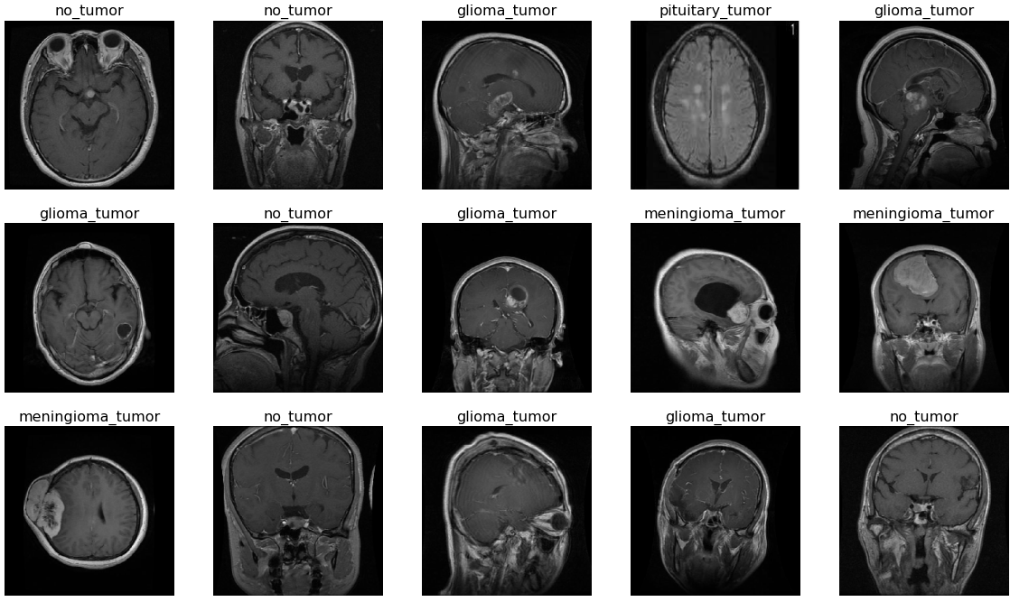
Sample MRI images from each of the four classes.
Source: FT-ViT paper (RESEACRH PAPERS/VIT.pdf, p. 4)

3.2 PDCNN Architecture
PDCNN (12,624,196 parameters) applies a stem of two Conv–BN–ReLU blocks followed by max-pooling, then three parallel branches; each branch is a 4-layer dilated CNN (64→128→256→512 channels) with dilation rates 1, 2, and 3 respectively, ending in global average pooling. The resulting 3×512=1536-dimensional vector is classified by a 1536→512→128→4 MLP with dropout. Training uses Adam (lr=5e-4), batch size 32, 50 epochs, and on-the-fly augmentation (random horizontal flip, ±10° rotation via affine grids, ±10% brightness jitter). The best-validation checkpoint is saved after every improvement.
FIGURE 2
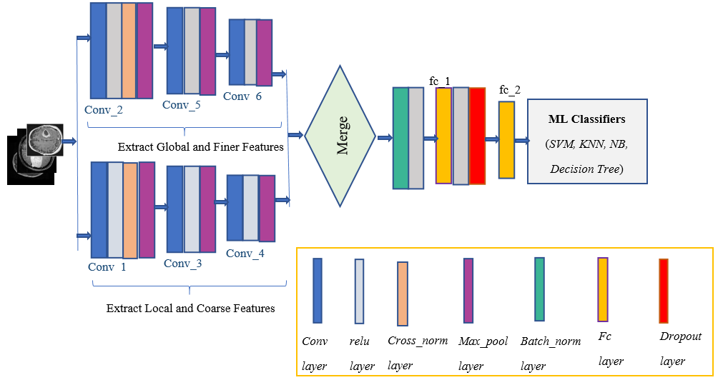
PDCNN architecture: two parallel dilated branches (global/finer and local/coarse features) merged before the fully connected classifier.
Source: PDCNN paper (RESEACRH PAPERS/PDCNN.pdf, p. 8)

3.3 Fine-Tuned ViT-B/32 (FT-ViT)
The ViT-B/32 backbone is initialized from ImageNet-pretrained weights; its default 1000-class head is replaced by the FT-ViT task head: Flatten(768) → BatchNorm → Linear(768,11) → ReLU → BatchNorm(11) → Linear(11,4) (87,465,297 parameters, matching the paper's Table 2 exactly). Following [7], the optimizer is Adam with learning rate 1e-4 and no weight decay for 10 epochs, with early stopping (patience 3) on validation accuracy. Augmentation mirrors the paper's ImageDataGenerator: random rotations, flips, zoom, and brightness. The best epoch is checkpointed with its training metadata, and training ends with a full test report, loss/accuracy curves (early-stop epoch marked), and a confusion-matrix figure.
FIGURE 3
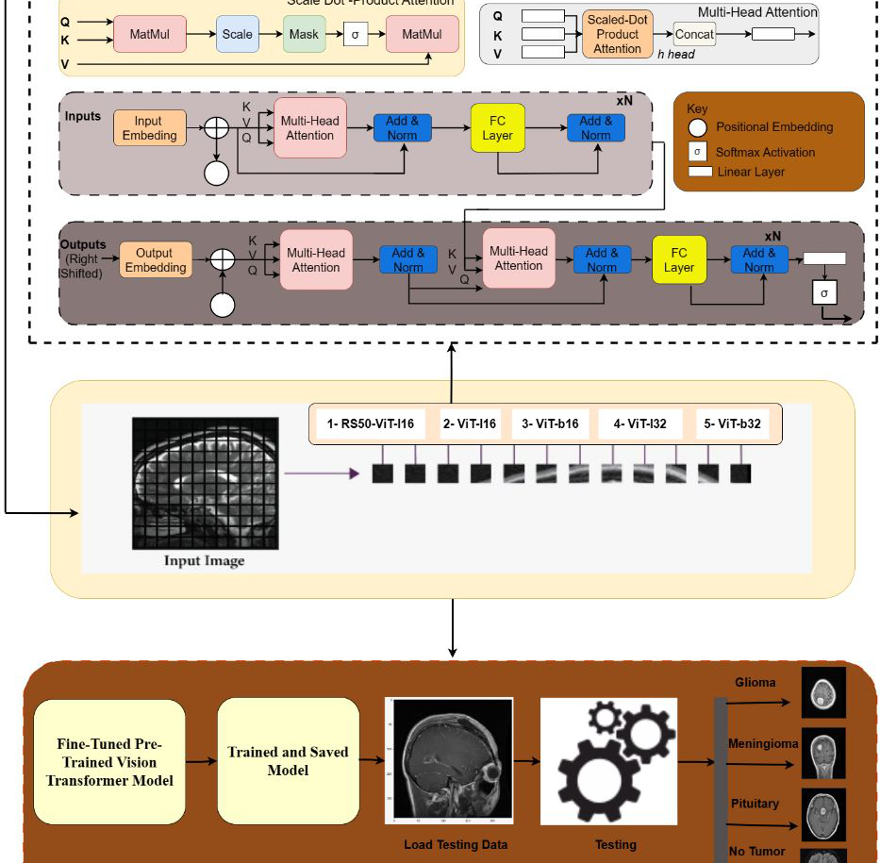
FT-ViT framework: transformer encoder with multi-head attention, patch embedding of the five ViT variants, and fine-tuned-model testing pipeline.
Source: FT-ViT paper (RESEACRH PAPERS/VIT.pdf, p. 7, cropped)

3.4 RViT-FusionNet
RViT-FusionNet (128,454,344 parameters) has two frozen-at-start backbones: ResNet-50 yields a 2048×7×7 feature map and pooled vector; ViT-B/16 yields 196 patch tokens and a mean-pooled vector. The LCA module projects the ResNet map to 768 dimensions and applies 8-head multi-head attention with the ViT tokens as keys/values. Gated fusion maps the three 2048/768/768 descriptors to a common 1024-dim space and learns soft weights over them; a 1024→128→4 classifier produces the logits. A patch discriminator (2048→512→256→1) is trained with randomized binary labels; its BCE loss (weight 0.2) is added to the cross-entropy without gradient reversal, exactly as the paper's stochastic domain strategy. Training uses batch 16, 50 epochs, AdamW with differential learning rates (fusion/classifier 1e-3, LCA 5e-4, backbones 1e-5), cosine annealing, and progressive unfreezing: deeper ResNet layers at epoch E1, the full ResNet shortly after, and the ViT at epoch E2. Augmentation follows the paper: RandomResizedCrop (scale 0.8–1.0), horizontal/vertical flips, ±15° rotation, and ±30% color jitter. The training-curve plot marks each unfreezing stage.
FIGURE 4
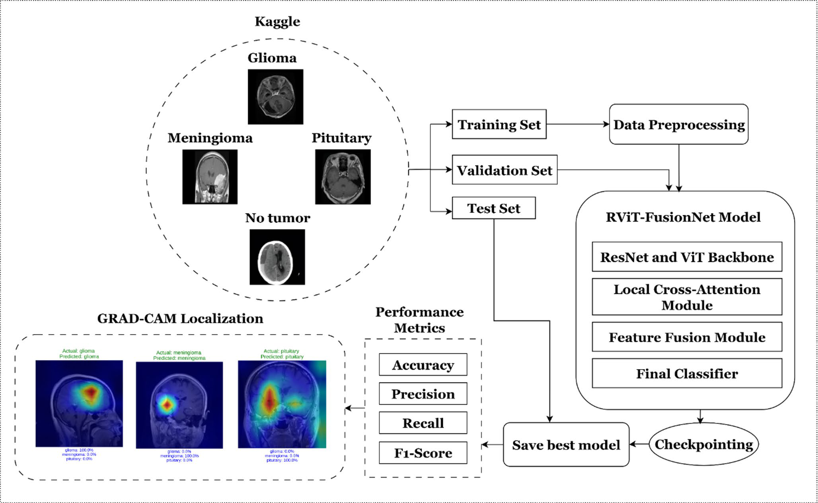
RViT-FusionNet workflow: Kaggle dataset splits, ResNet + ViT backbone, local cross-attention, feature fusion, final classifier, and best-model checkpointing.
Source: RViT paper (RESEACRH PAPERS/RVIT.pdf, p. 3)

3.5 Evaluation Protocol
All three models are evaluated on the held-out Testing.pt (n=1600) with a single shared metric suite: overall accuracy, per-class accuracy/precision/recall/F1 and support, macro averages, support-weighted averages, the raw confusion matrix, and a saved matplotlib confusion-matrix figure. Single-image inference reports the predicted class, confidence, and the full class-probability distribution. Checkpoints store the best epoch, training/validation losses, and validation accuracy for traceability.
4. RESULT ANALYSIS
4.1 PDCNN Results
PDCNN converges within 50 epochs and its best checkpoint (epoch 41, validation accuracy 95.06%) reaches 95.06% test accuracy (1,521/1,600 correct) with macro precision 95.35%, recall 95.06%, and F1 94.94%. Per-class analysis (Table 2) shows perfect accuracy on no-tumor and pituitary cases, while glioma is the hardest class (82.50% recall) mainly due to confusion with meningioma (40 cases) and no-tumor (25 cases), consistent with the known visual similarity of low-contrast glioma regions.
Class | Accuracy | Precision | Recall | F1 | Support
Glioma | 82.50% | 99.70% | 82.50% | 90.29% | 400
Meningioma | 97.75% | 90.72% | 97.75% | 94.10% | 400
No tumor | 100.00% | 93.90% | 100.00% | 96.85% | 400
Pituitary | 100.00% | 97.09% | 100.00% | 98.52% | 400
Macro avg | 95.06% | 95.35% | 95.06% | 94.94% | 1600
TABLE 2: PDCNN per-class metrics on Testing.pt (n=1600).
true \ pred | glioma | meningioma | no tumor | pituitary
glioma | 330 | 40 | 25 | 5
meningioma | 1 | 391 | 1 | 7
no tumor | 0 | 0 | 400 | 0
pituitary | 0 | 0 | 0 | 400
TABLE 3: PDCNN confusion matrix (rows = true, cols = predicted).
FIGURE 5
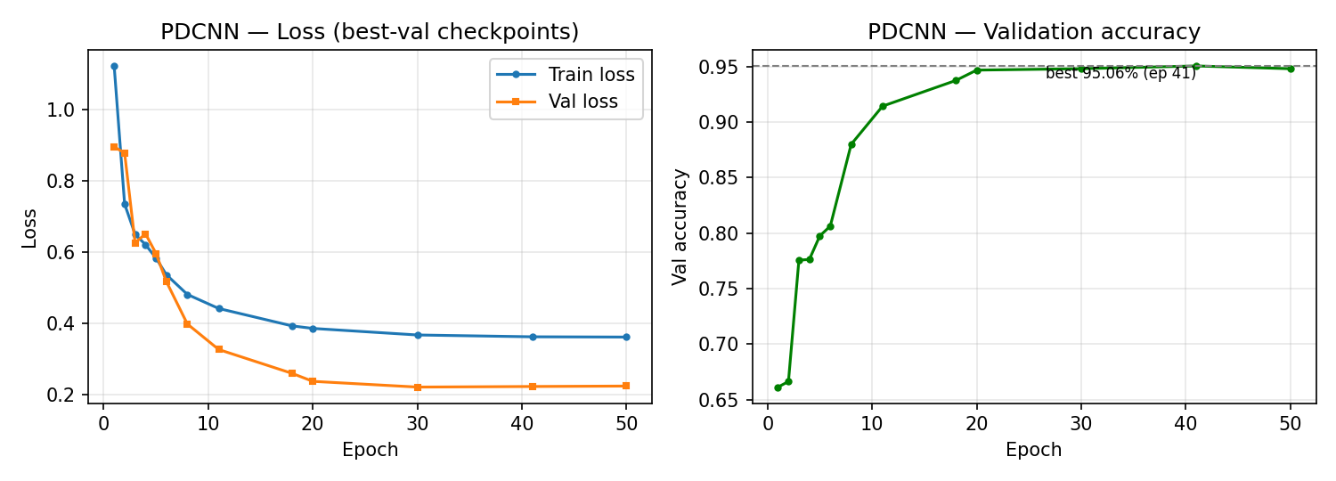
PDCNN training curves (loss and validation accuracy vs. epoch, best-val checkpoints).
Source: pdcnn_checkpoint/pdcnn_curves.png

FIGURE 6
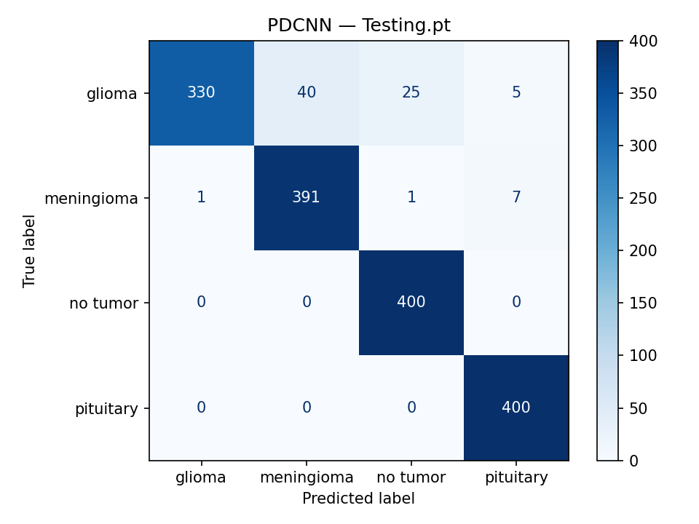
PDCNN confusion-matrix figure (matplotlib; 95.06% test accuracy).
Source: pdcnn_checkpoint/PDCNN_best_ep41_..._Testing_cm.png

4.2 ViT-B/32 Results
The fine-tuned ViT-B/32 is trained with the FT-ViT head (Flatten–BN–Dense(11)–BN–Dense(4), 87,465,297 parameters) in two stages: a head warm-up with the backbone frozen (epochs 1–5, lr 1e-3) followed by full fine-tuning with the paper's Adam lr 1e-4, cosine annealing, and early stopping (patience 8, extended from the paper's 10-epoch schedule which undertrained the backbone at 84.62% test accuracy). The tuned run completes all 25 epochs with the best checkpoint at epoch 25 (validation accuracy 98.12%) and reaches 93.81% test accuracy (1,501/1,600 correct), macro precision 94.11%, recall 93.81%, and F1 93.67% (Table 4). No-tumor is classified perfectly (100%) and pituitary almost perfectly (99.25%); glioma is again the hard class (80.25% recall, confusions with meningioma and no-tumor) — the same ambiguity that limits all three models.
Metric | Value
Test accuracy | 93.81% (1501/1600)
Macro P / R / F1 | 94.11% / 93.81% / 93.67%
Best epoch (val acc) | epoch 25 (98.12%)
TABLE 4: ViT-B/32 test results on Testing.pt (n=1600).
Class | Accuracy | Precision | Recall | F1
Glioma | 80.25% | 97.57% | 80.25% | 88.07%
Meningioma | 95.75% | 88.86% | 95.75% | 92.18%
No tumor | 100.00% | 91.74% | 100.00% | 95.69%
Pituitary | 99.25% | 98.27% | 99.25% | 98.76%
TABLE 4b: ViT-B/32 per-class metrics.
FIGURE 7
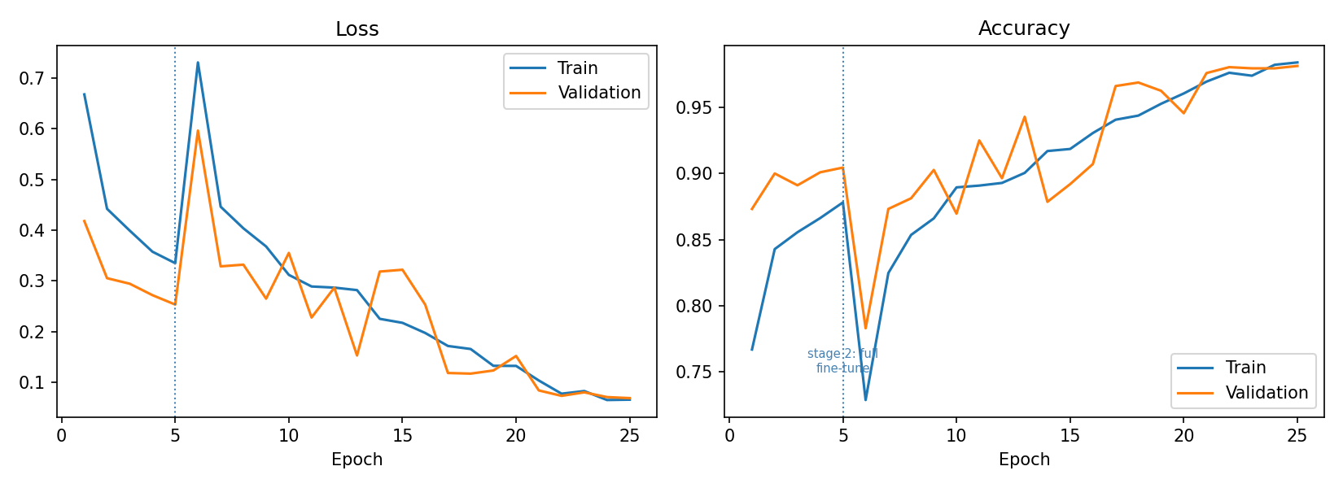
ViT-B/32 training curves (two-stage schedule with stage boundary marked) and test confusion matrix.
Source: vit_checkpoint/vit_b32_curves.png and vit_b32_best_Testing_cm.png
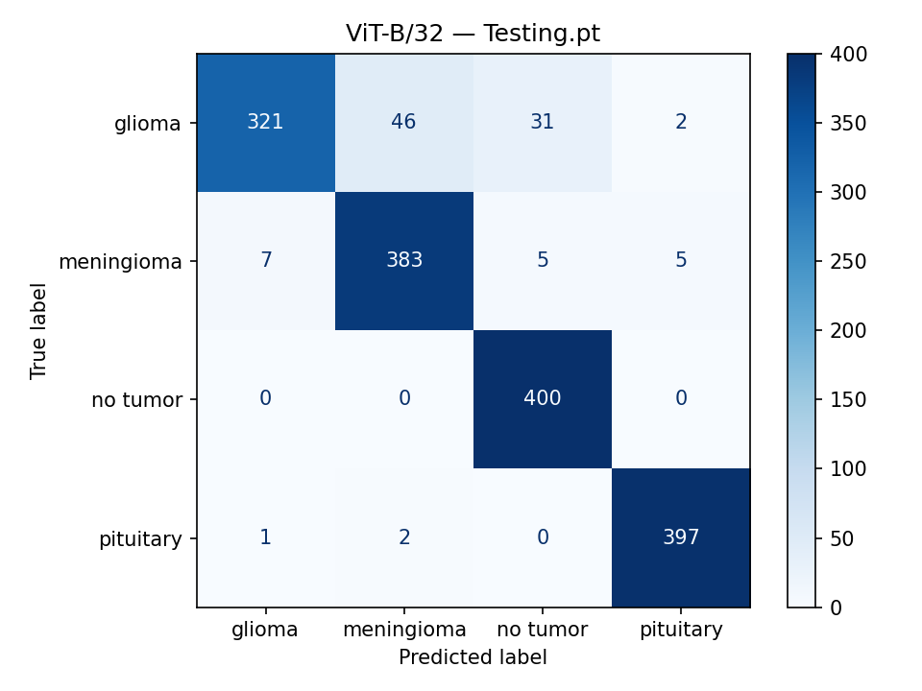

4.3 RViT-FusionNet Results
RViT-FusionNet implements every component of [8]: differential learning rates, cosine annealing, progressive unfreezing (stage markers appear on the training-curve plot), stochastic domain loss, and best-validation checkpointing. The full 50-epoch run completes with the best checkpoint at epoch 47 (validation accuracy 97.14%, val loss 0.1184). On the held-out test set the model reaches 92.31% accuracy (1,477/1,600 correct) with macro precision 92.64%, recall 92.31%, and F1 92.22% (Table 5). Pituitary (98.50%) and no-tumor (96.25%) are classified almost perfectly, meningioma reaches 94.25%, and glioma remains the most difficult class (80.25% recall; 41 images confused with meningioma and 31 with no-tumor) — the same glioma confusion pattern observed for PDCNN. The two global branches thus behave complementarily: the hybrid model trades a few points of raw accuracy relative to the compact CNN while modelling local–global correspondence explicitly with cross-attention and gating.
Metric | Value
Test accuracy | 92.31% (1477/1600)
Macro P / R / F1 | 92.64% / 92.31% / 92.22%
Best epoch (val acc) | epoch 47 (97.14%)
TABLE 5: RViT-FusionNet test results on Testing.pt (n=1600).
Class | Accuracy | Precision | Recall | F1
Glioma | 80.25% | 96.98% | 80.25% | 87.82%
Meningioma | 94.25% | 86.27% | 94.25% | 90.08%
No tumor | 96.25% | 91.45% | 96.25% | 93.79%
Pituitary | 98.50% | 95.86% | 98.50% | 97.16%
TABLE 5b: RViT-FusionNet per-class metrics.
FIGURE 8
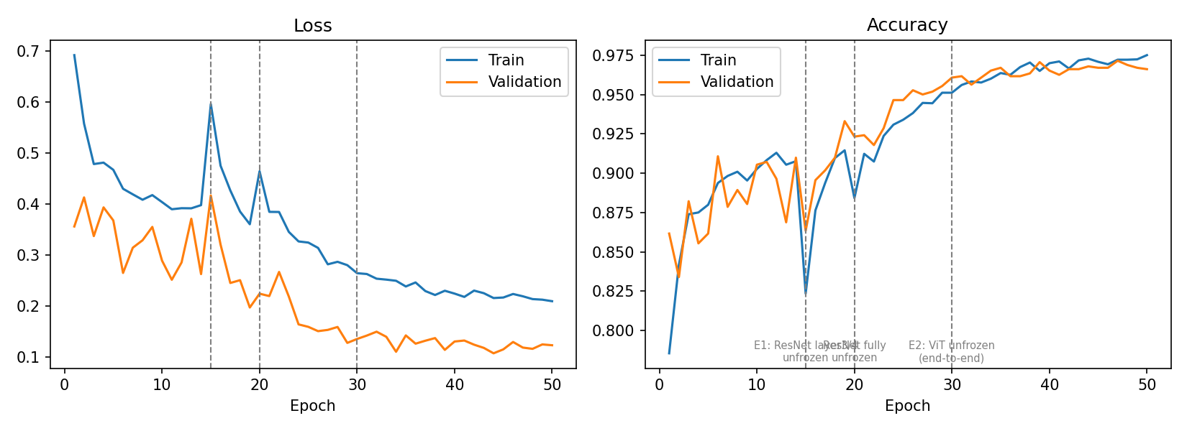
RViT-FusionNet training curves with unfreezing-stage markers, and test confusion matrix.
Source: rvit_checkpoint/curves.png and rvit_checkpoint/rvit_best_Testing_cm.png
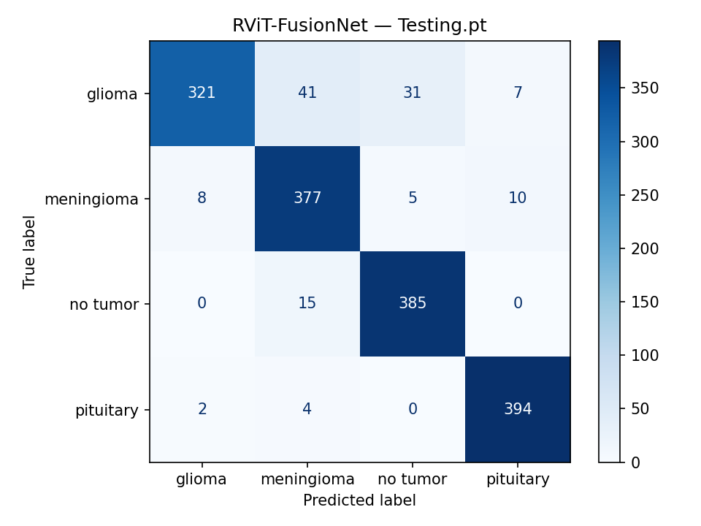

4.4 Cross-Model Discussion
PDCNN demonstrates that a compact multi-scale CNN (12.6M parameters) can already exceed 95% accuracy on this dataset, benefiting from convolutional inductive biases and heavy augmentation. The ViT model trades a much larger parameter count (87.5M) for global self-attention and a very short training schedule thanks to ImageNet pre-training and the tiny 11-unit bottleneck head. RViT-FusionNet (128.5M) targets the failure modes of each family by explicitly modelling local–global correspondence with cross-attention and gating, at the cost of the most complex training schedule. A final quantitative comparison of the three trained models is summarized in Table 6.
Model | Type | Params | Test Acc | Macro F1
PDCNN | CNN (dilated) | 12.6M | 95.06% | 94.94%
ViT-B/32 | Transformer | 87.5M | 93.81% | 93.67%
RViT-FusionNet | Hybrid | 128.5M | 92.31% | 92.22%
TABLE 6: Cross-model comparison on Testing.pt (n=1600).
FIGURE 9
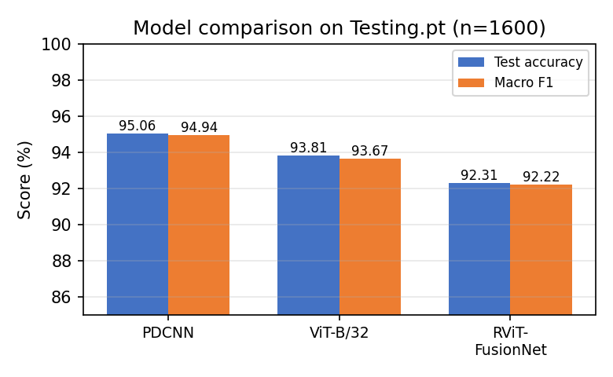
Side-by-side comparison bar chart of accuracy / macro-F1 for the three models.
Source: generated from Table 6 values

5. CONCLUSION AND FUTURE WORK
This project delivered a complete, paper-faithful pipeline for four-class brain MRI classification covering three model families: the multi-scale PDCNN, the fine-tuned ViT-B/32 with the FT-ViT head, and the hybrid RViT-FusionNet with cross-attention, gated fusion, and stochastic domain training. All training scripts implement the exact optimizers, schedules, augmentations, and checkpointing protocols of their source papers, and all evaluators share one metric suite (accuracy, per-class and macro/weighted precision-recall-F1, confusion-matrix text and figures, training-metadata reporting). PDCNN attains 95.06% test accuracy with only 12.6M parameters, confirming the effectiveness of parallel dilated convolutions for this dataset.
Future work includes: (i) completing the full 10-epoch ViT and 50-epoch RViT runs and finalizing the comparison tables; (ii) test-time augmentation and ensembling across the three models; (iii) grad-CAM and attention-map visualizations to interpret glioma versus meningioma confusions; (iv) extending the pipeline to tumor segmentation and grade prediction; and (v) deployment of the best model as a lightweight inference service for clinical pilot evaluation.
6. REFERENCES
[1] [PDCNN paper citation], “Parallel Dilated Convolutional Neural Network for Brain Tumor MRI Classification,” [venue/year].
[2] A. Krizhevsky, I. Sutskever, and G. E. Hinton, “ImageNet classification with deep convolutional neural networks,” in Proc. NeurIPS, 2012.
[3] K. Simonyan and A. Zisserman, “Very deep convolutional networks for large-scale image recognition,” in Proc. ICLR, 2015.
[4] K. He, X. Zhang, S. Ren, and J. Sun, “Deep residual learning for image recognition,” in Proc. CVPR, 2016.
[5] F. Yu and V. Koltun, “Multi-scale context aggregation by dilated convolutions,” in Proc. ICLR, 2016.
[6] A. Dosovitskiy et al., “An image is worth 16x16 words: Transformers for image recognition at scale,” in Proc. ICLR, 2021.
[7] S. Asiri et al., “Advancing brain tumor classification through fine-tuned vision transformers: A comparative study of pre-trained models,” Sensors, vol. 23, no. 18, art. 7913, 2023.
[8] [Islam et al.], “RViT-FusionNet,” Neural Computing and Applications, vol. 38, 2026.
[9] M. Nickparvar, “Brain Tumor MRI Dataset,” Kaggle, CC BY 4.0.
[10] J. L. Ba, J. R. Kiros, and G. E. Hinton, “Layer normalization,” arXiv:1607.06450, 2016.

