Implementation Plan: 8-Bit Retro RPG Gamification Platform
Project: Petualangan Ilmu 8-Bit (SD Edition) | Target Deployment: Vercel Edge
Target Audience: Elementary Students (SD Kelas 1–6) | Visual Style: 8-Bit Retro Pixel Art (Merah-Putih Uniform)
Core Gameplay: Non-Combat Exploration & Archive Puzzle | Tech Stack: Next.js 15, Zustand, Matter.js, jsPDF

1. Executive Summary & Vision
Petualangan Ilmu 8-Bit is a session-based, client-side gamified learning application designed to turn elementary school revision and test preparation into an engaging retro 8-bit adventure. Instead of traditional combat mechanics (HP bars, monster battles, penalty damage), the game employs non-violent exploration, puzzle-solving, and archive discovery (e.g., unlocking enchanted library shelves and constructing crystal bridges across ancient ruins).
★ Core Philosophy & Cultural Resonance
• Zero-Friction Ingestion: Parents upload school notes/photos to NotebookLM, copy the generated Markdown quiz, and load it into the web app to launch a session.
• Culturally Relatable 8-Bit Art Style: Authentic Indonesian elementary school characters (Merah-Putih uniform with red cap or white hijab) styled in clean retro pixel art.
• Cosmetic-Only Customization: Customization revolves around expressive gear (backpacks, magic pencils, magnifying glasses, scout badges, headgear) rather than combat stats.
• No-Fail Learning Loop: Mistakes are met with encouraging mentor hints from the 'Library Guardian Owl' rather than game-over screens.
• Interactive Antigravity Rewards: Physics-driven (Matter.js) floating stars, lore runes, and books on milestone completions.
• Downloadable 8-Bit Certificate: Instant, client-rendered pixel-art scroll diploma showcasing student name, custom avatar, score, and achievement stars.

2. User Interface & Visual Reference
The visual design follows a cohesive 8-bit retro arcade aesthetic featuring Indonesian elementary school students (Merah-Putih attire). Below is the comprehensive 4-panel visual mockup serving as the design blueprint:
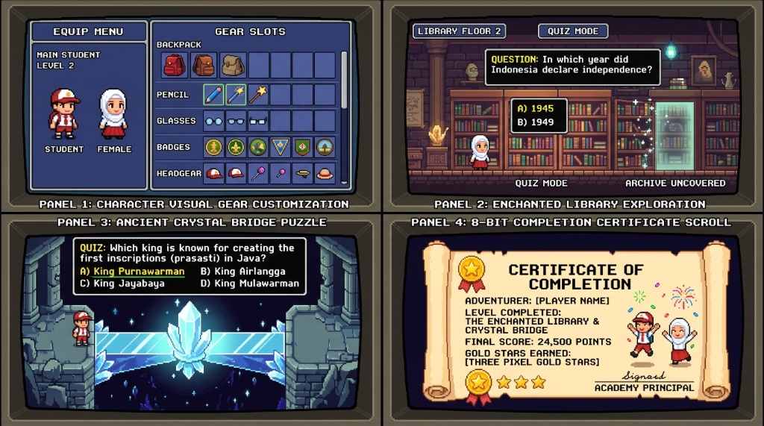
Figure 1: Core 8-Bit RPG Interface Panels (Panel 1: Equip Menu, Panel 2: Enchanted Library, Panel 3: Crystal Bridge, Panel 4: Completion Certificate)
UI Panel Reference | Core Features & Interaction Design
Panel 1: Character Visual Gear Customization | Allows choosing Boy (Red Cap) or Girl (White Hijab) and equipping cosmetic backpacks, giant magic pencils, glasses, scout badges, and headgear with live 8-bit preview.
Panel 2: Enchanted Library Exploration | Floor exploration mode where multiple-choice questions unlock glowing archives. Correct answers release Lore Runes; wrong answers prompt helpful hints from the Owl Guardian.
Panel 3: Ancient Crystal Bridge Puzzle | Overworld traversal across starry floating ruins. Correct quiz answers energize crystalline pedestals, creating luminous bridge pathways for the student sprite to walk across.
Panel 4: 8-Bit Completion Certificate Scroll | Parchment scroll diploma generated dynamically at session end. Features custom avatar with equipped gear, topic title, final score, star rating, and printable seal.

3. System Architecture & Tech Stack
Layer | Technology | Rationale & Key Functionality
Framework | Next.js 15 (App Router, TypeScript) | High-performance React framework with zero-config deployment on Vercel.
Styling & Theme | Tailwind CSS + NES.css / Custom Pixel CSS | Renders 8-bit dialog boxes, pixelated borders, retro buttons, and Press Start 2P fonts.
State Management | Zustand | Lightweight, ephemeral in-memory store for session progress, character gear, and scores.
Physics Engine | Matter.js | Powers 'Antigravity' sandbox effects (zero-g floating books, crystal shards, and reward stars).
File Parser | gray-matter + Custom Markdown AST | Client-side extraction of frontmatter metadata and structured quiz arrays from .md files.
Export Engine | html-to-image + jsPDF | Renders crisp, high-DPI 8-bit completion certificates for PNG download and A4 PDF printing.
Audio Engine | Web Audio API / Howler.js | Chiptune sound effects (gear equip click, page turn, magical chime, fanfare).

4. End-to-End User Flow
1. Ingestion Phase: Parent uploads study materials (photos/PDFs) to Google NotebookLM, prompts it with the provided schema template, and downloads/copies the .md quiz file.
2. Session Launcher: Parent/child drops the .md file into the web app dropzone. The app parses and validates the questions.
3. Character Creation: The child chooses their avatar (Boy with Red Cap or Girl with White Hijab) and equips cosmetic accessories (backpack, magic pencil, glasses, scout badges, headgear).
4. Exploration Quiz Loop: The student navigates through the Enchanted Library and Ancient Crystal Bridge, answering questions to unlock archives and build paths. Hints are provided on incorrect attempts.
5. Antigravity Victory Sandbox: Upon reaching the goal, zero-gravity physics (Matter.js) activate, allowing the student to play with floating reward stars, runes, and books.
6. Certificate Generation: An 8-bit retro parchment diploma is rendered displaying the customized student avatar, final score, star rating, and topic metadata, ready for instant PNG/PDF download.
5. Detailed Component & Feature Specifications
Module A: Material Ingestion & NotebookLM Integration
Parents paste the following standard prompt into NotebookLM to generate the exact Markdown schema required by the app:
You are an expert elementary school teacher. Based on the uploaded study materials, generate a structured quiz containing 10 multiple-choice questions suitable for elementary school students (SD).
Format the output strictly as Markdown following this exact structure:
---
title: "[Insert Subject & Topic Name]"
grade: [Insert Grade Number 1-6]
subject: "[Insert Subject: IPA / IPS / Matematika / Bahasa Indonesia / etc.]"
author: "NotebookLM"
---
### Q1
[Write Question 1 here]
- [ ] [Option A]
- [x] [Option B - Marked with x if correct]
- [ ] [Option C]
- [ ] [Option D]
*Hint: [Write a friendly 1-sentence clue explaining the answer for children]*
### Q2
...

Module B: Character & Cosmetic Gear Customization
Unlike standard RPGs that focus on combat stats (ATK, DEF, HP), this platform features visual-only customization designed to celebrate school identity and self-expression:
Slot Category | Available Options | Visual & Gameplay Meaning
Base Student Avatar | Boy Student (Red Cap, Shorts) / Girl Student (White Hijab, Long Skirt) | Classic Merah-Putih Indonesian elementary school uniform in crisp 8-bit sprites.
Backpack & Satchel | Red Explorer Rucksack, Scout Leather Satchel, Cosmic Pack | Equipped on character back; visible during exploration screen.
Tool / Magic Item | Giant Magic Pencil, Golden Ruler Wand, Starlight Compass, Magnifying Glass | Held in right hand; plays sparkle animation when unlocking archives.
Glasses & Specs | Retro Round Glasses, Smart Square Specs, Detective Monocle, None | Worn on face; adds academic flair.
Badges & Pins | Pramuka / Scout Merit Badge, Golden Honor Star, Science Flask Pin | Pinned to chest uniform; displayed prominently on the final certificate.
Headgear | Official Red SD Cap (Topi SD), Scholar Beret, Explorer Headband, None | Worn on head; authentic cultural styling.

Module C: Non-Combat Exploration Quiz Arenas
1. The Enchanted Library: Questions represent ancient locked archive shelves. Answering correctly unlocks books with glowing particle effects. Answering incorrectly brings up the Guardian Owl with a gentle hint for retry without penalty.
2. The Ancient Crystal Path: Questions activate glowing crystal pedestals that extend bridge tiles across a starry ruin. The customized student sprite walks across tiles in real-time.
Module D: Antigravity Physics Engine (Matter.js)
Upon reaching quiz completion, an interactive Matter.js 2D physics canvas is engaged. Gravity is set to zero or negative, causing books, gold star coins, and lore crystals to float upward. Students can drag, toss, and collide objects across the screen.
Module E: 8-Bit Certificate of Completion
The certificate is rendered in an 8-bit parchment scroll aesthetic (1920x1080 resolution) containing: Student Name, Rendered Custom Pixel Avatar, Subject & Grade metadata, Final Score (%), Gold Star Badge Rating (3-5 Stars), and Academy Wax Seal. Exportable as PNG and printable A4 PDF.
6. Technical Code Architecture
Zustand State Store (store/useGameStore.ts)
import { create } from 'zustand';
export interface QuizItem {
id: number;
question: string;
options: string[];
correctIndex: number;
hint: string;
}
export interface QuizMetadata {
title: string;
grade: number;
subject: string;
author: string;
}
export interface CharacterGear {
gender: 'boy' | 'girl';
backpack: string;
tool: string;
glasses: string;
badge: string;
headgear: string;
}
export interface GameState {
metadata: QuizMetadata | null;
questions: QuizItem[];
currentQuestionIndex: number;
character: CharacterGear;
studentName: string;
score: number;
correctAnswersCount: number;
isFinished: boolean;
loadQuizSession: (metadata: QuizMetadata, questions: QuizItem[]) => void;
setStudentName: (name: string) => void;
updateCharacterGear: (slot: keyof CharacterGear, itemValue: string) => void;
submitAnswer: (optionIndex: number) => { isCorrect: boolean; hint: string };
nextQuestion: () => void;
resetGame: () => void;
}
export const useGameStore = create<GameState>((set, get) => ({
metadata: null,
questions: [],
currentQuestionIndex: 0,
character: {
gender: 'boy',
backpack: 'red_backpack',
tool: 'magic_pencil',
glasses: 'none',
badge: 'scout_badge',
headgear: 'sd_cap',
},
studentName: '',
score: 0,
correctAnswersCount: 0,
isFinished: false,
loadQuizSession: (metadata, questions) =>
set({
metadata,
questions,
currentQuestionIndex: 0,
score: 0,
correctAnswersCount: 0,
isFinished: false,
}),
setStudentName: (name) => set({ studentName: name }),
updateCharacterGear: (slot, itemValue) =>
set((state) => ({
character: { ...state.character, [slot]: itemValue },
})),
submitAnswer: (optionIndex) => {
const { questions, currentQuestionIndex, score, correctAnswersCount } = get();
const currentQ = questions[currentQuestionIndex];
const isCorrect = optionIndex === currentQ.correctIndex;
if (isCorrect) {
set({
score: score + 100,
correctAnswersCount: correctAnswersCount + 1,
});
}
return { isCorrect, hint: currentQ.hint };
},
nextQuestion: () => {
const { questions, currentQuestionIndex } = get();
if (currentQuestionIndex + 1 < questions.length) {
set({ currentQuestionIndex: currentQuestionIndex + 1 });
} else {
set({ isFinished: true });
}
},
resetGame: () =>
set({
metadata: null,
questions: [],
currentQuestionIndex: 0,
score: 0,
correctAnswersCount: 0,
isFinished: false,
studentName: '',
}),
}));

Markdown Parser Engine (lib/markdownParser.ts)
import matter from 'gray-matter';
import { QuizItem, QuizMetadata } from '@/store/useGameStore';
export function parseQuizMarkdown(fileContent: string): {
metadata: QuizMetadata;
questions: QuizItem[];
} {
const { data, content } = matter(fileContent);
const metadata: QuizMetadata = {
title: data.title || 'Petualangan Ujian SD',
grade: Number(data.grade) || 4,
subject: data.subject || 'Materi Umum',
author: data.author || 'Guru / Orang Tua',
};
const questionBlocks = content.split(/###\s+Q\d+/g).filter((block) => block.trim().length > 0);
const questions: QuizItem[] = questionBlocks.map((block, index) => {
const lines = block
.split('\n')
.map((l) => l.trim())
.filter(Boolean);
const questionText = lines[0] || `Pertanyaan ${index + 1}`;
const options: string[] = [];
let correctIndex = 0;
let hint = 'Baca kembali materi dengan seksama!';
lines.slice(1).forEach((line) => {
if (line.startsWith('- [x]') || line.startsWith('- [X]')) {
correctIndex = options.length;
options.push(line.replace(/- \[[xX]\]\s*/, ''));
} else if (line.startsWith('- [ ]')) {
options.push(line.replace(/- \[\s*\]\s*/, ''));
} else if (line.startsWith('*Hint:') || line.startsWith('_Hint:')) {
hint = line.replace(/[*_]Hint:\s*[*_]?/, '').replace(/[*_]$/, '');
}
});
return {
id: index + 1,
question: questionText,
options,
correctIndex,
hint,
};
});
if (questions.length === 0) {
throw new Error('Format file Markdown tidak valid atau tidak memiliki soal.');
}
return { metadata, questions };
}

7. Phased Implementation Roadmap
Phase | Timeline | Core Deliverables & Milestones
Phase 1: Project Setup & Ingestion Engine | Days 1–2 | Initialize Next.js 15 app, Tailwind CSS, NES.css, pixel fonts, Dropzone, and gray-matter Markdown parser.
Phase 2: Character Customizer & 8-Bit Sprites | Days 3–4 | Build layered pixel sprite canvas for Merah-Putih boy/girl avatars and gear slot selector (backpacks, pencils, glasses, badges, caps).
Phase 3: Non-Combat Exploration Quiz Loop | Days 5–6 | Build Enchanted Library and Crystal Bridge exploration interfaces, retro typewriter dialogue, and Guardian Owl hint modal.
Phase 4: Antigravity Physics & Audio | Days 7–8 | Integrate Matter.js zero-g floating debris sandbox with touch/mouse interaction; integrate 8-bit synthesized Web Audio SFX.
Phase 5: 8-Bit Certificate Canvas & Export | Days 9–10 | Design pixel parchment scroll certificate; integrate html-to-image (PNG) and jsPDF (A4 Landscape PDF).
Phase 6: Tablet Testing & Vercel Deploy | Days 11–12 | Optimize touch controls for iPad/Android tablets, zero-config Vercel deployment, and add built-in NotebookLM prompt helper.

8. Quality Assurance & Verification Checklist
- File Ingestion: Uploading a valid .md file correctly loads subject title, grade level, and questions.
- Error Resilience: Malformed Markdown triggers an 8-bit friendly popup with helpful correction tips.
- Real-time Customization: Equipping accessories instantly reflects on the active exploration sprite and final certificate.
- Encouraging Loop: Incorrect answers provide hints without HP deductions or punitive game-over barriers.
- Antigravity Performance: Matter.js physics simulation maintains smooth 60 FPS across desktop, iPad, and mobile browsers.
- High-DPI Certificate: Exported PNG/PDF maintains razor-sharp pixel fonts without blurry scaling artifacts.
- Edge Compatibility: Next.js build deploys cleanly to Vercel with zero server-side state dependencies.

