CHEMISTRY AND BIOLOGY PROJECT

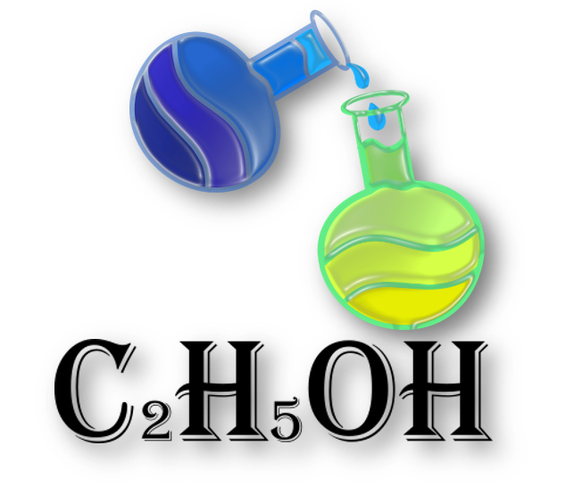Made by

C2H5OH

TABLE OF CONTENT

Team Members 3

Project Description 3

Completed Tasks 4

Method and manner of implementation……………………………………………………………………………………………5

# Team Members

|  |  |
| --- | --- |
| Name | Roles |
| Stiliyan Mishev | Scrum trainer |
| Ivaylo Bachvarov | Back-end developer |
| Martin Velkov | Back-end developer |
| Nikola Paskov | Designer |

Project description

|  |  |
| --- | --- |
| What is the main task? | The main task is to create a game about chemistry and biology. |
| Where to find our project? | You can find our project in GitHub or you can visit this link: https://github.com/SMMishev21/C2H5OH. |
| How we communicated and worked on the project? | During we make the game we communicated on Discord and Teams. We there discuss the game and how it was going. |
| What we are using for make the game? | For make the game we are using a lot of technologies like: Visual Studio and SFML for writing the code, Discord and Teams for communication, Piskel for the design, Power Point for creating the presentation, Word for creating the documentation and Excel for the QA tests. |

Completed Tasks

|  |  |
| --- | --- |
| Number | Tasks |
| 1 | Choosing the best idea  The first thing we have to do is to choose the best idea for game. |
| 2 | Create the design  We need to know what the game will look like and make it |
| 3 | Make the main part of the game  After discussing what the game will look like, we start working on it |
| 4 | Create QA documentation  After finish the game we have to look if all the functions worked and make table of them |
| 5 | Make a readme  In the readme you can get a quick overview of our project |
| 6 | Make presentation  We have made a little presentation so you can see what we have done. |
| 7 | Make documentation  The documentation provides very useful information in terms of the technical aspect. You can learn pretty much everything by reading it. |

| Acquaintance with the tasks and effective work. | The tasks are defined in a way that everyone is aware of the tasks performed so far to present and answer quickly, clearly, and accurately, and teamwork is more effective. |
| --- | --- |
| Allocation of tasks. | For each person there is a chosen task in which he is good and will be able to perform the task in the most competent way possible. |
| Terms | Meeting the deadlines is reminded by the Scrum Trainer. A team meeting is held every week to discuss the time required to complete the assigned task and whether progress is being made. |

METHOD AND MANNER OF IMPLEMENTATION