Gravity, Jumping & Platforms

We will use the default cat sprite for this project.

Create left/right sprite movement code
- Select the cat sprite and create the following code.

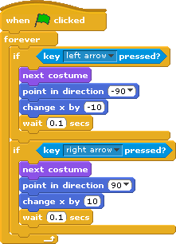
WHAT DOES THIS CODE DO?
This <FOREVER> loop continually checks for key presses and moves your sprite left/right whenever you press the left/right arrow keys on your keyboard. It does a few other things for animation purposes too.

Create gravity & a floor
In the real world, if you drop something, gravity will make it fall until it hits the floor. We we want our sprite to do that too.

- Draw a coloured line across the bottom of your stage – this will be the floor.
- Create a “Y-Speed” variable for your sprite (select “for this sprite only” when creating this variable). In a separate <when green flag clicked> control block, set this variable to 0.


WHAT DOES THIS CODE DO?
The Y-Speed variable will control the movement of your sprite on the screen in the up/down direction.

- Create a <FOREVER> loop that defines your sprite's behaviour under the influence of gravity. This continually checks whether your sprite is in contact with the floor and, if not, makes your sprite fall.

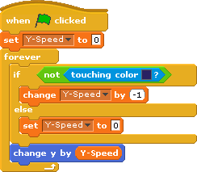
WHAT DOES THIS CODE DO?
In the real world, gravity accelerates an object's downward movement. In our code, we do this by decreasing the sprite's Y-Speed value with every repetition of the <FOREVER> loop while it is in mid-air (the <IF> condition).
In the real world, an object stops falling when it hits the floor. In our code, we do this by setting the sprite's Y-Speed value to zero whenever it is in contact with the floor (the <ELSE> condition).
At the end of every repetition of the <FOREVER> loop the sprite is moved up or down by an amount equal to its current Y-Speed value (the <change Y by Y-Speed> block). This results in the following sprite movement:
  - If Y-Speed > 0, the sprite moves up the screen (sprite is jumping).
  - If Y-Speed < 0, the sprite moves down the screen (sprite is falling).
  - If Y-Speed = 0, the sprite stays where it is (sprite is on the floor).

- TEST YOUR CODE: Click and drag the sprite to the top of the screen and let go. Does the sprite fall to the floor and then stop?
- SAVE YOUR CODE.

Create jumping code
Now that we've dealt with the effects of gravity, let's make the sprite leap into the air when we hit the space bar. We do this by setting the sprite's Y-Speed value to a positive number.

- Construct the following code that will be triggered when the space bar is pressed:

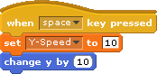
WHAT DOES THIS CODE DO?
You might remember that we have a rule in our gravity code that sets the sprite's Y-Speed value to zero when the sprite is in contact with the floor. While this rule is designed to stop the sprite falling through the floor, it also prevents the sprite from jumping off the floor. Can you see why this happens?
We get around this problem by moving the sprite off the floor at the same time as giving its Y-Speed value a boost.

- TEST YOUR CODE: With the sprite on the floor press the space bar. Does the sprite leap into the air and fall back to the floor?

Fix the jumping cheat
What happens if you press and hold the space bar down? Can you see why this happens?

We don't want the player to be able to cheat in our game. We need to stop the player from being able to boost the sprite's jump in mid-air.

- Place the jumping code inside an <IF> block that tests if the sprite is touching the floor colour.

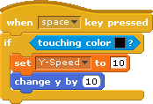
WHAT DOES THIS CODE DO?
The <IF> condition prevents the jumping code from being triggered unless the sprite is touching the floor.

- TEST YOUR CODE: With the sprite on the floor press the space bar. Does the sprite still leap into the air and fall back to the floor? Now repeat the test but keep your finger on the space bar. Have we successfully prevented multiple jumps?
- SAVE YOUR CODE

Jumping through a platform
Let's now see how our code interacts with a platform.

- Add another horizontal line to the stage, part way up the screen. Make this line the same colour as the floor. Make sure this line is low enough for the sprite to be able to jump higher than it. This will be our platform.
- Move your sprite beneath the platform and make it jump. What happens?
- To allow your sprite to jump through the platform, make the code inside the <ELSE> block in the gravity code from step 4 conditional upon the sprite falling:

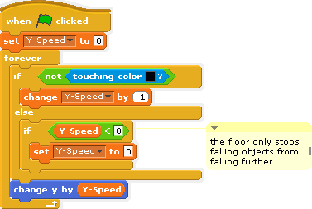

WHAT DOES THIS CODE DO?
You might remember that we have a rule in our gravity code that sets the sprite's Y-Speed value to zero when the sprite is in contact with the floor. While this rule is designed to stop the sprite falling down through the floor, it also stops the sprite from jumping up through the platform. Can you see why this happens?
We get around this problem by preventing the rule that sets the Y-Speed value to 0 from triggering unless the sprite is falling (i.e. when Y_Speed < 0). The floor now only stops falling objects from falling further. It no longer has any effect on rising objects.

  - TEST YOUR CODE: Walk underneath the platform and hit the space bar. Does the sprite jump through the platform from underneath and land on top? Now walk off the end of the platform. Does the sprite fall to the floor?
  - SAVE YOUR CODE

Fixing the platform drag cheat
- Remove the last platform and create a new one that is high enough for your sprite to reach when jumping but too high for your sprite to fully jump through.
- Compare the height that your sprite reaches when you jump without a platform above you and when there is. Is there difference? Can you explain why?
We really want our code to test if our sprite's feet are touching the floor. What our code is actually testing is whether ANY part of the sprite is touching the floor. As soon as the sprite starts to pass through a platform it stops falling. This allows it to continue passing up through the floor as if it is being slurped up by the platform. Look again at the gravity code in step 4. Can you see why this happens? Let's now fix this.
- Create a new sprite. Name this sprite “feet”.
- Create a touching_floor variable for this sprite (select “for this sprite only” when creating this variable).
- Write the following code for your feet sprite:

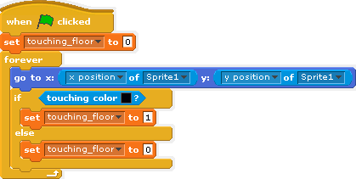
WHAT DOES THIS CODE DO?
What we are doing here is creating a sprite that represents our main sprite's feet and making it follow the main sprite around the screen while continuously testing whether it is touching the floor. However... we may find that it doesn't quite match the position of the main sprite's feet. We'll fix that next.

- Adjust the position that the foot sprite follows (the <go to x:[ ] y:[ ]> block in step 21) so that foot sprite sits directly underneath your main sprite's feet. Use the OPERATOR blocks to add or subtract values to the x & y positions as necessary. Alternatively, you can move the center position of the main sprite (and all its costumes) to be just under its feet. Positioned correctly with your code, the cat and foot sprites should look something like this:

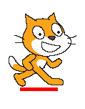
- TEST YOUR CODE: Click and drag your main sprite around the screen. Does the feet sprite follow your main sprite's feet wherever it goes?

Go back to your cat sprite. Where you have <touching colour> blocks, change these to tests for the value of <touching_floor of feet>. This exists in the gravity code as well as the jumping code.

If you want to ensure that the cat stays on top of platforms and the floor and doesn't end up falling partly through them, you can use a <repeat until [not touching colour]> condition to slowly raise the character one pixel at a time to the surface of the floor.

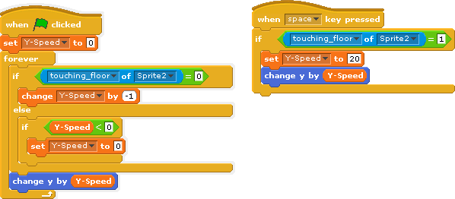
When you are satisfied that your code works as required, you can hide the foot sprite from view

