**Draft SMPTE Standard**

**Warning**

**This document is an unpublished, confidential work under development and shall not be referred to as a SMPTE Standard, Recommended Practice, or Engineering Guideline. It is distributed for review and comment; distribution does not constitute publication. Recipients of this document are strongly encouraged to submit, with their comments, notification of any relevant patent rights of which they are aware and to provide supporting documentation.**

**Information for document editors**

* This template is designed to focus on content and not on style. This means that editors should:
  + Refrain from adding styles inline unless absolutely necessary
  + Refrain from modifying styles unless absolutely necessary
  + Use the sample styles & layouts for all headings, figures, tables and math
  + Use the supplied auto numbering styles for headings and annexes

In the event that the content cannot be adequately expressed using this template, contact SMPTE HQ.

* The blue text (like this sentence) is editing information or boilerplate. This is information used by SMPTE HQ for publication and should not be changed by the author.
* The document editor must fill in the fields in black before submitting it to the Drafting Group.
* The red text (like this sentence) is helpful information that is not part of the final document. This information shall be deleted prior to FCD Ballot.
* The last page of this document has editing hints and a list of useful reference documents.

Project Group: 35PM DG IMF Audio with Metadata

Project Technology Committee: TC 35PM

Document type: ST

Document state: CD

Project chair(s): Dan Tatut / Thomas Heritage

Document editor(s): Dan Tatut / Thomas Heritage

Document number: SMPTE ST 2067-204

Document title: Interoperable Master Format — Audio with ADM Metadata Plug-in

BASED ON 35PM-FCD-ST-2067-203-MGA-S-ADM-Plugin-**20230612 – (N.B. no relevant changes introduced by the -203 version “20230626(Pre-DP-review-package)”**

**Title Page**

This page will be provided by SMPTE HQ Staff.

See AG-16 clause 3.1 (Title Page), and ISO Directive Part 2 clause 11 (Title).

Proposed SMPTE Standard

This document is subject to change.

Copyright  2019 SMPTE

All rights reserved.

Table of Contents Page

Foreword 3

Introduction 3

1 Scope 4

2 Normative References 4

3 Terms and Definitions 5

4 ADM Audio Track File 5

4.1. General 5

4.2. ADM metadata mapping 5

4.3. ADMAudioMetadataSubDescriptor constraints 5

4.4. Audio labeling 6

4.4.1. General 6

4.4.2. ADMSoundfieldGroupLabelSubDescriptor constraints 6

5 Composition 7

5.1. General 7

5.2. Overview (informative) 7

5.3. ADM Audio Virtual Track 8

5.3.1. XML Schema and Namespace 8

5.3.2. ADMAudioSequence element 8

5.3.3. Homogeneous Essence 9

5.3.4. ADMAudioVirtualTrackParameterSet 9

5.3.5. ADMSoundfieldGroupSelectorType type 10

6 Operational Modes 11

6.1. General 11

6.2. Operational Mode A 11

6.2.1. General 11

6.2.2. ADM Audio Track File constraints 11

6.2.3. Operational Mode identification 12

Annex A Illustrated examples for Audio with ADM Metadata Plug-in use cases (informative) 13

Annex B Additional elements (informative) 16

Bibliography (informative) 17

Foreword

SMPTE (the Society of Motion Picture and Television Engineers) is an internationally-recognized standards developing organization. Headquartered and incorporated in the United States of America, SMPTE has members in over 80 countries on six continents. SMPTE"s Engineering Documents, including Standards, Recommended Practices, and Engineering Guidelines, are prepared by SMPTE"s Technology Committees. Participation in these Committees is open to all with a bona fide interest in their work. SMPTE cooperates closely with other standards-developing organizations, including ISO, IEC and ITU.

SMPTE Engineering Documents are drafted in accordance with the rules given in its Standards Operations Manual. This SMPTE Engineering Document was prepared by Technology Committee TC 35PM.

Normative text is text that describes elements of the design that are indispensable or contains the conformance language keywords: "shall", "should", or "may". Informative text is text that is potentially helpful to the user, but not indispensable, and can be removed, changed, or added editorially without affecting interoperability. Informative text does not contain any conformance keywords.

All text in this document is, by default, normative, except: the Introduction, any clause explicitly labeled as "Informative" or individual paragraphs that start with "Note:"

The keywords "shall" and "shall not" indicate requirements strictly to be followed in order to conform to the document and from which no deviation is permitted.

The keywords "should" and "should not" indicate that, among several possibilities, one is recommended as particularly suitable, without mentioning or excluding others; or that a certain course of action is preferred but not necessarily required; or that (in the negative form) a certain possibility or course of action is deprecated but not prohibited.

The keywords "may" and "need not" indicate courses of action permissible within the limits of the document.

The keyword "reserved" indicates a provision that is not defined at this time, shall not be used, and may be defined in the future. The keyword "forbidden" indicates "reserved" and in addition indicates that the provision will never be defined in the future.

A conformant implementation according to this document is one that includes all mandatory provisions ("shall") and, if implemented, all recommended provisions ("should") as described. A conformant implementation need not implement optional provisions ("may") and need not implement them as described.

Unless otherwise specified, the order of precedence of the types of normative information in this document shall be as follows: Normative prose shall be the authoritative definition; Tables shall be next; then formal languages; then figures; and then any other language forms.

Introduction

This clause is entirely informative and does not form an integral part of this Engineering Document.

Audio content with Audio Definition Model (ADM) metadata is created by digital audio production and post-production tools. ADM metadata is specified in Recommendation ITU-R BS.2076 and provides an open, common metadata model for describing audio content beyond just fixed channel-based arrangements. For example, it supports channel-, object-, and scene-based audio to enable immersive and interactive experiences for broadcasting and cinema.

In many workflows (particularly for post-produced audio content) the ADM metadata is carried in BW64 files along with PCM audio (as specified in Recommendation ITU-R BS.2088). Such files can easily be converted to the ADM Audio Track Files defined in this document, allowing the content to be included in IMF Compositions. As such, the ADM-described content can be properly synchronized with related components (such as video), and can be managed, processed, versioned, and archived by IMF systems and workflows.

An ADM Audio Track File (Clause 4):

* carries audio essence: many characteristics are inherited from the IMF Audio Track File (as defined in SMPTE ST 2067-2)
* contains one set of ADM metadata: this is carried in the single <axml> BW64 RIFF Chunk (mapped according to SMPTE ST 2131), which contains a single well-formed XML document
* utilizes all the mechanisms defined in SMPTE ST 2131:20xx (that is, the full SMPTE ST 2131 “toolkit” is used per Clause 4 of the document and so all columns of the table would be marked as applicable for this application): this includes the ADM_CHNASubDescriptor, the ADMAudioMetadataSubDescriptor, the Audio Labeling Framework for ADM-described Content, and the Standard ADM Constraints configuration

As such, the example MXF file described and illustrated in SMPTE ST 2131:20xx, Clause C.1 could be a valid ADM Audio Track File.

Note that the definition of an ADM Audio Track File does not constrain:

* The Profile or Level to which the ADM metadata complies, or whether this is signaled in the ADMAudioMetadataSubDescriptor instance
* The presence of non-ADM XML elements in the <axml> BW64 RIFF Chunk XML document
* The presence of additional RIFF Chunks in the ADM Audio Track File
* The Soundfield Group Label(s) to be used in the Multichannel Audio (MCA) labeling (this means that MCALabelDictionaryID, MCATagSymbol and MCATagName in each ADMSoundfieldGroupLabelSubDescriptor instance can be set using values appropriate for the application)

The ADM Audio Virtual Track and its components are defined in Clause 5. An ADM Audio Virtual Track must conform to an Operational Mode (defined in Clause 6). Illustrated examples for the plug-in are given in Annex A.

Note that this plug-in complements the Audio with Frame-based S-ADM Metadata Plug-in defined by SMPTE ST 2067-203. Both plug-ins are designed to be as similar as possible to aid with interchange and conversion between the formats.

At the time of publication, no notice had been received by SMPTE claiming patent rights essential to the implementation of this Engineering Document. However, attention is drawn to the possibility that some of the elements of this document may be the subject of patent rights. SMPTE shall not be held responsible for identifying any or all such patent rights.

# Scope

This document specifies a plug-in mechanism to add audio with Audio Definition Model (ADM) metadata to IMF Compositions. ADM is specified in Recommendation ITU-R BS.2076. The mapping of ADM metadata (and other audio metadata RIFF Chunks) to MXF is specified in SMPTE ST 2131.

# Normative References

The following standard contains provisions that, through reference in this text, constitute provisions of this standard. Dated references require that the specific edition cited shall be used as the reference. Undated citations refer to the edition of the referenced document (including any amendments) current at the date of publication of this document. All standards are subject to revision, and users of this engineering document are encouraged to investigate the possibility of applying the most recent edition of any undated reference.

Recommendation ITU-R BS.2076, Audio definition model

SMPTE ST 377-1:2019, Material Exchange Format (MXF) — File Format Specification

SMPTE ST 2067-2:2020, Interoperable Master Format — Core Constraints

SMPTE ST 2067-3:2020, Interoperable Master Format — Composition Playlist

SMPTE ST 2131:20xx, Mapping Audio Definition Model (ADM) and other audio metadata RIFF Chunks to MXF (to be published)

World Wide Web Consortium (W3C) (28 October 2004), XML Schema Part 1: Structures (Second Edition)

# Terms and Definitions

For the purposes of this document, the terms and definitions given in SMPTE ST 2131 shall apply.

# ADM Audio Track File

## General

An ADM Audio Track File shall comply with the following subclauses of SMPTE ST 2067-2:2020:

* Subclause 5.1 ("Track Files → Overall")
* Subclause 5.3.2 ("Audio Track Files → Essence")
* Subclause 5.3.3 ("Audio Track Files → Wrapping")
* Subclause 5.3.4 ("Audio Track Files → Wave Audio Essence Descriptor") – except that the Channel Assignment element shall be equal to the AudioLabelingFrameworkADMContent label defined in SMPTE ST 2131
* Subclause 5.3.5 ("Audio Track Files → Additional Generic Sound Essence Descriptor Items")

## ADM metadata mapping

An ADM Audio Track File shall comply with SMPTE ST 2131, with the following constraints:

* The Sound Track in the Top-Level File Package of the ADM Audio Track File shall comply with the Standard ADM Constraints configuration defined in SMPTE ST 2131
* The RIFFChunkDefinitionSubDescriptor instance that describes the <axml> BW64 RIFF Chunk shall be accompanied by an instance of the ADMAudioMetadataSubDescriptor set defined in SMPTE ST 2131 (and further constrained in Subclause 4.3)

## ADMAudioMetadataSubDescriptor constraints

The ADMAudioMetadataSubDescriptor instance shall be constrained in accordance with Table 1.

Table – ADMAudioMetadataSubDescriptor constraints

|  |  |
| --- | --- |
| Item (Symbol) | Constraints |
| ADMProfileLevelULBatch | Should be present |

## Audio labeling

### General

The Top-Level File Package of an ADM Audio Track File shall utilize the Audio Labeling Framework for ADM-described Content defined in SMPTE ST 2131. It shall contain one instance of the ADMSoundfieldGroupLabelSubDescriptor set for each of the soundfield groups described by the ADM metadata carried in the <axml> BW64 RIFF Chunk (see Subclause 4.4.2 and Clause 6 for additional constraints).

An ADM Audio Track File shall not contain instances of AudioChannelLabelSubDescriptor, SoundfieldGroupLabelSubDescriptor, or GroupOfSoundfieldGroupsLabelSubDescriptor.

### ADMSoundfieldGroupLabelSubDescriptor constraints

Each ADMSoundfieldGroupLabelSubDescriptor instance shall be constrained in accordance with Table 2.

Table – ADMSoundfieldGroupLabelSubDescriptor constraints

|  |  |
| --- | --- |
| Item (Symbol) | Constraints |
| MCALabelDictionaryID | Shall be present and shall be populated in accordance with SMPTE ST 2131 |
| MCATagSymbol |
| MCATagName |
| RFC5646SpokenLanguage | Shall be equal to the primary spoken language associated with the soundfield group. It shall be absent if and only if the soundfield group is not associated with a primary spoken language. |
| MCAContent | Should be present |
| MCAUseClass |
| MCATitle |
| MCATitleVersion |
| MCAChannelID | Shall not be present |
| ADMAudioProgrammeID_ST2131 | May be present (see Clause 6 for additional constraints) |
| ADMAudioContentID_ST2131 | May be present (see Clause 6 for additional constraints) |
| ADMAudioObjectID_ST2131 | May be present (see Clause 6 for additional constraints) |

In the absence of additional provisions, other items defined for the ADMSoundfieldGroupLabelSubDescriptor may be present and shall be ignored by implementations. Related application standards may specify such additional provisions.

NOTE MCA Content, MCA Use Class, MCA Title and MCA Title Version contain human-readable descriptive text intended for display to the user. SMPTE ST 2131 defines normative requirements regarding the use of values from the MCA Controlled Vocabulary (SMPTE ST 377-41).

# Composition

## General

A Composition, as defined in SMPTE ST 2067-3, shall contain zero or more ADM Audio Virtual Tracks in accordance with Subclause 5.3.

## Overview (informative)

This clause defines the ADM Audio Virtual Track and its components. An ADM Audio Virtual Track consists of one or more Sequences, with each Sequence containing one or more consecutive Resources.

Each Resource references one ADM Audio Track File.

Because ADM Audio Track Files can carry more than one soundfield group, one or more specific soundfield groups from each ADM Audio Track File can be selected from a Resource by using the ADMAudioVirtualTrackParameterSet element in the ExtensionProperties element of a CPL.

Clause 6 defines Operational Modes constraining the ADM Audio Virtual Track.

Annex A illustrates example Use Cases.

## ADM Audio Virtual Track

### XML Schema and Namespace

The XML schema defined in this document shall conform to W3C XML Schema Part 1: Structures.

XML elements defined by this document shall conform to the XML schema definition found in the prose element and element “a” (see Annex Annex B for a list of elements).

In the event of a conflict between element “a” and the prose element, the prose element shall take precedence.

The XML schema root element shall be as defined in Table 3.

Table – XML Schema root element definition

<xs:schema targetNamespace="http://www.smpte-ra.org/ns/2067-204/2022"

xmlns:imfadm="http://www.smpte-ra.org/ns/2067-204/2022"

xmlns:cpl="http://www.smpte-ra.org/schemas/2067-3/2016"

xmlns:dcml="http://www.smpte-ra.org/schemas/433/2008/dcmlTypes/"

xmlns:xs="http://www.w3.org/2001/XMLSchema"

elementFormDefault="qualified" attributeFormDefault="unqualified">

<xs:import namespace="http://www.smpte-ra.org/schemas/2067-3/2016"/>

<xs:import namespace="http://www.smpte-ra.org/schemas/433/2008/dcmlTypes/"/>

<!-- schema definitions found in this document -->

</xs:schema>

### ADMAudioSequence element

An ADM Audio Virtual Track shall consist of one or more ADMAudioSequence elements as specified in Table 4. The ADMAudioSequence element shall be based on the SequenceType as defined in SMPTE ST 2067-3.

Table – ADMAudioSequence element schema definition

<!-- ADMAudioSequence definition -->

<xs:element name="ADMAudioSequence" type="cpl:SequenceType"/>

Each ADMAudioSequence element shall contain one or more Resource elements of type TrackFileResourceType, as defined in SMPTE ST 2067-3, with each Resource element referencing an ADM Audio Track File.

The EditRate of each Resource, as defined in Subclause 6.11.3 of SMPTE ST 2067-3:2020, shall be set to a value equal to the Edit Rate of the Essence Track in the referenced MXF file, as defined in SMPTE ST 377-1.

NOTE SMPTE ST 2067-203 requires that the Edit Rate is an integer multiple of the Edit Rate of the Main Image Virtual Track because its S-ADM metadata is “frame-based”. This consideraton does not apply in the case of ADM Audio Track Files and so the Edit Rate is not restricted in this way in this document.

### Homogeneous Essence

Within a given ADM Audio Virtual Track, the following characteristics of the referenced ADM Audio Track Files shall remain constant:

* Audio sampling rate
* EditRate

NOTE 1 No specific homogeneousness requirements for ADMSoundfieldGroupLabelSubDescriptor instances are defined. ADM processors can deal with varying soundfield group configurations within an ADM Audio Virtual Track.

NOTE 2 The Profile to which the ADM metadata complies can vary between ADM Audio Track Files of Resources belonging to a specific Virtual Track. Consuming applications need to verify that all Profiles, to which the ADM metadata complies, can be processed.

### ADMAudioVirtualTrackParameterSet

#### ADMAudioVirtualTrackParameterSet element

The ExtensionProperties element of the Composition Playlist shall include exactly one instance of the ADMAudioVirtualTrackParameterSet element for each ADM Audio Virtual Track in the Composition. The ADMAudioVirtualTrackParameterSet element shall be as defined in Table 5.

Table 5 – ADMAudioVirtualTrackParameterSet element schema definition

|  |
| --- |
| <!-- ADMAudioVirtualTrackParameterSet definition -->  <xs:element name="ADMAudioVirtualTrackParameterSet">  <xs:complexType>  <xs:sequence>  <xs:element name="Id" type="dcml:UUIDType"/>  <xs:element name="TrackId" type="dcml:UUIDType"/>  <xs:element name="ADMOperationalMode" type="xs:anyURI" />  <xs:element name="ADMSoundfieldGroupSelector"  type="imfadm:ADMSoundfieldGroupSelectorType" minOccurs="0" maxOccurs="unbounded" />  <xs:any namespace="##other" processContents="lax" minOccurs="0" maxOccurs="unbounded"/>  </xs:sequence>  </xs:complexType>  </xs:element> |

The values of the elements of the ADMAudioVirtualTrackParameterSet element shall be as defined in Subclauses 5.3.4.2 to 5.3.4.6.

#### Id

The Id element shall identify the ADMAudioVirtualTrackParameterSet instance. No two ADMAudioVirtualTrackParameterSet instances shall have the same Id values.

#### TrackId

The value of the TrackId element shall be the TrackId (as defined in SMPTE ST 2067-3) of the ADM Audio Virtual Track described by the ADMAudioVirtualTrackParameterSet instance.

#### ADMOperationalMode

The value of the ADMOperationalMode element shall be the URI of the Operational Mode to which the ADM Audio Virtual Track conforms (see Clause 6).

#### ADMSoundfieldGroupSelector

The ADMSoundfieldGroupSelector element can be used to select specific soundfield groups from an ADM Audio Track File referenced by a Resource.

The ADMSoundfieldGroupSelector element shall be of type ADMSoundfieldGroupSelectorType. The ADMSoundfieldGroupSelectorType type is defined in Subclause 5.3.5.

There shall be zero or one ADMSoundfieldGroupSelector elements for each Resource in the ADM Audio Virtual Track.

Each ADMSoundfieldGroupSelector element shall use the ResourceId child element (defined in Subclause 5.3.5.2.) to identify which of these Resources it describes.

Each ADMSoundfieldGroupLinkID child element (defined in Subclause 5.3.5.3) shall reference the MCALinkID of one ADMSoundfieldGroupLabelSubDescriptor instance present in the ADM Audio Track File referenced by this Resource.

Within each ADMSoundfieldGroupSelector element, no ADMSoundfieldGroupLabelSubDescriptor instance shall be referenced more than once.

If there is no ADMSoundfieldGroupSelector element for a Resource then all soundfield groups present in the ADM Audio Track File referenced by this Resource shall be selected from the Resource.

If there is an ADMSoundfieldGroupSelector element for a Resource then only those soundfield groups referenced by an ADMSoundfieldGroupLinkID child element shall be selected from the Resource.

Annex A illustrates the soundfield group selection mechanism.

#### xs:any (informative)

The xs:any element is a placeholder for future or application-specific extensions.

### ADMSoundfieldGroupSelectorType type

#### General

The ADMSoundfieldGroupSelectorType shall be as defined in Table 6.

The values of the elements in instances of ADMSoundfieldGroupSelectorType shall be as defined in Subclauses 5.3.5.2 and 5.3.5.3.

Table 6 – ADMSoundfieldGroupSelectorType type schema definition

|  |
| --- |
| <!-- ADMSoundfieldGroupSelectorType definition -->  <xs:complexType name="ADMSoundfieldGroupSelectorType">  <xs:sequence>  <xs:element name="ResourceId" type="dcml:UUIDType" />  <xs:element name="ADMSoundfieldGroupLinkID" type="dcml:UUIDType" maxOccurs="unbounded" />  </xs:sequence>  </xs:complexType> |

#### ResourceId

The value of the ResourceId element shall be the Id (as defined in SMPTE ST 2067-3) of the Resource from which soundfield groups are being selected.

#### ADMSoundfieldGroupLinkID

The value of each ADMSoundfieldGroupLinkID element shall be the MCALinkID of one ADMSoundfieldGroupLabelSubDescriptor instance present in the ADM Audio Track File referenced by the Resource identified by the value of the ResourceId element.

# Operational Modes

## General

An ADM Audio Virtual Track shall conform to an Operational Mode defined in this document or elsewhere.

Each Operational Mode shall be uniquely identified by a predefined URI.

NOTE Each Operational Mode defines a set of constraints that reflect a specific ADM workflow configuration selected during authoring. The constraints can apply to the properties of the ADM Audio Virtual Track and/or its underlying Track Files.

## Operational Mode A

### General

Operational Mode A represents the simplest form of an ADM workflow where each ADM Audio Track File contains all the audio essence and all ADM metadata required for processing.

### ADM Audio Track File constraints

The ADM metadata contained in each ADM Audio Track File shall define at least one ADM audioProgramme element.

Each ADM Audio Track File shall contain all of the audio samples required for all the ADM entities defined by the ADM metadata it contains.

Each ADM Audio Track File shall contain exactly one instance of the ADMSoundfieldGroupLabelSubDescriptor set for each ADM audioProgramme element defined by the ADM metadata contained in the Track File.

Each ADMSoundfieldGroupLabelSubDescriptor instance shall be further constrained in accordance with Table 7.

Table 7 – ADMSoundfieldGroupLabelSubDescriptor constraints for Operational Mode A

|  |  |
| --- | --- |
| Item (Symbol) | Constraints |
| MCATitle | Shall be equal to the first audioProgrammeLabel sub-element of the associated audioProgramme, as defined in Rec. ITU-R BS.2076. If no audioProgrammeLabel sub-element is present, the audioProgrammeName attribute should be used. |
| ADMAudioProgrammeID_ST2131 | Shall be present |
| ADMAudioContentID_ST2131 | Shall not be present |
| ADMAudioObjectID_ST2131 | Shall not be present |

NOTE In Operational Mode A, each ADMSoundfieldGroupLabelSubDescriptor instance represents the entire soundfield defined by the ADM audioProgramme element identified by the ADMAudioProgrammeID_ST2131 item. In Operational Mode A, the ADMSoundfieldGroupLabelSubDescriptor instance does not provide a way of referencing sub-elements of the soundfield of an ADM audioProgramme element.

### Operational Mode identification

Operational Mode A shall be identified by the following URI:

http://www.smpte-ra.org/ns/2067-204/2022#Operational-Mode-A

1. Illustrated examples for Audio with ADM Metadata Plug-in use cases (informative)

The following figures illustrate example use cases for the Audio with ADM Metadata Plug-in in IMF Compositions.

Figure A.1 depicts an example for a Composition Playlist (CPL) with ADM Audio Virtual Tracks, as defined in Subclause 5.3, and constrained by Operational Mode A, as defined in Subclause 6.2.

Figure A.1 is for illustrating the soundfield group selection mechanism, and does not contain all mandatory SMPTE ST 2131 SubDescriptors.

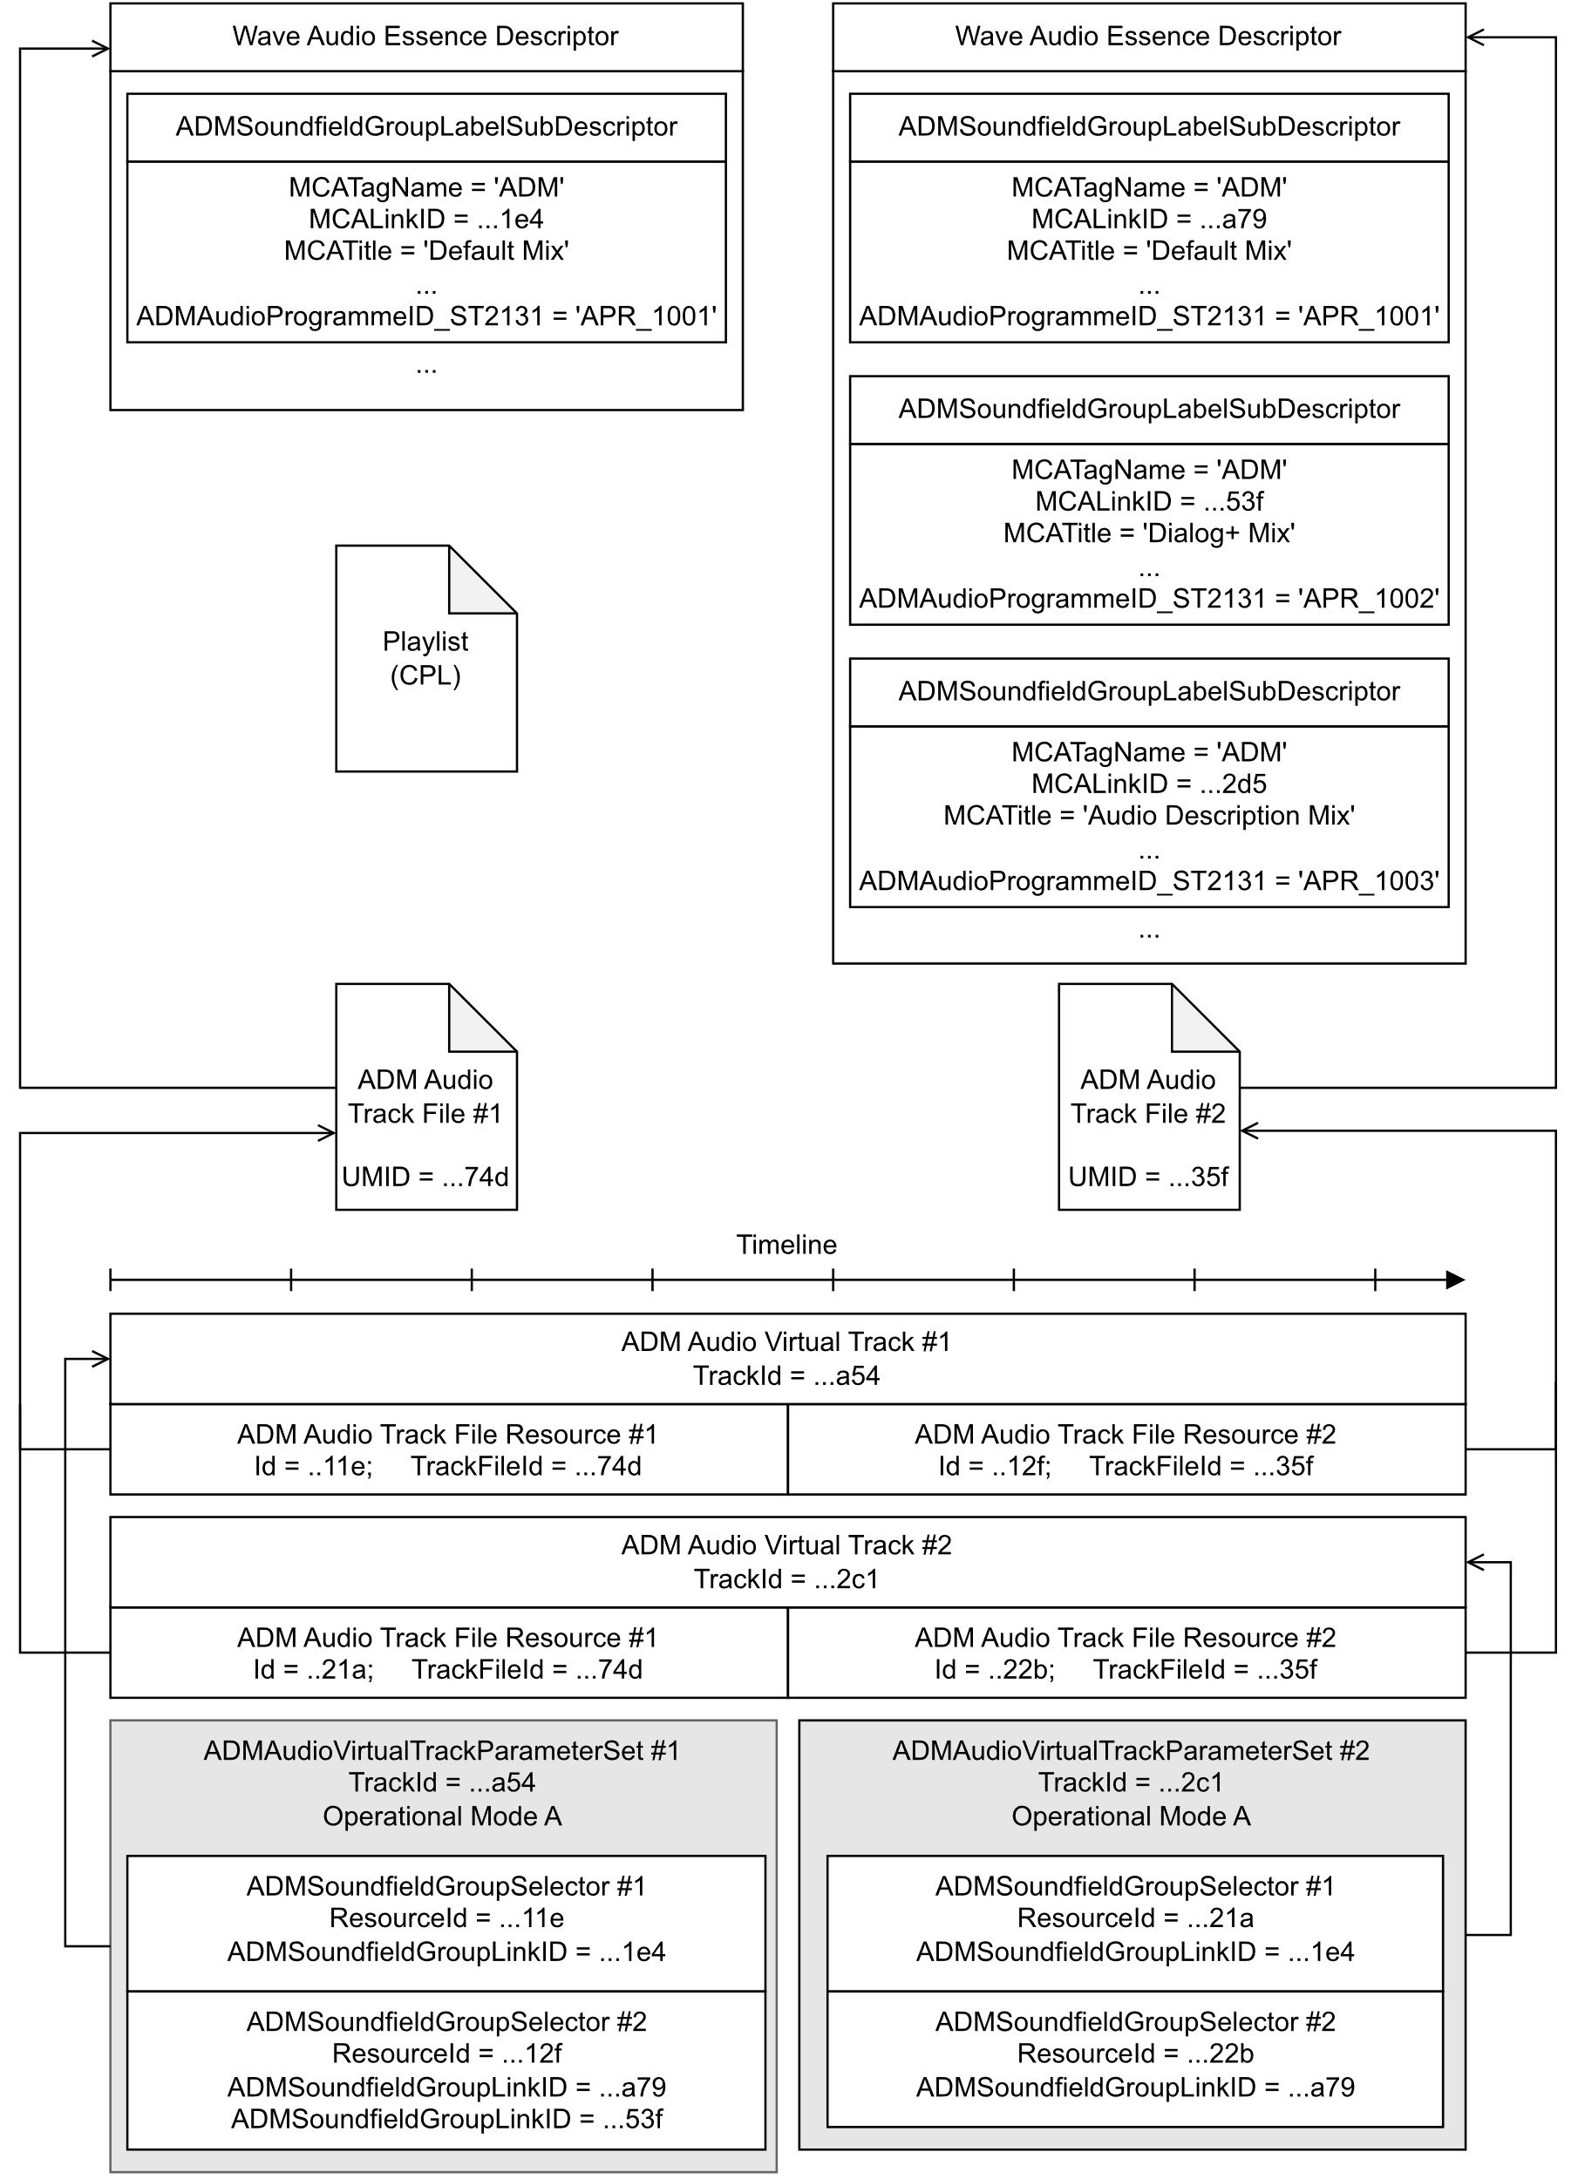

**Figure A.1 – Example CPL with ADM Audio Virtual Tracks (Operational Mode A) [Some mandatory SubDescriptors (and other details) are not shown]**

As shown in Figure A.1, the Wave Audio Essence Descriptor of the first ADM Audio Track File (UMID = ..74d) contains one ADMSoundfieldGroupLabelSubDescriptor instance, which corresponds to the soundfield group with MCATitle “Default Mix” defined by the ADM audioProgramme element with audioProgrammeID “APR_1001”.

The Wave Audio Essence Descriptor of the second ADM Audio Track File (UMID = ..35f) contains three ADMSoundfieldGroupLabelSubDescriptor instances, which correspond to the soundfield groups with MCATitle “Default Mix”, “Dialog+ Mix”, and “Audio Description Mix” defined by the ADM audioProgramme elements with audioProgrammeID “APR_1001”, “APR_1002” and “APR_1003”.

Both the first and second ADM Audio Virtual Tracks are constrained by Operational Mode A and both contain two Resource elements. Each Resource references one of the ADM Audio Track Files, placing them on the Composition timeline. Within the first ADM Audio Virtual Track (TrackId = …a54), two soundfield groups of the second ADM Audio Track File are selected via the ADMSoundfieldGroupLinkID elements. Within the second ADM Audio Virtual Track (TrackId = …2c1) just one soundfield group of the second ADM Audio Track File is selected.

The ADMAudioVirtualTrackParameterSet elements corresponding to ADM Audio Virtual Track #1 and ADM Audio Virtual Track #2, as depicted in Figure A.1, are given as EXAMPLE 1 and EXAMPLE 2, respectively.

EXAMPLE 1: ADMAudioVirtualTrackParameterSet for Virtual Track #1

<ADMAudioVirtualTrackParameterSet>

<Id>urn:uuid:85f19d9d-b454-47b6-bbae-b1d22dff649f</Id>

<TrackId>urn:uuid:...a54</TrackId><!-- Virtual Track #1-->

<ADMOperationalMode>http://www.smpte-ra.org/ns/2067-204/2022#Operational-Mode-A</ADMOperationalMode>

<ADMSoundfieldGroupSelector>

<ResourceId>urn:uuid:...11e</ResourceId><!-- Resource #1-->

<ADMSoundfieldGroupLinkID>urn:uuid:...1e4</ADMSoundfieldGroupLinkID><!-- Default Mix -->

</ADMSoundfieldGroupSelector>

<ADMSoundfieldGroupSelector>

<ResourceId>urn:uuid:...12f</ResourceId><!-- Resource #2-->

<ADMSoundfieldGroupLinkID>urn:uuid:...a79</ADMSoundfieldGroupLinkID><!-- Default Mix -->

<ADMSoundfieldGroupLinkID>urn:uuid:...53f</ADMSoundfieldGroupLinkID><!-- Dialog+ Mix -->

</ADMSoundfieldGroupSelector>

</ADMAudioVirtualTrackParameterSet>

EXAMPLE 2: ADMAudioVirtualTrackParameterSet for Virtual Track #2

<ADMAudioVirtualTrackParameterSet>

<Id>urn:uuid:459ce0fc-342f-4b31-ad8e-61cee4511ad1</Id>

<TrackId>urn:uuid:...2c1</TrackId><!-- Virtual Track #2-->

<ADMOperationalMode>http://www.smpte-ra.org/ns/2067-204/2022#Operational-Mode-A</ADMOperationalMode>

<ADMSoundfieldGroupSelector>

<ResourceId>urn:uuid:...21a</ResourceId><!-- Resource #1-->

<ADMSoundfieldGroupLinkID>urn:uuid:...1e4</ADMSoundfieldGroupLinkID><!-- Default Mix -->

</ADMSoundfieldGroupSelector>

<ADMSoundfieldGroupSelector>

<ResourceId>urn:uuid:...22b</ResourceId><!-- Resource #2-->

<ADMSoundfieldGroupLinkID>urn:uuid:...a79</ADMSoundfieldGroupLinkID><!-- Default Mix -->

</ADMSoundfieldGroupSelector>

</ADMAudioVirtualTrackParameterSet>

Figure A.2 depicts examples for consuming applications of ADM Audio Virtual Tracks. In the first example, the ADM Audio Virtual Track is converted into one or more MGA S-ADM MXF files according to SMPTE ST 2127-10, which can be used later for:

* real-time content playout of MGA S-ADM over IP. In this example, the associated audio essence is transported according to SMPTE ST 2110-30, and the S-ADM metadata is transported synchronously by a separate IP stream.
* creation of an MGA S-ADM Virtual Track in an IMF Composition according to SMPTE ST 2067-203
* encoding for distribution using an MGA S-ADM audio encoder

In the second example, an ADM Audio Virtual Track is exported as one or more MXF files with ADM metadata mapped according to SMPTE ST 2131 (or as one or more BW64 files), which can be used later:

* in Post Production systems for re-mastering
* in distribution encoding systems

In the third example, an ADM PCM Renderer is used to generate an Audio Track File (containing no ADM metadata) according to SMPTE ST 2067-2 and SMPTE ST 382.

The definition of detailed processing blocks and their requirements for PCM + ADM Conversion and ADM PCM Rendering can be further studied in the context of the IMF Output Profile List (OPL) framework described in SMPTE ST 2067-100. The “Control Parameters” illustrated have no editorial effect: they configure technical aspects of the output format in each case.

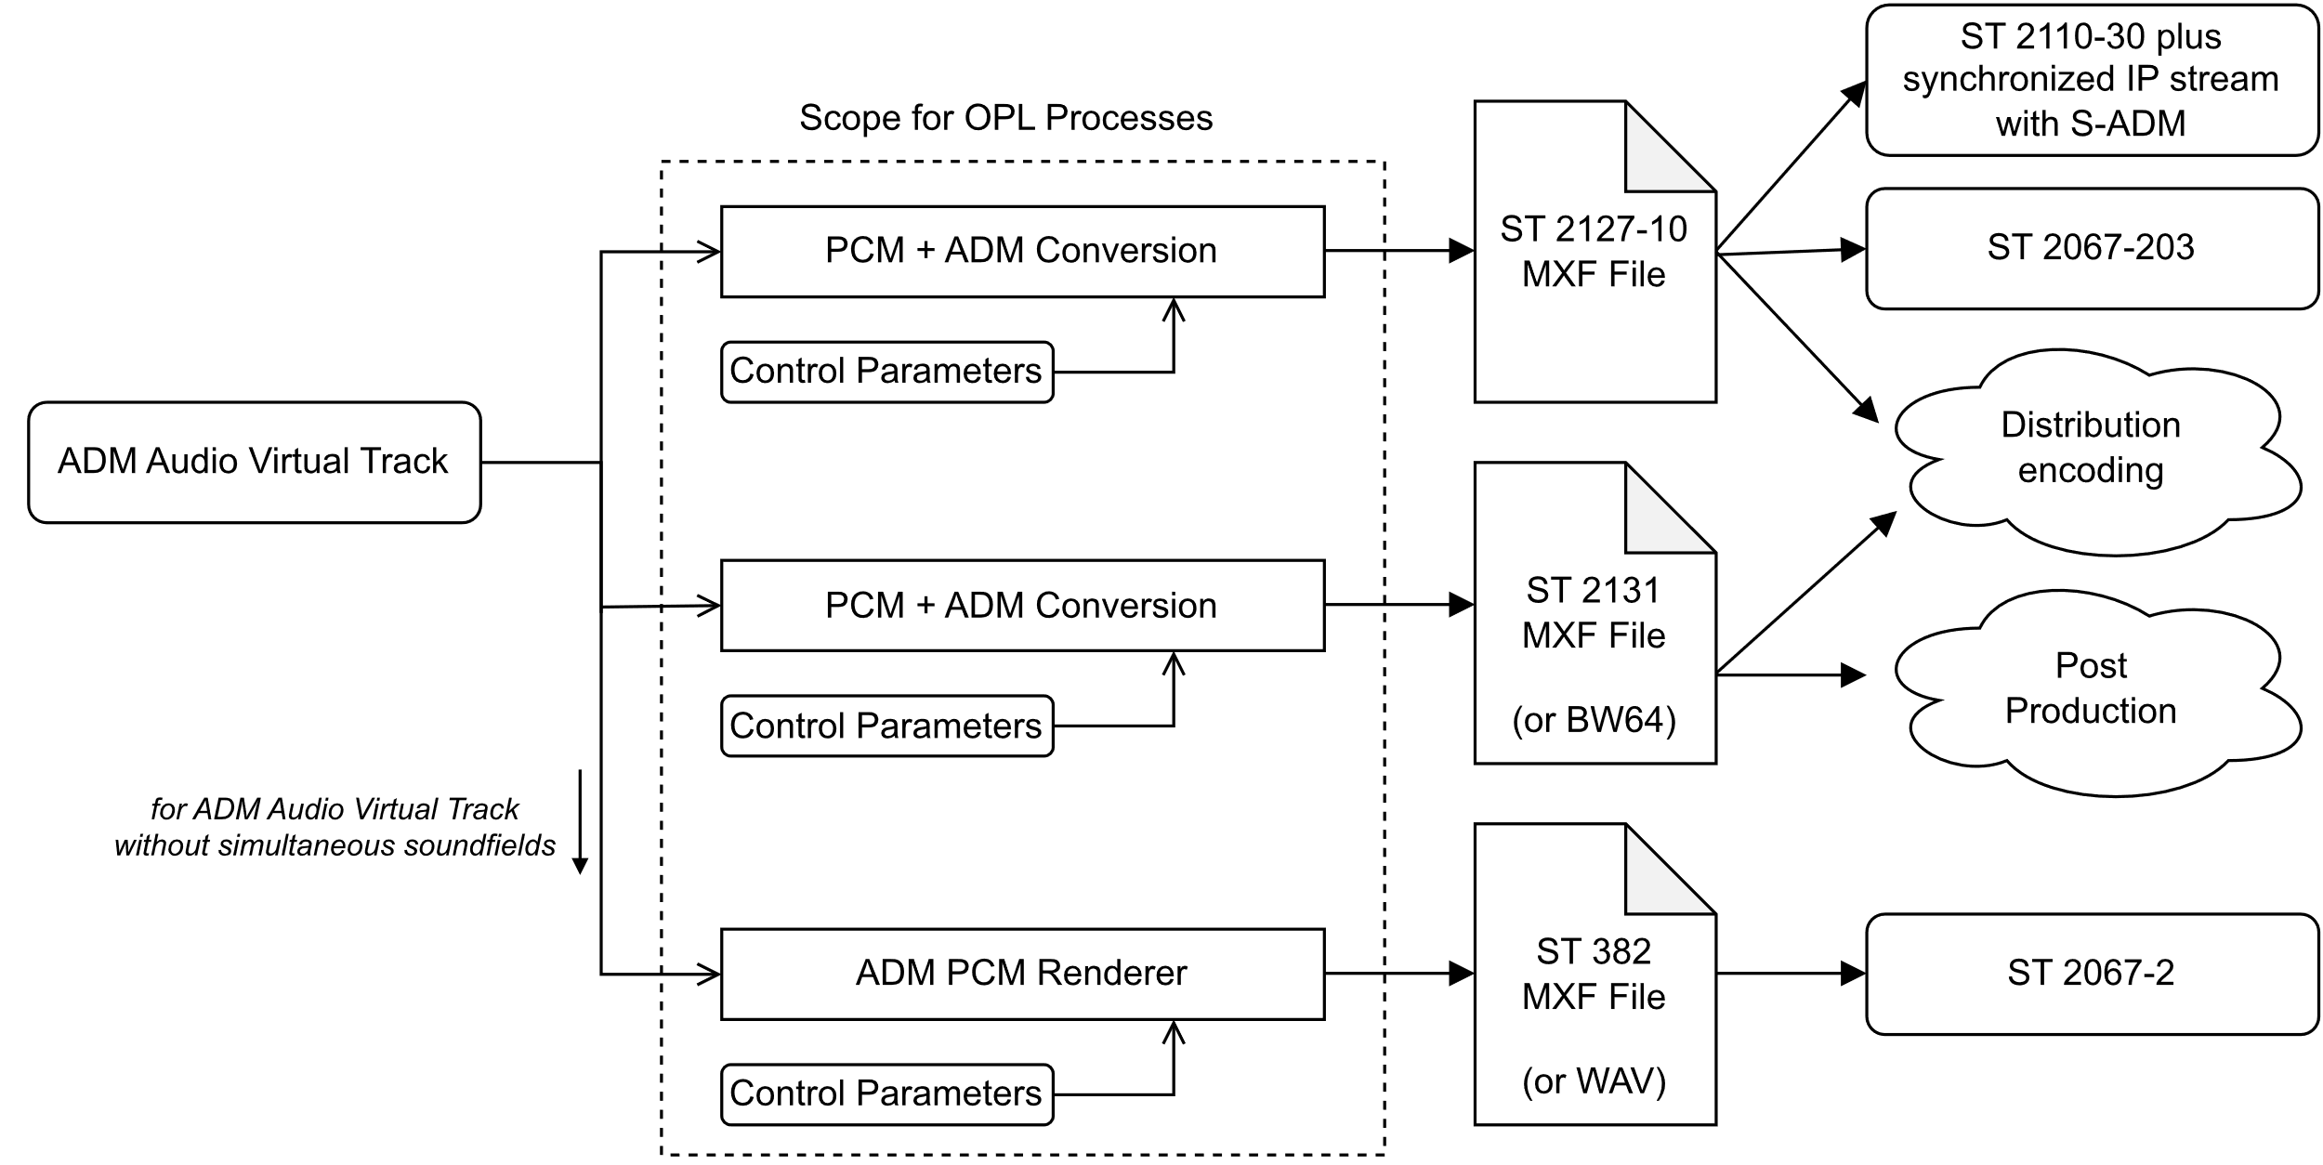

**Figure A.2 – Examples for Consuming Applications of ADM Audio Virtual Tracks**

1. Additional elements (informative)

This annex lists non-prose elements of this document.

|  |  |  |
| --- | --- | --- |
| Non-prose element | File name | Description |
| a | st2067-204a-20XX.xsd | XML schema document (normative) |

Bibliography (informative)

ISO/IEC 14496-14 Information technology — Coding of audio-visual objects — Part 14: MP4 file format

Recommendation ITU-R BS.2088, Long-form file format for the international exchange of audio programme materials with metadata

Recommendation ITU-R BS.2125, A serial representation of the Audio Definition Model

SMPTE ST 330, Unique Material Identifier (UMID)

SMPTE ST 377-41, MXF Multichannel Audio Controlled Vocabulary

SMPTE ST 377-42, MCA Label Controlled Vocabulary

SMPTE ST 382, Material Exchange Format — Mapping AES3 and Broadcast Wave Audio into the MXF Generic Container

SMPTE ST 2067-100, Interoperable Master Format - Output Profile List

SMPTE ST 2067-203, Interoperable Master Format – Audio with Frame-based S-ADM Metadata Plug-in

SMPTE ST 2110-30, [Professional Media Over Managed IP Networks: PCM Digital Audio](https://ieeexplore.ieee.org/document/8167392/)

SMPTE ST 2127-1, Mapping Metadata Guided Audio (MGA) signals into the MXF Constrained Generic Container

SMPTE ST 2127-10, Mapping Metadata Guided Audio (MGA) signals with S-ADM Metadata into the MXF Constrained Generic Container