

**Crossword Game**

GitHub Projects Part 2

Stoyan Ponchev, Ema Mateva, Dimitar Dyakov and Dimitar Georgiev

SMPonchev18@codingburgas.bg, emmateva18@vodingburgas.bg, dpdyakov18@codingburgas.bg, DMGeorgiev18@codingburgas.bg

Mentor: Mariana Encheva mencheva@codingburgas.bg

Table of Contents

1. Heading and information for the participants 1

2. Content 1

2.1. Short description of the project and objectives 1

2.2. Diagram describing menu 2

2.3. Description of the functions used 2

2.3.1. Purpose 2

2.3.2. Arguments 3

2.3.3. Return Value 3

2.4. Description of the application 3

# Heading and information for the participants

The people, which are a part of this project, are:

* Stoyan Ponchev, 9A class, e-mail: SMPonchev18@codingburgas.bg;
* Ema Mateva, 9B class, e-mail: EMMateva@codingburgas.bg;
* Dimitar Dyakov, 9V class, e-mail: DPDyakov18@codingburgas.bg;
* Dimitar Georgiev, 9G class, e-mail: DMGeorgiev18@codingburgas.bg;

Mentor: Mariana Encheva, e-mail: mencheva@codingburgas.bg

# Content

We have made a game, which is a type of a Crossword game. The game is totally user friendly and it is simple. The game has a simple menu by two buttons called “1. Play” and “2. Exit”. We have managed to make them easier to choose. By selecting the number, the program shows four levels of difficulties.

## Short description of the project and objectives

As we already said after the starting of the application, the app is showing easy understandable menu. After choosing by number the thing that they want to do which is 1. Play and 2. Exit. After choosing the first option, it is showing the second part of the menu that is a list of different types of difficulties. After choosing, the type of difficulty the program shows a 9x9 box with letters and there are still more options to choose. If you type a different coordinate about any word, the application is telling them that there are no existing words with these letters.

## Diagram describing menu

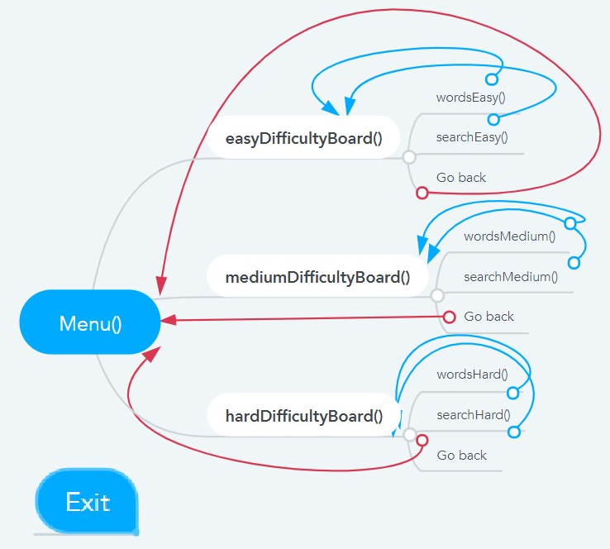

## Description of the functions used

* Play: After selecting this function, the program is going to show you different difficulties of the crossword game.
* Easy/Medium/Hard: These are the different difficulties which you would be able to choose by a number from 1-4. After selecting the difficulty, the program is showing you the coordinate crossword table.
* Options menu:
  + Show words that need to be found: This function shows all the words in the crossword table.
  + Search for a word: By using this function, you are going to be able to type the coordinates for the words you are searching for.
* Go back: Returns back to the difficulties.

### Purpose

|  |  |
| --- | --- |
| Functions | Designation |
| Menu() | Function to show the menu in which you can choose what to do. |
| easyDifficultyBoard() | Function that stores the board with letters for the easy difficulty of the game. |
| mediumDifficultyBoard() | Function that stores the board with letters for the medium difficulty board. |
| hardDifficultyBoard() | Function that stores the board with letters for the hard difficulty board. |
| wordsEasy() | Function that stores the words for the easy difficulty board. |
| wordsMedium() | Function that stores the words for the medium difficulty board. |
| wordsHard() | Function that stores the words for the hard difficulty board. |
| searchEasy() | Function that you use to find a word from the easy board. |
| searchMedium() | Function that you use to find a word from the medium board. |
| searchHard() | Function that you use to find a word from the hard board. |

### Arguments

* string wordsE: this string has all the correct words for easy level;
* string wordsM: this string has all the correct words for medium level;
* string wordsH: this string has all the correct words hard level;

### Return Value

The type of “return” we use mostly is “return 0”. We use it to stop the chosen function when the wanted data is been displayed. To output the data, we use “cout”.

## Description of the application

This is a game, which was mainly created for fun, and it has a big educational part. As we already said after the starting of the application, the app is showing an understandable menu. After choosing by number the thing, which they want to do which is 1. Play and 2. Exit. After choosing the first option, it is showing the second part of the menu that is a list of different types of difficulties. After choosing, the type of difficulty the program shows a box with letters and there are still more options to choose. If you type a different coordinate about any word, the application is telling them that there are no existing words with these letters.