WEBSITE COPY | READY TO PASTE
NeuroZehn
Institute for Brain Health & Neuroscience
Brain health, learned and built together.
How to use this file
- Every page starts with its URL, browser title and meta description.
- Under each page, sections appear in the order they should appear on the page.
- Plain paragraphs and bold headings are text to paste as written.
- Lines starting with Button: are buttons. Lines starting with Badge: are small status labels on a card (Open now, Opening soon, In planning).
- All details are filled in. Please do not change phone numbers, fees or dates without the owner's approval.
- Name: use the full name "NeuroZehn Institute for Brain Health & Neuroscience" in the logo, the home-page hero, the footer and legal lines. In running text use the short form "NeuroZehn".
- Figures: six ready-made images are included in this file and supplied as separate PNG files. Each figure shows its file name, the page and section where it goes, and its alt text. Urdu versions of the figures are not yet made.
- English and Urdu: Urdu versions of the main buttons and navigation are in Section 14. The site must work in both languages, with right-to-left layout for Urdu.

1. Global elements (every page)
Page URL | All pages
Browser title | (page-specific)
Meta description | (page-specific)

SECTION: LOGO (WORKING WORDMARK)
FIGURE 1: file 01_wordmark.png | place: header of every page and footer; replace later with the final logo | alt text: NeuroZehn Institute for Brain Health and Neuroscience wordmark
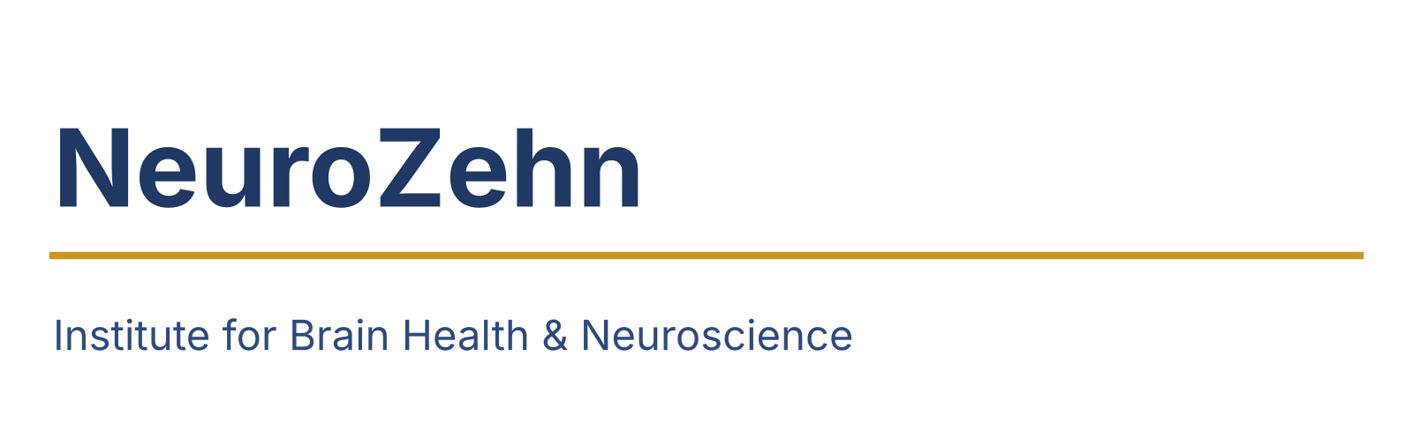
SECTION: TOP BAR
Language: English | اردو Link: Join the waitlist
SECTION: MAIN MENU
Learn | Brain Health | Programmes | Research | Partner With Us | About | Contact
SECTION: STATUS LABELS USED ON CARDS
- Open now
- Opening soon
- In planning
SECTION: FOOTER
NeuroZehn Institute for Brain Health & Neuroscience. Brain health, learned and built together.
Links: Learn · Brain Health · Programmes · Research · Partner With Us · About · People · Insights · Contact · Privacy Policy · Terms of Use · Cookie notice · Accessibility
Newsletter: Stay informed. Enter your email to hear about courses, brain-health guides, research and partnerships.
Button: Subscribe
NeuroZehn is not a hospital or a clinic and does not give medical advice. Content on this site is for education. © NeuroZehn Institute for Brain Health & Neuroscience. Registration in progress.
SECTION: EMERGENCY BOX (SHOWN ON EVERY HEALTH PAGE AND IN THE FOOTER OF BRAIN HEALTH)
If someone is in immediate danger, or has sudden weakness, a drooping face, trouble speaking, a seizure lasting more than five minutes, or thoughts of harming themselves, contact local emergency services now. Emergency: Rescue 1122 (ambulance, where available), Edhi ambulance 115, Police 15. Mental health support: Rozan 0800-22-444 (Mon to Fri, 9:30 AM to 5 PM), Taskeen +92 316 827 5336 (Mon to Sat, 11 AM to 11 PM), Humraaz through 1166.

2. Home
Page URL | /
Browser title | NeuroZehn | Brain health for Pakistan, built with partners
Meta description | Micro-credentials, brain-health education and partnerships for students, professionals and families in Pakistan. A founding institute, opening in stages.

SECTION: HERO
NEUROZEHN INSTITUTE FOR BRAIN HEALTH & NEUROSCIENCE
Brain health, learned and built together.
A Pakistan-based institute for brain and mental health. We are opening with practical micro-credentials for students and professionals, clear guidance for families, and partnerships that build Pakistani evidence, step by step.
Button: Explore micro-credentials
Button: Become a founding partner
SECTION: STATUS STRIP (THIN BAND UNDER THE HERO)
Open now: founding network and waitlist · Opening soon: first micro-credentials, early 2027 · In planning: brain-health hub, research programme, care navigation
SECTION: THREE DOORS (THREE CARDS)
Learn
Short, practical courses and supervised placements for pharmacy, rehabilitation, speech-language, nursing, psychology, medical, public-health and science students and professionals.
Button: Explore Learn
Brain Health
Plain-language guides, talks and school sessions for families, teachers and communities, checked against reliable sources.
Button: Explore Brain Health
Partner With Us
Universities, hospitals, services and funders who want to help shape a national brain-health institute from the start.
Button: Partner With Us
SECTION: WHAT WE ARE BUILDING
One place where people learn together
Brain health does not sit in one profession. A person with a stroke needs a doctor, a therapist, a pharmacist, a nurse and a family that understands. A child with a language difficulty needs a teacher, a speech-language therapist and a parent who knows what to do. NeuroZehn is building one place where these people learn together, where families find their way, and where Pakistan's own data guides what we do.
Our journey for every person: Understand. Protect. Treat. Rebuild. Learn. Discover.
FIGURE 2: file 02_journey.png | place: Home, section What we are building, under this line | alt text: Six steps: understand, protect, treat, rebuild, learn, discover
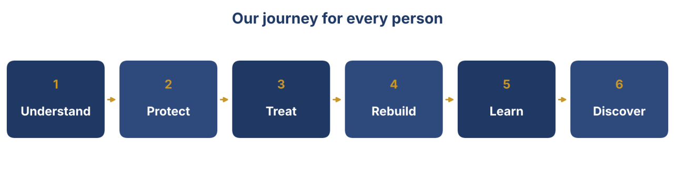
We start with teaching and public education. Clinical navigation, research and the physical hub follow, each opening only when it is ready and approved.
SECTION: WHY IT MATTERS (FOUR FACTS, EACH WITH ITS SOURCE LINE)
- About 0.19 psychiatrists per 100,000 people in Pakistan, compared with about 7 per 100,000 in high-income countries. Source: Frontiers in Health Services, 2025, citing Lancet Psychiatry 2020; WHO figure as reported October 2026.
- About 0.4% of Pakistan's health budget goes to mental health. Source: BJPsych International 2023, as cited in the same review.
- A young population of about 260 million, with a median age of about 20.6 years. Source: Worldometer (UN-based estimate), October 2026.
- Pakistan announced a National Mental Health Policy for 2026 to 2035 in October 2026, aiming to reach over 32 million people in need. Source: Pakistan Observer.
FIGURE 3: file 05_facts.png | place: Home, section Why it matters, above the four fact lines (or instead of the bullet list; keep the source lines visible) | alt text: Four facts about brain and mental health needs in Pakistan
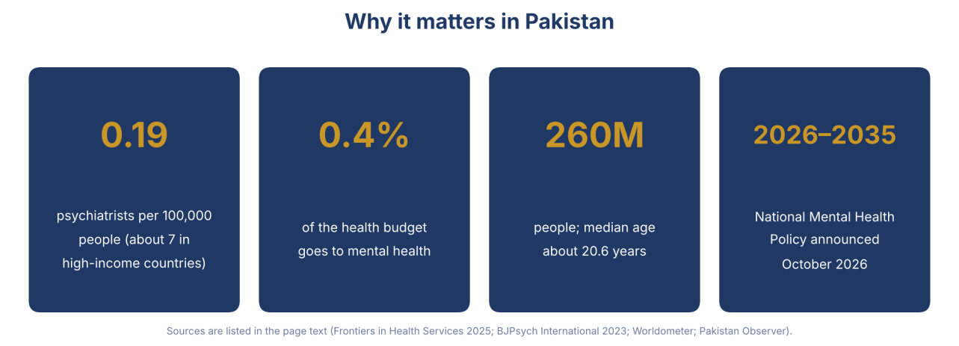
These gaps are in people, training and coordination. That is where we start.
SECTION: PROGRAMMES (TWELVE CARDS LINKING TO /PROGRAMMES)
Twelve connected programmes: Public and school brain health · Mental health and behaviour · Rehabilitation and allied health · Education · Brain genetics and family health · Child and adolescent brain health · Clinical research · Imaging and neurophysiology · New methods and technologies · Equity and access · Medicines and pharmacy · Basic brain science
Button: See all programmes
SECTION: FOUNDING PARTNERS
Build it with us from the start
We are at the founding stage and building with partners. If your university, hospital, service, professional body or foundation would like to help shape NeuroZehn, we would like to hear from you.
Button: Become a founding partner
SECTION: ROADMAP STRIP
Now: micro-credentials and public education. Next: first research survey and student programmes. Later: brain-health hub, care navigation and a wider research programme.
FIGURE 4: file 03_roadmap.png | place: Home, section Roadmap strip, and on the About page under Roadmap | alt text: Roadmap in four stages: now, next, then, later
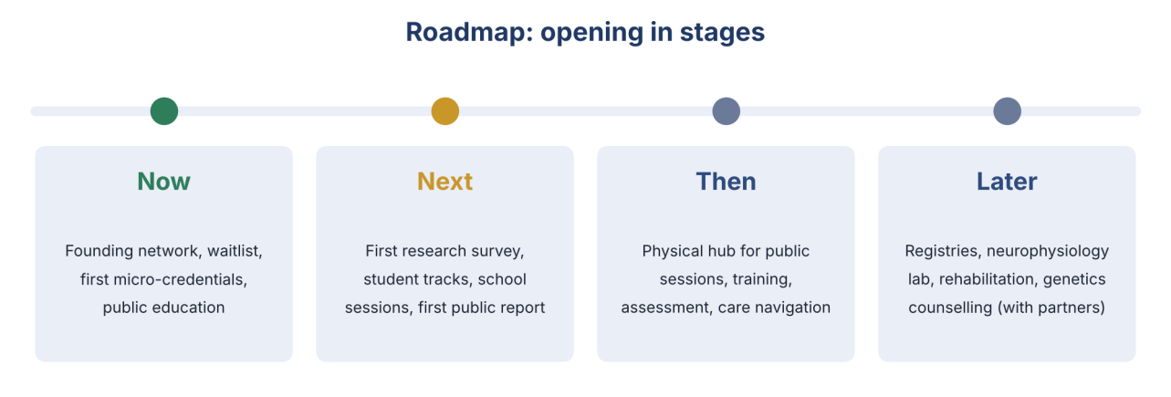
Button: See the full roadmap
SECTION: NEWSLETTER AND WAITLIST
Stay informed. Choose what you want to hear about: courses, brain-health guides, research participation, partnerships. We use your details only as described in our privacy policy.
Button: Join the waitlist

3. Learn
Page URL | /learn
Browser title | Micro-credentials in brain and mental health | NeuroZehn
Meta description | Short, practical micro-credentials and supervised student tracks in brain and mental health for pharmacy, rehabilitation, speech-language, nursing, psychology and medical students and professionals in Pakistan.

SECTION: HERO
Learn brain health in practice.
Short, focused micro-credentials and supervised student tracks, built with clinicians and educators, for the people who will carry brain and mental health care in Pakistan.
Button: See the catalogue
Button: Join the waitlist
SECTION: HOW MICRO-CREDENTIALS WORK
- Short. Each micro-credential is a focused module of 6 to 12 learning hours over 3 to 6 weeks, designed to fit around study or work.
- Practical. Cases, simulations and a small applied task, not only lectures.
- Assessed. You complete a short assessment and receive a certificate of completion from NeuroZehn, with a description of what you learned.
- Stackable. Modules can combine toward a pathway as pathways are approved.
- Clear about what it is. A micro-credential is not a degree or a professional licence. If a university or professional body recognises a module for credit, we will say so on that module's page.
FIGURE 5: file 06_micro_credentials.png | place: Learn, section How micro-credentials work, below the list | alt text: Four features of a micro-credential: short, practical, assessed, stackable
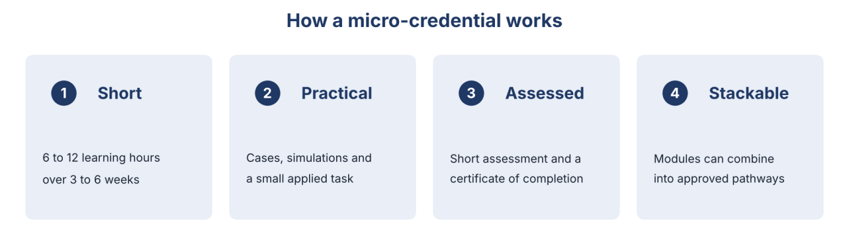
SECTION: CATALOGUE (CARDS LINKING TO EACH MICRO-CREDENTIAL PAGE)
Brain Health Essentials
For everyone: students, teachers, community workers, families.
Badge: Opening soon
Supporting Mental Wellbeing: Basics for Teachers and Community Workers
For teachers, school counsellors and community workers.
Badge: Opening soon
Stroke Recognition and Rehabilitation Basics
For nursing, physical therapy, occupational therapy, speech-language and medical students.
Badge: Opening soon
Safe Medicines for Brain and Mental Health
For pharmacy students and pharmacists, and nurses.
Badge: Opening soon
Research Methods and Ethics for Health Students
For students, residents and junior faculty.
Badge: Opening soon
Rehabilitation, Swallowing and Communication After Stroke
For physical, occupational and speech-language therapy students and therapists.
Badge: In planning
Child Language, Speech and Neurodevelopment
For speech-language, psychology and nursing students, teachers and parents.
Badge: In planning
Epilepsy Care and First Aid
For nurses, school staff and doctors.
Badge: In planning
EEG Foundations
For technologists, residents and biomedical students.
Badge: In planning
Clinical Research and Good Clinical Practice
For investigators and study coordinators.
Badge: In planning
Introduction to Non-Invasive Brain Stimulation
For clinicians and researchers, with a safety focus.
Badge: In planning
SECTION: STUDENT TRACKS
Learn by doing, with a supervisor
Beyond courses, students can join a supervised track: a defined period with a named supervisor, a written plan and a certificate. Placements never replace licensed clinical staff, and anything involving people is done under supervision and within each student's scope. We agree credit with your own university.
Discipline | What you do | Example
Pharmacy | Medication safety, adherence, counselling, drug-use studies | Adherence study in epilepsy, depression or stroke; Urdu patient leaflets
Physical therapy | Evidence-based rehabilitation, outcome measurement, tele-rehabilitation | Stroke rehabilitation outcome records; exercise-programme pilots
Occupational therapy | Cognitive and daily-living rehabilitation, child therapy | Home-programme guides; functional assessment pilots
Speech-language pathology | Screening, language and swallowing, aphasia care | School communication screening; stroke swallowing guidance
Nursing | Navigation, epilepsy and stroke care, family education | Nurse-navigator shadowing; patient education sessions
Clinical and counselling psychology | Screening, neuropsychological tests, supervised programmes | Urdu screening tool validation; caregiver group programme
Medicine and residents | Research methods, clinical neurophysiology, case reports | Registry studies; EEG reading sessions
Public health and social sciences | Surveys, community engagement, evaluation | Brain Health Survey fieldwork; school programme evaluation
Biomedical, neuroscience, engineering and data science | EEG analysis, data platforms, AI with clinical review | Normative EEG processing; dashboards
Button: Apply for a student track
SECTION: FOR PROFESSIONALS
Add brain and mental health skills to your practice
Short, credible courses with live case discussions, practical tasks and a certificate of completion. Continuing-education credit is offered only where a professional body has approved it.
SECTION: FEES AND SCHOLARSHIPS
Fees are set to be affordable and tiered: PKR 2,000 for students and PKR 5,000 for professionals in the first intake, with scholarship places that are free. A share of places is free or reduced for students and for people outside the largest cities. Apply for a scholarship when you enrol.
SECTION: QUESTIONS AND ANSWERS
Is this a degree?
No. These are short certificates of completion. We will tell you clearly if any module is recognised for credit by a university or professional body.
Who teaches?
Clinicians, educators and researchers, named with their credentials on each module page.
Are courses in Urdu?
Public courses are in Urdu and English. Professional modules are mainly in English, with Urdu support materials.
Can my university include it?
Yes. We are glad to talk to universities about placements and credit.
Button: Partner With Us
Can I learn online?
Yes. Practical sessions are added when partner sites are ready.
SECTION: WAITLIST FORM
Join the waitlist for the first micro-credentials. See the form fields in Section 15.

4. Micro-credential pages
Page URL | /learn/course-name (one page per course)
Browser title | Course title | Micro-credential | NeuroZehn
Meta description | One-sentence description of the course (use the first sentence of the course text below)

Each course page has: course title, status badge, who it is for, what you will learn, format and duration, assessment, certificate, fee, teachers, start dates, a waitlist or enrol button, and the line: Prepared by Dr. Shahid Bashir, PhD, neuroscientist. Last updated October 2026. The first four are written in full; the others use the short descriptions below.
Brain Health Essentials
Badge: Opening soon
For everyone who wants to understand the brain and look after it. You will learn how the brain works in plain language, the main risks to brain health across life, the early signs of common conditions such as stroke, epilepsy, dementia and mental-health difficulties, how to talk about them without stigma, and when and where to seek help.
What you will learn:
- Describe in simple terms how the brain supports thinking, feeling and movement.
- Recognise the main warning signs of stroke and know what to do.
- Name the main risk factors for brain health and the steps that reduce them.
- Explain how to support a person with a seizure, memory problems or low mood, and when to refer.
- Find reliable information and avoid common myths.
Format: online, 6 hours over 3 weeks, in Urdu and English. Assessment: short quiz and a personal action plan. You receive a certificate of completion. Fee: PKR 2,000 for students and PKR 5,000 for professionals; scholarship places are free.
Button: Join the waitlist
Safe Medicines for Brain and Mental Health
Badge: Opening soon
For pharmacy students, pharmacists and nurses. You will learn the safe and effective use of common medicines for epilepsy, stroke prevention, depression and anxiety, and dementia; how to talk about adherence and side effects; common interactions and when to refer; and how to run a small medication-use review.
What you will learn:
- Explain the purpose and common side effects of the main medicine classes in these conditions.
- Counsel a patient on taking medicines correctly and what to do if a dose is missed.
- Spot common interaction and safety issues and know when to refer.
- Plan a small adherence or drug-use review.
Format: online with case workshops, 10 hours over 4 weeks. Assessment: case-based. You receive a certificate of completion. Fee: PKR 2,000 for students and PKR 5,000 for professionals; scholarship places are free.
Button: Join the waitlist
Stroke Recognition and Rehabilitation Basics
Badge: Opening soon
For nursing, therapy and medical students and early-career professionals. You will learn how stroke happens, why speed matters, what recovery looks like, and the role of each profession in rehabilitation, including movement, swallowing and communication.
What you will learn:
- Recognise stroke and act quickly.
- Explain the phases of recovery.
- Describe the role of physical, occupational and speech-language therapy and nursing.
- Use basic outcome measures.
- Support the family.
Format: blended, 10 hours over 4 weeks. Assessment: case studies and a short practical. You receive a certificate of completion. Fee: PKR 2,000 for students and PKR 5,000 for professionals; scholarship places are free.
Button: Join the waitlist
Research Methods and Ethics for Health Students
Badge: Opening soon
For students, residents and junior faculty. You will learn how to frame a question, plan a study, consent participants, protect data, avoid common errors and report honestly. Real tools are used, and students may join a supervised study.
What you will learn:
- Write a clear research question.
- Choose a suitable design.
- Understand consent, confidentiality and ethics review.
- Collect and clean data safely.
- Explain results and their limits honestly.
Format: online with a supervised mini-project, 12 hours over 6 weeks. Assessment: protocol outline. You receive a certificate of completion. Fee: PKR 2,000 for students and PKR 5,000 for professionals; scholarship places are free.
Button: Join the waitlist
Supporting Mental Wellbeing: Basics for Teachers and Community Workers
Badge: Opening soon
For teachers, school counsellors and community workers. You will learn how to recognise stress, low mood and anxiety in young people, how to start a caring conversation, how to reduce stigma in a classroom or community, and when and how to refer for professional help.
Button: Join the waitlist
Rehabilitation, Swallowing and Communication After Stroke
Badge: In planning
For physical, occupational and speech-language therapy students and therapists. A practical course on working together after stroke: movement, swallowing, speech and language, and family training.
Button: Register interest
Child Language, Speech and Neurodevelopment
Badge: In planning
For speech-language, psychology and nursing students, teachers and parents. How speech and language develop, early signs of difficulty, and how families and schools can help.
Button: Register interest
Epilepsy Care and First Aid
Badge: In planning
For nurses, school staff and doctors. What epilepsy is, seizure first aid, medicines and safety, and how to reduce stigma at school and work.
Button: Register interest
EEG Foundations
Badge: In planning
For technologists, residents and biomedical students. How EEG works, how it is recorded, common patterns and artefacts, and how it is used in clinical care and research.
Button: Register interest
Clinical Research and Good Clinical Practice
Badge: In planning
For investigators and study coordinators. The principles of good clinical practice, consent, data quality and documentation in studies involving people.
Button: Register interest
Introduction to Non-Invasive Brain Stimulation
Badge: In planning
For clinicians and researchers. The principles of magnetic and electrical brain stimulation, safety screening, ethics and the current evidence, with a strong focus on safety.
Button: Register interest

5. Brain Health
Page URL | /brain-health
Browser title | Brain health guides for families in Pakistan | NeuroZehn
Meta description | Plain-language guidance on stroke, epilepsy, memory, child development, mental wellbeing and when to seek help. Checked against reliable sources.

SECTION: HERO
Understand your brain. Protect it. Know where to turn.
Clear, careful guidance for families, teachers and communities, written in plain language and checked against reliable sources. This is education, not a diagnosis or a replacement for your doctor.
SECTION: EMERGENCY BOX
If someone is in immediate danger, or has sudden weakness, a drooping face, trouble speaking, a seizure lasting more than five minutes, or thoughts of harming themselves, contact local emergency services now. Emergency: Rescue 1122 (ambulance, where available), Edhi ambulance 115, Police 15. Mental health support: Rozan 0800-22-444 (Mon to Fri, 9:30 AM to 5 PM), Taskeen +92 316 827 5336 (Mon to Sat, 11 AM to 11 PM), Humraaz through 1166.
SECTION: TOPIC GUIDES (CARDS LINKING TO GUIDE PAGES)
Stroke
Know the signs and act fast.
Epilepsy
What it is, first aid, stigma, school and work.
Memory and dementia
What is normal, what is not, and how to support a family member.
Badge: In planning
Child development
Speech, language, attention and learning.
Badge: In planning
Mental wellbeing
Stress, sleep, low mood and anxiety; how to talk and where to find help.
Badge: In planning
Headache and pain
Understanding common causes and when to seek care.
Badge: In planning
Head injury and concussion
Safety and what to do after a knock to the head.
Badge: In planning
Healthy habits for the brain
Sleep, activity, food, blood pressure and avoiding tobacco.
Badge: In planning
Medicines
Using them safely.
Badge: In planning
For caregivers
Looking after yourself while you care for someone else.
Badge: In planning
SECTION: GUIDE: STROKE, KNOW THE SIGNS AND ACT FAST
A stroke happens when blood flow to part of the brain is blocked, or when a blood vessel in the brain bleeds. Treatment works best when it starts early.
Look for these signs:
- Sudden drooping of the face or an uneven smile.
- Weakness or numbness in an arm or leg, often on one side.
- Trouble speaking or understanding.
- Sudden loss of vision or balance.
What to do: call emergency services at once and note the time the signs began. Do not give food, drink or medicine by mouth. Keep the person safe and comfortable while help arrives.
After a stroke, rehabilitation with a team of professionals, including doctors, nurses, therapists and a pharmacist, helps recovery, and families have an important part to play.
Prepared by Dr. Shahid Bashir, PhD, neuroscientist. Last updated October 2026.
SECTION: GUIDE: EPILEPSY, SEIZURE FIRST AID
Epilepsy is a condition in which the brain has repeated seizures. Most seizures stop on their own within a few minutes. Epilepsy is not contagious, and people with epilepsy can live full lives with the right care.
If someone has a seizure with shaking:
- Stay calm and note the time.
- Move hard or sharp objects away and cushion the head.
- Do not hold the person down and do not put anything in their mouth.
- When the shaking stops, gently turn the person onto their side.
- Stay until they are fully alert and speak calmly to them.
Call emergency services if the seizure lasts more than five minutes, if another seizure follows, if the person is injured, or if they do not wake up.
Prepared by Dr. Shahid Bashir, PhD, neuroscientist. Last updated October 2026.
SECTION: TALKS AND SCHOOL SESSIONS
Free talks, in your community
Free online talks and, in time, school and community sessions on brain health, mental wellbeing, stroke recognition and epilepsy first aid. Schools and community groups can ask us to partner.
Button: Register interest
SECTION: FIND HELP
NeuroZehn is not a clinic and cannot give medical advice. We are building a checked list of reliable services and helplines by province, so that you can find help close to you.
Badge: In planning

6. Programmes
Page URL | /programmes
Browser title | Programmes | NeuroZehn
Meta description | Twelve connected programmes in brain and mental health: education, rehabilitation, mental health, genetics, child development, research and more.

SECTION: INTRO
Twelve programmes, one approach
Brain and mental health are connected. Our programmes work together under one umbrella, share one approach to data and ethics, and teach through one academy. Each programme shows what exists today and what is planned.
FIGURE 6: file 04_programmes.png | place: Programmes page, under the intro; the cards below stay as clickable links | alt text: Twelve programmes with their status
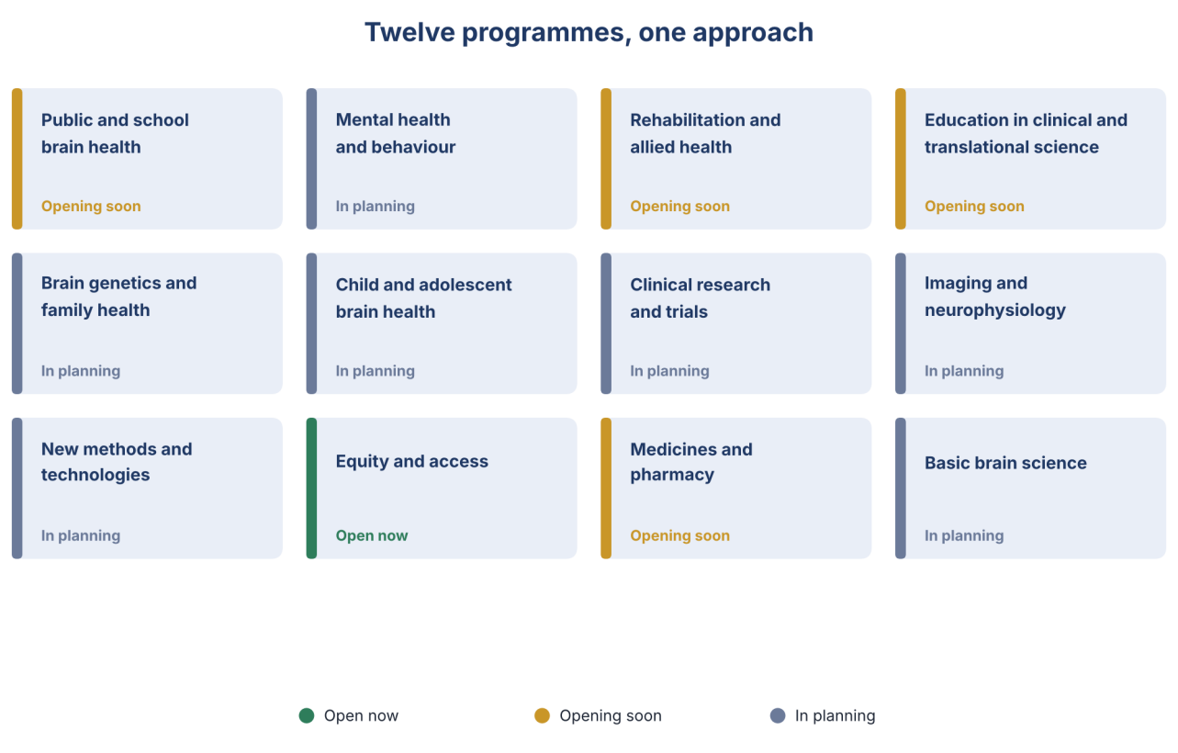
SECTION: PROGRAMME CARDS (EACH LINKS TO ITS OWN PAGE)
Public and school brain health
Education, stigma reduction and school and community sessions on brain health and mental wellbeing.
Badge: Opening soon
Mental health and behaviour
Guidance, training of non-specialists and, with partners, support pathways for depression, anxiety, stress and substance use.
Badge: In planning
Rehabilitation and allied health
Education and, with partners, outcome work for stroke, injury and communication disorders, with physical, occupational and speech-language therapy.
Badge: Opening soon
Education in clinical and translational science
Micro-credentials, student tracks, research methods and good clinical practice.
Badge: Opening soon
Brain genetics and family health
Family education and counselling, with partner laboratories and counsellors.
Badge: In planning
Child and adolescent brain health
Development, learning, language, epilepsy and neurodevelopment, with families and schools.
Badge: In planning
Clinical research and trials
Registries, pathway studies and trial readiness with partner hospitals.
Badge: In planning
Imaging and neurophysiology
EEG and related measures, normative data and training, with partners.
Badge: In planning
New methods and technologies
Evaluation of non-invasive brain stimulation, digital tools and AI with clinician oversight, through licensed partners.
Badge: In planning
Equity and access
Making sure rural, female, young and older people are not left out in every programme.
Badge: Open now
Medicines and pharmacy
Safe use of medicines for brain and mental-health conditions; pharmacy student projects.
Badge: Opening soon
Basic brain science
Laboratory research carried out by university partners, joined by students.
Badge: In planning
SECTION: EACH PROGRAMME PAGE USES THE SAME LAYOUT
Why it matters in Pakistan · Who it serves · What you can do now · What is planned · Partners · Contact. The first paragraph of each page is the card text above.

7. Research
Page URL | /research
Browser title | Research | NeuroZehn
Meta description | Ethics-approved, locally relevant research on brain and mental health in Pakistan: surveys, registries, normative data and validated tools.

SECTION: HERO
Pakistani evidence for Pakistani brain health.
Much of what is known about brain health comes from other countries. We design careful, ethics-approved studies with universities and hospitals to find out what is true here.
SECTION: WHAT WE PLAN TO STUDY (CARDS)
Pakistan Brain Health Survey
What people know and believe about the brain, risks and help-seeking, across provinces.
Badge: Opening soon
Mental health in schools and communities
How common are stress, low mood and anxiety, and does a brief programme help.
Badge: In planning
Communication disorders in children
How many children have speech, language or swallowing difficulty, and what care they reach.
Badge: In planning
Stroke and injury rehabilitation outcomes
Which rehabilitation approaches work in Pakistani settings, including tele-rehabilitation.
Badge: In planning
Medicine use and adherence
Medicine use for brain and mental-health conditions, led by pharmacy students under supervision.
Badge: In planning
Epilepsy, dementia and stroke registries
Care pathways and outcomes, with partner hospitals.
Badge: In planning
Normative EEG
What is normal EEG for Pakistani adults and children.
Badge: In planning
Validated tools
Urdu screening tools and EEG analysis methods tested with clinician review.
Badge: In planning
SECTION: HOW WE DO RESEARCH
- Ethics approval before any study involving people, through a partner institution's committee.
- Plain-language consent in Urdu and English; you can withdraw at any time.
- Privacy first: de-identified data, secure storage and controlled access.
- Honest reporting: we publish what we find, including negative results.
- Fair authorship and credit, agreed in writing, including for students and partners.
SECTION: TAKE PART
Volunteers are the heart of research
Register your interest to hear about studies you may be eligible for. Registering does not commit you to anything.
Button: Register interest
SECTION: METHODS WE TEACH AND PLAN TO USE
NeuroZehn's scientific approach connects several kinds of evidence about the brain, so that findings are checked from more than one angle: clinical history and behaviour, EEG, brain imaging, genetics and, where appropriate, digital measures, analysed with careful statistics and, where useful, machine learning with clinician review.
Method | What it is used for | Status
EEG and quantitative EEG | Recording the brain's electrical activity; normative data; training | In planning, through partners
Brain imaging (MRI, fMRI, DTI) | Structure and connections of the brain | Through partner centres
Non-invasive brain stimulation (TMS, tDCS) | Research and, later, approved therapy under a licensed clinician | In planning
Genetics | Family education, counselling, registries | In planning, with partner laboratories
Digital and wearable measures | Everyday measures of movement, sleep and activity | In planning
Artificial intelligence | Support for analysis and screening tools, always with clinician review | In planning
SECTION: TRIAL READINESS
In time, NeuroZehn hopes to help partner hospitals prepare for clinical studies: protocols, data capture, training in good clinical practice and quality. This is a future programme.
Badge: In planning

8. Partner With Us
Page URL | /partner
Browser title | Partner with NeuroZehn | Founding partners wanted
Meta description | Universities, hospitals, services, professional bodies and funders: help shape a national brain-health institute from the start.

SECTION: HERO
Build it with us from the start.
NeuroZehn is at the founding stage. We are looking for partners who share a simple belief: brain and mental health in Pakistan need more trained people, better pathways and local evidence.
Button: Request the partner brief
Button: Send an enquiry
SECTION: WHAT WE OFFER, AND WHAT WE ASK
Partner | What you get | What we ask
Universities and colleges | Short courses and student tracks for your students; supervised placements and projects; joint research; shared teaching | Faculty time, student access, supervision, agreement on credit and certificates
Hospitals, rehabilitation and mental-health services | Training for your staff; student support; joint studies and registries; referral pathways when open | Clinical advice, an ethics route, referral places, study sites
Professional bodies and societies | Educational content, speakers and evidence | Endorsement, speakers, reach to members, advice on continuing-education credit
Schools and community groups | Brain-health and wellbeing sessions for students, teachers and parents | Access, feedback, co-hosting
Funders and foundations | A transparent plan, early results and public reporting; support for scholarships, training and research | Programme or core funding without interference in findings
Technology and industry | Independent evaluation, training events and educational partnerships | Funding or equipment loans under clear independence and disclosure rules
International collaborators | Joint projects, teaching and mentoring for Pakistani trainees | Advice, supervision, introductions
SECTION: FOUNDING PARTNER PROGRAMME
Join at the start
Founding partners help shape the curriculum, programmes and governance, are named on this site with their permission, and are recognised in our first public report. There is no obligation to fund. We ask for a clear, specific contribution agreed in a short written letter.
SECTION: HOW TO START
- Tell us who you are and what you would like to do together.
- We reply within two working days and arrange a short call.
- We agree one first, small step, such as a student placement, a course for your staff or a joint survey.
- We confirm in a short letter. Larger agreements come later.
SECTION: ENQUIRY FORM
Fields: Name · Organisation and role · Email · Type of partner (list above) · What would you like to do together? · Timeline (optional) · Consent to be contacted (required) · Permission to be named as a founding partner later (optional).

9. About
Page URL | /about
Browser title | About NeuroZehn | Our mission, roadmap and governance
Meta description | Why NeuroZehn exists, how we work, who guides us and how we are growing.

SECTION: OUR STORY
Pakistan has a young, fast-growing population and too few trained specialists in neurology, mental health, rehabilitation and genetics. Many families travel long distances, and many young health graduates cannot find structured training or supervised research. NeuroZehn began from a simple idea: bring together people who care about the brain, and train and connect them, step by step.
SECTION: ABOUT THE NAME
Zehn (ذہن) means mind in Urdu. NeuroZehn joins neuroscience and the mind: science that serves how people think, learn, feel and recover.
SECTION: VISION
A Pakistan in which every person, from a child in school to an older adult at home, can understand, protect and, when needed, restore their brain health, supported by trustworthy science and local expertise.
SECTION: MISSION
To build a complete brain-health institution that turns research into everyday practice: informing the public, guiding patients and families to the right care, training clinicians and students, producing Pakistani evidence, and working with hospitals, universities and policymakers.
SECTION: VALUES
- Honesty. We say what is known and not known. We never promise cures.
- Patient and public first, in Urdu and English.
- Scientific integrity: real data, ethics approval and fair authorship.
- Equity: reaching beyond big cities and wealthy households.
- Accountability: clear governance, public reporting and privacy.
- Collaboration: we connect hospitals and universities; we do not compete with them.
SECTION: ROADMAP (PAGE /ABOUT/ROADMAP)
Stage | What happens | Status
Now | Founding network, waitlist, first micro-credentials, public education | Open now or Opening soon
Next | First research survey, student tracks and school sessions, first public report | In planning
Then | A physical hub for public sessions, student training, assessment and care navigation, with partners | In planning
Later | Registries, a neurophysiology lab, rehabilitation and genetics counselling with partners; brain stimulation only with licensed partners | In planning
SECTION: GOVERNANCE
We are establishing a Board of Trustees, a Scientific Advisory Board and an Ethics and Integrity Committee, with published conflict-of-interest rules and independent oversight of research and clinical safety.
SECTION: PREMISES
We are planning a physical brain-health hub in Pakistan (city to be announced) with space for public sessions, student training, assessment and care navigation, and a library and digital learning corner. The hub will open in phases, with each service starting only when it is approved and ready.
Badge: In planning
SECTION: OUR COMMITMENTS
We do not claim cures. We do not replace your doctor. We protect your information. We publish what we learn. We say plainly what is open, what is coming and what is only planned.

10. People
Page URL | /people
Browser title | People | NeuroZehn
Meta description | The clinicians, educators and scientists building NeuroZehn.

SECTION: INTRO
NeuroZehn is a community of clinicians, educators and scientists. We are growing our founding team and advisers.
SECTION: FOUNDER
Dr. Shahid Bashir, PhD
Founder
Neuroscientist with more than 20 years of international research experience across Switzerland, the United States, Singapore, South Korea and Saudi Arabia.
PhD in Neurophysiology from the University of Fribourg, Switzerland, and postdoctoral training at Harvard Medical School.
Author of more than 210 peer-reviewed publications. Serves on two task forces of the International League Against Epilepsy (ILAE) Diagnostic Methods Commission and on the ILAE EEG Platform Initiative for the Eastern Mediterranean Region.
Research spans non-invasive brain stimulation (TMS, tDCS, tACS), cortical neurophysiology, rare genetic epilepsies, neurodevelopmental disorders, neurodegeneration, stroke rehabilitation, and global burden of disease (GBD) epidemiological modeling.
Dr. Mirza Obaid Baig
Founder

SECTION: SCIENTIFIC TEAM
- Dr. Mirza Obaid Baig
- Dr. Kaleem Maqsood
- Dr. Kaleem Imdad Hussain
- Dr. Sumaiyah Obaid
- Dr. Aneesa Zafar
- Dr. Hamid Khan
- Prof. Dieter Ruegg
- Dr. Ali Hamza
More collaborators and advisers will be listed here as they confirm.
SECTION: ADVISERS WANTED
We are forming a Scientific Advisory Board and an Ethics and Integrity Committee. If you would like to be considered, please write to us.
Button: Contact us

11. Insights
Page URL | /insights
Browser title | Insights | NeuroZehn
Meta description | Short articles, explainers and progress updates from NeuroZehn.

Short articles, explainers and updates. All health content is dated and checked against reliable sources.
SECTION: FIRST ARTICLES
- Why Pakistan needs a brain-health institute: the numbers, with sources
- Stroke: five minutes that matter
- What is a micro-credential, and how does it help a student?
- What allied-health students can do in brain health: pharmacy, rehabilitation, speech-language and psychology
- Talking about mental health with teenagers: a guide for parents
- Behind the scenes: how we are building NeuroZehn, step by step

12. Ethics, privacy and responsible use
Page URL | /ethics-privacy
Browser title | Ethics and privacy | NeuroZehn
Meta description | How NeuroZehn protects your information and conducts research and education responsibly.

Neuroscience involves sensitive information: health, brain recordings, genetics and behaviour. We hold ourselves to clear standards.
- Ethics review before any study involving people.
- Informed consent in plain language, in Urdu and English, with the right to withdraw.
- Privacy: we collect the minimum, protect it, and do not sell personal data.
- Secure storage and controlled access; breaches are reported and handled under a published plan.
- Honest communication: we do not promise cures or guaranteed results.
- Responsible use of artificial intelligence: always with human review; never giving diagnosis or treatment advice to the public.
- Safeguarding of children and vulnerable adults.
- Fair authorship and credit for students and partners.
Related pages: Privacy Policy · Terms of Use · Cookie notice · Accessibility statement.

13. Contact
Page URL | /contact
Browser title | Contact NeuroZehn
Meta description | Get in touch about learning, partnerships, research participation or media.

SECTION: INTRO
We would like to hear from you
Choose the topic so the right person replies.
Topic | Email | We reply within
General | NeuroZehn@outlook.com | two working days
Learning and enrolment | NeuroZehn@outlook.com | two working days
Partnerships | NeuroZehn@outlook.com | two working days
Research participation | NeuroZehn@outlook.com | two working days
Media | NeuroZehn@outlook.com | two working days
Location: Pakistan. NeuroZehn is not a clinic. For medical emergencies, contact local emergency services.
SECTION: CONTACT FORM
Fields: Name · Email · Topic (dropdown: General, Learning, Partnerships, Research participation, Media) · Message · Consent. Please add above the message box: Please do not include personal medical information.

14. Urdu key strings
Page URL | Urdu version of each page
Browser title | (same as English)
Meta description | (same as English)

Use the same layout in right-to-left. These are the key strings. They should be checked by a native Urdu speaker before publication.
English | Urdu
NeuroZehn Institute for Brain Health & Neuroscience | نیوروذہن انسٹی ٹیوٹ برائے دماغی صحت و اعصابی سائنس
Brain health, learned and built together. | دماغی صحت: مل کر سیکھیں، مل کر بنائیں۔
Learn | سیکھیں
Brain Health | دماغی صحت
Programmes | پروگرام
Research | تحقیق
Partner With Us | ہمارے ساتھ شراکت کریں
About | ہمارے بارے میں
Contact | رابطہ
Explore micro-credentials | مختصر عملی کورسز (مائیکرو کریڈینشلز) دیکھیں
Become a founding partner | بانی شراکت دار بنیں
Join the waitlist | انتظار کی فہرست میں شامل ہوں
Register your interest | اپنی دلچسپی درج کریں
Open now | اب دستیاب
Opening soon | جلد شروع ہو رہا ہے
In planning | منصوبہ بندی میں
Certificate of completion | تکمیل کا سرٹیفکیٹ
Understand your brain. Protect it. Know where to turn. | اپنے دماغ کو سمجھیں، اس کی حفاظت کریں، اور جانیں کہ مدد کہاں سے ملے گی۔
This is education, not a diagnosis or a replacement for your doctor. | یہ معلومات تعلیم کے لیے ہیں؛ یہ تشخیص یا آپ کے معالج کا متبادل نہیں۔
We are not a clinic and do not give medical advice. In an emergency, contact local emergency services. | ہم کلینک نہیں ہیں اور طبی مشورہ نہیں دیتے۔ ہنگامی صورت میں مقامی ہنگامی خدمات سے فوراً رابطہ کریں۔
A Pakistan-based institute for brain and mental health. | پاکستان میں قائم دماغی اور ذہنی صحت کا ادارہ۔

15. Forms and messages
Page URL | Forms across the site
Browser title
Meta description

Form | Fields | Confirmation message
Waitlist and newsletter | Name (optional), email, interests (courses, guides, research participation, partnerships), role (student, professional, family member, institution), city, consent checkbox | Thank you. You are on the list. We will email you when it opens. You can unsubscribe at any time.
Course interest | Name, email, role, discipline, university or workplace, which course, scholarship needed (yes or no), consent | Thank you. We will tell you the start date and fee as soon as they are set. This does not commit you to anything.
Student track application | Name, email, university, discipline, year, short statement, reference (optional), consent | Thank you. We will review your application and reply within two weeks.
Partner enquiry | As on the Partner With Us page | Thank you. We will reply within two working days to arrange a short call.
Research interest | Name, email, age group, city, conditions of interest (optional), consent | Thank you. Registering your interest does not commit you to anything. We will contact you only about studies you may be eligible for.
Contact | Name, email, topic, message, consent | Thank you. We have your message and will reply within two working days.
Consent checkbox text
I agree that NeuroZehn may contact me about this. I understand how my information will be used and that I can withdraw at any time. (link to Privacy Policy)
System messages
- Required field: Please complete this field.
- Invalid email: Please check your email address.
- Sending failed: Something went wrong. Please try again, or email us at NeuroZehn@outlook.com.
- Page not found: This page is not available. It may be opening soon. Go to the home page or join the waitlist.

