Technical Project Report
Irish Passive-Active Retrofit Optimisation Pilot
A screening workflow for integrated passive retrofit and heat-pump decision support
Table 1. Project report metadata.
Item | Detail
Prepared for | SEAI Fellowship research narrative and portfolio support
Prepared by | Muhammad Reshaeel
Date | 16 June 2026
Archetype | Representative Irish semi-detached dwelling, circa 1980s
Packages evaluated | 46,656
Pareto-efficient packages | 453

Scope note: the numerical results in this report are screening-level estimates generated by the pilot reduced-order model. They demonstrate the workflow and decision variables; they should be validated with dynamic EnergyPlus simulations and refined Irish BER/DEAP or monitored dwelling data before formal research or policy use.

2. Abstract
This technical project presents a reproducible pilot workflow for integrated passive-active retrofit optimisation of a representative Irish semi-detached dwelling. The project responds to the need for retrofit decisions that consider fabric upgrades and heat-pump performance together rather than as separate sequential choices. A synthetic Irish dwelling archetype is combined with passive retrofit variables, heat-pump type, capacity, flow temperature and emitter options. The screening model estimates heat-loss coefficient, annual heating demand, peak heat load, temperature-dependent seasonal COP, heat-pump electricity demand, operational emissions, retrofit cost and overheating-risk proxy. A Pareto filtering routine is then used to identify retrofit packages that balance cost, emissions, heat-pump performance and comfort-related risk. The pilot evaluated 46,656 packages and identified 453 Pareto-efficient options. The results show that low-emission packages require coordinated fabric and heat-pump decisions, while low-cost or heat-pump-only options can leave higher electricity use, poorer COP or comfort risks. The project also exports EnergyPlus-ready IDF cases for selected solutions, creating a bridge between rapid screening and future dynamic simulation validation.

3. Objectives
- Demonstrate an integrated passive-active retrofit workflow for a representative Irish semi-detached dwelling.
- Represent passive retrofit options and heat-pump design variables in the same optimisation problem.
- Quantify trade-offs between cost, operational emissions, annual heating demand, heat-pump electricity use, seasonal COP and overheating risk.
- Generate EnergyPlus-ready IDF cases so that selected Pareto packages can be validated using dynamic building simulation.
- Provide a compact technical output that can support the applicant's SEAI Fellowship narrative on decision support, heat-pump-aware retrofit and scalable optimisation.

4. Methodology
The project follows a transparent engineering workflow. First, a representative Irish semi-detached archetype is defined using dwelling geometry, thermal properties, baseline heating system and monthly weather assumptions. Second, passive and active retrofit variables are enumerated in one combined design space. Third, each candidate package is evaluated using a reduced-order physics model that calculates envelope and ventilation heat losses, degree-hour heating demand, peak load and heat-pump performance. The heat-pump COP is not treated as a constant value; it is estimated as a bounded Carnot-based function of source temperature, flow temperature and heat-pump type. Finally, the outputs are filtered using Pareto dominance so that no selected package is worse across all objective dimensions than another feasible package.
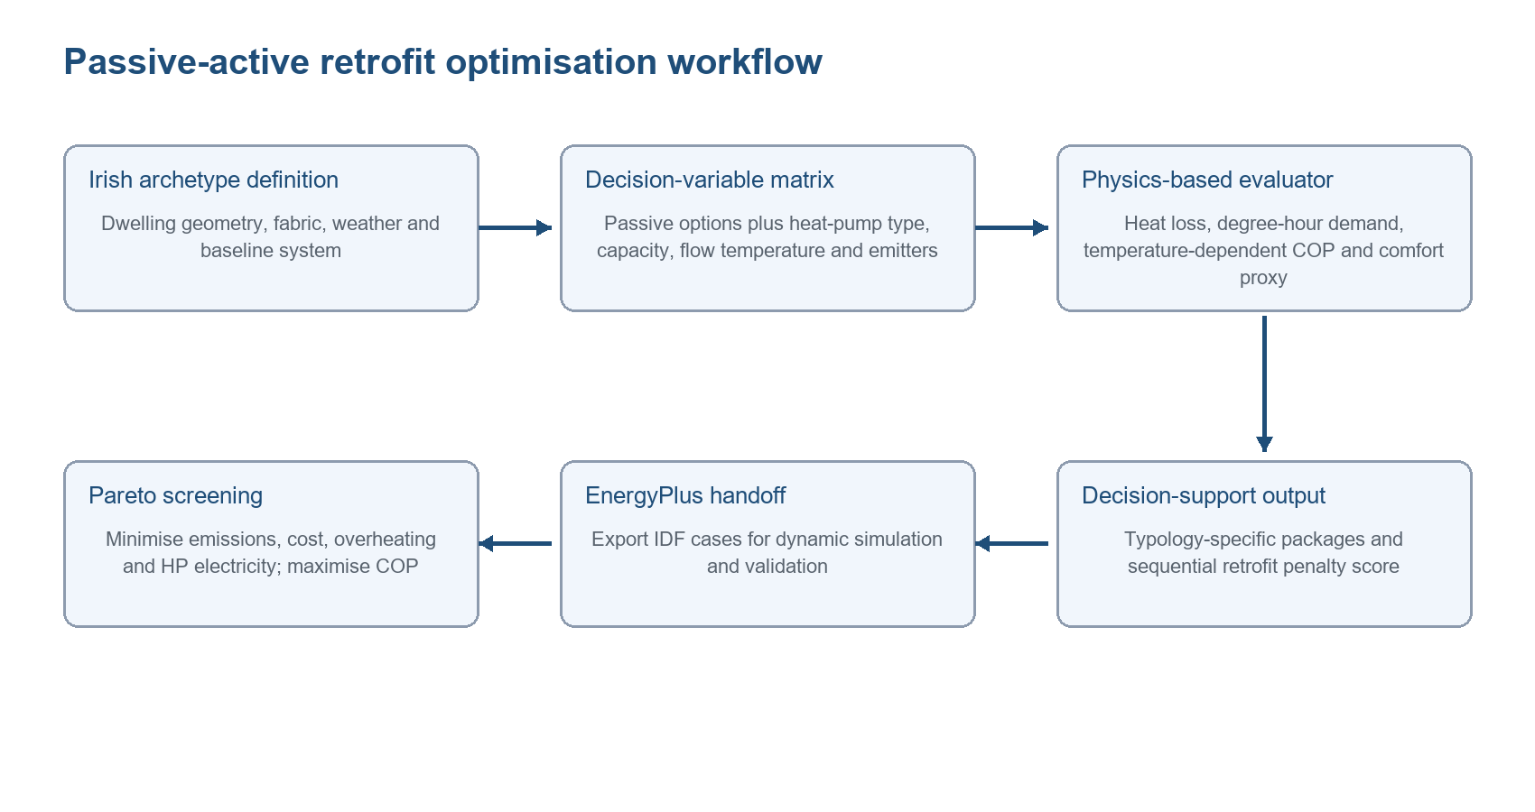
Figure 1. Proposed passive-active retrofit optimisation workflow used in the pilot.
The workflow is deliberately modular. The reduced-order model provides a fast screening layer, while the generated EnergyPlus IDF files provide the route for later dynamic simulation validation. This matters because fellowship-scale research should be able to scale across Irish dwelling typologies without losing the ability to test selected designs in a physics-based building simulation environment.

5. Dataset Description
Table 2. Representative archetype assumptions used in the pilot.
Dataset item | Value used in pilot
Dwelling type | Representative Irish semi-detached dwelling, circa 1980s
Location | Dublin, Ireland
Floor area / conditioned volume | 100.0 m2 / 250.0 m3
Envelope areas | Walls 110.0 m2; roof 55.0 m2; floor 55.0 m2; windows 18.0 m2
Baseline U-values | Wall 1.0 W/m2K; roof 0.45 W/m2K; floor 0.7 W/m2K; window 2.8 W/m2K
Baseline air-change rate | 0.75 ACH
Baseline heating | oil boiler; boiler efficiency 0.82
Weather representation | Monthly Dublin temperatures; design outdoor temperature -3.0 degC
Emission factors | Electricity 0.296 kgCO2/kWh; oil 0.257 kgCO2/kWh

The dataset is synthetic and archetype-based. It is not a measured dwelling record. It represents a plausible Irish semi-detached dwelling, circa 1980s, and is intended for method demonstration. In the fellowship project, these inputs would be replaced or calibrated using Irish BER/DEAP records, SEAI guidance, dwelling surveys, monitored data where available, and local weather files.

6. Optimisation Scheme
Table 3. Passive and active decision variables included in the pilot.
Decision variable | Category | Levels
Wall insulation | Passive | baseline; moderate; deep
Roof insulation | Passive | baseline; moderate; deep
Floor insulation | Passive | baseline; improved
Glazing | Passive | baseline; double low-e; triple
Airtightness | Passive | baseline; improved; deep
Ventilation | Passive/supporting system | natural; MEV; MVHR
Shading | Passive/comfort | none; external shading
Heat-pump type | Active | air-to-water; ground-source
Heat-pump capacity | Active | 6, 8, 10 or 12 kW
Flow temperature | Active | 35, 45 or 55 degC
Heat emitters | Active/system interface | existing radiators; oversized radiators; low-temperature emitters

The optimisation task is formulated as a multi-objective package-selection problem. The passive variables change the dwelling heat-loss coefficient and overheating-risk proxy; the active variables change the heat-pump COP, system capacity, backup heat, electricity use and installed cost. The core objectives are to minimise operational emissions, retrofit cost, overheating hours and heat-pump electricity use, while maximising seasonal COP. In the Pareto filter, maximising COP is handled by minimising negative COP.
A simple sequential penalty proxy is also calculated to flag packages that may be technically workable but poorly matched. The penalty increases when the package relies on high flow temperature, existing radiators, oversized heat-pump capacity, backup heat or high overheating risk. This is not yet a final policy metric; it is a demonstration of how the fellowship framework could convert optimisation results into decision-support signals.

7. Results and Discussion
The pilot evaluated 46,656 feasible retrofit packages and identified 453 Pareto-efficient packages. The baseline heat-pump case in the pilot uses an air-to-water heat pump, 55 degC flow temperature and existing radiators. It has a seasonal COP of 2.73, heat-pump electricity demand of 9,052.2 kWh/y and operational emissions of 2,679.5 kgCO2/y. This baseline is useful because it illustrates a central research issue: replacing a boiler with a heat pump can reduce emissions, but the system outcome depends strongly on the fabric state, flow temperature and emitter compatibility.
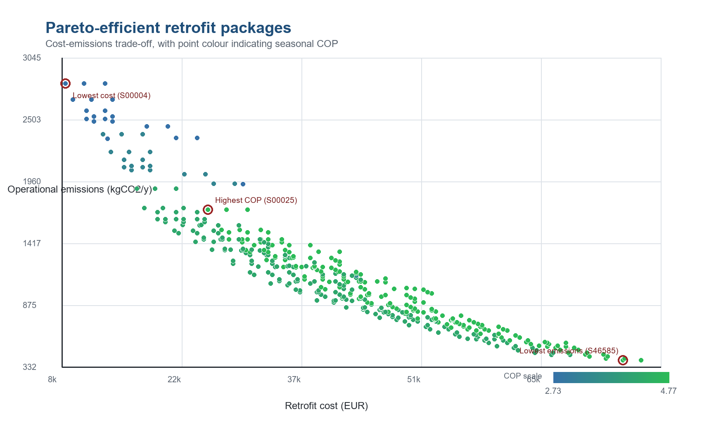
Figure 2. Pareto-efficient retrofit packages showing cost-emissions trade-off and seasonal COP.
Table 4. Notable optimisation outcomes from the pilot.
Criterion | Scenario | Emissions | Retrofit cost | COP / overheating
Lowest cost | S00004 | 2,819.9 kgCO2/y | EUR 8,500 | COP 2.73; OH 79.5 h/y
Highest COP | S00025 | 1,710.7 kgCO2/y | EUR 25,500 | COP 4.77; OH 79.5 h/y
Lowest emissions | S46585 | 390.3 kgCO2/y | EUR 75,000 | COP 4.77; OH 176.5 h/y

Table 5. Technical package composition for notable scenarios.
Criterion | Retrofit package selected
Lowest cost | baseline wall, baseline roof, baseline floor, baseline glazing, baseline airtightness, natural, air to water, 55 degC flow, existing radiators
Highest COP | baseline wall, baseline roof, baseline floor, baseline glazing, baseline airtightness, natural, ground source, 35 degC flow, low temp emitters
Lowest emissions | deep wall, deep roof, improved floor, triple glazing, deep airtightness, mvhr, ground source, 35 degC flow, low temp emitters

The lowest-emissions package combines deep envelope upgrades, MVHR, ground-source heat pump technology, low-temperature emitters and a 35 degC flow temperature. It achieves 390.3 kgCO2/y and a seasonal COP of 4.77, but at a high retrofit cost of EUR 75,000. The same package also has a high overheating-risk proxy because deep insulation and airtightness reduce heat loss but can also trap internal and solar gains if shading and ventilation are not optimised. This result supports the fellowship argument that passive retrofit quality cannot be judged only by annual heating-demand reduction.
The lowest-cost package installs an air-to-water heat pump without fabric upgrades or emitter improvement. It costs EUR 8,500 but has higher emissions, lower COP and backup heat compared with integrated deep-retrofit options. The highest-COP package shows a different pathway: it achieves COP 4.77 using ground-source heat pump technology, 35 degC flow and low-temperature emitters, even without envelope upgrades. This demonstrates that heat-pump-side variables can be as important as passive measures, and that an integrated framework is needed to compare the cost and performance consequences of different combinations.

8. Conclusion
This pilot provides a compact technical proof of concept for an Ireland-focused passive-active retrofit decision-support framework. It shows how dwelling archetypes, passive retrofit packages and heat-pump design variables can be assessed within one optimisation workflow. The results are not final design recommendations, but they demonstrate the scientific logic of the proposed fellowship: passive measures should be evaluated not only for heat-demand reduction, and heat pumps should be evaluated not only as equipment replacements. The useful retrofit decision is the combined package that balances cost, emissions, comfort risk and heat-pump operating performance for a specific dwelling type.
The next technical step is to replace the screening assumptions with calibrated Irish archetypes, run selected Pareto packages through EnergyPlus using Irish EPW weather files, and train a physics-informed surrogate model for fast optimisation across multiple representative Irish dwelling typologies. This would turn the pilot into a scalable research workflow aligned with the proposed SEAI Fellowship.

