Jules QA Protocol - Advanced DOCX Test
This document tests the limits of the python-docx library.

1. Text Styles & Formatting
Bold text. Italic text. Underlined text. Colored text.

2. Large Table (100 Rows)
ID | Random String | Value | Status
1 | BCDFM21NIfD+w+* | 387 | Pending
2 | &F+W_jJ1cv!ueQW | 189 | Error
3 | VBztGdDaOjZ)OB4 | 132 | Error
4 | !D7P$Sn+n$q@+T( | 664 | Pending
5 | aL3PVBbN^F7(E(a | 529 | Inactive
6 | B#q$wpvvELx6z%i | 859 | Error
7 | yBG5FCvn43i@BnA | 40 | Pending
8 | UvO5cFVs8SPLDoH | 581 | Inactive
9 | *ocx39qj_J53HKO | 874 | Active
10 | tUiVL^oWmQcV%oJ | 316 | Active
11 | dsGUgoYiVGzM2Vq | 191 | Active
12 | !rLYlDwFENFj0gc | 646 | Inactive
13 | 8BV#)pYq88_Zi1m | 882 | Inactive
14 | 4*1kxmQL)uaei!V | 411 | Inactive
15 | aYHrNDhaLZ649$O | 156 | Inactive
16 | 9dzTcoMD9dUePw$ | 514 | Inactive
17 | ^FV*D7$XqM71Hb3 | 246 | Inactive
18 | SM4J^1!TE+hEW6J | 187 | Inactive
19 | +soXYSPbeZ9$%98 | 517 | Active
20 | )zgL+FasLt5Go6R | 268 | Active
21 | Rv%re$Qvvgtckho | 433 | Error
22 | Ddb^P7cAq(!JHP^ | 230 | Pending
23 | JDaKFu0qo9Sir&5 | 232 | Inactive
24 | *RIy@2xwbhONLH@ | 502 | Pending
25 | s_1NmP)k_75DmE( | 918 | Inactive
26 | a(_DC9PNlVkY#QG | 122 | Active
27 | *+ayPVVNjI7X%*y | 357 | Pending
28 | E#P)^WhEGi3%_d4 | 753 | Error
29 | (JmEu6Zoq#pn+u4 | 230 | Pending
30 | zc$7*L2fO)GD5hD | 358 | Error
31 | bjq&o3OLBy0M1J2 | 25 | Inactive
32 | NL)+FP4+vNwrAU9 | 581 | Inactive
33 | unI&B2dPIi%l5DZ | 873 | Pending
34 | ^)mIzU$8kXlhV6% | 733 | Pending
35 | q$ZkQAI!a&(hLU! | 548 | Active
36 | QxNd(PcSCFMw7w_ | 65 | Error
37 | oNr6%MTbDy!GWKC | 586 | Error
38 | tY(0_Pdw5@y2Rqr | 562 | Error
39 | ^+$iWB86X!XA0Bn | 770 | Active
40 | tYWkyJ&()(Ib3uS | 918 | Active
41 | xwQZOiN@W+LL*yB | 979 | Pending
42 | )x&2fjn_u(Z1s%K | 9 | Active
43 | ge4B8w!(7@h*RQG | 815 | Inactive
44 | z+g)rxP9TdH(b_2 | 757 | Inactive
45 | 8gEYcuwU8KW%AZ+ | 732 | Pending
46 | J1xznqA1(gb*m$t | 742 | Error
47 | yi6VP_9w4^A^Wrk | 718 | Inactive
48 | kXVS^QG6w_9q@Q5 | 150 | Error
49 | $RQDz8q8HV^Mt85 | 202 | Active
50 | qY+uM6JTfE$A4#C | 782 | Pending
51 | 86AWJcPHrtAW6lE | 224 | Pending
52 | FMz8NQg*&I(u(iz | 197 | Error
53 | XmxJLrkVtu_EuVx | 829 | Active
54 | k#@3XQsxywtsxAd | 107 | Inactive
55 | 0J(U3DWUnKa4^d8 | 421 | Pending
56 | 86ezfa8J%vPRwZ8 | 498 | Pending
57 | euoddiHrpdOq%se | 179 | Active
58 | m^sYl#qmg&m0@!m | 873 | Error
59 | 4awYMzj5g)Zqd@K | 157 | Error
60 | %dT%PLBFk&K+VUk | 840 | Error
61 | z2btSVNL$WaSgw( | 304 | Error
62 | CXB6CoUM4PE+4We | 800 | Active
63 | asUJ8YXI*9xq7zZ | 622 | Pending
64 | _fNm5%qj!K9NNii | 482 | Active
65 | POmMxcxM$jC6Wui | 460 | Error
66 | z^I3fEr2OBB#1mn | 306 | Active
67 | CaaI$c2EK^9FOZ6 | 806 | Error
68 | e4N_O5QC9sVXvH6 | 826 | Inactive
69 | +APtk$OeTSSJ_et | 487 | Active
70 | C*vZnrRT+RmRHZh | 119 | Pending
71 | zDf)@fbGJdM1m5E | 823 | Error
72 | ^FO7YZv3ickcJ!q | 400 | Pending
73 | (jr!vwsLVYrXmCZ | 45 | Pending
74 | ^suajS$IVtUV+D@ | 474 | Inactive
75 | okLOB9h(&TNEiwQ | 882 | Error
76 | wUjzXz21XtmnZW( | 864 | Inactive
77 | dr%+c3wDY5D*9Rs | 372 | Error
78 | y4c*ausL69ZxP!S | 128 | Pending
79 | l*0Wsu%MsBmPp)C | 39 | Error
80 | 2DG1Pak+EX#pFY* | 322 | Pending
81 | *3#mVymKN&S2gq% | 190 | Inactive
82 | EQ07eoVtIy*)u+! | 860 | Active
83 | FO4PEVcok5ZOnzO | 725 | Inactive
84 | Hra4LGRnwOpqCKN | 374 | Error
85 | )5INi*#5k^0$Yyu | 241 | Inactive
86 | 0yRlrl^^RneTDA1 | 708 | Active
87 | I@KN%HcYbEXgBq7 | 97 | Pending
88 | )nwbAOJ!UT9268E | 635 | Inactive
89 | vkTI9wa@cFBWThY | 403 | Active
90 | NV82k#y^cJDJ3kY | 398 | Pending
91 | n68B^m@3tybvdzR | 428 | Pending
92 | b3&uGJZQ5$(7hE3 | 838 | Error
93 | eRdm+twagw^fQbS | 263 | Active
94 | D+HDRA+xPAYfi9w | 994 | Inactive
95 | yLRAMGZeIQcsDb! | 221 | Inactive
96 | UZ6XVVkPimfefd4 | 182 | Inactive
97 | $h&SKw0ft_rdR5P | 483 | Inactive
98 | ROgYOx3AsymFv4B | 299 | Active
99 | n^ENX0IuhleoT*D | 993 | Active
100 | J*K!V#Rfqa3spl+ | 482 | Pending

3. Embedded Images
Image: test_chart_sine.png
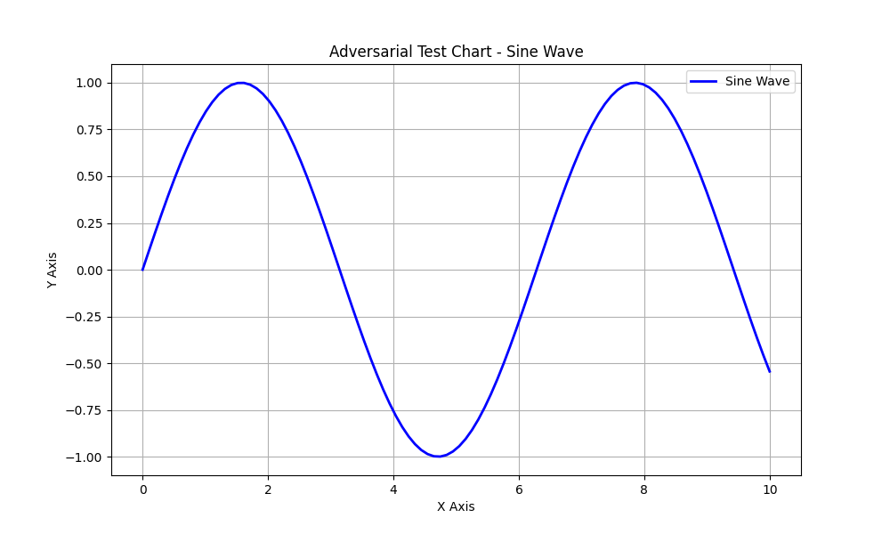
Image: test_chart_scatter.png
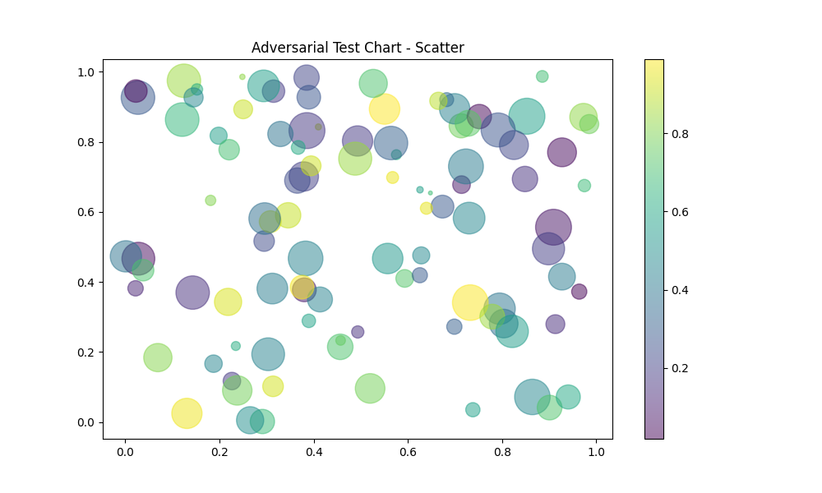

4. Special Characters & Unicode
Emoji: 🚀 ✅ ❌ 🐍 🐳
Languages: English, Español, Français, Deutsch, 日本語, 中文
Symbols: © ® ™ § ¶ † ‡

