MTConnect Agent Installation

NOTE This MTConnect Agent install package only works for 64 bit Windows (Windows 7 and 8) machines!

This is the C++ open source agent from the MTConnect Institute github website.

Shdr Adapters will output text like this thru a telnet connection:

2014-04-08T20:40:42.0280Z|heartbeat|714

2014-04-08T20:40:44.0426Z|heartbeat|715

2014-04-08T20:40:46.0544Z|heartbeat|716

# Installation

Start Install package: MtConnectAgentx64Setup.msi

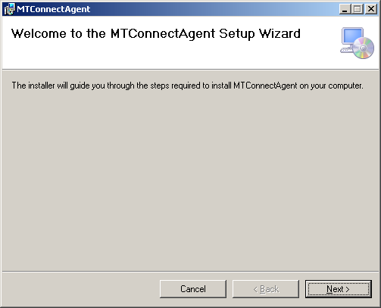

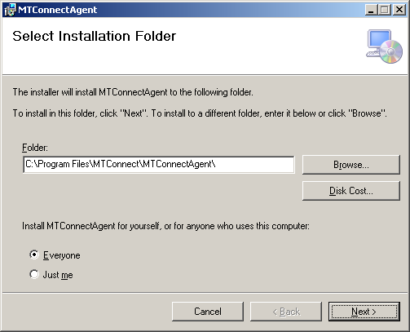

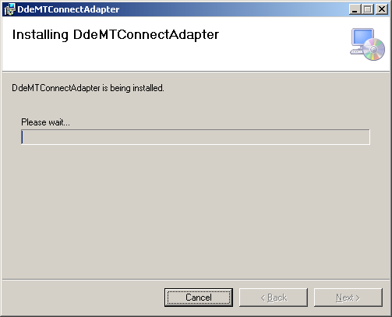

When done you will see the configuration page. You must enter the name of the Device, the IP address of the Adapter, and the port the Adapter uses (usually 7878). If you want to talk to more than one SHDR Adapter back end, enter comma separated values . M1,M2 and 127.0.0.1,127.0.0.3 and 7878,7878 are for two SHDR adapters.

Note, the agent is hardwired to use port 5000 for http access (e.g., <http://127.0.0.1:5000/current> will give the output from your adapter in MTConnect XML format).

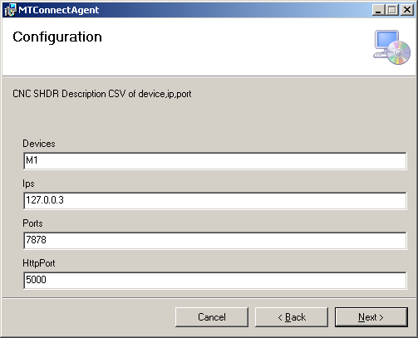

Now you are ready to install:

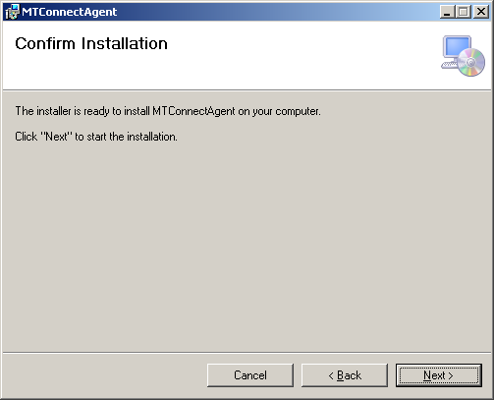

Please be patient, it takes a while. You should see some black cmd screens install the service and start the service. (Hopefully).

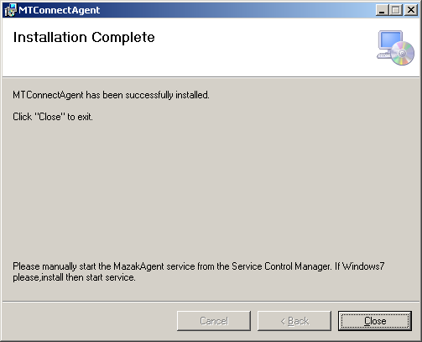

## Checking that install worked:

1. <http://127.0.0.1:5000/current> will give you some XML.
2. C:\Program Files\MTConnect\MTConnectAgent

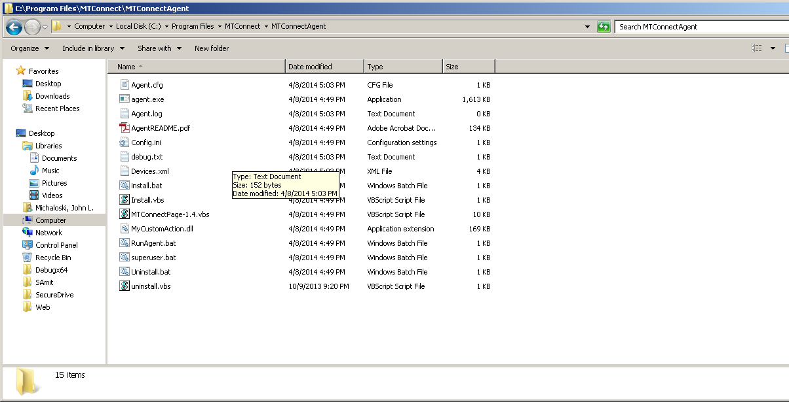

And the agent.cfg file should match the install parameterization:

Devices = Devices.xml

ServiceName = MTCAgent

Port = **5000**

CheckpointFrequency=10000

AllowPut=true

Adapters

{

**M1**

**{**

**Host = 127.0.0.3**

**Port = 7878**

**}**

}

# Logger Configuration

logger_config

{

logging_level = fatal

output = file Agent.log

}

## Uninstall

Make sure the MTConnectAgent service is not running (bug in msi ). Navigate to servies (Right click on My Computer, select Manage, select Service, and stop MTConnectAgent) . Now uninstall.

