**Section 1: Data Loading and Overview**



Explanation:

* In this section, you load the Iris dataset, display the first few rows, and provide a statistical overview. You also check the number of unique flower species in the dataset.
* Ensure that the dataset is loaded correctly, and the basic statistics (mean, std, etc.) make sense for each feature. Verify that the number of unique species matches your expectations.

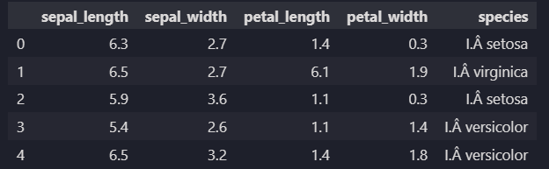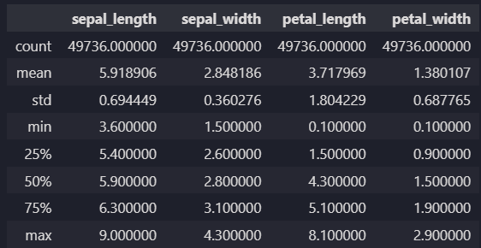

**Section 2: Data Visualization**



Explanation:

* This section generates pair plots and box plots for better visualization of the dataset.
* Ensure that the pair plot provides insights into the relationships between features, and the box plots show how each feature varies across different species.

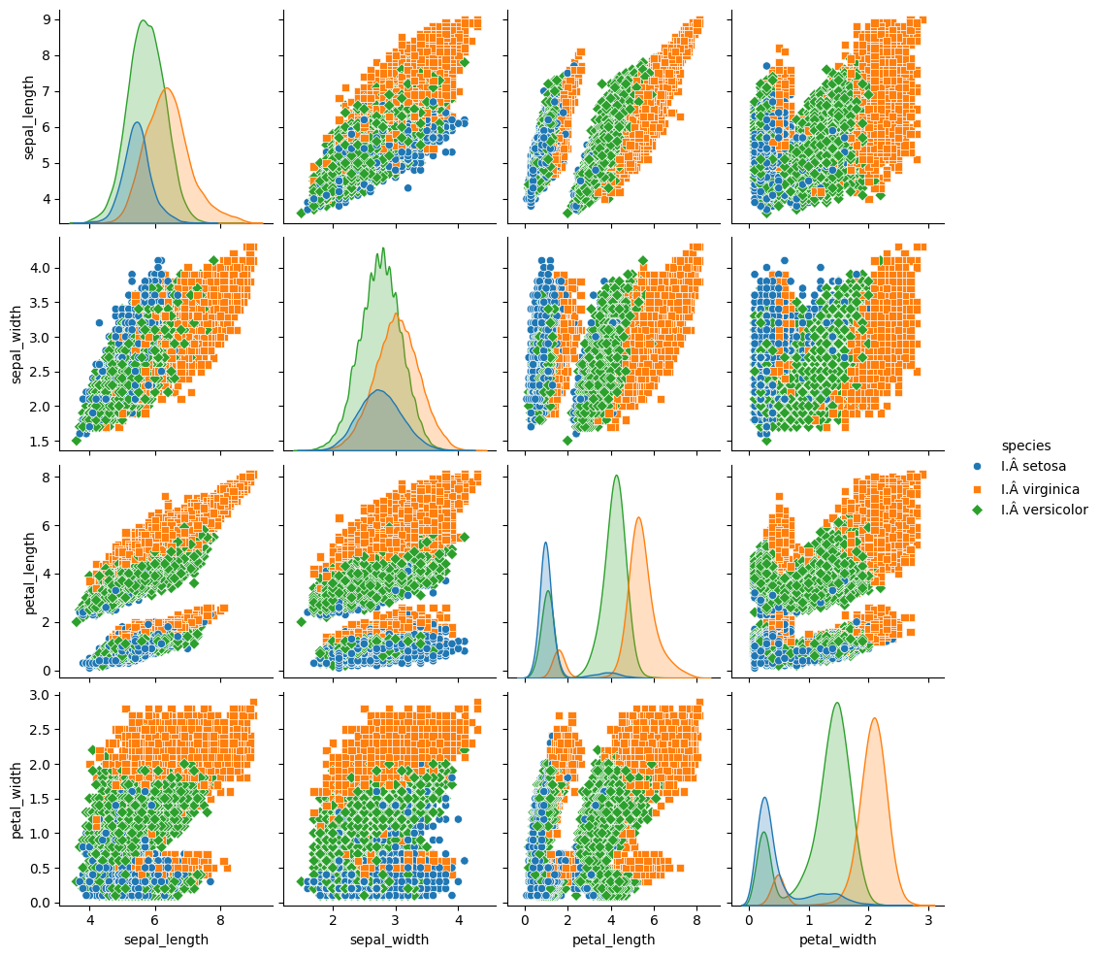

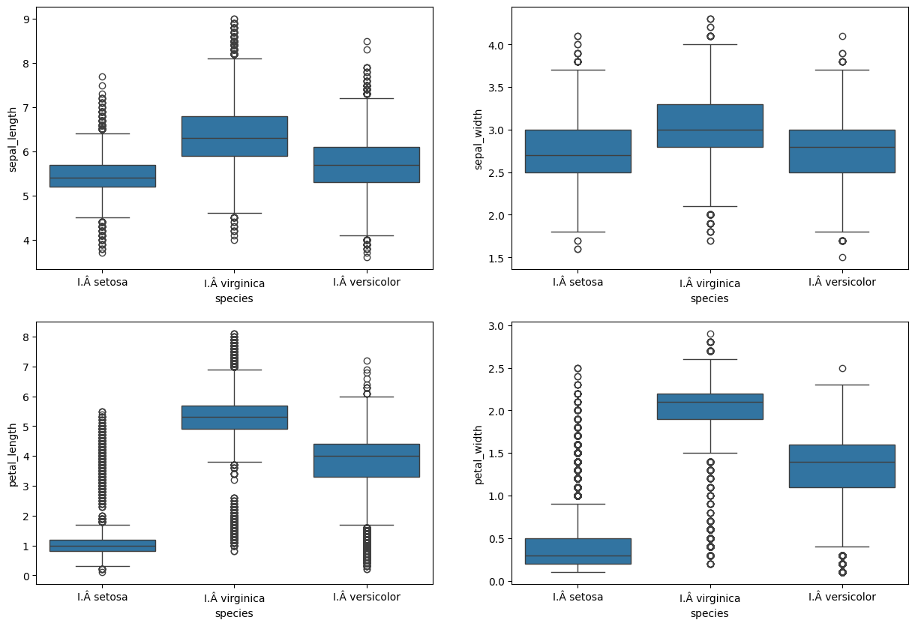

**Section 3: Data Preprocessing and Model Training (SDBP)**



Explanation:

* This part preprocesses the data, splits it into training and testing sets, creates an MLP classifier with Steepest Descent Backpropagation (SDBP) solver, trains the model, and prints the results.
* Check that the training process completes without errors, and review the results, including the number of iterations, time taken, and accuracy.

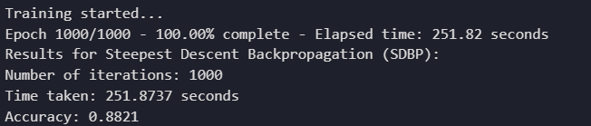

**Section 4: Model Training (LM)**



Explanation:

* This section trains another MLP classifier using the Levenberg-Marquardt (LM) solver and prints the results.
* Confirm that the training process with LM completes successfully and review the accuracy and the number of iterations.

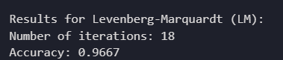

**Section 5: TensorFlow Model Training (Powell-Beale-CG)**



Explanation:

* This section uses TensorFlow to implement a custom Powell-Beale Conjugate Gradient optimization algorithm and trains the model.
* Ensure that the training process completes, and review the accuracy. Note that the time taken is marked as "Not applicable" since it's not explicitly measured.

