**I work with MATLAB 2023b, please be careful.**

1. **Header Comments:**

* Provides introductory information about the MATLAB script, including the purpose of the code, the student's details, and a fun welcome message.

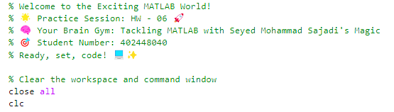

1. **Input Initialization:**

* Initializes input values for physical parameters or uses hardcoded values.
* Sets values for energy, mass, length, and alpha.

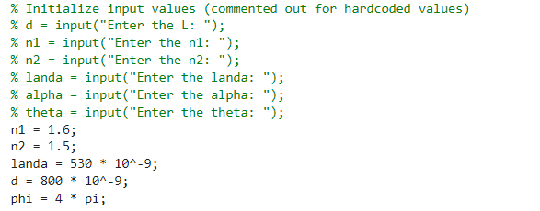

1. **Circle Radius Calculation:**

* Uses the defined constants to calculate the radius of a circle in a potential energy landscape.



1. **Function Plotting:**

* Generates x values and calculates y values for tangent and cotangent functions.
* Plots these functions along with a circle using parametric equations.

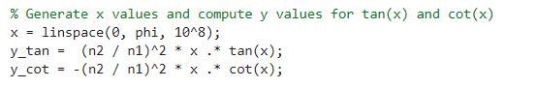

1. **Intersection Points Calculation:**

* Iterates through x values to find intersection points of tangent and cotangent functions with the circle.

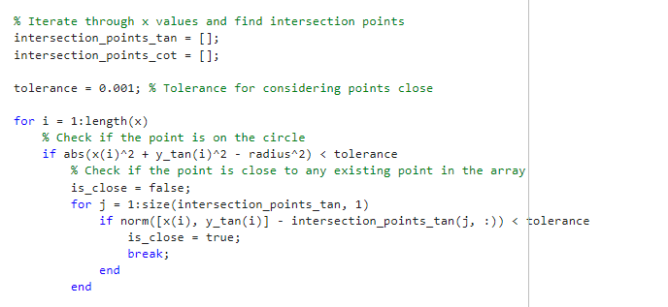

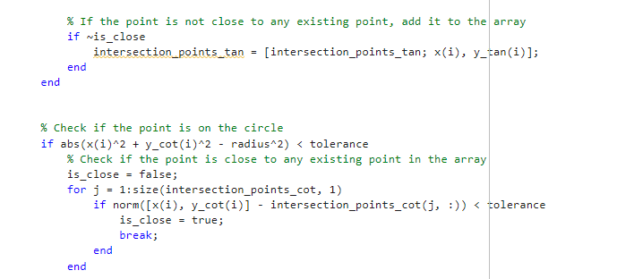

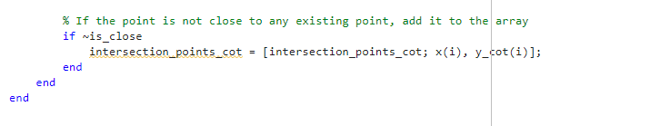

1. **Result Display:**

* Displays the intersection points and corresponding energies for both functions.
* Counts and displays the number of points for tangent and cotangent.

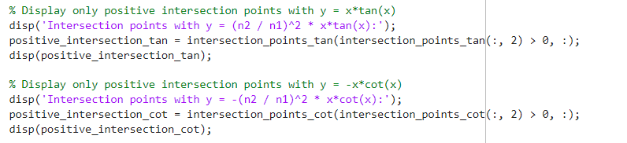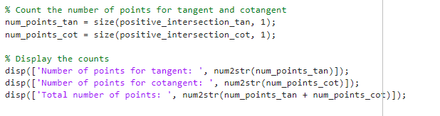

1. **Intersection Points Plotting:**

* Plots intersection points on the tangent and cotangent functions.

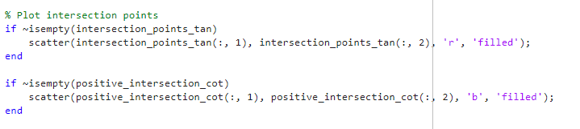

1. **Additional Plotting:**

* Creates new variables for scaled intersection points.
* Plots wave functions in subplots based on the calculated intersection points.

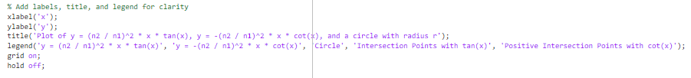

1. **Subplot Generation:**

* Iterates through intersection points and plots corresponding wave functions in separate subplots.

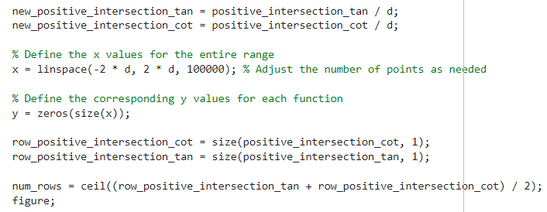

1. **Closing Comments:**

* Ends the script with a comment and ensures clarity in the code structure.

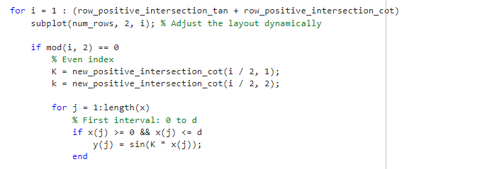

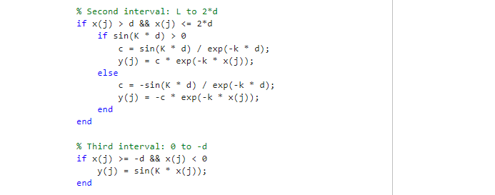

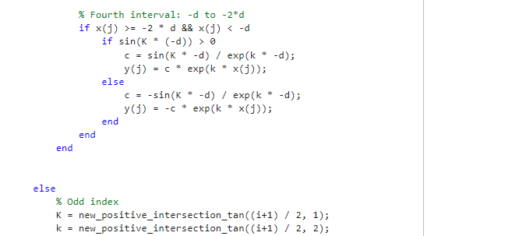

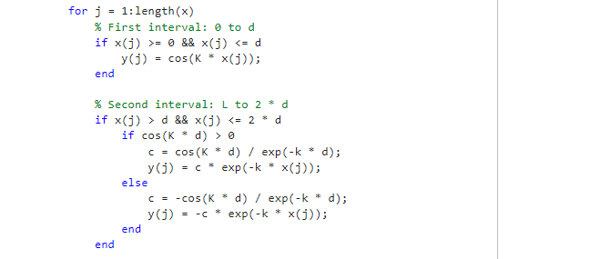

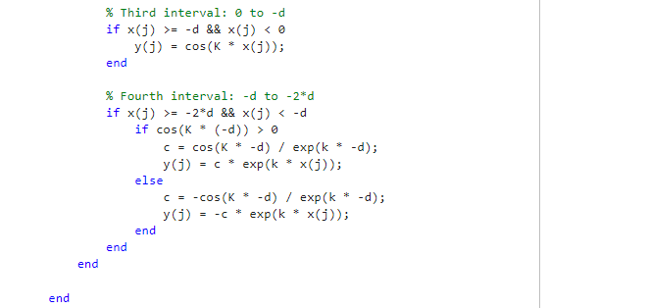

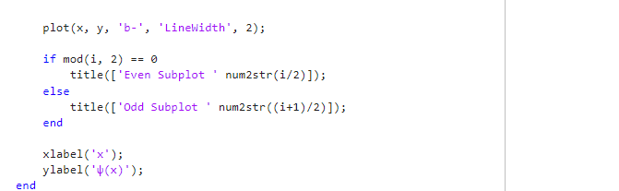

1. **Result** 😊

Now let's check the final results:

As it is known, based on the data, the following figure appears because the circle has been drawn and the tan and cot graphs and its intersection have been checked and drawn.

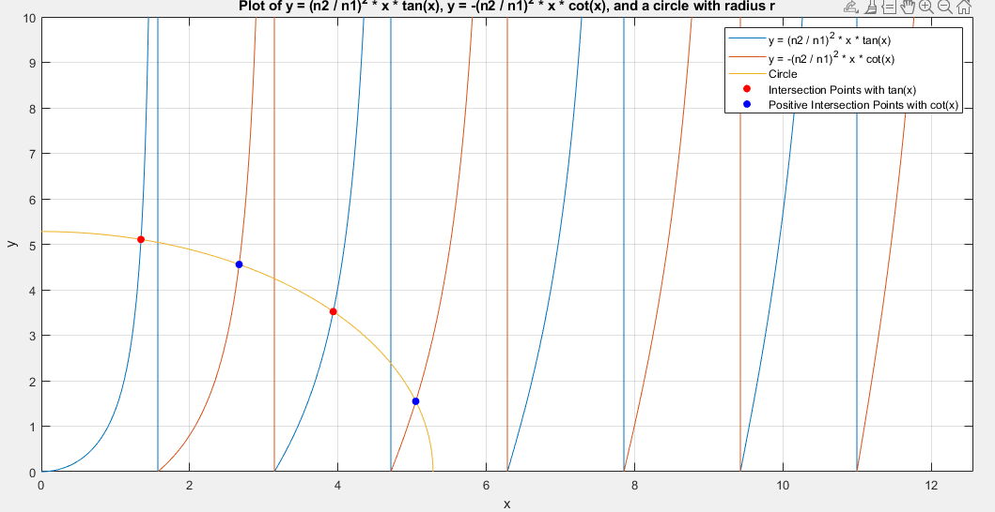

The radius of the circle, the intersection points of the circle with each graph, the number of intersections with each graph, and the total number of points and energy of each are determined:

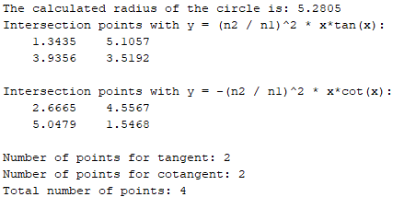

The wave function is as follows:

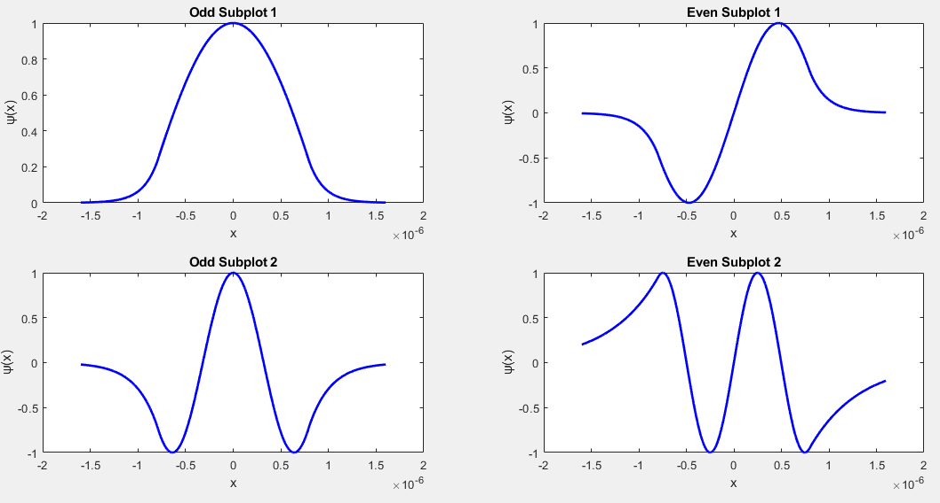

1. Analysis:

Now, if we change the length, the graph and results will be as follows: ($d=1000 nm$)

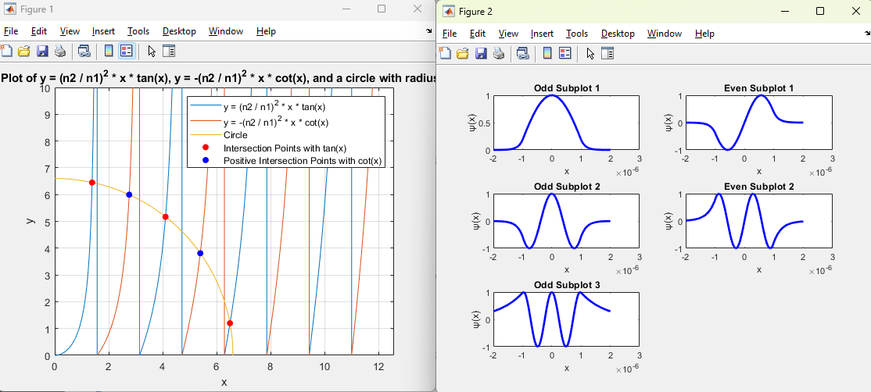

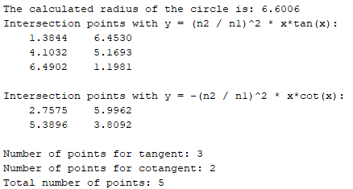

As it is known, with the increase of the width of the waveguide, the circle becomes bigger and includes more modes.

Now, if we change the length, the graph and results will be as follows: ($L=600 nm$)

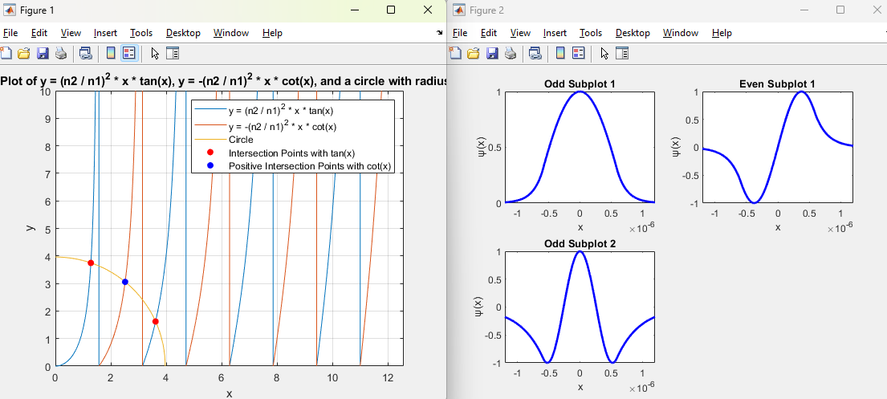

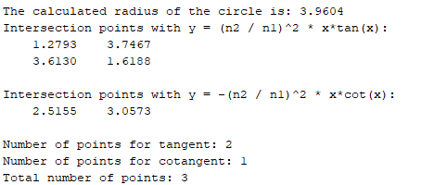

As it is known, with the reduction of the width of the waveguide, the circle becomes smaller and includes fewer modes.

Now, if we change the $n_{1}$, the graph and results will be as follows:  ($n_{1}=1.8$)

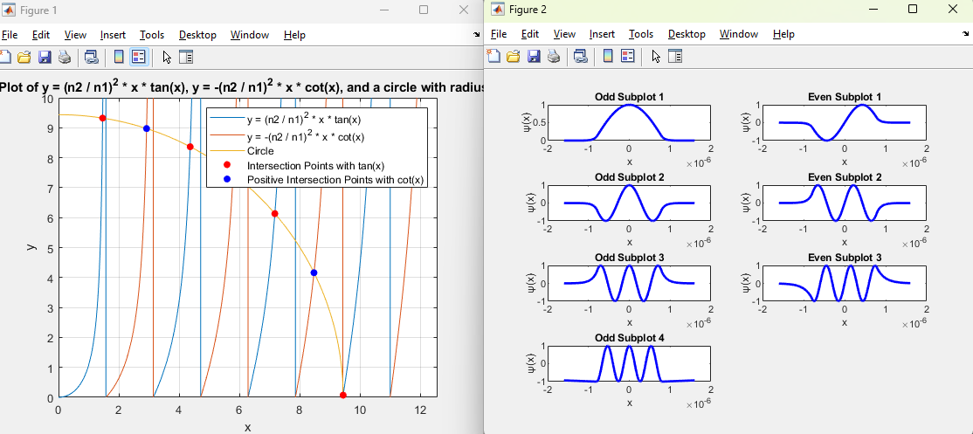

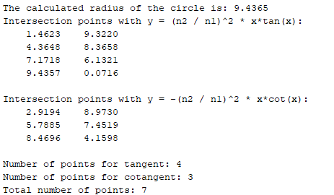

As it is known, with the increase of the refractive index of the waveguide, the circle becomes larger and includes more modes.

Now, if we change the $n_{1}$, the graph and results will be as follows:  ($n_{1}=1.55$)

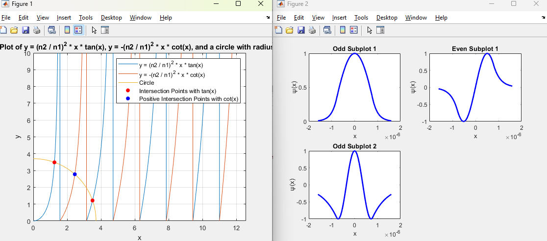

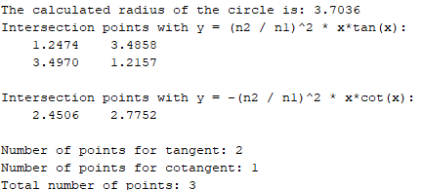

As it is known, by decreasing the value of refractive index, the waveguide circle becomes smaller and includes fewer modes.