***Q:***

1. Show that if the maximum positive displacement of a sine wave at t=0 is at a distance of $x_{0}$ cm from the origin, its initial phase angle is given by the following equation

$$φ_{o}=\frac{π}{2}-\left(\frac{2π}{λ}\right) x_{0}$$

where the wavelength λ is in centimeters.

1. Obtain the initial phase and draw the wave for $λ=10 cm$ and the initial distances $x_{0}$ equal to 0, $\frac{5}{6}$, $\frac{5}{2}$, 5 and $-\frac{1}{2}$ cm.
2. If we use the cosine function instead of the sine function, determine the initial phase angles for part (b).

***Sol:***



$$y=Asin(k\left(x+vt\right)+φ)$$

$$y=1, t=0→Asin\left(kx+φ\right)=1→kx+φ=\frac{π}{2}→φ=\frac{π}{2}-\frac{2π}{λ}x$$

$$λ=10$$

$$\left\{\begin{aligned}x=0→φ=\frac{π}{2} \\ x=\frac{5}{6}→φ=\frac{π}{2}-\frac{2π}{10}*\frac{5}{6}=\frac{π}{2}-\frac{π}{6}=\frac{π}{3} \\ x=\frac{5}{2}→φ=\frac{π}{2}-\frac{2π}{10}*\frac{5}{2}=0 \\ x=5→φ=\frac{π}{2}-\frac{2π}{10}*5=-\frac{π}{2} \\ x=-\frac{1}{2}→φ=\frac{π}{2}-\frac{2π}{10}*\frac{1}{2}=\frac{π}{2}-\frac{π}{5}=\frac{3π}{10}\end{aligned}\right.$$

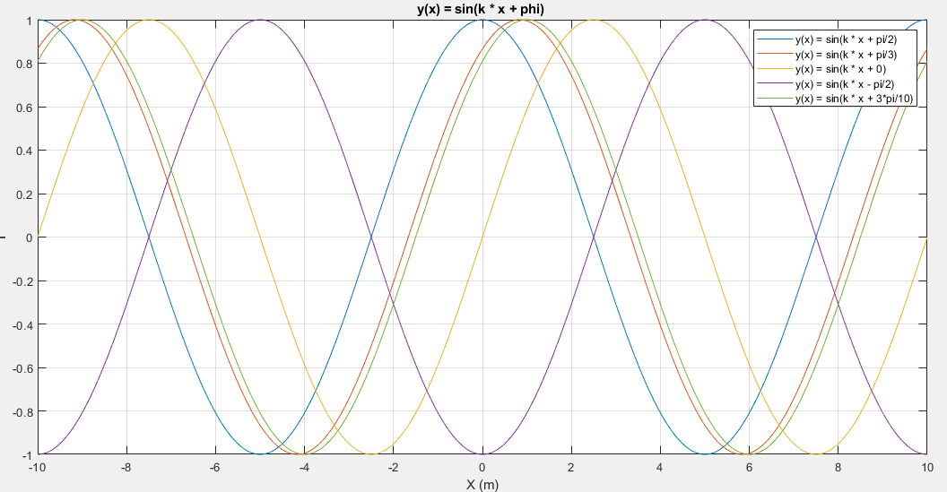

1. As it is known, the difference of sine or cosine is only $\frac{pi}{2}$, so we have to add $\frac{pi}{2}$ to the answers.

$$λ=10$$

$$\left\{\begin{aligned}x=0→φ=\frac{π}{2}+\frac{π}{2}=π \\ x=\frac{5}{6}→φ=\frac{π}{2}-\frac{2π}{10}*\frac{5}{6}+\frac{π}{2}=\frac{π}{2}-\frac{π}{6}+\frac{π}{2}=\frac{π}{3}+\frac{π}{2}=\frac{5π}{6} \\ x=\frac{5}{2}→φ=\frac{π}{2}-\frac{2π}{10}*\frac{5}{2}+\frac{π}{2}=0+\frac{π}{2}=\frac{π}{2} \\ x=5→φ=\frac{π}{2}-\frac{2π}{10}*5+\frac{π}{2}=-\frac{π}{2}+\frac{π}{2}=0 \\ x=-\frac{1}{2}→φ=\frac{π}{2}-\frac{2π}{10}*\frac{1}{2}+\frac{π}{2}=\frac{π}{2}-\frac{π}{5}+\frac{π}{2}=\frac{3π}{10}+\frac{π}{2}=\frac{8π}{10}\end{aligned}\right.$$

