***Q:***

1. Show the following two harmonic waves in a phasor diagram
$$E_{1}=2\sin\left(ωt\right), E_{2}=7\sin\left(ωt+\frac{π}{4}\right)$$

2. Obtain the mathematical relation of Briand wave.

***Sol:***



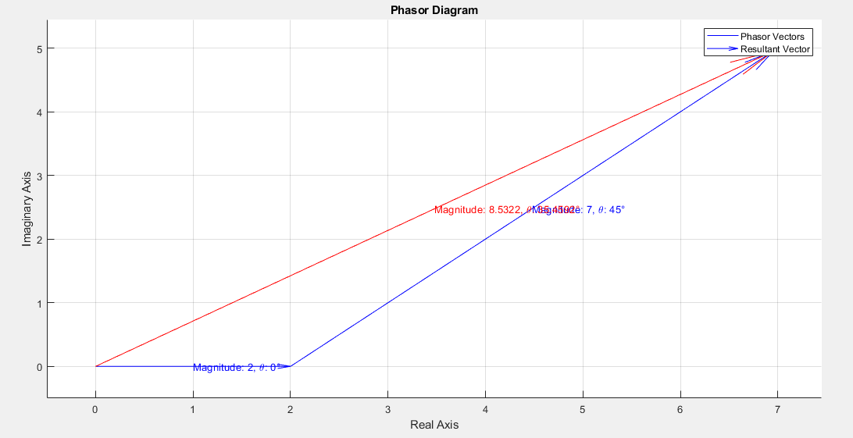

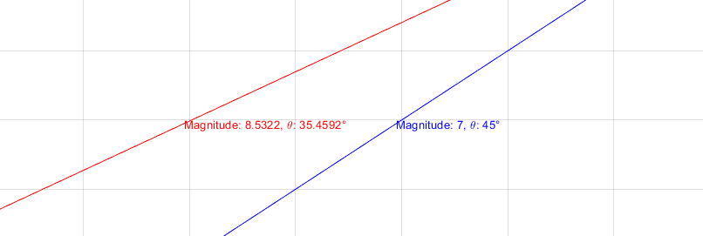



$$E_{T}=E_{1}+ E_{2}=E_{o1}\sin\left(ωt+a_{1}\right)+E_{o2}\sin\left(ωt+a_{2}\right)$$

$$=\left(E_{o1}\cos\left(a_{1}\right)+E_{o2}cos⁡(a_{2})\right)\sin\left(ωt\right)+\left(E_{o1}\sin\left(a_{1}\right)+E_{o2}sin⁡(a_{2})\right)\cos\left(ωt\right)$$

$$=2\sin\left(ωt\right)+ 7\sin\left(ωt+\frac{π}{4}\right)$$

$$=\left(2\cos\left(0\right)+7cos⁡(\frac{π}{4})\right)\sin\left(ωt\right)+\left(2\sin\left(0\right)+7sin⁡(\frac{π}{4})\right)\cos\left(ωt\right)$$

$$=\left(2+\frac{7\sqrt{2}}{2}\right)\sin\left(ωt\right)+\frac{7\sqrt{2}}{2}\cos\left(ωt\right)$$

$$E_{T}=E_{o}sin⁡(ωt+a)$$

$$\left\{\begin{aligned}{|E}_{T}|=\sqrt{{\left(2+\frac{7\sqrt{2}}{2}\right)}^{2}+{\left(\frac{7\sqrt{2}}{2}\right)}^{2}}=8.53 \\ a=\arctan\left(\frac{\frac{7\sqrt{2}}{2}}{2+\frac{7\sqrt{2}}{2}}\right)=35.46\end{aligned}\right.$$

Which is exactly the same as simulation 😊