**Q:** The figure below shows the micro ring amplifiers:

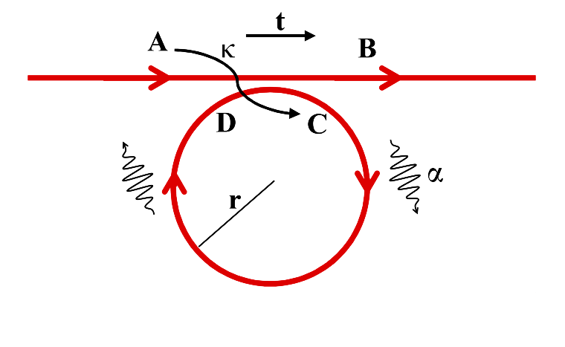

Why should $\hat{κ}$ and $\hat{t}$ be conjugate to calculate C and the coefficient of A should be negative?

$$\left[\begin{matrix}B \\ C\end{matrix}\right]= \left[\begin{matrix}\hat{t} & \hat{κ} \\ -{\hat{κ}}^{*} & {\hat{t}}^{*}\end{matrix}\right]\left[\begin{matrix}A \\ D\end{matrix}\right]$$

**Sol:**

In a ring resonator system with coupling, we need to consider:

1. **Power conservation**: Total power must remain constant, meaning no loss of power.

2. **Reciprocity**: The system should behave symmetrically with respect to the direction of propagation.

**Coupling Relations**

In a simple ring resonator with a single waveguide, we have two important coupling regions where the waveguide interacts with the ring resonator. These interactions are described by coupling coefficients $t$ and $κ$. Let's represent the electric fields at these interaction points.

**Definitions**

- Input field to the waveguide.

- Output field from the waveguide.

- Field inside the ring resonator entering the coupling region.

- Field inside the ring resonator after the coupling region.

**Coupling Matrix**

The coupling matrix for a directional coupler is generally written as:

$$\left({E_{t1} \atop E_{t2}}\right)=\left(\begin{matrix}\hat{t} & \hat{κ} \\ -{\hat{κ}}^{*} & {\hat{t}}^{*}\end{matrix}\right)\left({E_{i1} \atop E_{i2}}\right)$$

This matrix represents the relationship between the input and output fields in terms of the transmission $t$ and coupling $κ$ coefficients.

**Derivation**

1. **Power Conservation**:

For power to be conserved, the sum of the squared magnitudes of the coefficients must be **1**:

2. **Reciprocity**:

Reciprocity implies that the system should work the same way in the reverse direction. This principle demands symmetry in the coupling matrix.

**Coupling Relations:**

Using the coupling matrix:

$$\left({E_{t1} \atop E_{t2}}\right)=\left(\begin{matrix}\hat{t} & \hat{κ} \\ -{\hat{κ}}^{*} & {\hat{t}}^{*}\end{matrix}\right)\left({E_{i1} \atop E_{i2}}\right)$$

we get the following equations:

$$E_{t2}=tE_{i1}+κE_{i2}$$

$$E_{t1}=-κ^{*}E_{i1}+t^{*}E_{i2}$$

To understand why the negative sign appears, consider the following:

1. **Interference and Phase**:

The fields $E_{i1}$ and $E_{i2}$ can interfere constructively or destructively, depending on their phase relationship. The negative sign accounts for the phase shift that naturally occurs during the coupling process.

2. **Symmetry and Reciprocity**:

For the system to be reciprocal, the process should look the same if we reverse the direction of propagation. This symmetry implies that the coefficients for coupling must be complex conjugates when considering the reverse process.

3. **Mathematical Consistency**:

The coupling matrix should be unitary to preserve power. A unitary matrix $U$ satisfies $U^{†}U=I$, where $U^{†}$ is the conjugate transpose of $U$ and $I$ is the identity matrix.

Let's check the unitarity of the matrix:

$$U=\left(\begin{matrix}t & κ \\ -κ^{*} & t^{*}\end{matrix}\right)$$

The conjugate transpose $U^{†}$ is:

$$U^{†}=\left(\begin{matrix}t^{*} & -κ \\ κ^{*} & t\end{matrix}\right)$$

Now, $U^{†}U$ should equal the identity matrix $I:$

$$U^{†}U=\left(\begin{matrix}t^{*} & -κ \\ κ^{*} & t\end{matrix}\right)\left(\begin{matrix}t & κ \\ -κ^{*} & t^{*}\end{matrix}\right)$$

Calculate the elements of the product:

$$\left(\begin{matrix}t^{*}t+\left(-κ\right)\left(-κ^{*}\right) & t^{*}κ+\left(-κ\right)t^{*} \\ κ^{*}t+tκ & κ^{*}κ+tt^{*}\end{matrix}\right)=\left(\begin{matrix}{\left|t\right|}^{2}+{\left|κ\right|}^{2} & 0 \\ 0 & {\left|κ\right|}^{2}+{\left|t\right|}^{2}\end{matrix}\right)=\left(\begin{matrix}1 & 0 \\ 0 & 1\end{matrix}\right)=I$$

This confirms that $U$ is indeed unitary.

**Understanding Unitarity**

Unitarity is a mathematical property of matrices that is directly related to energy conservation in physical systems. A matrix $U$ is unitary if it satisfies the following condition:

$$U^{†}U=I$$

where $U^{†}$ is the conjugate transpose of $U$. This condition ensures that the transformation described by $U$ preserves the total norm (or energy) of the system.

**Why Multiply by the Conjugate Transpose?**

1. **Norm Preservation**:

- In the context of quantum mechanics and wave propagation, the norm of a vector (which can represent the amplitude of electric fields in our case) corresponds to the total probability or energy. For a physical system to conserve energy, the norm of the state vector before and after applying the transformation should remain the same.

- Mathematically, this is expressed as:

$$|Uv|^{2}=|v|^{2}$$

for any vector $v.$ This norm preservation implies that the inner product (dot product) of the vector with itself is preserved.

2. **Inner Product Preservation**:

- The inner product of two vectors $u$ and $v$ should remain unchanged after the transformation by $U$. For $U$ to preserve the inner product, it must satisfy:

$$⟨Uu, Uv ⟩= ⟨u, v ⟩$$

This leads to the condition:

$$U^{†}U=I$$

This condition is equivalent to saying that $U$ is unitary.

3. **Energy Conservation**:

- In the context of waveguides and resonators, the input power should equal the output power. If $E_{in}$ is the input vector of electric fields and $E_{out}=UE_{in}$ is the output vector, then energy conservation implies:

$$|E_{out}|^{2}=|E_{in}|^{2}$$

This can be rewritten using the inner product as:

$$⟨E_{out}, E_{out}⟩= ⟨E_{in},E_{in}⟩$$

Substituting $E_{out}=UE_{in}$, we get: $$⟨UE_{in}, UE_{in}⟩= ⟨E_{in},E_{in}⟩$$

This simplifies to:

$$(UE_{in})^{†} (UE_{in})=E_{in}^{†} E_{in}$$

Using properties of the conjugate transpose, we have:

$$E_{in}^{†}U^{†}UE_{in}=E_{in}^{†} E_{in}$$

Since this must hold for any $E_{in}$, it implies:

$$U^{†}U=I$$

The multiplication of the matrix $U$ by its conjugate transpose $U^{†}$ to obtain the identity matrix $I$ ensures that the transformation represented by $U$ is unitary. This unitarity condition is critical because it guarantees that the transformation conserves energy (or power) in the system.

In simpler terms, the matrix itself $U$ being unitary means that it inherently ensures energy conservation. The mathematical requirement $U^{†}U=I$ is a formal way of verifying that $U$ does not alter the total energy of the system, thereby confirming that the coupling process described by $U$ is physically valid and conserves power.