In this assignment, we have to draw the wave functions and the probability of presence, of course we print the energy values in each level.

First, we observe the energy values for 4 levels:

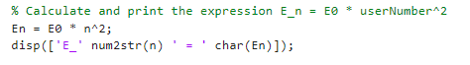

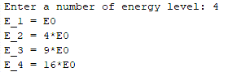

Now, based on what was discussed in the class, we drew the wave functions (of course, the code is also given below).



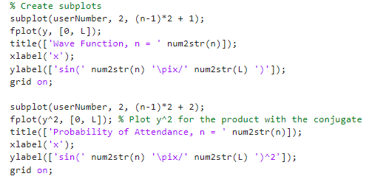

As it is clear, since we have to get the probability, we have to use the $\int_{0}^{L}{ψψ^{*}}$ formula:

