In this assignment, we have to draw the wave functions and the probability of presence, of course we print the energy values in each level. ($m_{1}≠m_{2}$)

***It is noteworthy that the results and calculation items are stated in the previous part.***

We have to consider two conditions:

$E>U_{0}$

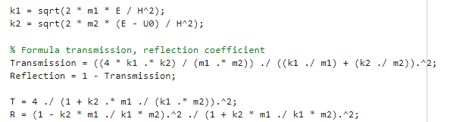

Enter the following data:



Now the results will be as follows:

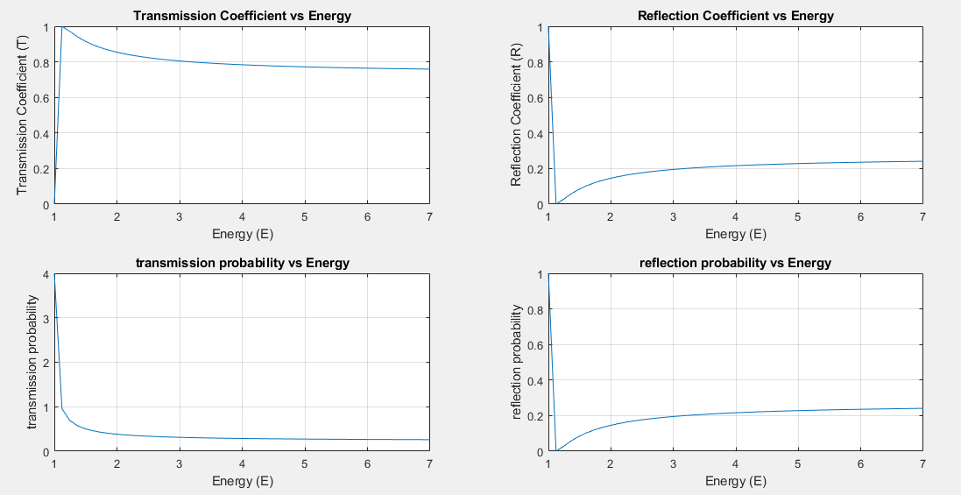

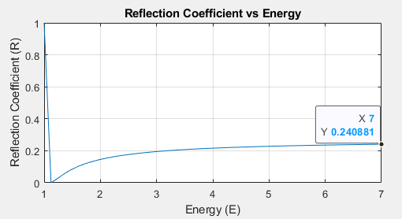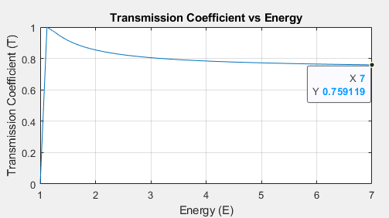As it is known, for Transmission, as much energy is transmitted (starting from U0) and it continues until the transmission becomes more, i.e. 1, now with the increase of energy, as discussed in the analytical part, it reaches a constant value and decreases.

As it is known, for the Reflection function, it is its inverse because it follows the relationship $Transmission+ Reflection = 1$

Two other graphs are displayed based on its formulas.

Now, if we put the mass values as below, the output will be as below, which is correct based on our analysis. (Because when the mass of the second medium increases, it will be difficult to reach more transmission mode)



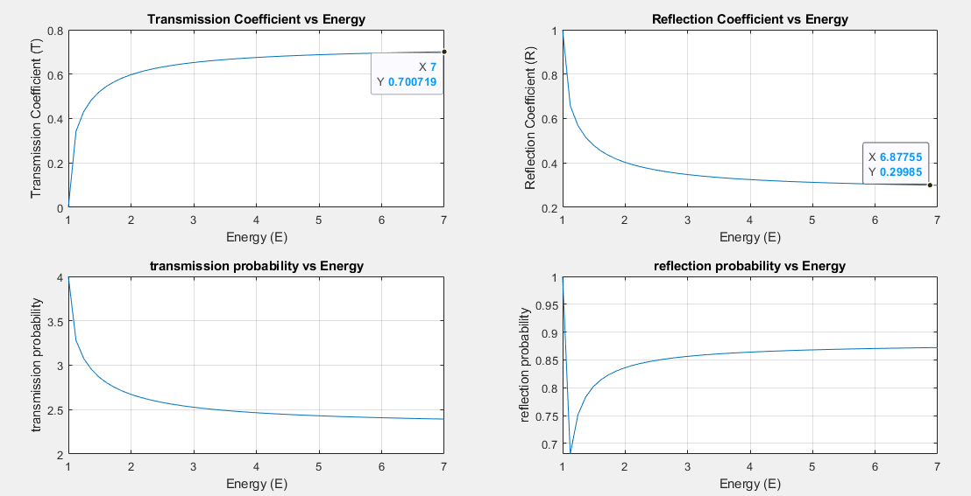

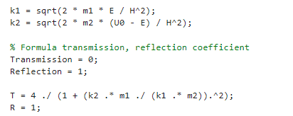

Enter the following data:



Now the results will be as follows:

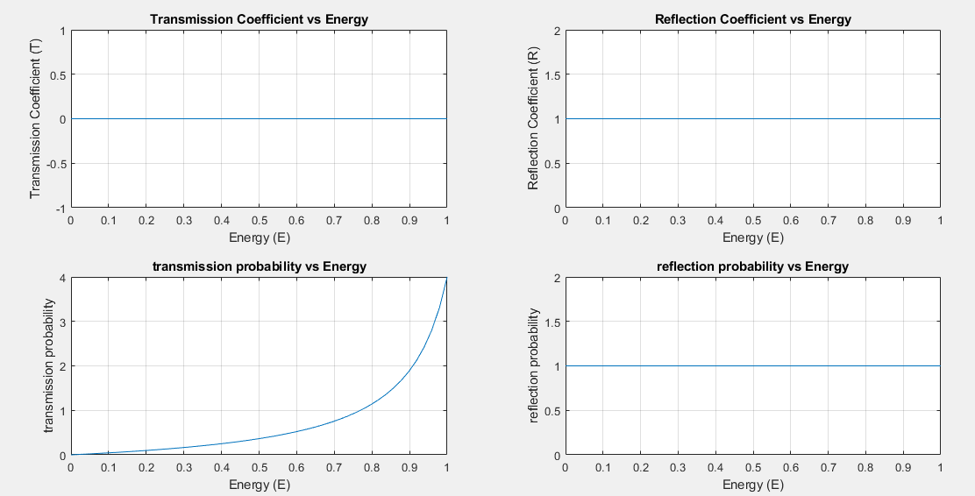

As we checked it in the analytical part, because the flow of current will not be possible due to less energy and we will have a reverse flow.

As it is known, for the Reflection function, it is its inverse because it follows the relationship $Transmission+ Reflection = 1$

Two other graphs are displayed based on its formulas.

Now, if we put the mass values as below, the output will be as below, which is correct based on our analysis. (Because when the mass of the second medium increases, it will be difficult to reach more transmission mode)



