**I work with MATLAB 2023b, please be careful.**

1. **Header Section:**

* **This section provides introductory information, including the purpose of the MATLAB script, the session it belongs to, and the student's identification number.**



1. **Initialization and Constants:**

* **The code starts by clearing the workspace, closing any open figures, and defining physical constants such as Planck's constant, reduced Planck's constant, and potential barrier parameters.**

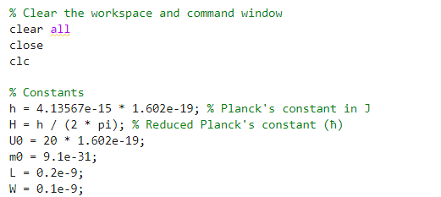

1. **User Input:**

* **Although currently commented out, this section allows the user to input the number of simulation steps, providing flexibility for experimentation.**
* **Because the circuit is checked by RTD sounder, so the number of dams and valleys should be 4, now if we want to change it to another model, we can change this comment.**

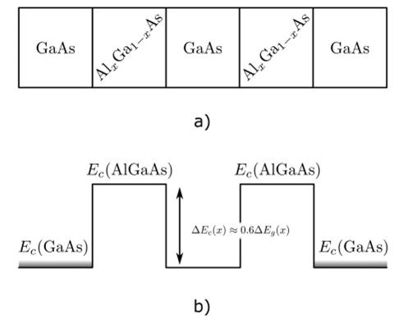



1. **Energy Range Setup:**

* **The script generates an array of energy values within a specified range using the linspace function.**

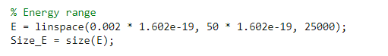

1. **Main Computation Loop:**

* **The nested loops iterate over energy values and simulation steps to calculate transmission probabilities through a quantum barrier. It employs matrices to represent wave transformations during odd and even steps, considering potential barriers and free spaces.**

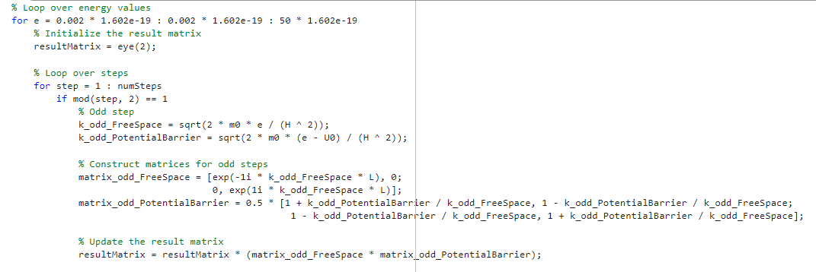

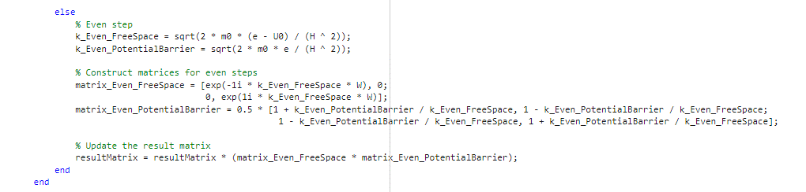

1. **Probability Calculation and Storage:**

* **The code calculates and stores the transmission probability at each energy step in the array P11, representing the squared amplitude of the transmission coefficient.**

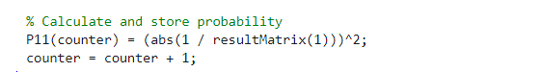

1. **Plotting Results:**

* **The script generates a plot of transmission probability versus energy, providing a visual representation of quantum tunneling phenomena. The plot is formatted for clarity with labeled axes, a title, and a grid.**

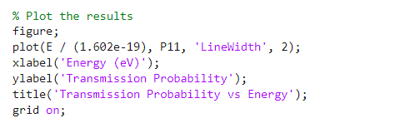

1. **Result (for base parameter $W=0.1^{nm} , L=0.2^{nm} , U_{0}=10^{e.v}$)**

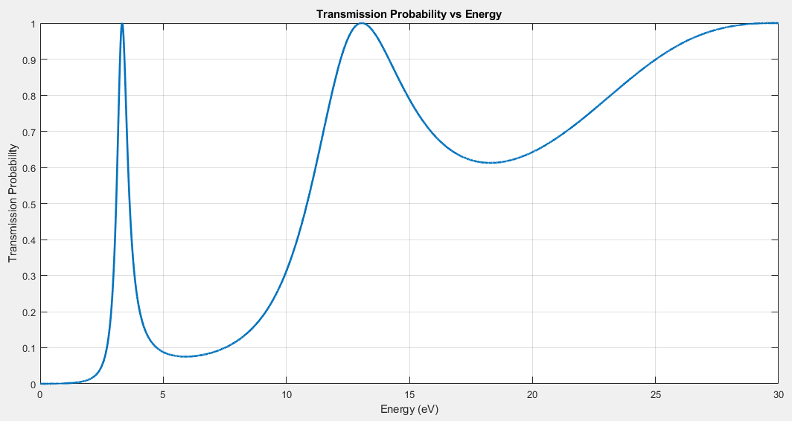

This Report delves into the intricate phenomenon of quantum tunneling in potential barriers, with a particular focus on two distinct phases: before and after reaching the potential of dams. The discussion revolves around key factors such as impedance matching and energy dynamics, shedding light on the behavior of particles as they encounter these barriers.

**Before the Amount of Potential of Dams**: Impedance Matching and Energy Transitions

In the initial phase, attention must be directed towards two critical aspects—impedance matching values and their corresponding limits. The diagram illustrates that, as energy increases, the likelihood of tunneling also rises until it reaches a specific value corresponding to impedance matching. Beyond this point, the trend becomes inclined. It's noteworthy that the energy barrier is set at 20 electron volts, and after surpassing the initial limit, a distinct electron trend emerges. This increase in energy signifies the energy level between barriers, where the system strives to transition to the next level. A comprehensive understanding of this process involves manipulating barrier values and well lengths, revealing a multitude of fluctuations.

**After the Value of the Potential of Dams**: Enhanced Energy and Reduced Fluctuations

Following the potential of dams, the increased energy further elevates the probability of particle transmission. However, a crucial distinction lies in the reduced distance between energy levels, resulting in diminished fluctuations. Notably, the decrease in the distance from peak to peak is accompanied by an increase in settling time. This phenomenon signifies a unique aspect of quantum tunneling in this phase, showcasing the interplay between heightened energy levels and the corresponding dynamics of particle behavior.

1. **Result (for changing $W=0.{01}^{nm} and W=0.5^{nm}$** **)**

$$W={0.01}^{nm}$$

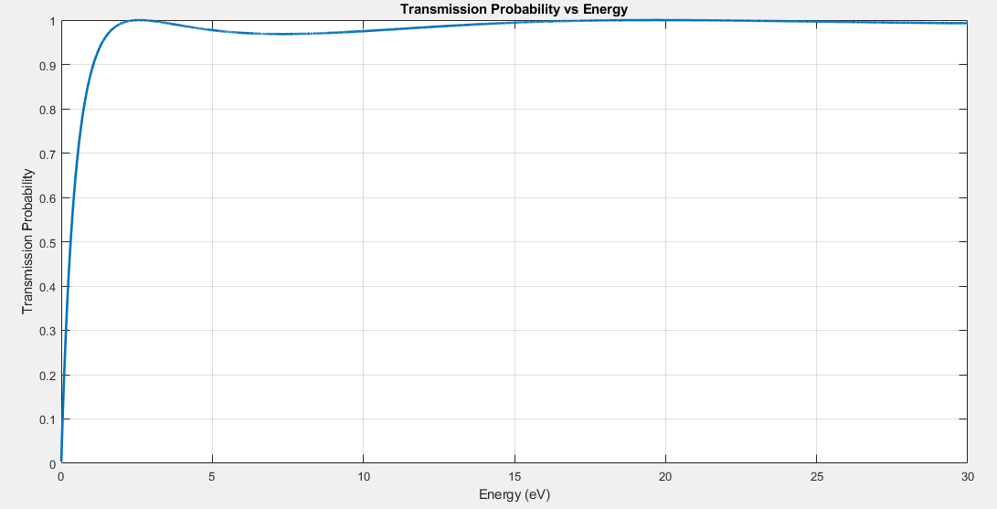

In this case, when we decrease the width of the barrier, the homogenizer that is thought to decrease the weight of the barrier increases, and as it is clear in the figure, it tends to 1 only after the first level; As mentioned earlier, impedance matching and the limit of the height of the barrier can also be seen.

$$W={0.5}^{nm}$$

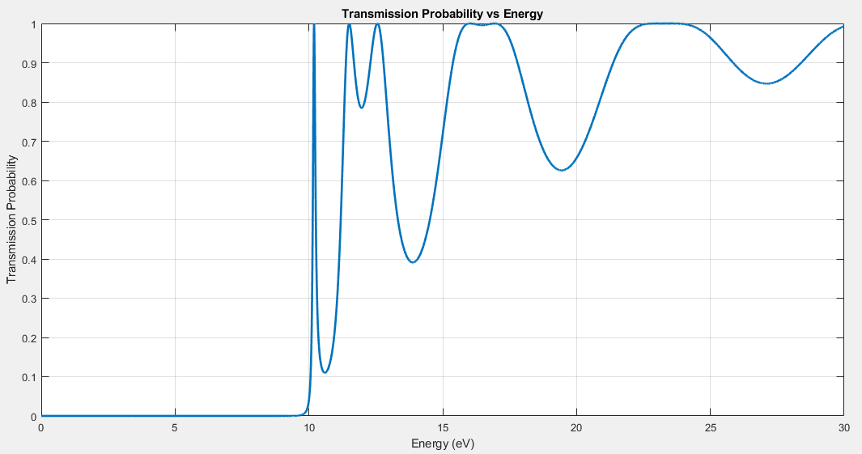

In this case, when we increase the width of the barrier, it is assumed that the width of the barrier increases, so the probability of passing decreases, and as shown in the picture, before the value of $U_{0}$, because the amount of energy is low, and the distance between the two barriers decreases. So, two points can be checked:

* The two peaks that are closer to each other show the empty space between the two dams, which decreases with the increase of energy and turns into a straight line, as well as the valleys that have a strong drop. It shows that there are barriers in which the electron gets stuck.
* Energy levels. It was discussed earlier that the energy levels change as the energy levels rise and fall, and due to the increase in energy, the level increases.

1. **Result (for changing $L=0.{02}^{nm} and L=0.5^{nm}$** **)**

$$L={0.02}^{nm}$$

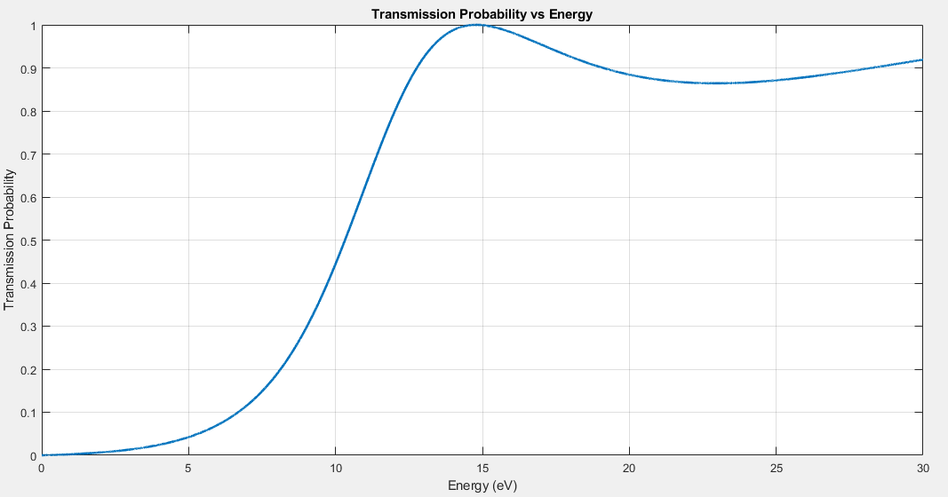

Now we want to reduce the length of the well in this case because the electron no longer has a chance to go to the energy levels between the two barriers and it takes so long to go to the next level that it crosses the border of the barrier height and tends to 1, even before this Impedance matching energy does not occur because most of the electron movement is inside the barrier, so the probability of passage decreases.

$$L={0.5}^{nm}$$

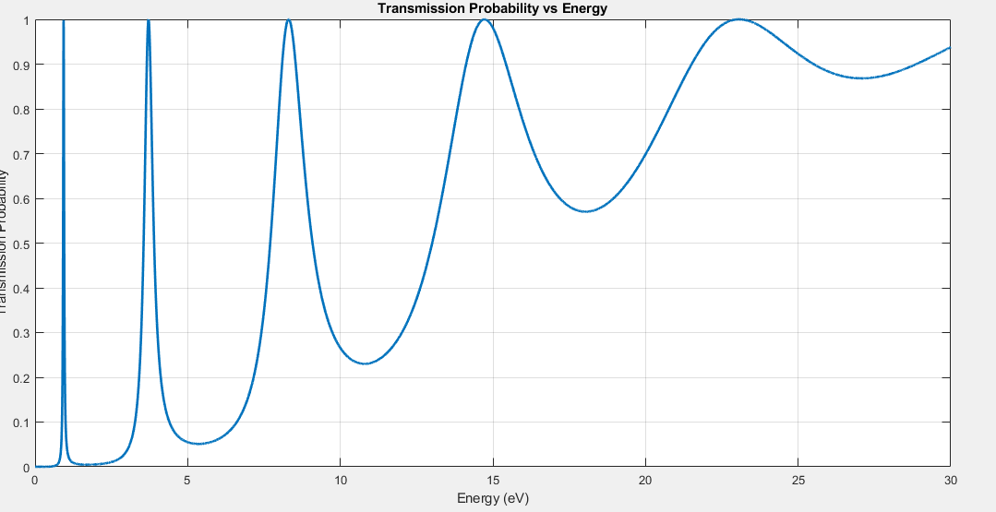

But in this case, because there is a good gap between the barriers, it can enter higher levels and have the impedance matching of each level.

1. **Result (for changing $U_{0}=5^{e.v} and U_{0}={20}^{e.v}$** **)**

$$U_{0}=5^{e.v}$$

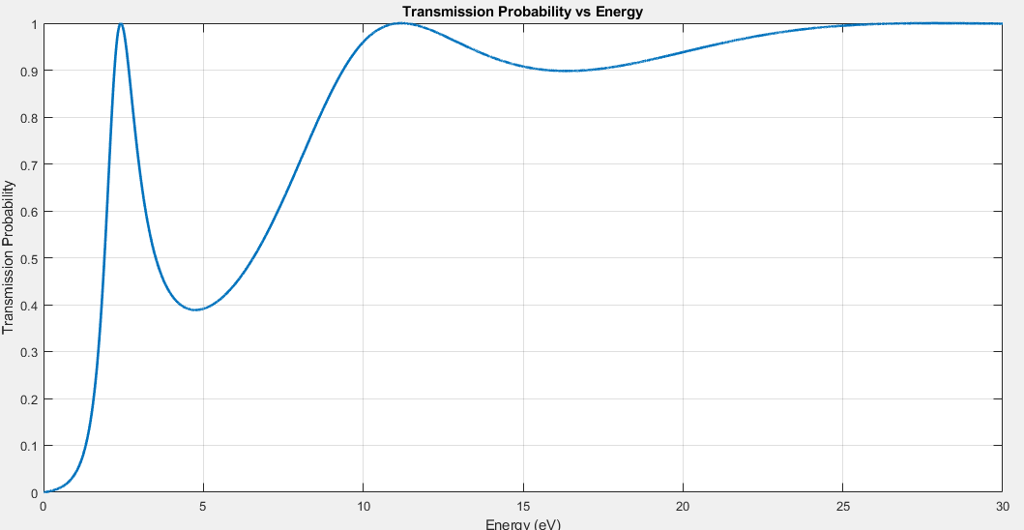

Now we want to reduce the energy of the dam or the height of the dam; When the energy of the barrier decreases, the electron reaches the upper limit faster and is less placed between the two barriers and energy levels and reaches its limit faster (I am talking about the base state). As you can see in the figure, we no longer have 2 peaks, but 1. It is the peak that represents the cropping of the base chart.

$$U_{0}={20}^{e.v}$$

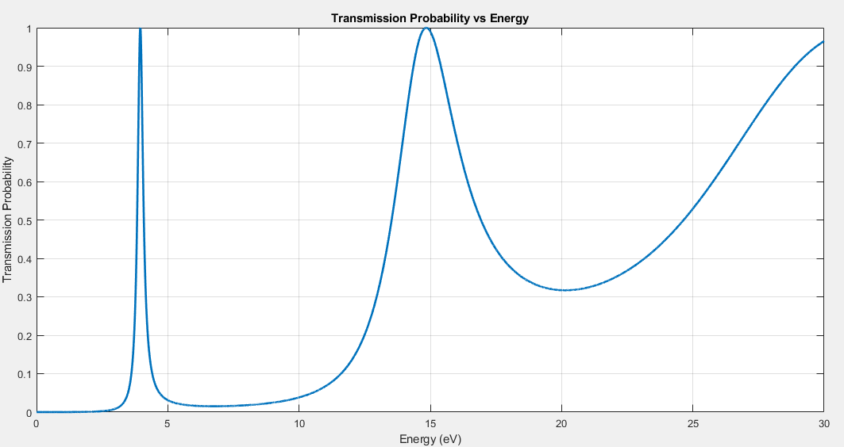

Now we increase the energy of the barrier, as expected, the graph is extended and the same two peaks are seen, although with a greater slope because it is placed more in the levels and requires more energy to cross this barrier and get to 1.

1. **Summary**

* In this diode, one should pay attention to the parameters such as the energy of the well length, the length of the dam and the height of the dam, and the factors that affect the probability of passage.
* With the increase in the weight of the well, more energy levels are placed between the dams, and more levels must be passed to reach the energy of the dam.
* By increasing the weight of the barrier, more time remains in the barrier and the probability of tunneling increases, so the probability of impedance matching is less; Of course, because the distance between the dams is also reduced compared to the previous state, it causes more energy to appear from the dam in two ways: deep valleys and shallow valleys, the first one is due to the long length of the dam and the second one is due to the short length between the dams. is more visible in this state.
* By increasing the energy of the barrier, it causes the electron to travel further until it reaches that energy, so it travels through the peaks of the emission.
* With these works, it is possible to change the working process and structure of the diode in such a way that what voltage should be applied to it and what impurity should be given to it to increase the probability of electron passage.

1. **Application:**
2. Frequency multipliers: RTDs can be used to generate high-frequency oscillations due to their NDR (Negative Differential Resistance) characteristic.
3. Low-noise amplifiers: RTDs can enhance the signal-to-noise ratio in low-noise amplifiers due to their sharp and well-defined NDR peak.
4. Microwave oscillators: RTDs can be used to create compact and stable microwave oscillators for applications such as communications and radar systems.
5. Tunable filters: RTDs can serve as tunable filters by utilizing their NDR characteristic to modify their frequency response.