Master Documentation

RAD Project

Team F

Table of Contents

Source Control 2

Project Management Plan 3

Software Development Testing Plan 4

Analysis Report 5

Multi-Platform Report 6

Adaptive 6

Responsive 6

# Source Control

This project will use GitHub which can help developers easily to manage software’s version to store and distribute every version. The history of application version will record in GitHub repository. <https://github.com/SMT-Diploma-of-Software-Development/Movie_Theater_Database>

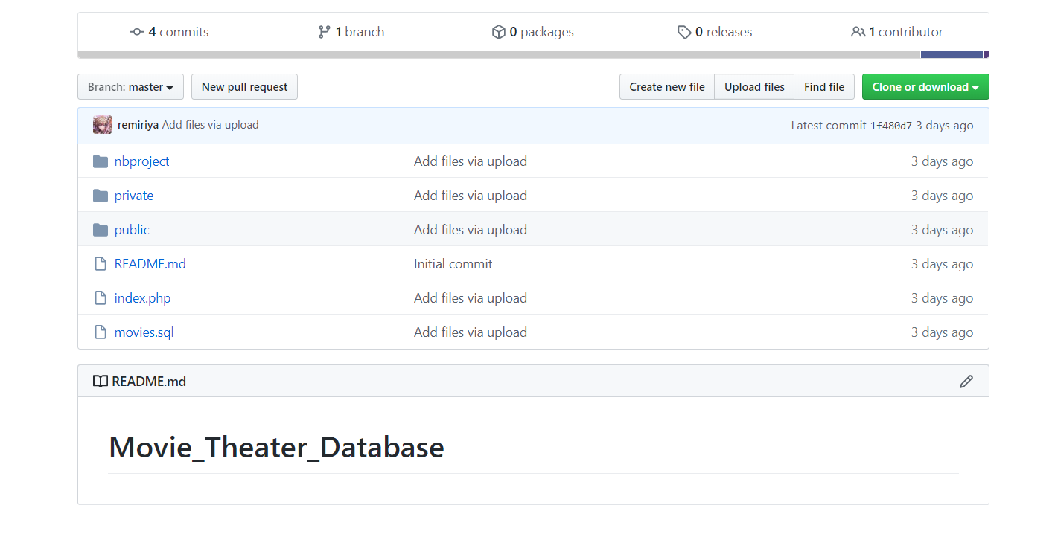

<https://team-f-org.monday.com/boards/583057251/>

# Project Management Plan

RAD Project.pdf

Crate management plan and Task allocate

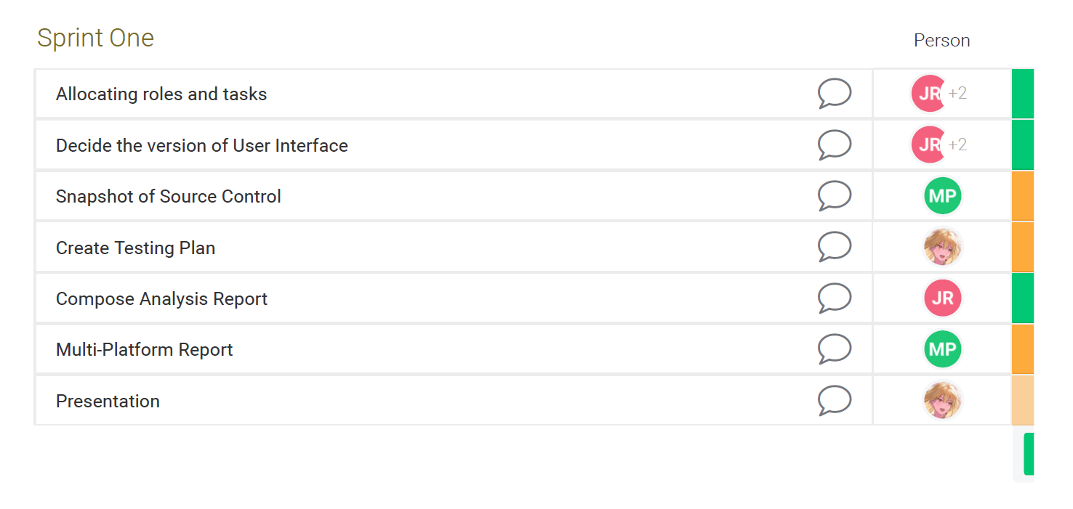

Gantt chart (Monday version)

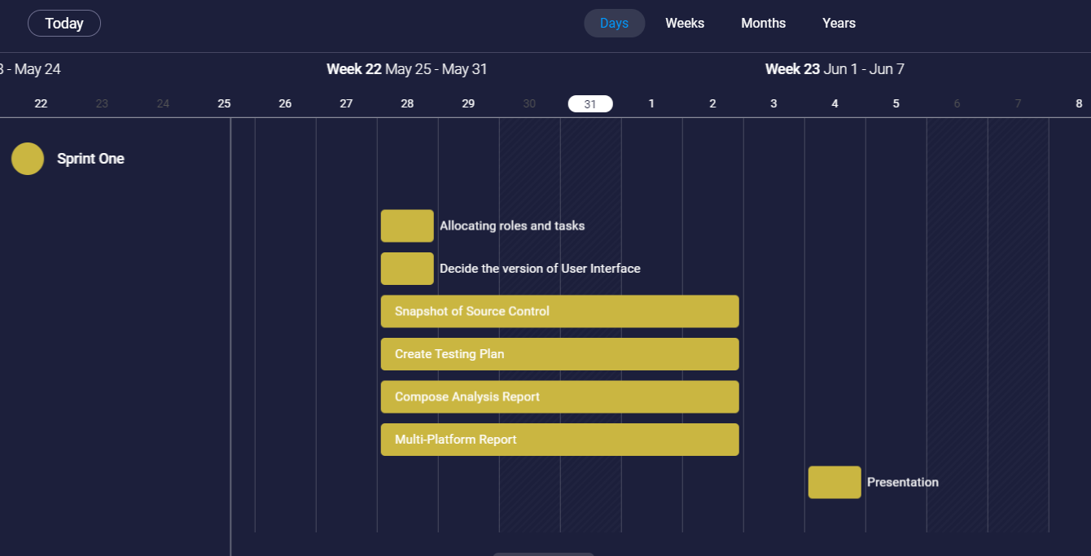

Excel version

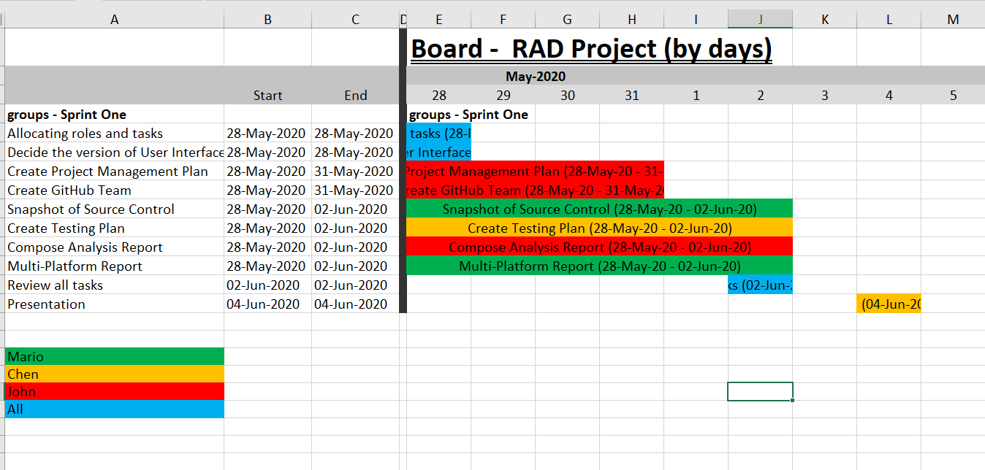

# Software Development Testing Plan

## Scope

### In Scope

Defines the features, functional or non-functional requirements of the software that **will be** tested

Functional(foundamental):

* Search movie function(by title, genre, rating year)
* Display found movie’s detail
* Top ten searched movie graph

Non-functional:

* Appropriate GUI
* **Able to be used in Multi-Platform**

## Quality Objective

* Ensure the Application Under Test conforms to functional and non-functional requirements
* Product quality verification and validation to ensure that it complies with clients’ business needs and expectations
* Bugs/issues are identified and fixed before release
* GUI provide user a good experience

## Roles and Responsibilities

* CITE Managed Services QA department: QA testing, configuration manage, risk manage
* Test Manager
* Developers and tester

# test methodology

## methodology

This project will adopt Agile model and RAD model, testing phase will be in the end of each iteration.

Agile model and RAD model

Agile model is a combination of iterative and incremental process models with focus on process adaptability and customer satisfaction by rapid delivery of working software product. Agile Methods break the product into small incremental builds. These builds are provided in iterations. Each iteration (Requirement->Design->Development->**Testing**->Evaluation) typically lasts from about one to three weeks. **At the end of the iteration, a working product is displayed to the customer and important stakeholders**. (tutorialspoint, 2019)

Hence testing phase will execute in each interation, it ensure bug can be found early.

Rapid Application Development (formerly known as Rapid Application Development, abbreviated as RAD) is a methodology for software development. RAD methodology is quite different with traditional SDLC, traditional SDLC emphasize requirement analysis before code start. Changing requirement may not so feasible. However**, RAD emphasize the iterative and incremental delivery of working models to the customer rapidly and allow customer give feedback**.

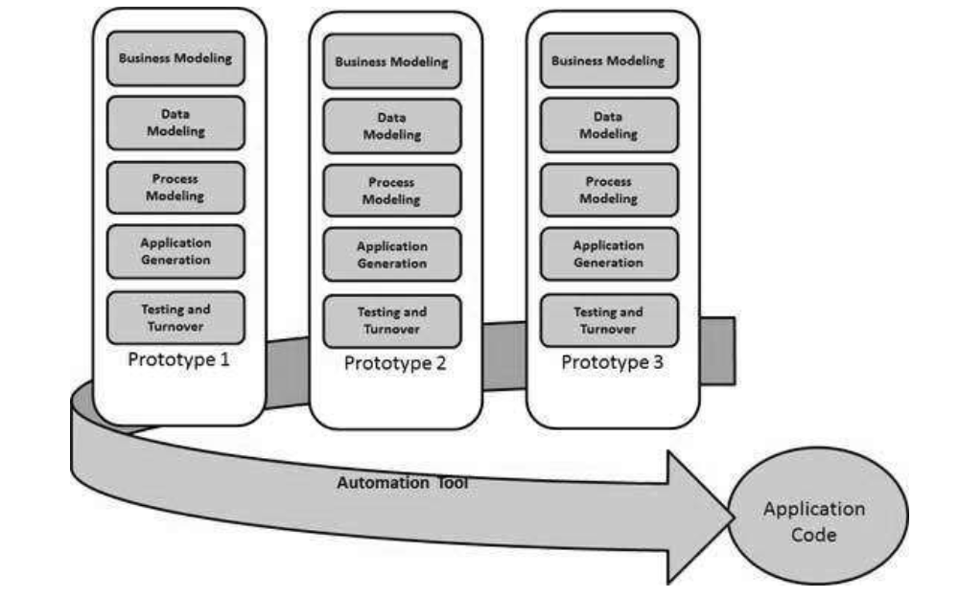

## Test method

White box testing:

White box testing or structural testing is tested by who understand the structural or implementation of application. Tester understand how the application works. Usually, white box testing tests application’s internal structure or working. Testers will choose inputs to exercise path through the code and determine the expected outputs.

## Test Completeness

Criterias that deem testing complete.

* 100% test coverage (all functionalities)
* All Test cases executed manually
* **Software are tested under a various of platform.**
* All testing result will be documented.

# 

# ource & Environment Needs

## Resource & Environment Needs

## Testing Tools

* XAMPP or server environment
* Multiplatform simulation environment (Google Developer tools)
* Testing document
* Computer

## Test Environment

Hardware:

OS: Windows 10 64bit

* Processor: Intel Core i7
* Memory: 16 GB RAM
* Graphics: NVIDIA GeForce GTX 1650
* Storage: 100 GB available space

## Test Deliverables

Here mention all the Test Artifacts that will be delivered during different phases of the testing lifecycle.

## Test case

Functional test

|  |  |  |  |
| --- | --- | --- | --- |
| Test case (In laptop 1440 X 900) | Data inputted | Expect Result | Result |
| Test search function by title | ‘10’ | Found movie title ‘10’ | Correct  Screen shot in attach video **test.mp4** |
| Test search function by rating | ‘R’ | Found movies which rating are ‘R’ | Correct  Screen shot in attach video **test.mp4** |
| Test search function by year | ‘1979’ | Found movies which year are ‘1979’ | Correct  Screen shot in attach video **test.mp4** |
| Test search function by title | ‘Comedy’ | Found movies which genre are ‘comedy’ | Correct  Screen shot in attach video **test.mp4** |
| Test search function (input incorrect info) | Title=’1’ | Error message | Correct  Screen shot in attach video **test.mp4** |
| Test search function (input multiple info) | Title=10  Rating=R  Year=1979  Genre=comedy | Found one movie which title is ‘10’ | Correct screen shot in attach video **test.mp4** |

|  |  |  |  |
| --- | --- | --- | --- |
| Test case (In mobile 360 X 640) | Data inputted | Expect Result | Result |
| Test search function by title | ‘10’ | Found movie title ‘10’ | Correct screen shot in attach video **test.mp4** |
| Test search function by rating | ‘R’ | Found movies which rating are ‘R’ | Correct screen shot in attach video **test.mp4** |
| Test search function by year | ‘1979’ | Found movies which year are ‘1979’ | Correct screen shot in attach video **test.mp4** |
| Test search function by title | ‘Comedy’ | Found movies which genre are ‘comedy’ | Correct screen shot in attach video **test.mp4** |
| Test search function (input incorrect info) | Title=’1’ | Error message | Correct screen shot in attach video **test.mp4** |
| Test search function (input multiple info) | Title=10  Rating=R  Year=1979  Genre=comedy | Found one movie which title is ‘10’ | Correct screen shot in attach video **test.mp4** |

|  |  |  |  |
| --- | --- | --- | --- |
| Test case (In ipad 1024 X 768) | Data inputted | Expect Result | Result |
| Test search function by title | ‘10’ | Found movie title ‘10’ | Correct screen shot in attach video **test.mp4** |
| Test search function by rating | ‘R’ | Found movies which rating are ‘R’ | Correct screen shot in attach video **test.mp4** |
| Test search function by year | ‘1979’ | Found movies which year are ‘1979’ | Correct screen shot in attach video **test.mp4** |
| Test search function by title | ‘Comedy’ | Found movies which genre are ‘comedy’ | Correct screen shot in attach video **test.mp4** |
| Test search function (input incorrect info) | Title=’1’ | Error message | Correct screen shot in attach video **test.mp4** |
| Test search function (input multiple info) | Title=10  Rating=R  Year=1979  Genre=comedy | Found one movie which title is ‘10’ | Correct screen shot in attach video **test.mp4** |

## Report

Meet requirement:

* Every logic path are tested, all output are as expected.
* In the applictaoin, there are no significant bug.
* Every path had noticed users when the operating of users is wrong.
* The layout is responsive

# Analysis Report

# Multi-Platform Report

## Adaptive

* Allow user to build best UX for each device
* Have more controller

## Responsive

Content would move dynamically if size changed

* Easier to implement
* SEO friendly