Team F

Master Documentation

RAD Project

Table of Contents

Source Control 3

Project Management Plan 4

Table Format 4

Gantt chart Format 5

Excel format 6

Software Development Testing Plan 7

Scope 7

In Scope 7

Quality Objective 7

Roles and Responsibilities 7

methodology 8

Agile model and RAD model 8

Test method 8

Test Completeness 9

Resource & Environment Needs 9

Testing Tools 9

Test Environment 9

Test Deliverables 9

Test case 9

Report 10

Analysis Report 11

Business Rules 11

Intellectual Property Protection 11

Information Non-Disclosure 11

Quality Assurance 11

QMS Tasks and Objectives 11

Comprehensive Approach to Quality 12

Multi-Platform Report 13

Introduction/Purpose 13

Adaptive Web Design 13

DEFINITION 13

IMPLICATIONS 13

RESULTS 14

Responsive Web Design 14

DEFINITION 14

IMPLICATIONS 14

RESULTS 15

Summary/Decision 15

References 16

# Source Control

|  |  |  |  |  |  |
| --- | --- | --- | --- | --- | --- |
| **Version #** | **Implemented**  **By** | **Revision**  **Date** | **Approved**  **By** | **Approval**  **Date** | **Reason** |
| 1.0 | *<Cheng Liang Chen>* | *<28/05/2020>* | *< Team F >* | *<28/05/2020>* | Implement responsive web site |
|  |  |  |  |  |  |
|  |  |  |  |  |  |

This project will use GitHub which can help developers easily to manage software’s version to store and distribute every version. The history of application version will be recorded in GitHub repository. <https://github.com/SMT-Diploma-of-Software-Development/Movie_Theater_Database>

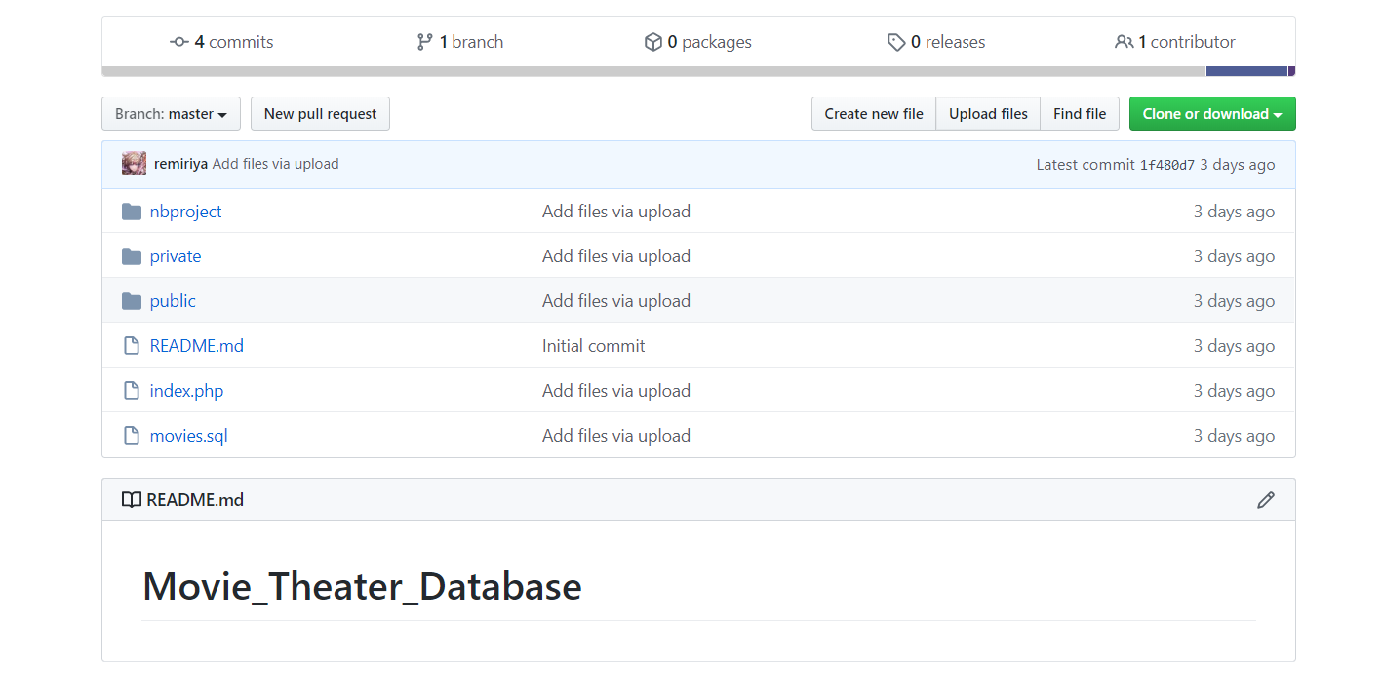

# Project Management Plan

**Tool**

Monday.com is used for project management. Below images showed the project plan in a table format and Gantt chart format. Future amendment of project will be recorded on Monday.com. The project plan is public and can be accessed on this link <https://team-f-org.monday.com/boards/583057251/>

### Table Format

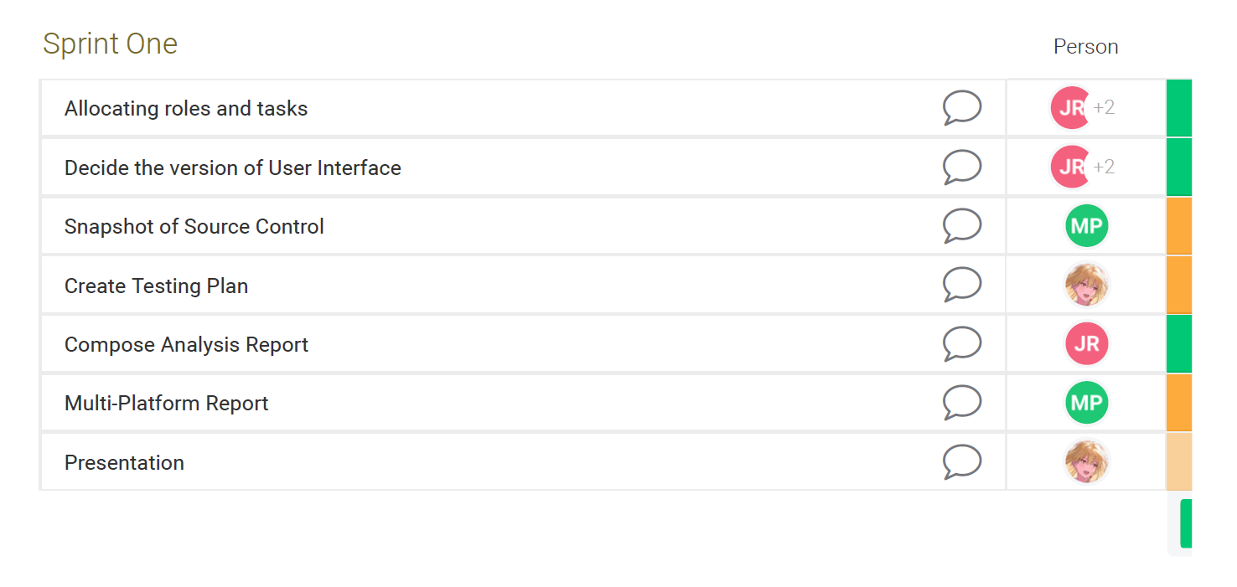

### Gantt chart Format

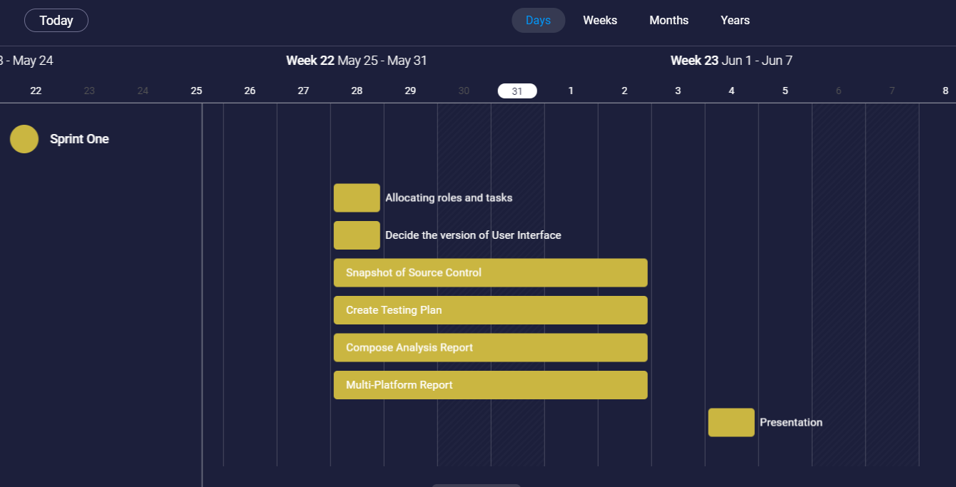

### Excel format

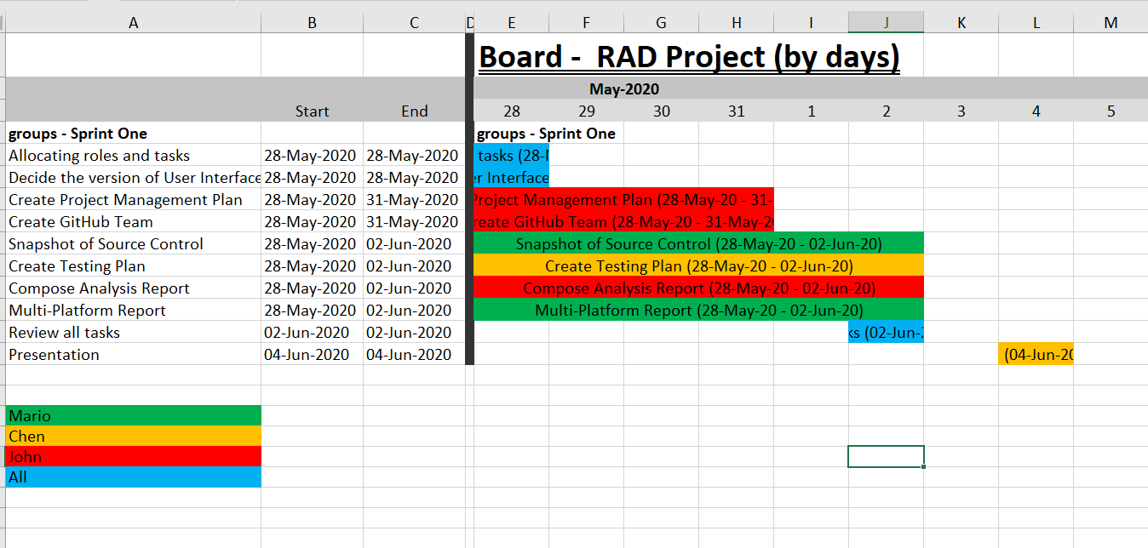

# Software Development Testing Plan

## Scope

### In Scope

Defines the features, functional or non-functional requirements of the software that **will be** tested

Functional(foundamental):

* Search movie function(by title, genre, rating year)
* Display found movie’s detail
* Top ten searched movie graph

Non-functional:

* Appropriate GUI
* **Able to be used in Multi-Platform**

### Quality Objective

* Ensure the Application Under Test conforms to functional and non-functional requirements
* Product quality verification and validation to ensure that it complies with clients’ business needs and expectations
* Bugs/issues are identified and fixed before release
* GUI provide user a good experience

### Roles and Responsibilities

* CITE Managed Services QA department: QA testing, configuration manage, risk manage
* Test Manager
* Developers and tester

## methodology

This project will adopt Agile model and RAD model, testing phase will be in the end of each iteration.

### Agile model and RAD model

Agile model is a combination of iterative and incremental process models with focus on process adaptability and customer satisfaction by rapid delivery of working software product. Agile Methods break the product into small incremental builds. These builds are provided in iterations. Each iteration (Requirement->Design->Development->**Testing**->Evaluation) typically lasts from about one to three weeks. **At the end of the iteration, a working product is displayed to the customer and important stakeholders**. (tutorialspoint, 2019)

Hence testing phase will execute in each interation, it ensure bug can be found early.

Rapid Application Development (formerly known as Rapid Application Development, abbreviated as RAD) is a methodology for software development. RAD methodology is quite different with traditional SDLC, traditional SDLC emphasize requirement analysis before code start. Changing requirement may not so feasible. However**, RAD emphasize the iterative and incremental delivery of working models to the customer rapidly and allow customer give feedback**.

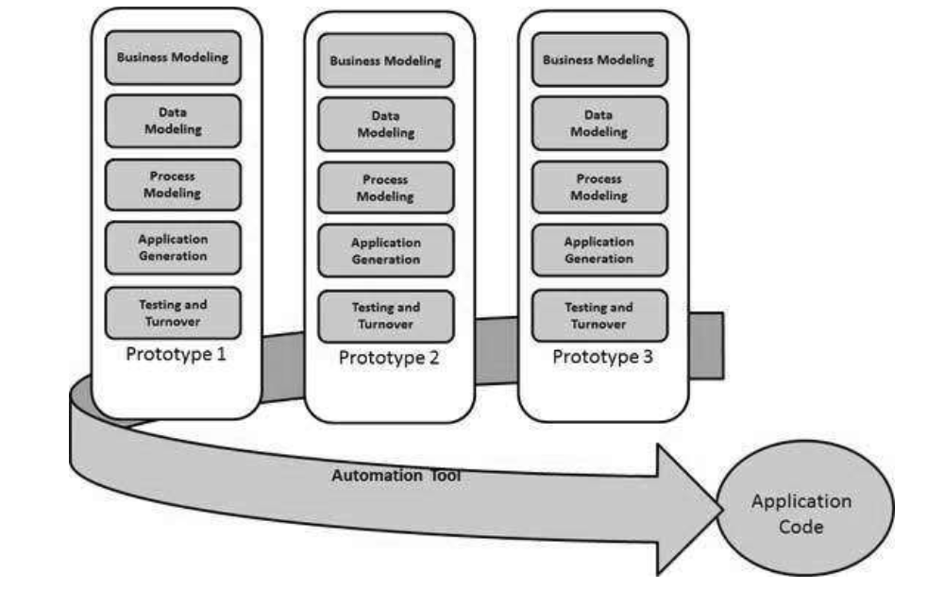

### Test method

White box testing:

White box testing or structural testing is tested by who understand the structural or implementation of application. Tester understand how the application works. Usually, white box testing tests application’s internal structure or working. Testers will choose inputs to exercise path through the code and determine the expected outputs.

### Test Completeness

Criterias that deem testing complete.

* 100% test coverage (all functionalities)
* All Test cases executed manually
* **Software are tested under a various of platform.**
* All testing result will be documented.

## Resource & Environment Needs

### Testing Tools

* XAMPP or server environment
* Multiplatform simulation environment (Google Developer tools)
* Testing document
* Computer

### Test Environment

* OS: Windows 10 64bit
* Processor: Intel Core i7
* Memory: 16 GB RAM
* Graphics: NVIDIA GeForce GTX 1650
* Storage: 100 GB available space

## Test Deliverables

Here mentions all the Test Artifacts that will be delivered during different phases of the testing lifecycle.

### Test case

Functional test

|  |  |  |  |
| --- | --- | --- | --- |
| Test case (In laptop 1440 X 900) | Data inputted | Expect Result | Result |
| Test search function by title | ‘10’ | Found movie title ‘10’ | Correct  Screen shot in attach video **test.mp4** |
| Test search function by rating | ‘R’ | Found movies which rating are ‘R’ | Correct  Screen shot in attach video **test.mp4** |
| Test search function by year | ‘1979’ | Found movies which year are ‘1979’ | Correct  Screen shot in attach video **test.mp4** |
| Test search function by title | ‘Comedy’ | Found movies which genre are ‘comedy’ | Correct  Screen shot in attach video **test.mp4** |
| Test search function (input incorrect info) | Title=’1’ | Error message | Correct  Screen shot in attach video **test.mp4** |
| Test search function (input multiple info) | Title=10  Rating=R  Year=1979  Genre=comedy | Found one movie which title is ‘10’ | Correct screen shot in attach video **test.mp4** |
| Test case (In mobile 360 X 640) | Data inputted | Expect Result | Result |
| Test search function by title | ‘10’ | Found movie title ‘10’ | Correct screen shot in attach video **test.mp4** |
| Test search function by rating | ‘R’ | Found movies which rating are ‘R’ | Correct screen shot in attach video **test.mp4** |
| Test search function by year | ‘1979’ | Found movies which year are ‘1979’ | Correct screen shot in attach video **test.mp4** |
| Test search function by title | ‘Comedy’ | Found movies which genre are ‘comedy’ | Correct screen shot in attach video **test.mp4** |
| Test search function (input incorrect info) | Title=’1’ | Error message | Correct screen shot in attach video **test.mp4** |
| Test search function (input multiple info) | Title=10  Rating=R  Year=1979  Genre=comedy | Found one movie which title is ‘10’ | Correct screen shot in attach video **test.mp4** |

|  |  |  |  |
| --- | --- | --- | --- |
| Test case (In ipad 1024 X 768) | Data inputted | Expect Result | Result |
| Test search function by title | ‘10’ | Found movie title ‘10’ | Correct screen shot in attach video **test.mp4** |
| Test search function by rating | ‘R’ | Found movies which rating are ‘R’ | Correct screen shot in attach video **test.mp4** |
| Test search function by year | ‘1979’ | Found movies which year are ‘1979’ | Correct screen shot in attach video **test.mp4** |
| Test search function by title | ‘Comedy’ | Found movies which genre are ‘comedy’ | Correct screen shot in attach video **test.mp4** |
| Test search function (input incorrect info) | Title=’1’ | Error message | Correct screen shot in attach video **test.mp4** |
| Test search function (input multiple info) | Title=10  Rating=R  Year=1979  Genre=comedy | Found one movie which title is ‘10’ | Correct screen shot in attach video **test.mp4** |

### Report

The test met these requirements:

* Every logic path are tested, all output are as expected.
* In the applictaoin, there are no significant bug.
* Every path had noticed users when the operating of users is wrong.
* The layout is responsive

# Analysis Report

## Business Rules

### Intellectual Property Protection

We realize that the economic value of your software assets critically depends on the nature of IP rights involved. Bearing that in mind, we utilize best practices and all the available legal and physical means to protect your legitimate interests.

### Information Non-Disclosure

We sign a non-disclosure agreement with our customers as to provide their sensitive information with maximum security and confidentiality. Upon acceptance of employment, all employees are required to execute a confidentiality agreement and must acknowledge receipt of and compliance with CITE Managed Services security policies.

## Quality Assurance

CITE Managed Services has implemented a Quality Management System (QMS) comprising a complex set of engineering and managerial activities that ensure bespoke quality of delivered software throughout the entire workflow.

### QMS Tasks and Objectives

* Elaboration and implementation of procedures and regulations for software development process based on industry standards and best practices;
* Product lifecycle monitoring to ensure compliance with established processes and guidelines
* Product quality verification and validation to ensure that it complies with clients’ business needs and expectations;
* Establishment of an effective collaboration between all project team members.

### Comprehensive Approach to Quality

#### Quality Planning

CITE Managed Services puts together quality plans that govern the applicable set of standards, regulations, procedures, guidelines and tools during the development lifecycle in each project.

#### Quality Assurance

We have established processes that evaluate project performance and aim to assure that quality standards are being followed and that the deliverables comply with customer requirements.

#### Quality Control

We measure performance trends to identify defective pieces of code, verify that deliverables are of high quality and that they are complete and correct.

#### Independent QA Department

CITE Managed Services QA department is an independent structural subdivision. Our QA team consists of skilled QA engineers who get involved in projects on a dedicated or an on-demand basis. The allocation of QA engineers depends on project size and complexity: they can be easily reallocated from one project to another upon necessity. Such flexibility allows us to optimize efforts and, thus, the overall project budget. Our QA Department is responsible for:

* Full-cycle QA Testing
* Document and Code Reviews
* Defect Tracking
* Configuration Management
* Process Monitoring
* Risk Management

# Multi-Platform Report

## Introduction/Purpose

Acme Entertainment wish to review the movie database prototype so it may be used across all major digital platforms, this requires a multiplatform report that defines and outlines the merits derived from the results and implications of using two current design options – adaptive vs responsive. This report attempts to provide enough information regarding the topic to justify the Responsive Design approach chosen by Team F for developing the application across multiple platforms.

## Adaptive Web Design

### DEFINITION

Was introduced in 2011 by Aaron Gustafson in a book he wrote called “Adaptive Web Design: Crafting Rich Experiences with Progressive Enhancement”, as such ‘adaptive web’ design is also known as ‘progressive enhancement of a website’.

As a user connects to the website an Adaptive **Design will establish the layout design most appropriate for that user’s system based on the space(size) available on their screen**, for example if said user connects via a smartphone vs a desktop the server side logic will detect this and respond by sending the appropriate style in the index html that corresponds with the users system.

### IMPLICATIONS

The implication of using an Adaptive Design is that it is labor intensive to create, detect and implement all the multiple design templates and pages which may be required, furthermore resolutions that don’t conform to the these templates are may to have trouble with the site configuration as they likely won’t fit any layout’s predefined parameters. Search Engines may also regard your site lower in their rankings if they can recognize multiple URLs have identical content or as Google calls it “appreciably similar”, these URLs are penalized only because they search engine’s know which version to include/exclude from indices or whether to keep everything separated to different versions.

### RESULTS

The resolution of implementing an Adaptive Design is that you can deliver the UX intended for the appropriate device, this can mean loading pages faster depending if a platform has lower capabilities/resources (i.e. smart phones) by retrofitting the original site content as appropriate, furthermore some devices such as smartphones have the option to gather user data for optimizing advertisement and user experience, (Windows 10 has it also via Cortana) with this data web developers may optimize their advertisements to suit the user and therefore be more effective.

* Best UX in different type of devices
* Loading faster
* Designers can optimize advertisements based on user data from smart devices.

## Responsive Web Design

### DEFINITION

Ethan Marcotte first coined the term Responsive Design in his book “Responsive Web Design”. Responsive Design involves responding to a browser’s specified width by adjusting the layout of the webpage content. A good example of responsive web design is [Youtube’s](https://www.youtube.com/) website, notice as you resize the browser window that elements of content will disappear/appear or be modified according to current size and intended priority.

Majority of new sites use Responsive Design as it can be implemented easily for less experienced developers, most cotemporary Responsive Design is enabled by themes and CMS (Content Management System).

### IMPLICATIONS

Using pre-set themes for implementing a Responsive Design has its implications such as less control over how content may be displayed, however it still costs less time to build and maintain than an Adaptive Design. Responsive Web design implements a ‘one for all’ approach which can create longer load times for pages on smaller system such as mobile when compared to desktop, in comparison Adaptive Design will have the ability to portion the content as appropriate for the user’s system. Responsive Design usually includes all content but under the influence for composition of a CMS theme, advertisements may not be optimized for the user if the developers don’t manually integrate some additional of platform detection technique and apply its relevant data collection service to advertisements.

### RESULTS

The resolution of using a Responsive Web Design is a website which offers a good UX for its intended user at a small margin of the time cost compared to that of a website with Adaptive Design. The resulting webpage is Search Engine friendly regarding its webpages being "appreciably similar" as there is only one website to index. Responsive Design is the easiest to implement especially for developers who are beginners or under time constraints.

* Easier to implement
* Abundance of templates to use.
* Lower cost
* Search engine friendly

## Summary/Decision

Team F has decided to proceed **with using a Responsive Design** approach for updating the movie database prototype, this is partially because there is no real necessity to limit any particular platform layout based on slow load time as there aren’t excessive elements to display, additionally the allocated **time(3/4 weeks)** for development of this project is not enough for a implementing a successful Adaptive Design approach, that would take too long to develop with only 3 members who have limited web development experience.

# References

Blackboard Reading – Adaptive vs Responsive

<https://css-tricks.com/the-difference-between-responsive-and-adaptive-design/>

<https://www.uxpin.com/studio/blog/responsive-vs-adaptive-design-whats-best-choice-designers/>

<https://moz.com/learn/seo/duplicate-content>

<https://pixelprivacy.com/resources/windows-privacy-settings/>

# Master Documents Tree/Links

**Folder:**

Sprint Two Master Document – [folder-link](Master_Document_Sprint_Two.docx)

Sprint Three Master Document – [folder-link](Master_Documentation_Sprint_Three.docx)

Handover Master Document – [folder-link](Master_Documentation_Handover.docx)

**Github:**

Sprint Two Master Document – [hyperlink](https://github.com/SMT-Diploma-of-Software-Development/Movie_Theater_Database/blob/final_version/Master_Document_Sprint_Two.docx)

Sprint Three Master Document – [hyperlink](https://github.com/SMT-Diploma-of-Software-Development/Movie_Theater_Database/blob/final_version/Master_Documentation_Sprint_Three.docx)

Handover Master Document – [hyperlink](https://github.com/SMT-Diploma-of-Software-Development/Movie_Theater_Database/blob/final_version/Master_Documentation_Handover.docx)